SDC 1. Instructional leaflet for Video Filming for General Movement Assessment*
整體動作評估法錄影說明單Instructional leaflet for Video Filming for General Movement Assessment
面向 I  Domain I | 打勾Check | 錄影機設定準備Camera and Environment Setting for Video Filming | 正確示範Correct | 錯誤示範Incorrect
項目1  Item 1 | □ | 攝影畫素設定至少為2048x1536以上(300萬畫素以上)。Video resolution set to 2048 × 1536 or above (3,000,000 pixels or above).
項目2  Item 2 | □ | 使用橫式拍攝，而幼兒直躺或是橫躺皆可。Horizontal shooting used, regardless of whether infant is lying straight or horizontal. | 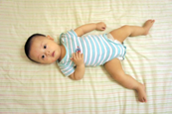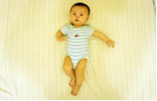  橫式拍攝Horizontal shooting | 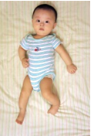  非橫式拍攝Non-horizontal shooting
項目3  Item 3 | □ | 攝影機、相機或智慧型手機拍攝由上往下拍，攝影高度需能拍到幼兒的全身(頭部、軀幹及四肢必須同時入鏡)，拍攝畫面請力求穩定，盡量不移動或晃動攝影機。建議可使用足夠高度的三腳架(需注意角架擺設位置不要被幼兒拉到)。Position the camera or smart phone above the infant for filming. The camera or smart phone needs to be high enough to be able to include the infant’s whole body (head, trunk, and limbs) in the shot. Video stability requires that the camera is not moved or shaken. Using a tripod with sufficient height is recommended (ensure that the tripod is positioned such that it cannot be pulled by children). | 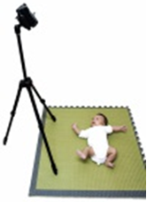 | 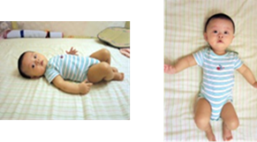
 |  |  | 智慧型手機拍攝由上往下拍，Camera or smart phone filming from above. | 未拍攝到左側手腳。 Non-horizontal shooting and did not include the left hand and foot. | 非橫式拍攝且手腳未入鏡。Hands and feet not included in the shot.
項目4  Item 4 | □ | 必須要拍到幼兒的臉，以確認幼兒的僵硬動作不是因為哭泣所導致。 翻身是被允許的，但必須拍攝到小朋友的臉，以確認小朋友動作的僵硬不是因為哭泣所導致。Include the infant's face in the shot to rule out that stiff movements are not caused by crying. The infant can turn over during filming, but the infant’s face must be kept in shot. | 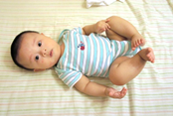  拍到幼兒的臉Includes the infant's face | 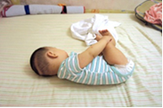  未拍攝到臉部Cannot see the infant’s face
項目5  Item 5 | □ | 在仰躺的姿勢之下進行拍攝，不能使用枕頭，兒童仰躺的材質，以不干擾幼兒的活動為佳，如安全舒適的遊戲墊、床墊。不建議使用過厚的底被，因為幼兒的活動容易受限或遮蔽。The infant must be kept in the lying position. Do not use pillows and ensure that the materials of the mattress do not interfere with the activities of infant. Suitable surfaces include a safe and comfortable pad or mattress. Using a thick quilt is not recommended, because the infant’s activities are easily limited or obscured. | 在仰躺姿勢下拍攝Kept in the lying position. | 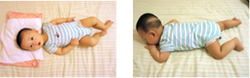  使用枕頭The use of a pillow. 趴姿In the prone position.
項目6  Item 6 | □ | 拍攝背景需要單純不雜亂。The background of the image needs to be clean and not messy. | 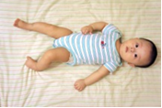  畫面背景單純Background is clean. | 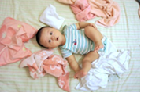  畫面背景雜亂Background is messy.
面向 II  Domain II | 打勾Check | 幼兒相關準備Infant’s Preparation | 正確示範 Correct | 錯誤示範 Incorrect
項目1  Item 1 | □ | 必須在幼兒清醒的時候進行錄影，錄影時間至少為5分鐘或更長(以確保幼兒能夠產生足夠的自主動作以提供分析)。Video must be recorded when the infant is awake, and for at least 5 minutes to ensure that the child can generate enough general movements for analysis. | 在小朋清醒時拍攝Infant is awake. | 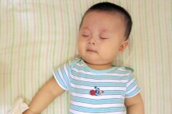  小朋友在睡覺Infant is asleep.
項目2  Item 2 | □ | 幼兒的穿著以舒適為主(建議穿著短袖包屁衣)，必須暴露四肢(不要穿著手套或是襪子)。Dress the infant in comfortable clothes (short-sleeved clothes are recommended), and ensure all four limbs are exposed (do not dress infant in gloves or socks). | 必須露出四肢All four limbs clearly visible. | 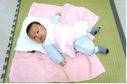  使用枕頭並穿著長袖衣物Use of a pillow and infant is wearing long-sleeved clothing.
面向 III  Domain III | 打勾Check | 停止拍攝情境Scenes for Stop Filming | 正確示範 Correct | 錯誤示範 Incorrect
項目1  Item 1 | □ | 當小朋友哭泣、躁動不安或是吸奶嘴的時候便不要進行拍攝。當幼兒哭泣時如果只是啜泣，而不會因此導致肢體僵硬便可繼續拍攝。 但如果在五分鐘的錄影時間當中有超過一半的時間都在哭，那段影片就不適合做為評估，就必須要擇日再拍攝。Do not film when the infant is crying, restless or breastfeeding. If infant is only weeping without limb stiffness, you can continue to film. However, if more than half of five minutes of video recording contains crying, the video is not suitable for assessment and must be retaken at other suitable times. |  | 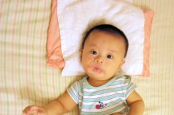  吸奶嘴及使用枕頭Nipple sucking and use of a pillow.
項目2  Item 2 | □ | 在整個錄影的過程當中不要以聲音、動作、手勢或玩具去逗弄幼兒。環境的噪音是可以被接受的(因為它是一直存在的，而不可利用聲音去吸引小朋友的注意)，另外也不要使用表情去逗弄幼兒，因為幼兒若被家屬吸引，四肢的肢體動作數量會變少。Do not tease the infant with sounds, gestures, or toys throughout the video recording. Environmental noise is acceptable because it is always present, but do not use voice to attract infant's attention. Do not use facial expressions to tease the infant, because they will be attracted to parents, resulting in decreased body and limb movements. |  | 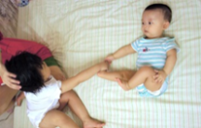  逗弄小朋友Infant is being teased.
 | 恭喜您完工了! 錄影完成後，請先自我檢查影片一次。Congratulations, you're done! Please check the video yourself after filming.
20120925 第二版
*For review, the original Chinese leaflet was translated into English (in in italics) in Taiwan. It has been checked by professional translator, but the style in English writing may be influenced by the original leaflet and culture

