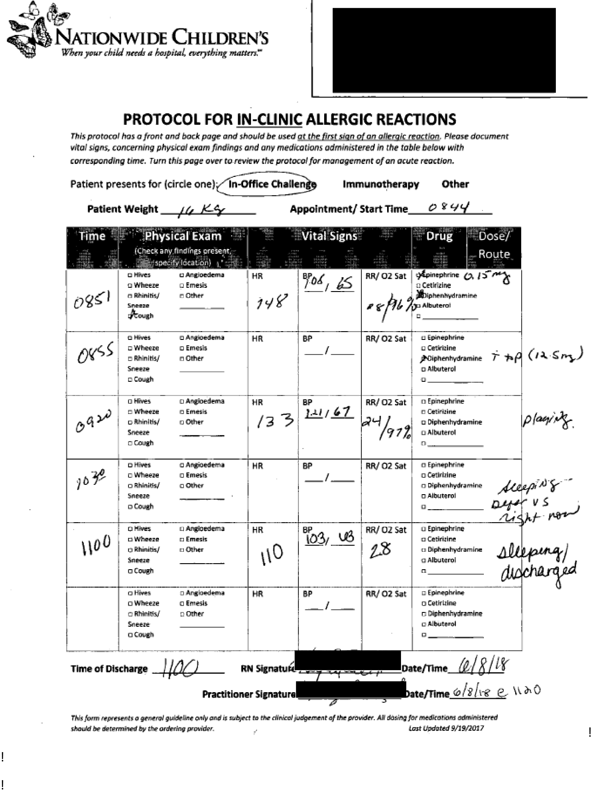
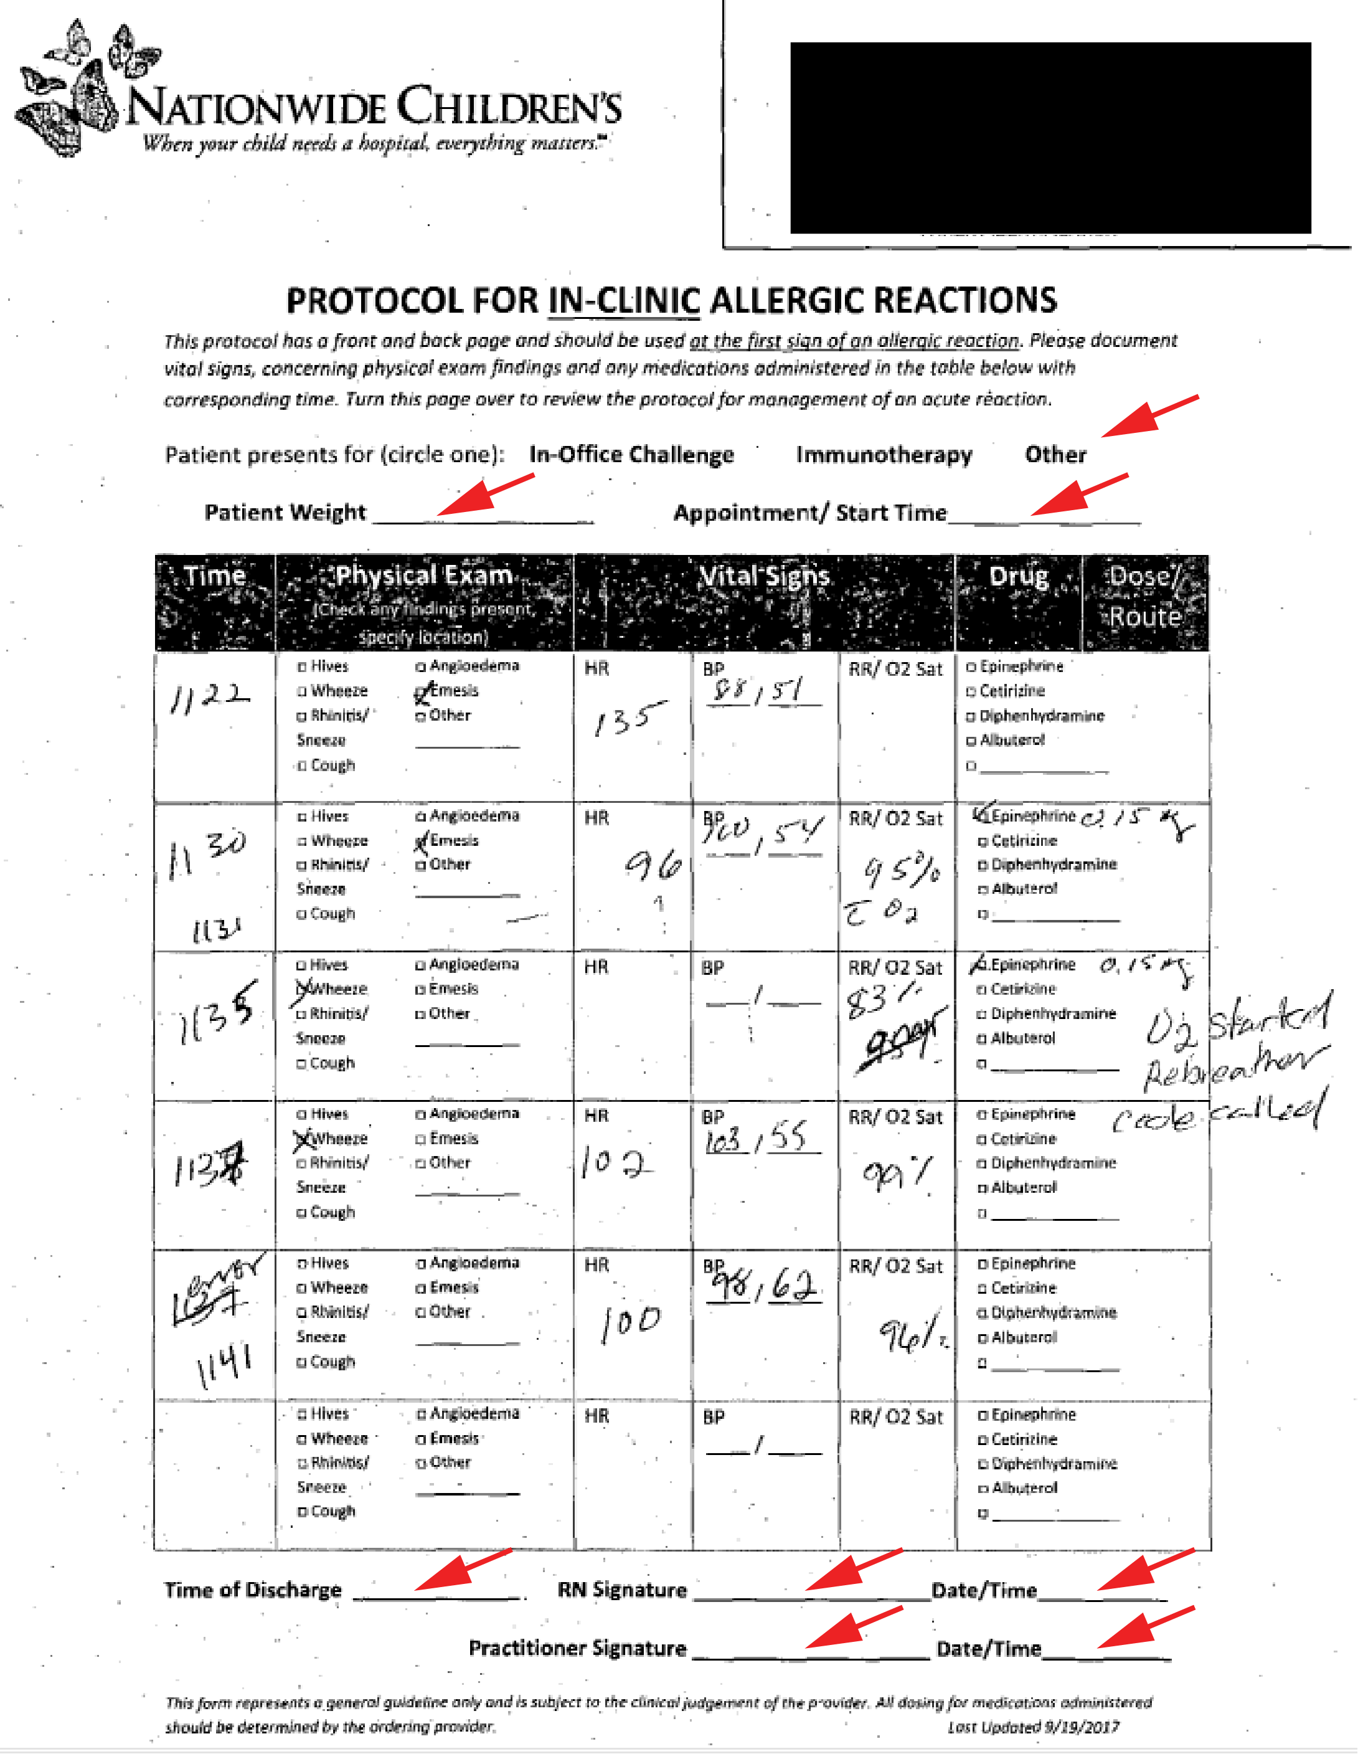

Supplemental Figure S2. Examples of completed anaphylaxis forms. Following the rollout of the standardized treatment plan and documentation for anaphylaxis in the allergy clinic, we reviewed the EMR of patients who had received epinephrine in the allergy clinic. Most forms were appropriately completed for signs, symptoms, vital signs, and medication administration, as shown in (A). However, 45% of the forms were lacking at least one component being filled out. (B) An example of a form with missing information, indicated by red arrows.

