Supplemental Digital Content 1
Quality Improvement in Pediatric Head Trauma with PECARN Rules Implementation as Computerized Decision Support, Atabaki, SM

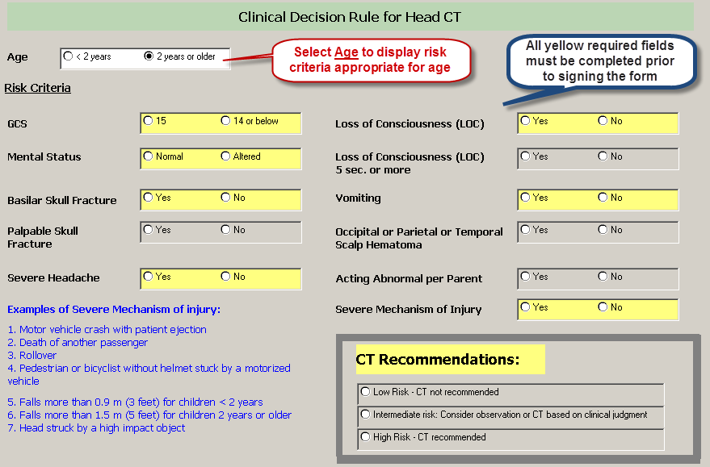
SDC 1. PECARN prediction rule in format embedded in the electronic health record, preceding the head CT order and also as a stand-alone form for reference available to the provider at any point in the continuum of care.

