BBD PRE-VISIT QUESTIONNAIRE
Staff only
Participant ID:____
Dear Patient/Parent:
Before your visit, please fill out this survey on your/your child’s bladder and bowel habits. Your feedback will help us improve your/ your child’s care and the care of other children with bladder and bowel dysfunction. Your participation is voluntary and your answers will be kept confidential. At the end of your appointment, you will be asked to answer a short experience survey. The experience survey is completely anonymous. You will be asked to fill out a repeat survey in your next 2 follow-up appointments. Your/ your child’s care will not be affected by your decision on participating.
Site where you were/your child was seen: ___________
Date (MM/DD/YYYY):__/__/___
Please circle ALL that apply:
Over the last month | Almost Never  (0) | Less Than Half the Time (1) | About Half the Time  (2) | Almost Every Time  (3) | Not Applicable  (NA)
I have had wet clothes or wet underwear during the day.
When I wet myself, underwear is soaked.
I miss having a bowel movement every day.
I have to push for my bowel movements to come out.
I only go to the bathroom one or two times each day.
I can hold onto my pee by crossing my legs, squatting or doing the “pee dance”.
When I have to pee, I cannot wait.
Over the last month | Almost Never  (0) | Less Than Half the Time (1) | About Half the Time  (2) | Almost Every Time  (3) | Not Applicable  (NA)
I have to push to pee.
When I pee it hurts.
Parents to answer. Has your child experienced something stressful like to example below? Please circle if ALL that apply.  - New baby.  - New home.  - New school.  - School problems.  - Abuse (sexual/physical).  - Home problems (divorce/death).  - Special events (birthday).  - Accident/injury.  - Others. | NO(0) |  |  | YES(3)
Total
BBD PRE-VISIT QUESTIONNAIRE
How does your/your child’s poop looks like most of the days? Please circle the 2 options that best apply:
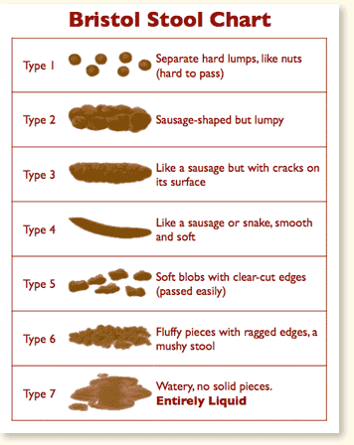

BBD PRE-VISIT QUESTIONNAIRE
DIETARY AND FLUID HISTORY

Staff only
Participant ID:____
Dear Parents - Please complete this form to the best of your knowledge about what your child eats and drinks. This information will help us better understand what comes out (pee and poo).
- Tell me about your child’s most recent diet (ate and drank) in the past 24 hours.

______________________________________________________________________

______________________________________________________________________

______________________________________________________________________

______________________________________________________________________

- Does your child eat fruits/vegetables?

  - Yes No

a) If YES, how much?: ________ servings/day

- Does your child drink teas/soda/pop/coffee?

  - Yes No

a) If YES, how often?: ________ times/week

- How much of the following fluids does your child drink in a day (in cups)?
  - Milk: ___ cups
  - Juice: ___ cups
  - Water: ___ cups
  - Pop: ___ cups

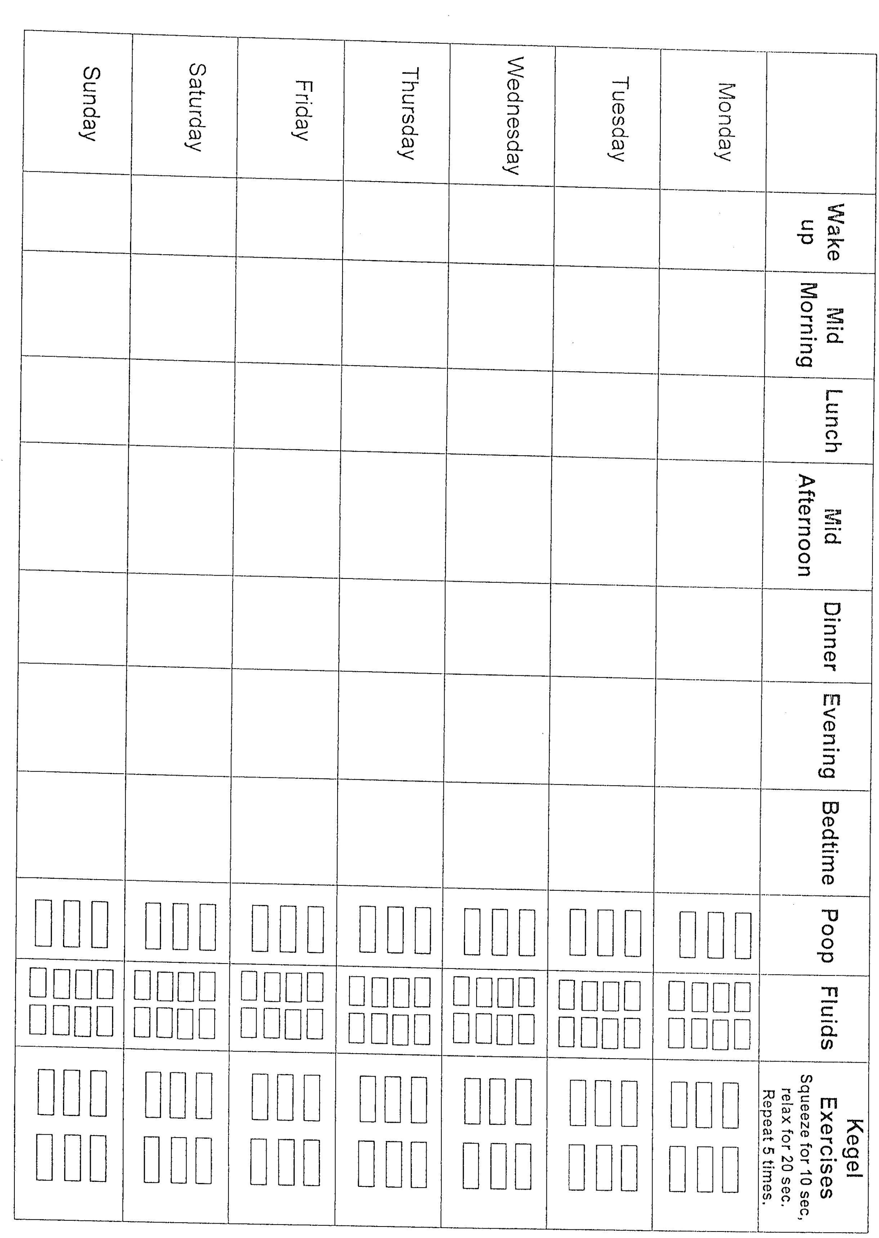
VOIDING DIARY
BBD PRE-VISIT QUESTIONNAIRE
Staff only
Participant ID:____

