Supplementary Figures exploring the association between pain severity and the Cluster D symptoms
8. DIFFICULTY REMEMBERING | 9. LOSS OF INTEREST | 10. FEELING CUT OFF | 11. EMOTIONALLY NUMB | 12. FORESHORTENED FUTURE
r² = .32, p<.001 | r² = .54, p<.001 | r² = .47, p<.001 | r² = .37, p<.001 | r² = .48, p<.001
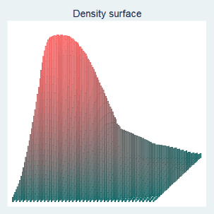 | 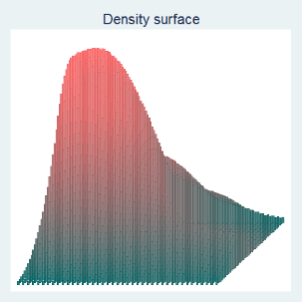 | 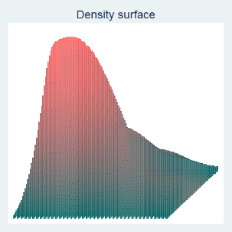 | 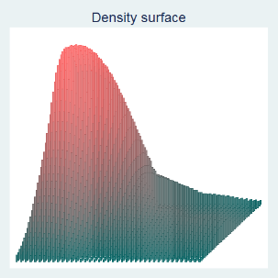 | 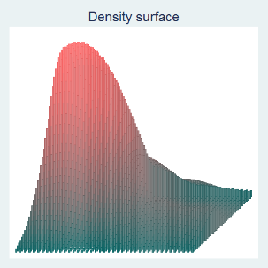
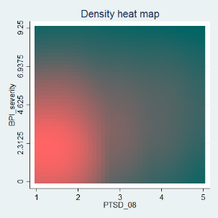 | 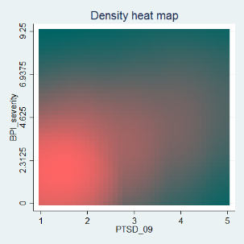 | 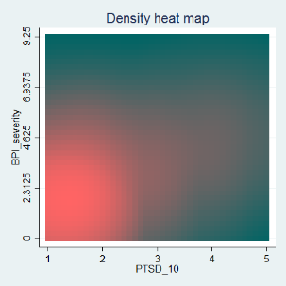 | 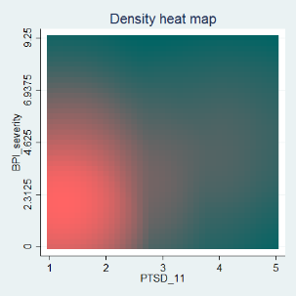 | 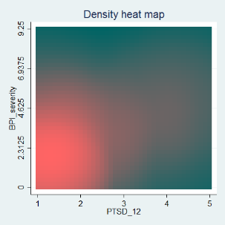
Memory and loss of interest |  | Dissociative symptoms
r² = .52, p<.001 |  | r² = .50, p<.001
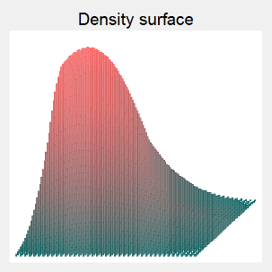 |  | 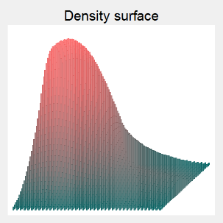
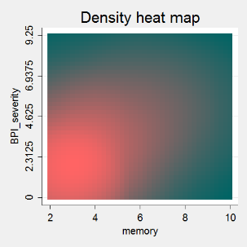 |  | 