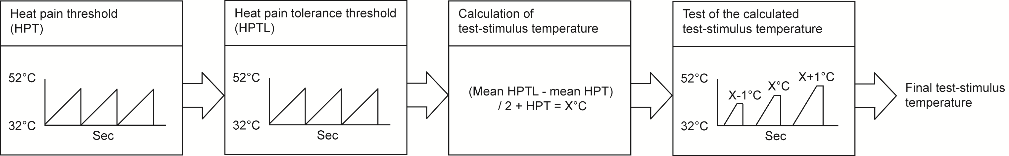

Supplementary figure.
The pre-test with a novel technique for calculation of the test-stimulus temperature for both protocols. Before the main experiment, a pre-test was performed to identify the subjects’ individual test-stimulus temperature. The test-stimulus temperature was found by 4 steps. In step 1 and 2, heat pain threshold (HPT) and heat pain tolerance level (HPTL) was determined with the methods of limits. These tests were performed on the subject’s distal volar aspect of the forearm with a heat stimulus which gradually increased from 32°C with 1°C/second to maximum 52°C. The subjects were told to click on a computer mouse when they felt the first feeling of pain during HPT, and when they could not tolerate further stimulation during HPTL. An average of three measurements was used to determine the thresholds. In step 3, a temperature was calculated with the equation HPTL – HPT / 2 + HPT. In step 4, the estimated temperature was tested in a series of three heat stimulations of 5 seconds duration with 10 seconds intervals with pain ratings on a 0-10 numeric rating scale (NRS). The first stimulation was set at 1°C below the calculated temperature and increased 1°C for each of the following stimulations. The heat stimulation that was rated closest to 6/10 during this test was identified as the test-stimulus temperature in both protocols. In the instances that the all of the heat stimulations were rated outside the range 4-9 NRS, step 4 were repeated with a stimulation temperature adjusted up or down 1°C.

