Supplementary material-1:

Cluster analysis
Cronbach’s alpha was 0.716 showing a good reliability by responders. Hierarchical cluster analyses of NPSI scores in non-leprosy group were expressed as ((((squeezing+pressure)+stabbing) + (pins and needles) + burning) + (electric shocks) + tingling). The items on deep spontaneous pain (squeezing and pressure) showed the highest association in similarity within responders of the questionnaire in the group of peripheral neuropathic pain of non-leprosy etiologies. The symptoms stabbing, burning and tingling have associations progressively from more homogeneous to less homogeneous within the responders. Hierarchical cluster analyses of NPSI in Leprosy group were expressed as (((((Squeezing + Pressure) + stabbing) + Burning) + (pins and needles) + electric shocks) + tingling). The items squeezing and pressure symptoms showed the highest association in similarity within responders of the questionnaire in the group of leprosy neuropathic pain. The questions stabbing, burning, electric shocks and tingling have associations progressively from more homogeneous to less homogeneous within the responders. Comparing the dendogram graphs of hierarchical cluster analyses (Figure 3 and 4), the visual analysis showed similar pattern of response between groups related to symptoms profile. To further analyze the data, an individual cluster by k means method was performed to identify by individuals if one could determine from each group patients belonged, and whether both neuropathic pain groups could be discriminated (Pearson chi-square=0.072, p=0.788)

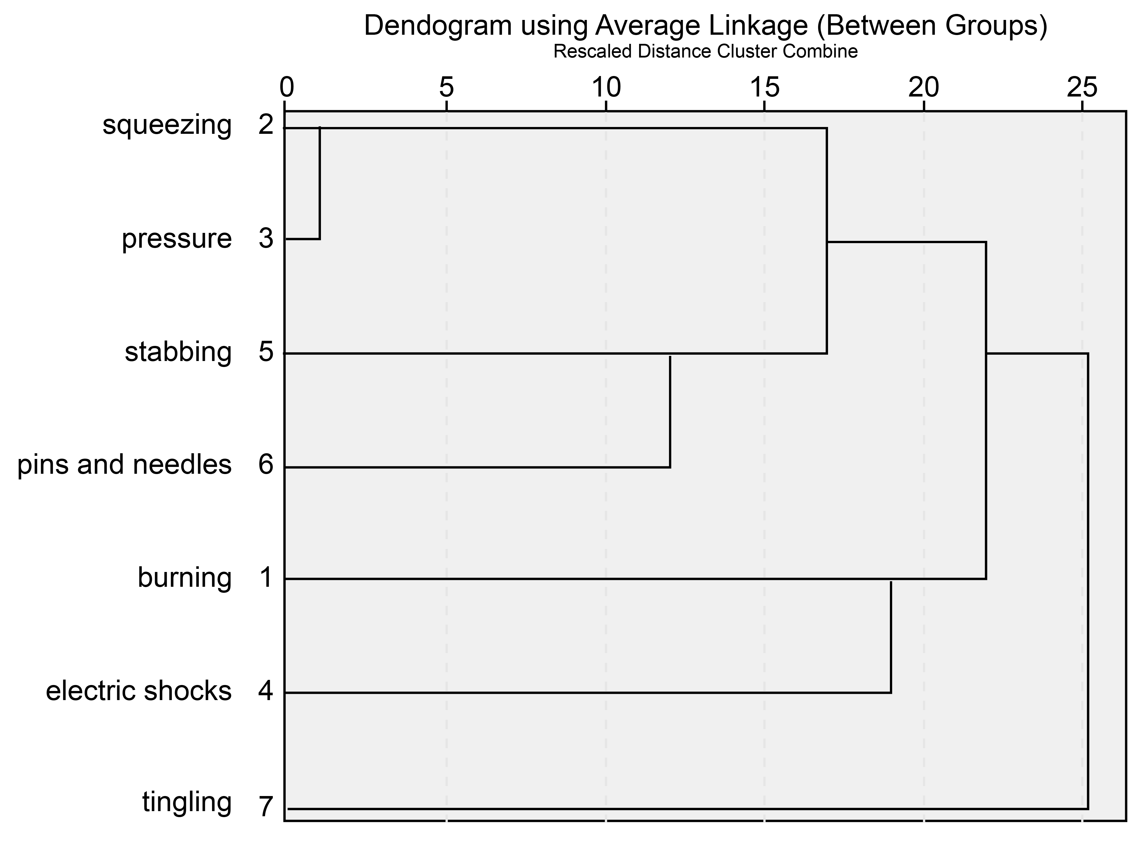

Figure 3 (supplementary material-1).
Title: Cluster Dendogram of NPSI questions in Non-leprosy patients

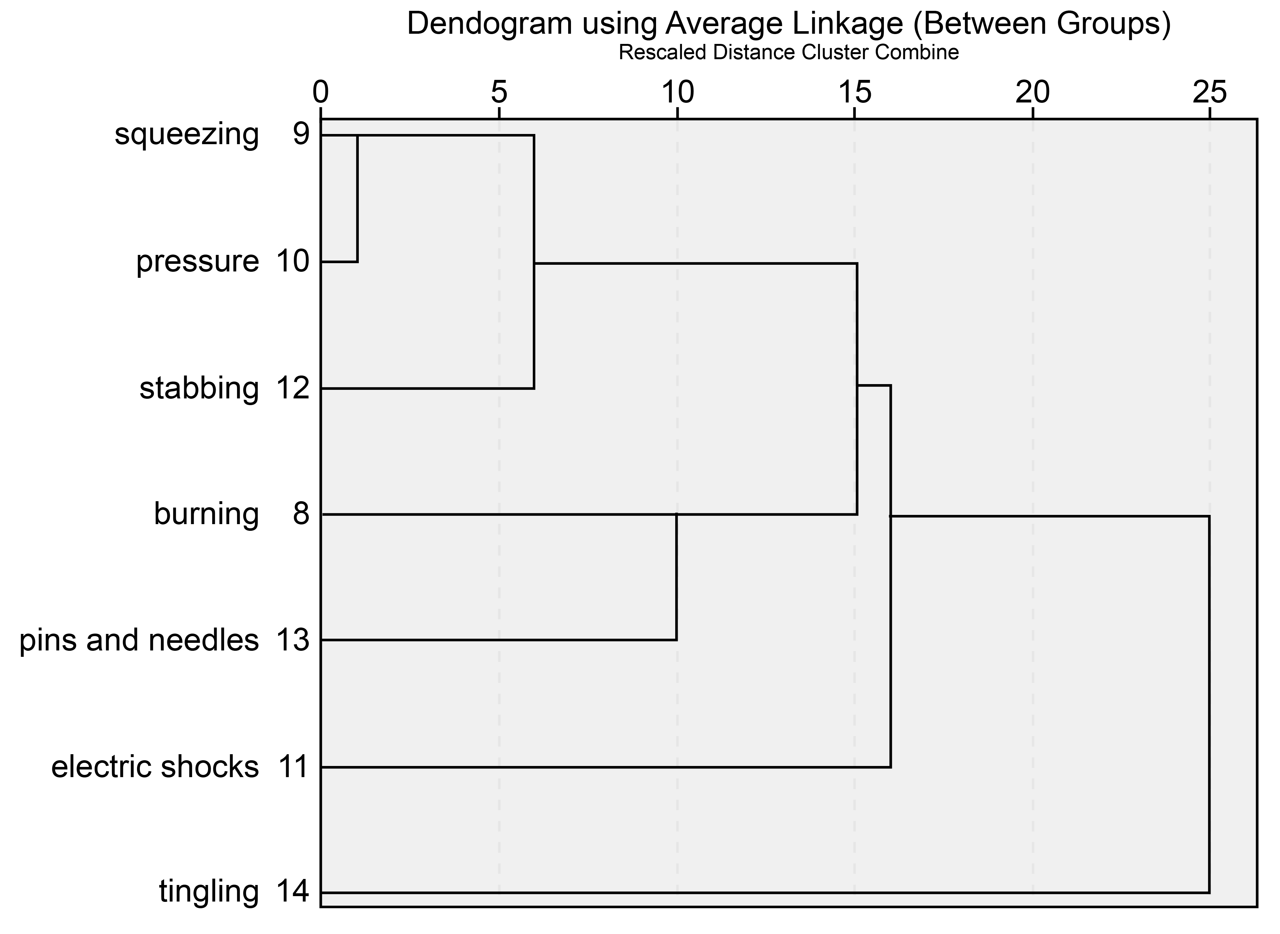
Figure 4 (supplementary material-1).
Title: Cluster Dendogram of NPSI questions in Leprosy patients

