Supplemental Digital Content- Case Presentations (text)

Case I:

A five year and three month old male patient presented to the emergency department after falling from his bicycle onto his chin. Upon evaluation, which included non-contrast CT imaging, he was noted to have multiple fractures of the mandible and a laceration of the sub-mental area. The patient had sustained an oblique fracture of the symphysis and parasymphisis of the mandible extending from the right primary canine to the left primary canine, a moderately displaced fracture of the right condylar head, and a minimally displaced fracture of the left condylar head (SDC Figure 1a,b). A full thickness stellate laceration communicated with the fracture of the anterior mandible. Physical examination revealed an occlusal step deformity of the mandibular dentition and freely mobile segments. The left mandibular primary canine tooth was fractured below the level of the cemento-enamel junction. Though bilateral condylar fractures were present, the vertical dimension of occlusion was stable and preserved due to the fracture pattern. Lastly, full range of motion of the temporomandibular joints without intracapsular obstruction was appreciated.

Case II:

A four year old female patient presented after falling into a barbed wire fence while playing with a group of children. The patient sustained a displaced, oblique fracture of the symphisis and parasymphisis, and a minimally displaced fracture of the right condyle (SDC Figure 2a,b). Multiple, complex, facial lacerations were present, some of which communicated with the mandibular fracture segments. Physical examination showed a grossly displaced occlusal step-off deformity of the mandibular dentition, frank mobility of bone segments and open communication with a submental laceration. The vertical dimension of occlusion was preserved despite the presence a mandibular condyle fracture, and full, unobstructed motion of the temporomandibular joints was appreciated following gross reduction of the symphyseal fracture.

In both cases, operative intervention was deemed necessary due to the presence of significant occlusal step off deformity and frank mobility of segments. The presence of condylar fractures with a preserved vertical dimension of occlusion was the main motivation in avoiding maxillomandibular fixation so as to minimize the risk for post-traumatic ankylosis. With preserved vertical dimension of occlusion, no interference in condylar function, and easily reproducible occlusion intra-operatively without “fall back”, as previously described by Ellis (19), fracture management with avoidance of maxillomandibular fixation was employed.

Both patients were treated for all of their injuries in a single surgical encounter and discharged to home on post-operative day number one following one night of observation in the hospital. Both were allowed to receive a full liquid diet and were not placed in maxillomandibular fixation at any time. They were evaluated weekly as outpatients until union was achieved. Splints were maintained for approximately four weeks and then removed under sedation in an outpatient setting. Both had an uncomplicated course and achieved satisfactory outcomes at the six week follow up visit with regards to range of motion, resolution of discomfort, establishment of satisfactory occlusion and the ability to resume an unrestricted diet. (SDC Figure 3a,b).

Supplemental Digital Content-Image Captions
SDC Image 1a,b: [CT Scan, Case 1] Axial Cuts show bilateral fractures of the mandibular condyles and an oblique fracture of the of the parasymphysis in five year, three month old male.

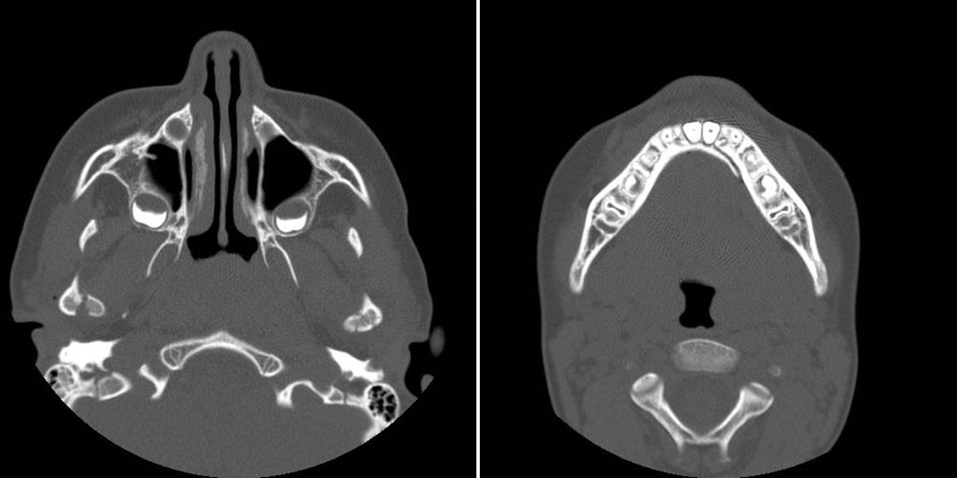

SDC Image 2a,b [CT Scan, Case 2] Axial cuts show fracture of the right mandibular condyle and fracture of the mandibular symphysis/parasymphysis in a four year old female.

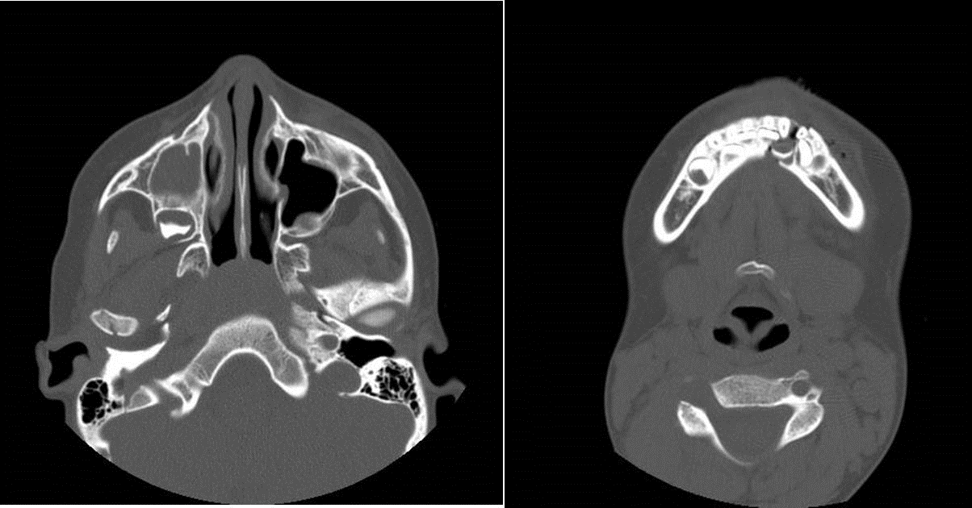

SDC Image 3a,b [Clinical Photos] Oral photos show restoration of pre-traumatic occlusion and maintenance of mandibular range of motion at six week follow-up exam in clinical case number 1.

