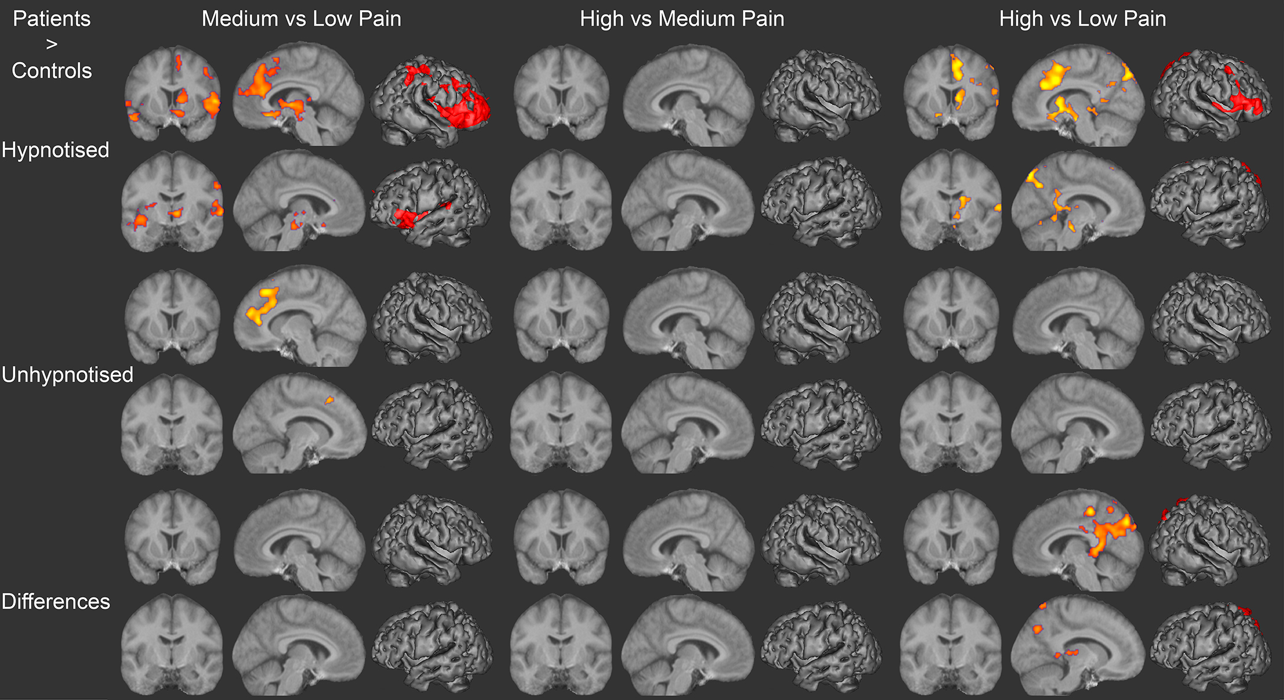
Figure S1 shows greater BOLD activation in patients versus controls for the contrasts of medium with low, high with medium and high with low pain epochs during hypnotic and non-hypnotic suggestion and the differences between patients and controls and hypnotic and non-hypnotic suggestion. Regions of significant deactivation are shown superimposed on an averaged structural MRI derived from the patient’s structural scans.

Figure S1 shows the differences between patients and controls for each of the contrasts shown in figures 3 and 4 from the main paper. Patients demonstrated significantly greater activation in the right ACC, right PFC and right thalamus when hypnotised for the contrast of medium versus low and high versus low pain. There were no significant differences for the high versus medium contrast and no significantly increased activity in controls compared with patients. Medium vs low pain also generated greater patient activity in the bilateral insula and right primary sensory cortex. When not hypnotised, the greater right ACC activity was maintained in the patients but no other differences reached significance. Further interaction effects (“Differences” indicating greater activity in patients versus controls when hypnotised versus unhypnotised) can be observed in the posterior cingulate cortex for the high versus low pain contrast.

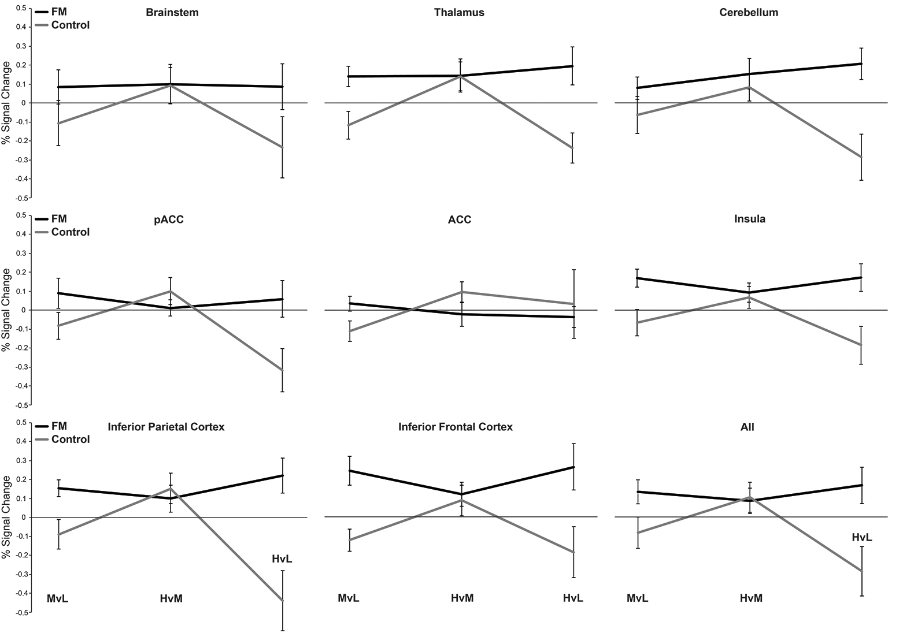
Figure S2 shows the percentage BOLD change for each condition when hypnotised for the fibromyalgia patients (FM) and control subjects. Error bars show standard error.

Figure S2 shows the percentage BOLD changes in a series of regions of interest (ROI), for the hypnosis conditions in patients and controls. Figure S3 shows the same results using the percentage BOLD changes for the unhypnotised conditions. The ROIs were selected using the standard atlases available as part of the FSL package. Specifically, the Harvard-Oxford subcortical atlas was used to define the brain-stem and thalamic regions; the MNI structural atlas was used to define the cerebellum; and the Harvard-Oxford cortical atlas was used to define the remaining cortical ROIs. These ROIs were selected based on our previous work (34, main paper) and several reviews indicating these areas as key regions involved in pain experience (53-56, main paper).

Clear differences between the patients and controls can be observed, with controls demonstrating consistently negative changes for the medium versus low contrast when hypnotised and unhypnotised and consistently negative changes for the high versus low contrast when hypnotised. Patients, in contrast, never demonstrated negative changes.

A linear mixed-effects model was used to assess the main effects of group, contrast, hypnosis, region any interactions. There was a highly significant effect of group (F_{1,1350} = 47.9, p<0.0001) and contrast (F_{2,1350} = 10.8, p<0.0001), with no other main effect reaching significance. There was a highly significant interaction of group with hypnosis (F_{1,1350} = 30.8, p<0.0001), group with contrast (F_{2,1350} = 24.8, p<0.0001), contrast with hypnosis (F_{2,1350} = 9.2, p<0.0001) and a significant three-way interaction of group x hypnosis x contrast (F_{2,1350} = 16.2, p<0.0001). No other effects or interactions reached or trended towards significance.

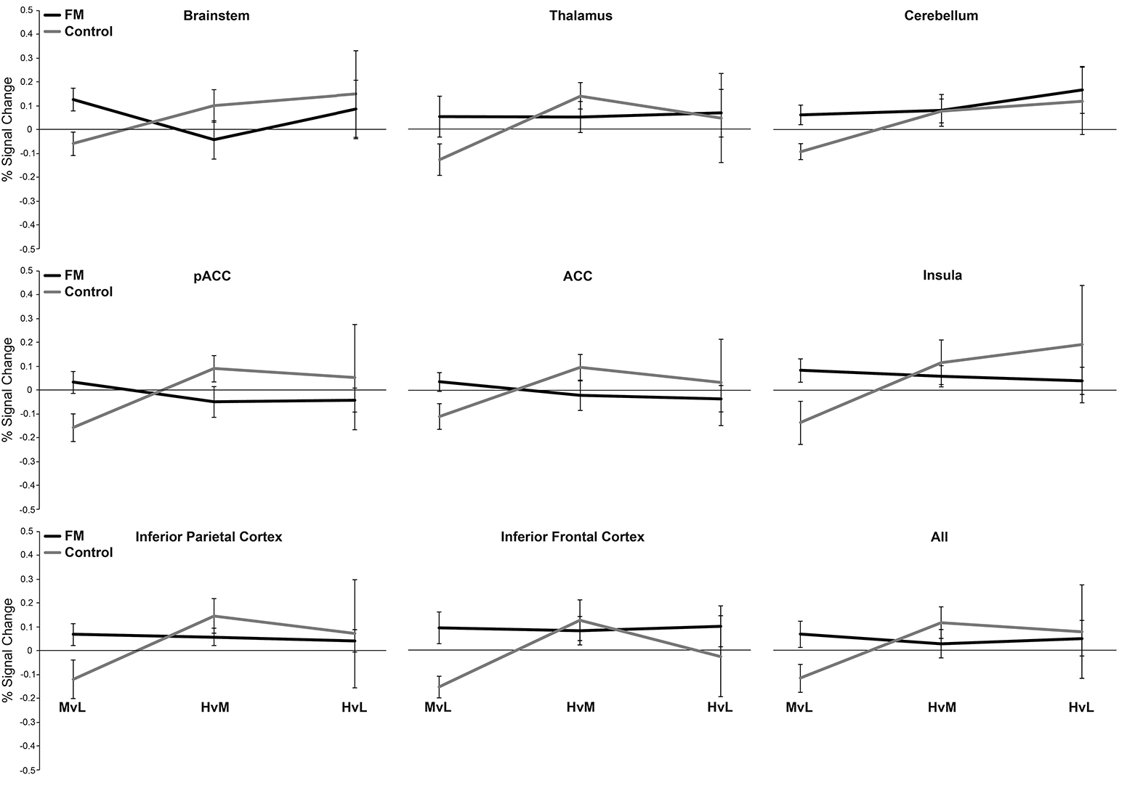
Figure S3 shows the percentage BOLD change for each condition when unhypnotised for the fibromyalgia patients (FM) and control subjects. Error bars show standard error.

