Supplemental Digital Content

# Original CBRQ Subscales

**Table S1. Original 7 factors/subscale model for the CBRQ**

|  |  |
| --- | --- |
|  |  |
| F1. Fear avoidance | I am afraid that I will make my symptoms worse if I exercise (FA1)  My symptoms would be relieved if I were to exercise (FA2)  Avoiding unnecessary activities is the safest thing I can do to prevent my symptoms from worsening (FA3) Physical activity makes my symptoms worse (FA12) Doing less helps symptoms (FA14) I should avoid exercise when I have symptoms (FA17) |
| F2. Catastrophizing | I worry that I may become permanently bedridden because of my symptoms (C1) I think that if my symptoms get too severe they may never decrease (C2)  My illness is awful and I feel that it overwhelms me (C4) I will never feel right again(C6) |
| F3. Damage | The severity of my symptoms must mean there is something serious going on in my body (FA4) Even though I experience symptoms, I don’t think they are actually harming me (FA9) When I experience symptoms, my body is telling me that there is something seriously wrong. (FA10)  Symptoms are a signal that I am damaging myself (FA15)  I am afraid I will have more symptoms if I am not careful (FA16) |
| F4. Embarrassment avoidance | I am embarrassed about my symptoms (EA1) I worry that people will think badly of me because of my symptoms (EA2)  The embarrassing nature of my symptoms prevents me from doing things (EA3)  I avoid social situations because I am scared my symptoms will get out of control (EA4)  I am ashamed of my symptoms (EA5)  My symptoms have the potential to make me look foolish in front of other people (EA6) |
| F5. Symptom focusing | When I experience symptoms, I think about them constantly (SF1) I worry when I am experiencing symptoms (SF2)  When I am experiencing symptoms it is difficult for me to think of anything else (SF3)  I think a great deal about my symptoms (SF5)  My symptoms are always at the back of my mind (SF9)  I spend a lot of time thinking about my illness (SF12) |
| F6. All-or-nothing behaviour | I tend to overdo things when I feel energetic (AL1)  I find myself rushing to get things done before I crash (AL2)  I tend to overdo things and then rest up for a while (AL3)  I tend to do a lot on a good day and rest on a bad day (AL4)  I'm a bit all or nothing when it comes to doing things (AL5) |
| F7. Avoidance/resting behaviour | I stay in bed to control my symptoms (L2)  When I experience symptoms, I rest (L3)  I tend to avoid activities that make my symptoms worse (L4)  I tend to nap during the day to control my symptoms (L7)  I sleep when I'm tired in order to control my symptoms (L9)  I avoid making social arrangements in case I'm not up to it (L10)  I avoid exerting myself in order to control my symptoms (L11)  I avoid stressful situations (L13) |

**Figure S1. Boxplots for the original subscale structures in each data set**

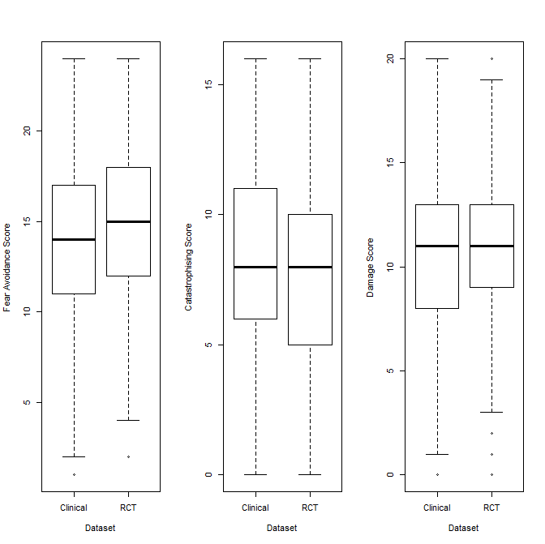

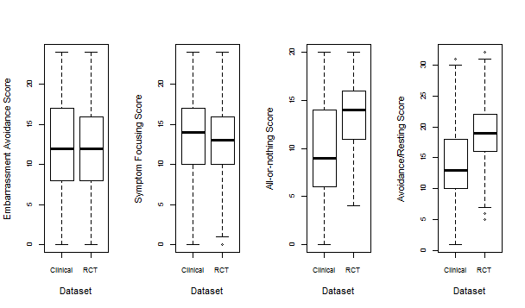

# EFA performed on Clinical CFS data

**Figure S2. Scree plot for the EFA performed on the clinical CFS data**

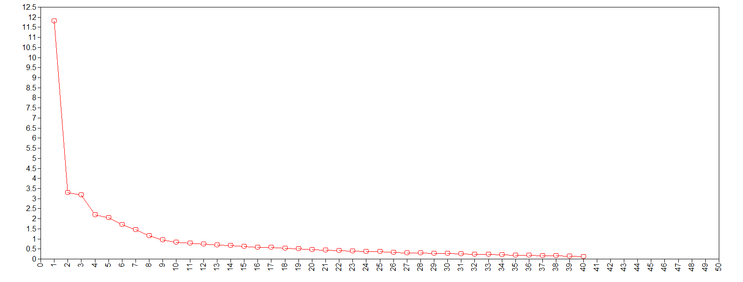

**Eigenvalues**

**# Factors**

**Figure S3. Parallel analysis scree plot for the EFA performed on the clinical CFS data**

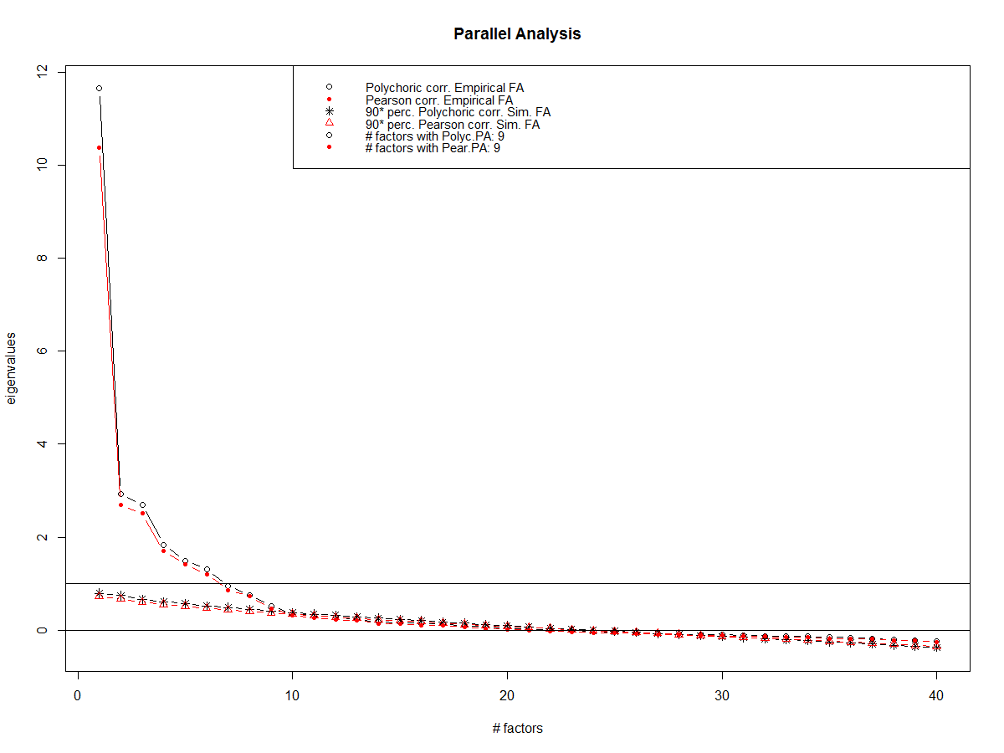

**Table S2. Factor loadings for seven-factor model obtained from EFA (GEOMIN Rotation) performed on the clinical dataset, n=576**

|  |  |  |  |  |  |  |  |
| --- | --- | --- | --- | --- | --- | --- | --- |
|  | **1** | **2** | **3** | **4** | **5** | **6** | **7** |
| **FA1** | **0.718** | 0.008 | 0.077 | -0.026 | -0.045 | 0.043 | -0.008 |
| **FA2** | **0.537** | 0.01 | 0.008 | -0.126 | -0.072 | -0.07 | 0.132 |
| **FA3** | **0.599** | 0.129 | -0.009 | 0.04 | 0.133 | -0.011 | 0.03 |
| **FA12** | **0.685** | -0.054 | -0.018 | -0.073 | 0.01 | 0.132 | 0.158 |
| **FA14** | **0.424** | 0.072 | 0.068 | -0.184 | -0.009 | 0.117 | -0.02 |
| **FA17** | **0.563** | 0.16 | -0.019 | 0.035 | 0.025 | 0.089 | 0.083 |
|  |  |  |  |  |  |  |  |
| **FA4** | 0.04 | **0.834** | 0.031 | -0.158 | -0.021 | -0.027 | -0.023 |
| **FA9** | -0.182 | **0.719** | 0.034 | 0.004 | 0.084 | -0.023 | 0.088 |
| **FA10** | -0.001 | **0.843** | 0.046 | -0.146 | -0.021 | 0.082 | -0.009 |
| **FA15** | 0.166 | **0.643** | -0.141 | 0.095 | 0.022 | 0.059 | 0.009 |
| **FA16** | 0.185 | **0.428** | 0.073 | 0.098 | 0.015 | 0.037 | -0.096 |
|  |  |  |  |  |  |  |  |
| **C1** | 0.124 | ***0.254*** | ***0.358*** | 0.066 | 0.024 | -0.038 | **0.458** |
| **C2** | 0.026 | ***0.302*** | ***0.42*** | 0.131 | -0.082 | -0.044 | **0.456** |
| **C4** | 0.074 | 0.11 | **0.426** | 0.163 | 0.091 | 0.065 | 0.168 |
| **C6** | -0.005 | -0.03 | **0.464** | 0.123 | -0.035 | -0.035 | 0.229 |
| **SF1** | 0.051 | -0.131 | **0.914** | 0.015 | -0.03 | 0.003 | 0.054 |
| **SF2** | -0.089 | 0.152 | **0.662** | 0.073 | -0.022 | 0.018 | -0.022 |
| **SF3** | 0.074 | -0.075 | **0.835** | -0.017 | -0.019 | 0.038 | 0.063 |
| **SF5** | -0.027 | 0.022 | **0.864** | -0.042 | 0.064 | 0.04 | -0.272 |
| **SF9** | -0.024 | 0.065 | **0.671** | -0.011 | 0.056 | 0.063 | -0.194 |
| **SF12** | -0.056 | 0.044 | **0.847** | -0.032 | 0.039 | -0.034 | ***-0.299*** |
|  |  |  |  |  |  |  |  |
| **EA1** | -0.019 | -0.031 | 0.007 | **0.887** | -0.064 | 0.031 | 0.027 |
| **EA2** | -0.024 | 0.008 | 0.008 | **0.854** | -0.075 | 0.113 | -0.02 |
| **EA3** | 0.086 | 0.069 | 0.069 | **0.62** | 0.201 | 0.025 | 0.061 |
| **EA4** | 0.163 | -0.019 | 0.132 | **0.508** | ***0.295*** | 0.007 | -0.042 |
| **EA5** | -0.024 | 0.033 | -0.052 | **0.865** | -0.001 | 0.031 | 0.06 |
| **EA6** | -0.044 | 0.103 | 0.008 | **0.686** | 0.057 | -0.037 | -0.02 |
|  |  |  |  |  |  |  |  |
| **L2** | -0.02 | 0.115 | -0.033 | -0.004 | **0.6** | -0.009 | ***0.385*** |
| **L3** | ***0.273*** | 0.024 | -0.008 | -0.099 | **0.585** | 0.051 | 0.202 |
| **L7** | -0.053 | -0.019 | 0.001 | -0.052 | **0.635** | 0.059 | ***0.559*** |
| **L9** | -0.047 | -0.014 | 0.014 | -0.025 | **0.741** | 0.059 | ***0.585*** |
| **L4** | ***0.466*** | 0.057 | -0.014 | 0.045 | **0.532** | -0.067 | -0.073 |
| **L10** | 0.151 | -0.088 | 0.127 | 0.335 | **0.458** | 0.01 | -0.014 |
| **L11** | ***0.483*** | -0.004 | 0.004 | 0.096 | **0.553** | -0.092 | -0.141 |
| **L13** | 0.198 | 0.015 | 0.117 | 0.142 | **0.416** | -0.049 | -0.118 |
|  |  |  |  |  |  |  |  |
| **AL1** | 0.116 | 0.011 | 0.018 | 0.044 | -0.052 | **0.792** | -0.01 |
| **AL2** | 0.022 | 0.035 | 0.02 | 0.074 | -0.04 | **0.817** | 0.07 |
| **AL3** | -0.012 | -0.017 | 0.008 | -0.038 | 0.037 | **0.888** | -0.035 |
| **AL4** | -0.016 | -0.037 | -0.029 | 0.006 | 0.225 | **0.741** | 0.027 |
| **AL5** | -0.017 | 0.092 | 0.027 | 0.157 | 0.164 | **0.503** | -0.041 |

The questions for each of the item abbreviations are written out in full in Table S1, Supplemental Digital Content. The highest factor loading for each item is boldfaced. Items that have cross-loading on a factor are both boldfaced and italicised in their loading value.

# Summary statistics for the eight subscales obtained from EFA/CFA performed on full (40-item) CBRQ

**Table S3. Medians (IQR) and ranges of each of the eight subscales (obtained from EFA/CFA) in clinical dataset and RCT dataset**

|  |  |  |  |  |
| --- | --- | --- | --- | --- |
| **Subscale** | **Potential range** | **Clinical dataset (n=576)** | **RCT dataset (n=640)** | **Comparison**  **Mann-Whitney U-test p-value** |
| **Fear avoidance  (FA1, FA2, FA3, FA12, FA14, FA17)** | 0-24 | 14 (11-17) Min: 1; Max: 24 | 15 (12-18) Min: 2; Max: 24 | P < 0.001 |
| **Catastrophising  (C1, C2, C4, C6)** | 0-16 | 8 (6-11) Min: 0; Max: 16 | 8 (5-10) Min: 0; Max: 16 | P = 0.015 |
| **Damage  (FA4, FA9, FA10, FA15, FA16)** | 0-20 | 11 (8-13) Min: 0; Max: 20 | 11 (9-13) Min: 0; Max: 20 | P = 0.42 |
| **Embarrassment avoidance  (EA1, EA2, EA3, EA5, EA6)** | 0-20 | 11 (7-14) Min: 0; Max: 20 | 11 (7-14) Min: 0; Max: 20 | P=0.57 |
| **Symptom focusing  (SF1, SF2, SF3, SF5, SF9, SF12)** | 0-24 | 14 (10-17) Min: 0; Max: 24 | 13 (10-16) Min: 0; Max:24 | P = 0.011 |
| **All-or-nothing (AL1, AL2, AL3, AL4, AL5)** | 0-20 | 9 (6-14) Min: 0; Max: 20 | 14 (11-16) Min: 4; Max: 20 | P < 0.001 |
| **Avoidance  (EA4, L4, L10, L11, L13)** | 0-20 | 9 (6-13) Min: 0; Max: 20 | 12 (9-14) Min: 1; Max: 20 | P < 0.001 |
| **Resting (L2, L3, L7, L9)** | 0-16 | 6 (4-8) Min: 0; Max: 16 | 9 (7-11) Min:1; Max: 16 | P < 0.001 |
| **Total CBRQ** | 0-160 | 82 (68-97) Min: 14; Max: 145 Cronbach’s alpha for all items: 0.928 | 91 (78-105) Min:29; Max: 152 Cronbach’s alpha for all items:0.914 | P < 0.001 |

The questions for each of the item abbreviations are written out in full in Table S1, Supplemental Digital Content

**Figure S4. Boxplots for the Embarrassment avoidance, Avoidance, and Resting subscale scores for each dataset. (These are the only subscales to have changed from the original subscale structure)**

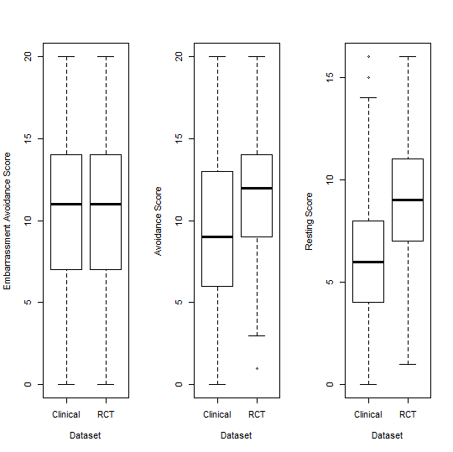

# Summary statistics for the six subscales obtained from EFA/CFA performed on reduced (18-item) CBRQ

**Table S4. Medians (IQR) and ranges of each of the six subscales in the reduced CBRQ (obtained from EFA/CFA) in clinical dataset and RCT dataset**

|  |  |  |  |
| --- | --- | --- | --- |
| **Subscale** | **Clinical dataset (n=576)** | **RCT dataset (n=640)** | **Comparison**  **Mann-Whitney U-test p-value** |
| **Fear avoidance  (FA1, FA2, FA12)** | 7 (6-9) Min: 0; Max: 12 | 8 (6-9) Min: 1; Max: 12 | P=0.016 |
| **Damage  (FA4, FA9, FA10)** | 7 (5-9) Min: 0; Max: 12 | 6 (5-8) Min: 0; Max: 12 | P=0.48 |
| **Embarrassment avoidance  (EA1, EA2, EA5)** | 7 (4-9) Min: 0; Max: 12 | 7 (4-9) Min: 0; Max: 12 | P=0.28 |
| **Symptom focusing  (SF5, SF9, SF12)** | 7 (5-9) Min: 0; Max: 12 | 7 (5-9) Min: 0; Max: 12 | P=0.001 |
| **All-or-nothing (AL1, AL2, AL3)** | 6 (3-9) Min: 0; Max: 12 | 9 (7-10) Min: 1; Max: 12 | P < 0.001 |
| **Resting (L2, L7, L9)** | 3 (2-6) Min: 0; Max: 12 | 7 (4-8) Min: 0; Max: 12 | P < 0.001 |
| **Total CBRQ** | 38 (31.5-44) Min: 8; Max: 65 Cronbach’s alpha for all (18) items: 0.824 | 42 (36-48) Min:11; Max: 69 Cronbach’s alpha for all (18) items: 0.814 | P < 0.001 |

The questions for each of the item abbreviations are written out in full in Table S1. The possible range of scores for each subscale is 0-12.

# Short version CBRQ

**Table S5. Short version of the CBRQ (18 items)**

|  |  |
| --- | --- |
|  |  |
| F1. Fear avoidance | I am afraid that I will make my symptoms worse if I exercise (FA1)  My symptoms would be relieved if I were to exercise (FA2)  Physical activity makes my symptoms worse (FA12) |
|  |  |
| F2. Damage | The severity of my symptoms must mean there is something serious going on in my body (FA4) Even though I experience symptoms, I don’t think they are actually harming me (FA9) When I experience symptoms, my body is telling me that there is something seriously wrong. (FA10) |
| F3. Embarrassment avoidance | I am embarrassed about my symptoms (EA1) I worry that people will think badly of me because of my symptoms (EA2)  I am ashamed of my symptoms (EA5) |
| F4. Symptom focusing | I think a great deal about my symptoms (SF5)  My symptoms are always at the back of my mind (SF9)  I spend a lot of time thinking about my illness (SF12) |
| F5. All-or-nothing behaviour | I tend to overdo things when I feel energetic (AL1)  I find myself rushing to get things done before I crash (AL2)  I tend to overdo things and then rest up for a while (AL3) |
| F6. Resting behaviour | I stay in bed to control my symptoms (L2)  I tend to nap during the day to control my symptoms (L7)  I sleep when I'm tired in order to control my symptoms (L9) |

# Metric invariance (MIMIC models)

**Table S6. Items that did not have metric invariance across dataset source (clinical dataset or RCT dataset) based on CFA performed on proposed short version of CBRQ.**

|  |  |  |
| --- | --- | --- |
| **Item** | **Estimate (SE)** | **P** |
| **SF5** | -0.446 (0.172) | 0.009 |
| **EA2** | 0.559 (0.154) | <0.001 |
| **AL1** | -0.427 (0.172) | 0.013 |
| **AL3** | 0.935 (0.176) | <0.001 |
| **L2**  **L7** | -0.764 (0.157)  2.340 (0.171) | <0.001  <0.001 |

Estimates were obtained using the ML estimator and are presented on the log-odds scale.

**Table S7. Items that did not have metric invariance for age and/or sex based on CFA performed on proposed short version of CBRQ.**

|  |  |  |  |  |  |
| --- | --- | --- | --- | --- | --- |
|  |  | **Clinical dataset (n=576)** | | **RCT dataset (n=640)** | |
| **Variable** | **Items** | **Estimate (SE)** | **P** | **Estimate (SE)** | **P** |
| **Sex** | EA1  L2 | -  - | -  - | 0.364 (0.114)  -0.198 (0.072) | 0.001  0.006 |
| **Age** | FA10  L2  L7 | 0.021 (0.009)  -  0.038 (0.010) | 0.020  -  <0.001 | -  0.447 (0.187)  - | -  0.017  - |

Estimates were obtained using the ML estimator and are presented on the log-odds scale. Note that ‘-‘ indicates that the item did not have metric non-invariance in that dataset.