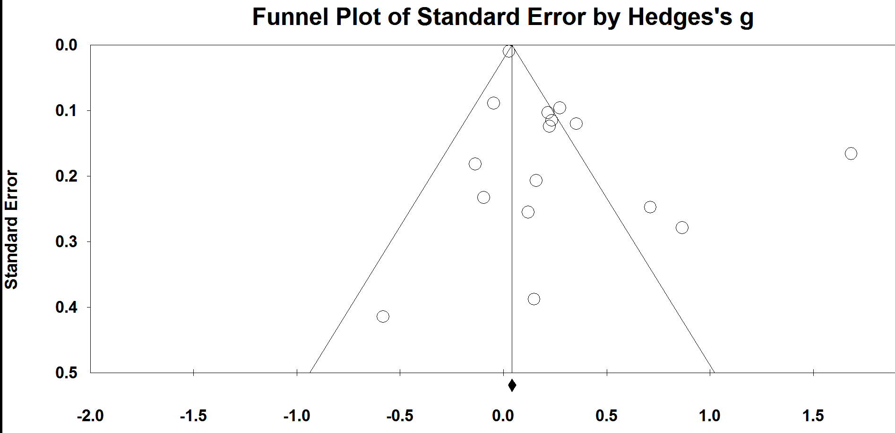
Supplement 3. Funnel Plot demonstrating the significant risk of publication bias for effect sizes of dietary interventions on symptoms of depression.
Note: Findings remained significant after Duval and Tweedie ‘trim-and-fill’ correction.

