Supplementary material to manuscript:

Looking upstream to prevent HIV transmission: can interventions with sex workers alter the course of HIV epidemics in Africa as they did in Asia?
Richard Steen, Jan AC Hontelez, Andra Veraart, Richard G White, Sake J de Vlas

Summary of modeling approach
The underlying model structure, data and assumptions behind this work come from an STDSIM quantification developed for Kisumu as part of the 4-cities study, which has previously been described in detail. [1] This supplemental material expands on the Methods section of the paper to document (1) changes made to the original quantification for this study, (2) model fitting, and (3) explorations of alternative scenarios.
1. Changes to the original quantification
As described in Methods, four main improvements were made to the quantification of sex work used in the 4-cities study. We updated HIV transmission probabilities used in 4-cities modelling to lower values that resulted from a recent systematic review. [2] Data and assumptions related to sex work were reviewed and updated, and the simulation of sex work refined to permit more detailed estimates and analyses. This involved changing the quantification of sex work, using the mean number of clients per week (1.6) from survey data, rather than the median (1.0) as reported by Morison and used by Orroth. [3,1] We also refined the simulation of commercial sex to include three categories of sex workers with different rates of partner change (numbers of clients). Finally, STI treatment assumptions were updated based on recent programme evaluation data. [4] After making these changes, STI transmission probabilities were refitted in order to arrive at observed STI prevalences. All other quantifications remain unchanged.
1.1. Updating and refining the quantification of sex work. We reviewed all original parameter assumptions related to sex work in the original quantification for Kisumu and made several changes. Four parameters determine the overall level of sex work – sex worker and client population sizes and activity (number of clients for sex workers, number of sex worker visits for clients) per unit time. These parameters are closely linked in STDSIM with client demand driving sex worker supply. As in the original study, we consider data on sex worker parameters (from mapping studies and behavioural surveys) more reliable than for male clients (where there are important biases). We thus quantified the client parameters to give sex worker population sizes and activity levels that approximate values from the data.
The main change from the original study for sex workers was increasing their number of clients per week from the median of 1.0 as reported by Morison to the mean value of 1.6 from 4-cities survey data. [1,3] More recent (2006) survey data from Kisumu using respondent-driven sampling suggest even higher client numbers (median = 3 per week, interquartile range = 2-5). [7,8] We then extended STDSIM to permit disaggregation of sex workers into 3 activity groups. This was done in a way to maintain overall sex worker population size and mean client numbers as already described. The assumptions are examined further in 3.3.
One important parameter set – client activity – was increased in order to reach sex worker population sizes and reported activity as informed by data (sex worker selection is random, proportional to sex workers’ defined client numbers). Client activity includes two components – client population size as a proportion of adult males and their visiting behaviour or frequency of visiting sex workers, which varies by marital (regular partner) status. Reliable data on both of these are sparse due to inherent biases of household surveys. [5,6] Our approach was to maintain the client population sizes from the 4-cities and to increase visiting behaviour (demand side) – from 1 to 3 visits per year for less active, and from 12 to 18 times per year for more active clients – in order to support the sex worker parameters (supply side).
The overall size of the sex worker population, an output variable, remained essentially the same (2.2% of women 15-49 compared to 2.1% in original). This is still lower than data (3.0%) suggest, however, which may underestimate the contribution of sex work to disease transmission. [9] Increasing sex worker population size further would have required raising client numbers and/or their rate of visiting sex workers even more than we did. Taken together, these changes result in ‘more’ sex work than in the original 4-cities quantification although this may still be underestimated considering the most reliable data (sex worker reported client numbers and population size). The effect of varying these assumptions is examined in 3.1 and 3.2.

1.2. Updating transmission probabilities and STI treatment assumptions. A recent systematic review suggests that HIV transmission probabilities are lower than those used in the original 4-cities modeling study. [2 Boily] We thus reduced HIV transmission probabilities to values from the systematic review (see Table S1).
Table S1. HIV transmission probabilities used in the model (from Boily et al.) [2]
 | HIV primary | HIV asymptomatic | HIV symptomatic | AIDS
M –> F | 1.426% | 0.095% | 0.285% | 0.713%
F –> M | 0.713% | 0.047% | 0.143% | 0.356%

STI cofactor estimates for HIV transmission and acquisition were not changed. These remain at 3x for gonorrhea and chlamydia, 7.5x for ulcerative syphilis, 25x for ulcerative chancroid and primary HSV-2, and 10x for non-primary HSV-2 ulcers.
Two STI treatment interventions in the original quantification – STI syndrome case management introduced in 1992 and an STI screening intervention introduced for sex workers in 1993 – were removed. These changes were based on more recent data, which describe improvements in the 1990s to be marginal and short-lived, virtually collapsing in 2001 following the end of World Bank project funding which supported STI drug provision. [4]
STI transmission probabilities were then refitted within a priori ranges (based on estimates with wide confidence intervals) maintaining the 2:1 ratio for male-to-female compared to female-to-male transmission, as was done in the original 4-cities model. These crude fits resulted from 10% steps of deviation from the original quantifications in such a way that (1) the model predictions fitted the prevalences for M, F and CSW best, and (2) transmission probabilities stayed within the fitting range set for the 4-cities study. These changes are summarised in Table S2.

Table S2. Original 4-cities and revised STI transmission probabilities and refitted STI outputs
Transmission probabilities
 |  | Syphilis  (average over first 6 months) | Gonorrhoea  (14 weeks) | Chlamydia  (14 weeks men, 52 weeks women) | Chancroid  (11 weeks)
M–>F revised |  | 0.0875 | 0.156 | 0.126 | 0.18
F–>M revised |  | 0.0438 | 0.078 | 0.063 | 0.10*
(% of original) |  | 50% | 60% | 50% | 80%
STI prevalences 1997 (data and model outputs)
 |  | Syphilis | Gonorrhoea | Chlamydia | Chancroid
Male | Data (CI) | 3.1 (1.5) | 0 (1.2) | 2.6 (1.4) | no data
 | Original | 7.7 | 1.4 | 2.8 | 0.0
 | Revised | 5.0 | 0.8 | 1.6 | 2.0
Female | Data (CI) | 3.9 (1.3) | 0.9 (0.6) | 4.5 (1.4) | no data
 | Original | 8.7 | 2.1 | 6.0 | 0.0
 | Revised | 5.2 | 1.0 | 3.5 | 1.2
Sex worker | Data | 11.0 | 13.0 | 8.0 | no data
 | Original | 20.6 | 8.8 | 11.9 | 0.0
 | Revised | 15.5 | 6.9 | 13.9 | 11.8**
* Lower limit of a priori range
**Note that while there are no data on chancroid, indirect data supports its presence. Morison reports very high prevalence of genital ulcers (29%) among Kisumu sex workers based on clinical examination.
2. Fit of the model to HIV prevalence data
The changes described above influenced the fitting of our revised quantification, which has a somewhat lower prevalence trend than the original, but a good fit to the original study data (Figure S1).
Fig S1. Original 4-cities and revised quantification for Kisumu
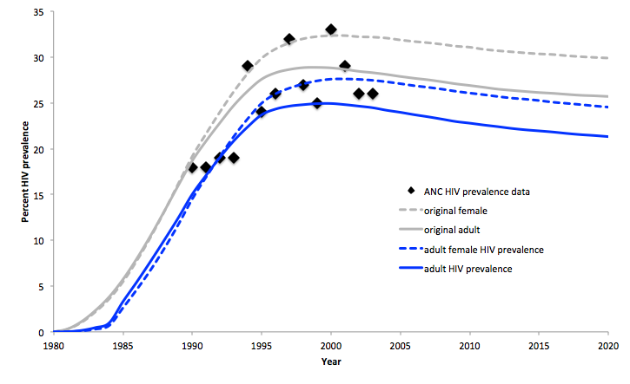

3. Alternative scenarios
3.1 Effect of varying key parameter values
Several parameter assumptions were subject to further exploration to assess whether changes in their values would affect the main conclusions of the study. The primary outcome of interest is HIV prevalence in 2010, ten years after the time when interventions are introduced in the paper. For example, in the paper’s quantification, HIV prevalence is estimated to be 22.8% in 2010 with no intervention. After removing transmission from the 40% of most active sex workers (HM) in 2000, this declines to 16.4%. Table S3 summarizes effects of varying selected parameter values on these outcomes.
Table S3. Effect of varying select parameter values on HIV prevalence and intervention outcomes
Parameter | Parameter value | HIV prevalence 2010 | % change after blocking transmission in sex work (HM) | Conclusions
Reference |  | 22.8% | 28.2%
1. Sex worker and client population sizes.  Sex worker population size may be underestimated in the quantification, suggesting that client demand is also low. | Decrease by 2/3 | 14.9% | 24.4% | Varying assumptions about population size affects overall HIV transmission level and proportional effect of interventions, but not main conclusions.
 | Increase by 1.5 | 31.4% | 33.2%
2. Sex worker partner change (mean number of clients in last week), which may be underestimated in the quantification. [4,5]  Reference (mean=1.6) | Increase by 1.5 | 27.6% | 33.7% | Increasing sex worker client numbers increases the contribution of sex work to HIV transmission and the effect of interventions, strengthening conclusions.
3. Sex worker partner change (mean client number by sex worker subgroup, skewness of distribution).  Reference parameter values were taken from distribution of sex worker survey responses (mean = 1.6 clients per week as in #2).  Reference (L=0.55, M=2.19, H=5.67 ) | Decrease (L=1, M=2, H=4) | 18.2% | 19.7% | Varying assumptions about the skewness of the sex worker partner change parameter affects HIV transmission level and proportional effect of interventions, but not main conclusions.
4. Condom use in sex work at baseline.  This parameter value is based on reported condom use at baseline, which may be overestimated due to social desirability bias. | Decrease by 2/3 | 27.8% | 35.7% | At lower baseline rates of condom use, the relative effect of interventions on transmission is greater.
5. STI transmission probabilities and treatment interventions.  These were updated from original 4 cities parameter values as described in section 1. | Original STI transmission probabilities; same treatment assumptions until 2000. | 26.4% | 28.8% | Varying STI transmission probabilities and treatment increases STI and HIV transmission levels but does not alter main conclusions.
6. At a specific level of overall client demand (see #1 above), are assumptions about the number of sex worker visits by clients in two risk categories (H/L). Original quantification uses H=12, L=1, and revised uses H=18, L=3. | H= 24/year, L=2/year  H=12/year, L=4/year | 24.3%  19.2% | 31.7%  22.9% | Increasing the difference between high and low-activity clients increases HIV transmission but does not alter main conclusions.
3.2 Effect of sex worker interventions in context of ART rollout
In addition, as described in the main paper, we ran several simulations in a quantification that included progressive roll-out of ART as has been reported for Kenya. [10]
HIV and ART in STDSIM
Based on data from Orange Farm, South Africa, we assumed the initial (HIV-negative) CD4 cell count in the population to follow a lognormal distribution with median 7.02 (equivalent to 1116 cells/µL) [11]. CD4 cell counts to decline by 25% during acute infection, and decline linearly over the other stages until the CD4 cell count reaches 0.5% of its initial value, after which an individual dies of AIDS. Therefore, based on the average HIV-negative CD4 cell counts and duration of HIV infection, an individual will on average reach a CD4 cell count of ≤350 cells/µL after about 6 years following infection, and at that point will have a remaining life expectancy of about 4 years.
In the model, ART coverage is the result of two components: (i) an individual's demand for ART as a function of HIV-disease stage, and (ii) the capacity of the health system to meet this demand. ART coverage in our model is the ART demand met by the capacity of the health system. We assumed the ART demand function to be the same as previously estimated for the Hlabisa sub district of KwaZulu-Natal, South Africa [12], in which about 30% of all infected individuals start to seek care for HIV well after their CD4 cell counts drop below 200 cells/µL. We fitted the model predictions to observed ART coverage levels over the period 2004 -2010 by performing a grid-search on three parameter: start-year of ART scale-up, rate of ART scale-up, and ART scale-up function (3 options: linear, square-root, or quadratic). We optimized predicted ART coverage by calculating the Mean Squared Error of predicted ART coverage in the model compared to coverage data reported by WHO [13]. We assumed eligibility criteria to change from ART at ≤200 cells/µL to ≤350 cells/µL in mid-2011, and the ART scale-up to continue according to the estimated scale-up pattern for the years 2012 - 2050 in the baseline.
For Kenya, the optimal fit was given by a start of the ART scale-up in 2003, and by 2010, 50% of those eligible (at CD4 cell counts of ≤350 cells/µL) are on treatment. Universal access (coverage of >80%) in the model is achieved in 2014 and maintained thereafter.
Figure 5 in the manuscript shows the more rapid decline in HIV prevalence when condom use among sex workers (HM) increased in 2000 as compared to the ART only scenario. We also ran the same simulations with later introduction of sex worker condom use interventions. Figure S2 shows HIV prevalence estimates in the ART scenario where sex worker condom use increases to 70% in 2012.
We conclude that the main findings of our study are also valid in settings with ART scale-up, and that the prevention effects of sex worker interventions and ART appear to be largely independent and complementary.
Fig S2. ART roll-out with sex worker condom use intervention (70% HM) delayed until 2012
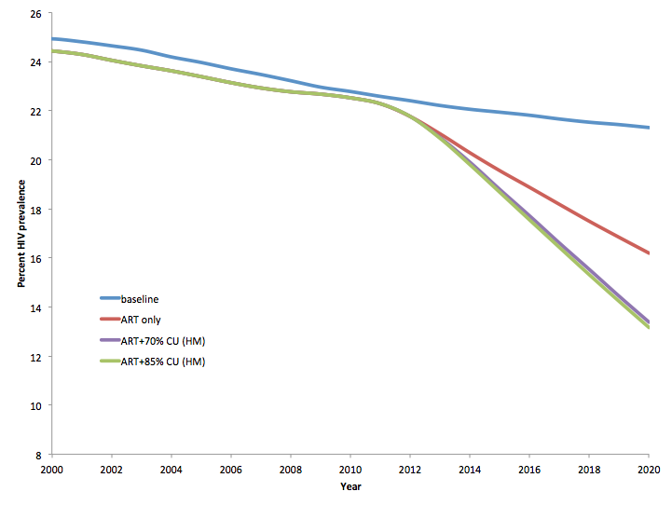
References
- Orroth KK, Freeman EE, Bakker R, et al. Understanding the differences between contrasting HIV epidemics in east and west Africa: results from a simulation model of the Four Cities Study. Sex Transm Infect 2007; 83 Suppl 1:i5-16
- Boily MC, Baggaley RF, Wang L, Masse B, White RG, Hayes RJ, et al. Heterosexual risk of HIV-1 infection per sexual act: systematic review and meta-analysis of observational studies. Lancet Infect Dis 2009; 9(2):118-29
- Morison, L., Weiss, H. A., Buvé, A. et al. Commercial sex and the spread of HIV in four cities in sub-Saharan Africa. AIDS 2001; 15 Suppl 4:S61–9
- Cheluget B, Joesoef MR, Marum LH et al. Changing Patterns in Sexually Transmitted Disease Syndromes in Kenya After the Introduction of a Syndromic Management Program. Sex Transm Dis 2004; 31:522–525
- Korenromp EL, Van Vliet C, Bakker R, De Vlas SJ, Habbema JDF. HIV spread and partnership reduction for different patterns of sexual behaviour: a study with the microsimulation model STDSIM. Math Popul Studies 2000; 8:135–173
- Buvé, A., Caraël, M., Hayes, R. J. et al. Multicentre study on factors determining differences in rate of spread of HIV in sub-Saharan Africa: methods and prevalence of HIV infection. AIDS 2001; 15 Suppl 4: S5–14
- Vandenhoudt H, Langat L, Zeh C, et al. Community based study of HIV, STI, and sexual behavior among female sex workers in Kisumu, Nyanza Province, Kenya. 18th ISSTDR 2009, London, 28 June–1 July
- Langat L, Vandenhoudt H, Menten J, et al. Estimating the size of the female sex worker population in Kisumu, Western Kenya. 18th ISSTDR 2009, London, 28 June–1 July
- Vandepitte, J., Lyerla, R., Dallabetta, G. et al. (2006). Estimates of the number of female sex workers in different regions of the world. Sex. Transm. Infect., 82(Suppl. 3), iii18–25
- Hontelez JA, de Vlas SJ, Baltussen R, et al. The impact of antiretroviral treatment on the age composition of the HIV epidemic in sub-Saharan Africa. AIDS 2012; 26 Suppl 1: S19-30
- Williams BG, Korenromp EL, Gouws E, Schmid GP, Auvert B, Dye C. HIV Infection, Antiretroviral Therapy, and CD4⁺ Cell Count Distributions in African Populations. J Infect Dis 2006; 194 (10): 1450-1458 doi:10.1086/508206
- Hontelez JA, de Vlas SJ, Tanser F, et al. The impact of the new WHO antiretroviral treatment guidelines on HIV epidemic dynamics and cost in South Africa. PLoS One 2011; 6(7):e21919
- Hontelez JA, Lurie MN, Bärnighausen T, et al. Elimination of HIV in South Africa through expanded access to antiretroviral therapy: a model comparison study. PLoS Med 2013; 10(10): e1001534. doi:10.1371/journal.pmed.1001534
- World Health Organization (2010) Towards universal access: scaling up priority HIV/AIDS interventions in the health sector: progress report 2010. Geneva: World Health Organization

