Appendix to: Treatment as prevention among injecting drug users; extrapolating from the Amsterdam cohort study, de Vos AS, Prins M, Coutinho RA, van der Helm JJ, Kretzschmar MEE. Created 9th of December 2013.
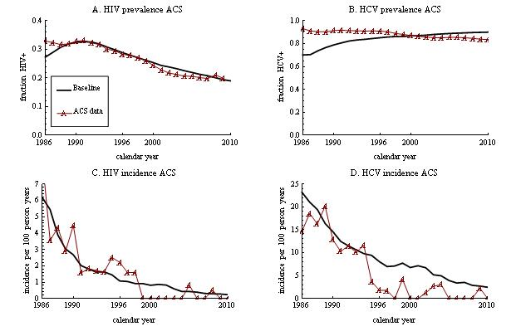
Figure A1
HIV and HCV incidence and prevalence within the modeled cohort as compared to data from the actual Amsterdam Cohort Studies (ACS) among IDU, for the baseline scenario. Since direct measurements for risk behavior were lacking, syringe sharing rate parameters were chosen based on this model fit to ACS incidence and prevalence data (see also reference 10).
AIDS was first reported in Amsterdam in 1982, with a first IDU AIDS case reported in 1985 [10]. The quick spread of this disease among Amsterdam IDU could only be reproduced in our model by assuming a high-risk subgroup of individuals sharing syringes mostly among themselves, while lower risk by remaining IDU limited the maximum HIV prevalence reached. High HCV prevalence among all IDU indicated the non-negligible risk level of these remaining IDU.
One cause for the lowered HIV and HCV incidence in the model over calendar time was a cohort-effect due to the limited inflow of new IDU from 1985 onwards; high-risk IDU were infected first, leaving mostly low-risk IDU at risk for infection. Also, the fraction of ACS participants actively injecting declined over time; a criterion for ACS recruitment was recent injecting, but IDU that stopped injecting remained as participants. HIV prevalence decreased as HIV-related mortality mainly affected the high-risk subgroup, decreasing the total level of population risk over time.
Our baseline model slightly underestimated the actual decline in HCV incidence from the mid-1990s, and showed a slight increase rather than a slight decrease in HCV prevalence over time. This may indicate that the actual Amsterdam IDU lowered their risk-behavior over calendar time, perhaps under influence of harm reduction interventions [10]. We do not assume such behavior change here, in order to keep the model interpretation as straight forward as possible.

