Supplementary materials and methods

Generation of CTL cultures
HLA A11-restricted EBV-specific CTL cultures reacting against the EBV-encoded nuclear Ag 4 (EBNA4)-derived IVTDFSVIK (IVT, aa 416–424) and HLA A2-restricted EBV-specific CTL cultures reacting against the EBV-encoded LMP2-derived CLGGLLTMV (CLG, aa 426–434) epitope and the LMP1-derived YLQQNWWTL (YLQ, aa 159–167) epitope were obtained by stimulation, in the absence or presence of Tat (0.1 µg/ml), of lymphocytes from HLA-A2-positive and HLA-A11-positive EBV-seropositive volunteers with peptide-pulsed T2 cells. HLA A2-restricted survivin-specific CTL cultures reacting against the survivin tumor antigen ELT (ELTLGEFLKL) were obtained by stimulation, in the absence or presence of Tat (0.1 µg/ml), of lymphocytes from HLA-A2-positive healthy volunteers with peptide-pulsed T2 cells.
The 174/T2 cell line (T2) was obtained by fusion of the peptide transporter mutant 174 LCL with the T cell line CEM. Cells were cultured overnight at 26°C in 1 ml of serum-free AIM-V medium (Gibco), were washed, treated with mitomycin C (Sigma-Aldrich), and pulsed with 10-5 M of the different peptides for 3 hours at 37°C in AIM-V medium.
Briefly, PBLs were plated at 3x10⁶ cells per well in 24-well plates in complete medium and stimulated with peptide-pulsed T2 cells at a stimulator-responder ratio of 1:20, in the absence or presence of Tat. Alternatively, cells were stimulated directly with peptides (10⁻⁵ M) in the absence or presence of Tat. Cultures were re-stimulated after 7 and 14 days, and the medium was supplemented from day 8 with 10 U/ml rIL-2. On days 21, CTL cultures were tested for activity using cytotoxicity or Elispot assays.
Peptides were synthetized by solid phase method and purified by HPLC to >98% purity (UF Peptides, University of Ferrara).

Cytotoxicity assay
The cytotoxic activity was assayed in standard 5-hours ⁵¹Cr-release assays. Target cells (PHA blasts) were labeled with Na₂⁵¹CrO₄ (3.5 MBq/10⁶ cells; PerkinElmer, Waltham, MA, USA) for 60 minutes at 37°C and, where indicated, pulsed for 45 minutes with 10⁻⁶ M of the different peptides at 37°C. Subsequently, cells were washed three times and incubated with effector cells. ⁵¹Cr-release was measured after 5 hours at 37°C through the use of a γ-counter. Maximum ⁵¹Cr-release was evaluated treating target cells with Triton X-100, while spontaneous ⁵¹Cr-release was evaluated in target cells incubated alone in complete medium. Cytotoxicity tests were routinely run at different E:T ratios in triplicate. Percentage of specific lysis was calculated as 100 x (cpm sample - cpm medium)/(cpm Triton X-100 - cpm medium). Spontaneous release was always <10%. None of the tested peptides affected spontaneous release.
PHA-activated blasts were obtained by stimulation of PBLs with 1 µg/ml purified PHA (Sigma-Aldrich, St. Louis, MO, USA) for 3 days at 37°C and expanded in complete medium supplemented with human rIL-2 (10 U/ml; R&D Systems).

Elispot assay
CTLs (4 x 10⁴) were seeded in triplicate on microplate 96-well unifilter (Whatman, GE Healthcare, Little Chalfont, U.K.) pre-coated with an anti-IFNγ or anti-granzyme B mAb (Pierce, Waltham, MA, USA). CTLs were stimulated with CLG and YLQ EBV-derived CD8 peptides. CTLs incubated with medium alone were used as negative control, whereas CTLs stimulated with PHA represented the positive control. Plates were incubated for 24 hours and washed, and then a biotinylated anti-IFNγ or anti-granzyme B mAb (1 µg/ml) was added to the wells. After 60 min, the plates were washed again and HRP-conjugated streptavidin (Pierce) was added at room temperature for 45 minutes. Individual IFNγ or granzyme B producing cells were detected using 3-amino-9-ethylcarbazole cromogen kit (Sigma-Aldrich) and counted by ELISPOT reader (AELVIS, Hannover, Germany). The number of specific IFNγ-secreting or granzyme B-secreting T cells, expressed as spot-forming units per 10⁶ cells, was calculated by subtracting the negative control values.

Reverse transcription (RT) and quantitative real time PCR
DNase-treated total RNA was isolated from cells using Trizol reagent (Life Technologies) according to the manufacturer's instructions and used to perform cDNA synthesis (High Capacity cDNA Reverse Transcription Kit, Applied Biosystems, Life Technologies). cDNA was PCR-amplified with a Chromo4 real-time PCR Detection System using Kapa SYBR Green Fast qPCR Kit (Kapabiosystems, Wilmington, MA, USA) according to the manufacturer's recommendations with the following cycle conditions: 3 minutes at 95°C, then 40 cycles of 15 seconds at 95°C, and 20 seconds at 60°C. Quantitative PCR was performed using the pairs of primers (TEMA ricerca, Bologna, Italy) as follows: T-bet forward 5’-GCGCCAGGAAGTTTCATTTG-3’, T-bet reverse 5’-GGAAAGTAAAGATATGCGTGTTGG-3’, Eomes forward 5’-TCATTACGAAACAGGGCAGG-3’, Eomes reverse 5’-TGCATGTTATTGTCGGCTTTG-3’, IL-2 forward 5’-AAGAATCCCAAACTCACCAGG-3’, IL-2 reverse 5’-ATTGCTGATTAAGTCCCTGGG-3’, IFNγ forward 5’-TGACCAGAGCATCCAAAAGAG-3’, IFNγ reverse 5’-CGACAGTTCAGCCATCACTTG-3’, Bcl-2 forward 5’-GATCCAGGATAACGGAGGC-3’, Bcl-2 reverse 5’-GGCATGTTGACTTCACTTGTG-3’, Bcl-6 forward 5’-CCCTATCCCTGTGAAATCTGTG-3’, Bcl-6 reverse 5’-CTGGCTTTTGTGACGGAAATG-3’, Blimp-1 forward 5’-ACTGGGTAGAGATGAACGAGAC-3’, Blimp-1 reverse 5’-CCACAGAGTCATATCCGCATC-3’, 18S forward 5’-GTAACCCGTTGAACCCCATT-3’ and 18S reverse 5’-CCATCCAATCGGTAGTAGCG-3’.
The relative levels for each RNA were calculated by the 2^{−ΔΔCT} method using human 18S as housekeeping gene. CT values are the mean of two biological replicates and each assay was performed a minimum of two times.

Flow Cytometry
All stainings were carried out in PBS containing 1% FCS for 30 min at 4°C with the following antibodies: CD45RO-FITC, CD25-FITC, CD8-PE, CD27-PE, CD8-PE/Dy647 (ImmunoTools, Friesoythe, Germany); PD-1-PE, CD127-PerCP-Cy 5.5 (BD Pharmingen, San Diego, CA, USA). Detection of intracellular IL-2 expression was carried out after 18 h of stimulation in the presence of brefeldin A (Sigma-Aldrich) using the Cytofix/Cytoperm kit (BD Pharmingen) and a IL-2-PE antibody (BD Pharmingen). Data were acquired on a BD FACScan and analyzed using BD Cell Quest Pro software.

Fig. S1. The effect of Tat is inhibited by anti-Tat antibodies. PBLs from healthy donors (n=6) unstimulated or activated with anti-CD3/CD28 were cultured in the absence or presence of Tat (0.1 µg/ml) and anti-Tat immune sera. IL-2 mRNA levels were quantified by qPCR and normalized to untreated cells. The results of one representative experiment out of six are shown.
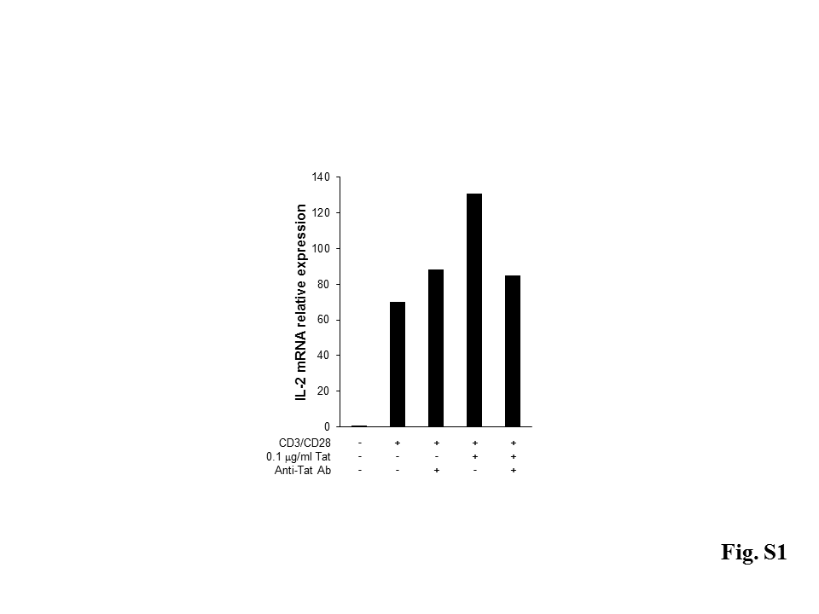

Fig. S2. Tat enhances IL-2 production. PBLs from healthy donors (n=8) were activated with anti-CD3/CD28 in the absence or presence of Tat (0.1 µg/ml). After 18 hours of stimulation, the IL-2 production by CD8⁺ T cells was assessed by intracellular cytokine staining. Data are presented as mean ± SEM. For statistical analysis two-tailed Wilcoxon signed rank test was used. *P<0.05: Tat-treated cells compared to control cells.
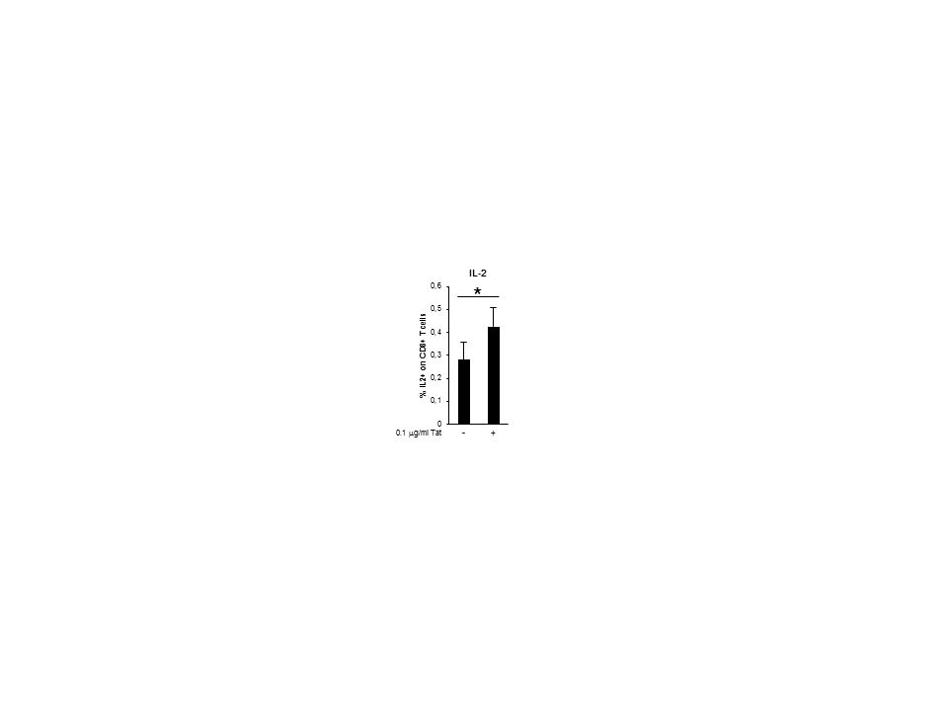

Fig. S3. Tat does not affect PD-1 expression. PBLs from healthy donors (n=5) unstimulated or activated with anti-CD3/CD28 were cultured in the absence or presence of Tat (0.1 µg/ml). After 8 days, PD-1 expression was measured on CD8⁺ T cells. One representative experiment out of five is shown.

