Figure S1. CBA kit cytokine data for serum samples from Patient 4 (A) compared to healthy control samples. (B) The x-axis for Patient 4 shows the days since the NVP HSR (NVP stop date). The Y axis shows pg/ml of cytokine detected. Blue bars - IL-2, orange bars - IL-4, grey bars - IL-6, dark blue bars - TNF, green bars - IFNγ, IL-17a - navy blue bars.

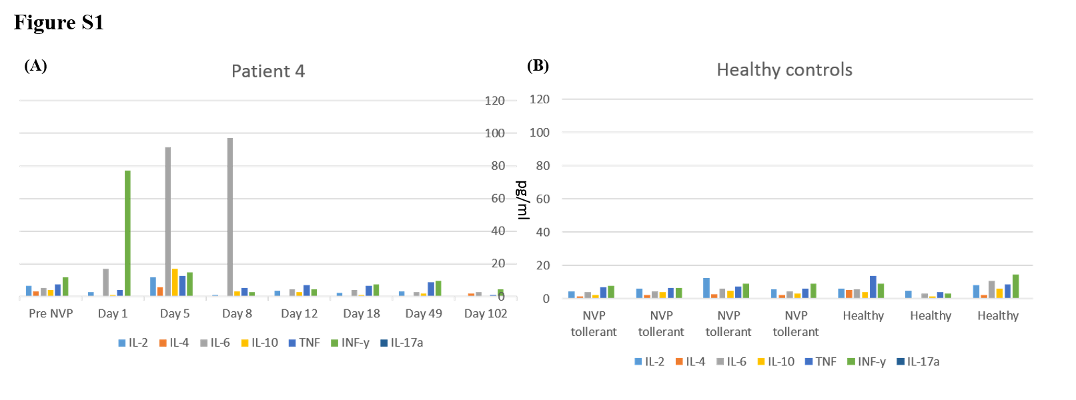

Table S1. Haplotype data for NVP HSR patients with NVP induced INFγ response for patients 1,2,3 and 4.
Patient | HLA-A | HLA-A | HLA-B | HLA-B | HLA-C | HLA-C | HLA-DRB1 | HLA-DRB1 | HLA-DQB1 | HLA-DQB1 | Ethnicity | INFγ response: SFU/Million cells (Days post HSR)
1# | 24:07 | 24:10 | 35:30 | 38:02 | 04:01 | 07:02 | 12:01 | 15:02^ | 05:02 | 05:02 | SEA | 115 SFU (6), 235 SFU (61),285 SFU(81), 225 SFU (90) and 870 SFU (144)
2 | 11:01 | 24:02 | 35:01 | 13:01 | 03:04 | 04:01 | 11:01 | 16:01 | 03:01 | 05:02 | SEA | 400 SFU (97) and 20 SFU (476)
3 | 02:06 | 34:01 | 15:21 | 56:01 | 04:03 | 07:01 | 04:06 | 15:02^ |  |  | SEA | 300 SFU (2) and 45 SFU (62)
4 | 29:02 | 31 | 14:01* | 44:03 | 08:02 | 16:01 | 07:01 | 07:01 | 02:02 | 02:02 | C | 1600 SFU (5), 150 SFU (8), 40 SFU (18), 0 SFU (49)
5 | 02 | 30 | 18:01 | 58:01* | 07:04 | 07:04 | 08:02 | 15:01^ | 04:02 | 05:01 | SEA
6 | 11 | 24 | 35:01 | 39:06 | 04 | 07:02 | 01:01 | 08:01 | - | - | C
7 | 01 | 02 | 08:01 | 27:01 | 07 | 02:02 | 01:01 | 03:01 | 01 | 02 | C
8 | 02 | 31 | 27:05 | 44:02 | 01:02 | 05:01 | 01:01 | 01:01 | 05:01 | 05:01 | C
9 | 01 | 01 | 08:01 | 50:01 | 07 | 06:02 | 03:01 | 04:01 | 03 | 03 | C
10 | 03:01 | 11:01 | 35:01 | 40:02 | 02:02 | 04:01 | 04:01 | 11:01 | 03 | 03 | C
11 | 03:01 | 33:01 | 14:02* | 57:01 | 06:02 | 08:02 | 03:01 | 07:01 | 02:01 | 03:03 | C
12 | 02:01 | 02:01 | 13:02 | 15:01 | 03:03 | 06:02 | 15:01^ | 07:01 | 02 | 06:02 | C
13 | 01:01 | 01:01 | 08:01 | 08:01 | 07 | 07 | 03:01 | 03:01 | 02:01 | 02:01 | C
14 | 01:01 | 24:02 | 08:01 | 39:06 | 07:02 | 07:02 | 03:01 | 08:01 | 02:01 | 04:02 | C
15 | 24 | 24:07 | 15:02 | 38:02 | 07:02 | 08:01 | 15:02^ | 12:02 | 03:01 | 05:01 | SEA
16 | 02:03 | 24:07 | 15:02 | 40:01 | 04:03 | 08:01 | 14:01 | 15:01^ | 05:03 | 06:01 | SEA
17 | 02 | 03 | 35:01 | 15:01 | 03:03 | 04:01 | 01:01 | 04:01 | 03:02 | 05:01 | C
18 | 03 | 24 | 51:01 | 56:01 | 01:02 | 15:06 | 01:01 | 01:01 | 05:01 | 05:01 | C
19 | 03:01 | 11:01 | 35:01 | 51:01 | 04:01 | 14:02 | 01:01 | 11:04 | 03:01 | 05:01 | C
C=Caucasian, SEA=South East Asian.
*HLA allele was found significant in other published studies [13, 14],
#Re-challenged with NVP after initial HSR reaction.

Table S2. HLA allele frequencies for NVP hypersensitive and tolerant individuals, and frequency ranges observed in comparable ethnic groups

HLA allele | DRB1*01:01 |  | B*35:01 |  | Cw*04 |  | Cw*08
 | Caucasian | SE Asian | Caucasian | SE Asian | Caucasian | SE Asian | Caucasian | SE Asian
NVP HSR | 0.346 | 0.000 | 0.154 | 0.167 | 0.154 | 0.333 | 0.077 | 0.167
Tolerant | 0.073 | 0.045 | 0.054 | 0.000 | 0.094 | 0.136 | 0.044 | 0.000
Reference range* | 0.08-0.13 | 0.00-0.04 | 0.05-0.10 | 0.00-0.07 | 0.01-0.20 | 0.00-0.18 | 0.00-0.07 | 0.00-0.18
*Reference range is taken from global distribution plots for Europeans and South East Asians (www.allelefrequencies.net) where n ≥ 100.

