Supplementary Appendix for: “The causal effect of opioid substitution treatment on highly active antiretroviral treatment adherence”
Weighted estimation of the parameters of marginal structural models requires fitting several models: (i) the structural (ie, weighted) model; (ii) the exposure model, and (iii) the censoring model. The formula for stabilized weight (treatment weight) is as follows:
$$sw\left(t\right)=\prod_{k=0}^{t}{\frac{f[A\left(k\right)|\overline{A}\left(k-1\right),V]}{f[A\left(k\right)|\overline{A}\left(k-1\right),\overline{L}\left(k\right)]}}$$
where $A\left(t\right)$ indicates the treatment at time $t$, $\overline{A}(t)$ represents a subject’s treatment history up to $t$, $V$ represents a vector of time-independent baseline covariates, and $L(t)$ represents time-dependent covariates, which includes baseline variables $V$. Non-stabilized weights can be obtained by replacing the numerator by 1. Each factor in the denominator is the probability that the subject received his own observed treatment at month k, given his past treatment and both the time-independent and dependent covariates, and each factor in the numerator is the probability that the subject received his observed treatment conditional on his past treatment history and baseline covariates. For estimating the weights, separate regression models for the numerator and denominator were fitted, as shown in Table A1 below. In the numerator, a pooled logistic regression model was estimated for the probability OST, including only the baseline covariates described above, as well as the number of days in OST in the previous month. The model used to estimate the denominator of the weight included the baseline covariates, the previously noted time-varying covariates, as well as HAART receipt in month t-1. To adjust for potential selection bias by measured factors due to loss to follow-up, a second set of censoring weights were obtained by fitting similar models to estimate the probability of censorship (either loss to follow-up or death before Mar 31, 2010). Time-dependent intercepts were estimated as a restricted cubic spline with knots at the 5th, 25th, 75th, and 95th centiles. The final weight for each individual’s observation was obtained by multiplying the treatment weights and the censoring weights.

Table A1: Results of 4 regression models used in the calculation of the stabilized inverse probability of treatment weights
 | Probability of OST exposure |  |  | Probability of non-censorship
 | Numerator model* | Denominator model |  | Numerator model* | Denominator model
 | AOR (95% CI) | AOR (95% CI) |  | AOR (95% CI) | AOR (95% CI)
Age (t₀) vs. <30
30-39 | 1.25 (1.18-1.32) | 1.22 (1.16-1.29) |  | 0.74 (0.60-0.93) | 0.73 (0.59-0.92)
40-49 | 1.70 (1.59-1.82) | 1.64 (1.53-1.76) |  | 0.51 (0.40-0.64) | 0.48 (0.38-0.61)
50+ | 1.88 (1.66-2.14) | 1.82 (1.61-2.07) |  | 0.41 (0.30-0.57) | 0.36 (0.26-0.49)
Male | 1.20 (1.15-1.26) | 1.27 (1.27-1.27) |  | 0.97 (0.81-1.17) | 0.91 (0.76-1.09)
AIDS status (t₀) | 0.59 (0.52-0.67) | 0.48 (0.41-0.57) |  | 1.98 (1.39-2.81) | 2.87 (1.92-4.30)
CD4 count (t₀) vs. ≥ 500
Missing | 0.95 (0.88-1.04) | 0.97 (0.88-1.07) |  | 0.55 (0.42-0.72) | 0.82 (0.58-1.15)
<200 | 0.77 (0.72-0.83) | 0.75 (0.70-0.81) |  | 0.52 (0.40-0.67) | 0.88 (0.67-1.16)
200-499 | 0.89 (0.84-0.95) | 0.89 (0.83-0.94) |  | 0.85 (0.67-1.08) | 1.01 (0.79-1.29)
Calendar year (t₀) vs. 2004-2010
1996-1999 | 1.01 (0.93-1.09) | 1.07 (0.99-1.16) |  | 0.57 (0.43-0.76) | 0.69 (0.52-0.91)
2000-2003 | 0.93 (0.86-1.01) | 0.96 (0.89-1.05) |  | 0.81 (0.60-1.10) | 0.89 (0.66-1.21)
OST history (number of prior episodes, t₀)
≥1 vs. 0 | 1.35 (1.28-1.43) | 1.37 (1.30-1.45) |  | 0.62 (0.51-0.75) | 0.63 (0.53-0.77)
HAART adherence (t₀) | 1.00 (0.94-1.07) | 0.98 (0.92-1.05) |  | 0.99 (0.80-1.24) | 0.91 (0.73-1.14)
Days on OST (t-1) | 1.27 (1.27-1.28) | 1.27 (1.27-1.27)
OST (t-1) |  |  |  | 2.55 (2.01-3.24) | 2.20 (1.73-2.80)
HA of residence (t-1) vs. Vancouver Coastal
Vancouver Island |  | 1.13 (1.05-1.20) |  |  | 1.14 (0.91-1.44)
Fraser |  | 1.00 (0.94-1.05) |  |  | 1.34 (1.10-1.44)
Interior |  | 1.07 (0.96-1.19) |  |  | 1.23 (0.87-1.75)
Northern |  | 1.06 (0.91-1.24) |  |  | 1.05 (0.68-1.63)
AIDS status (t-1) |  | 1.24 (1.12-1.38) |  |  | 0.57 (0.45-0.72)
CD4 count (t-1) vs. ≥ 500
Missing |  | 0.98 (0.85-1.14) |  |  | 0.43 (0.28-0.67)
<200 |  | 0.89 (0.83-0.96) |  |  | 0.25 (0.20-0.33)
200-499 |  | 0.99 (0.93-1.05) |  |  | 1.03 (0.78-1.36)
HAART adherence (t-1) |  | 1.25 (1.19-1.31) |  |  | 1.69 (1.42-2.02)
Cumulative years of follow-up (t) | 1.05 (0.97-1.13) | 1.01 (0.94-1.09) |  | 0.87 (0.67-1.12) | 0.79 (0.61-1.03)
t₀: fixed covariates; t-1: time-varying covariates measured one period prior to OST exposure or censorship. *Including only time-invariant covariates + OST exposure at time t-1.

Figure A1. Distributions of stabilized vs. non-stabilized weights at selected time points from HAART eligibility to the end of study follow-up

PANEL A: Distribution of stabilized weights
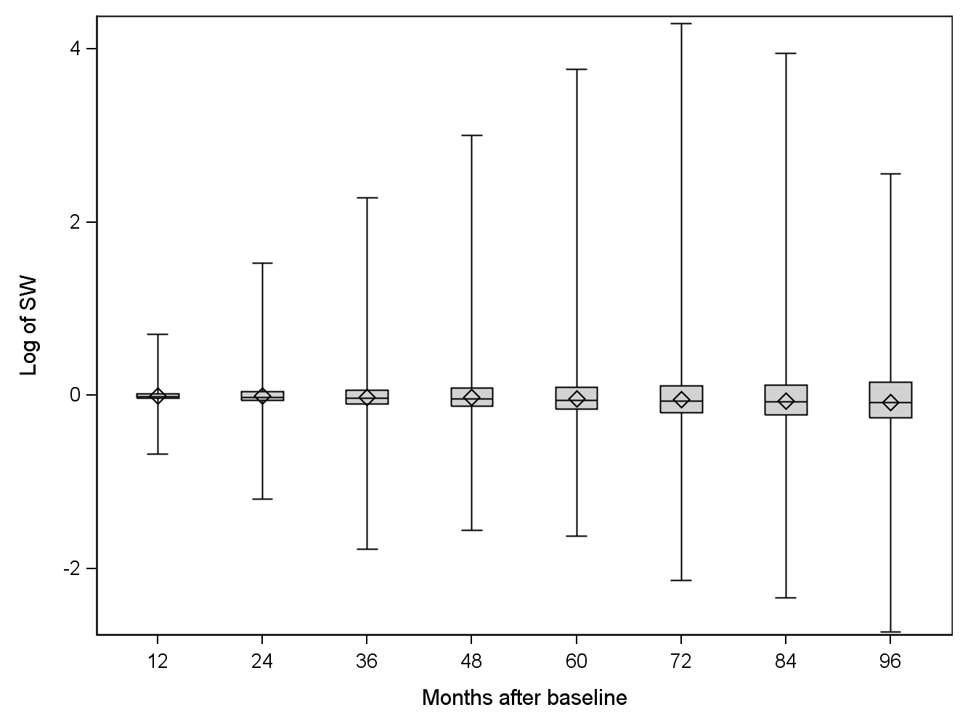
PANEL B: Distribution of unstabilized weights
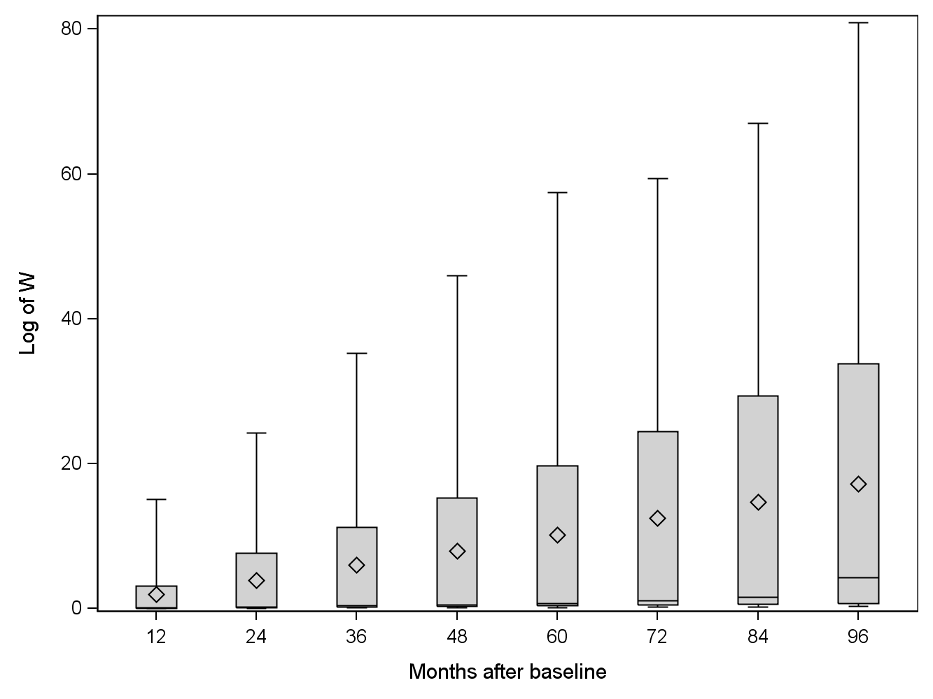
Legend: The box for each time point shows the location of the mean (<>) median (middle horizontal bar and second and third quartiles (border horizontal bars). Vertical lines extend to the maximum and minimum values.

