Potential impact on HIV incidence and cost effectiveness of higher HIV testing rates and earlier ART initiation in men-who-have-sex-with-men

SUPPLEMENTARY MATERIAL

Details of the model and calibration procedure have been described in detail elsewhere in Supporting information S1 and S2 in Phillips et al 2013¹. Here we briefly summarize the model and calibration process. We reconstruct sexual risk behaviour, HIV transmission, HIV progression and the effect of ART for the population of MSM in the UK from 1980 using an individual-based stochastic computer simulation model which aims to capture the key underlying mechanisms which determine these processes. We assume all transmission takes place via condomless anal sex and sexual risk behaviour is modelled as the number of short term (e.g. casual) and long term condomless sex partners which, as for all variables modelled, were updated in 3 month periods. We consider distributions for the parameters that determine levels of condomless sex to reflect uncertainty in the value (20 parameters in total are sampled from distributions in this way). For each of over 100,000 runs of the simulation model we sample from each of these distributions to obtain a set of parameter values to be used and generate a full reconstructed epidemic scenario for 1980-2012. We then consider the parameter sets that provide the closest calibration to the observed data. Details of distributions for all parameters are given in Supporting information S2 of Phillips et al 2013¹. The sampling from distributions for the parameters relating to sexual risk behaviour and transmission rate means that we explore a range of possible scenarios, including ones in which the ratio of short to long term partners increases or decreases or the number of short term partners occurring in the same period as a man has a longer term partner (concurrency) increases or decreases. All distributions are the same as used previously and reported in Supporting information S2 in Phillips 2013¹ with the exception that the proportion of men who substantially reduce the number of short term partners after HIV diagnosis was sampled from Beta (3,7) instead of Beta (7,7) previously, and the proportion of men who substantially reduce condomless sex with long term negative partner was sampled from Beta (3,7) instead of Beta (5,20) previously, reflecting persisting uncertainty over the extent of reductions in condomless sex, and the extent to which this is more likely to be the case with short term or long term partners (Beta (3,7) means there is about a 5% chance of the proportion being < 0.1 and the same probability of it being > 0.55). The parameterization of changes in condomless sex and testing is as previously, with the additional assumption that rates are constant after 2012 (see Suppl Figure 1) and with broader distributions for sexual risk behaviour to allow a wider search for parameter values (distributions of α_{r,} α'_{r} and β_{r} of 0.27 x exp (Normal(0, 0.35²)), 0.35 x exp (Normal(0, 0.35²) and Normal (0.012, 0.012), respectively, compared with 0.27 x exp (Normal(0, 0.25²)), 0.35 x exp (Normal(0, 0.25²) and Normal (0.012, 0.006) previously).

In any given period, the probability of an uninfected person having a condomless sex partner who is infected with HIV depends on their number of partners and on the prevalence of HIV amongst partnerships formed by other men in the population, accounting for patterns of age mixing. On exposure to an infected partner, the probability of transmission depends on the viral load level of the partner (obtained by sampling from the distribution of viral load levels in partnerships formed by HIV infected MSM, accounting for age), the estimated risk of transmission at that viral load and presence of a concurrent sexually transmitted infection. We assume a very low rate of transmission (0.00001 per 3 months) when the viral load is undetectable² but, again, we consider a distribution of possible values reflecting uncertainty¹. For MSM who have become infected with HIV the variables modelled include; primary infection (a period of raised infectivity of duration 3 months), viral load, CD4 count, adherence to ART, risk of AIDS and death. Resistance acquisition and transmission is also incorporated, and its effects accounted for, although this is not a focus in the present paper. The model of progression of HIV and the effect of ART has been shown to provide a generally close fit to observed data relating to natural progression of HIV infection and the effect of ART³⁻⁵. Based on data from NATSAL^{6,7}, we assume that the population of MSM aged over 15 was approximately 500,000 in 1980 and, as for the UK population as a whole, has increased in size by around 10% up to 2012.

The calibration process used in Phillips et al 2013¹ has been repeated with inclusion of data additionally from the years 2011 and 2012 (Supplementary Table 1). For each data item the fit was calculated as: , where O indicates the observed value and M the model output value The overall fit was calculated as the sum of the fit to each of the data items with the weights shown in Supplementary Table 1. The model was run >100,000 times, independently varying at random the 20 parameter values relating to sexual behaviour, testing and transmission¹. We recorded parameter sets which provided a fit value < 1.8, which represents a situation where on average the model outputs are within 12% of the data (sum of the weights = 1.49). To generate uncertainty bounds we present the median and 90% range (5%-95% centiles) over runs in this fit value range. 101 such parameter sets were identified. These parameter sets were used (by selecting from the 101 at random each time the model was run, always from 1980) when doing repeated runs to project forward to 2030. Only runs in which the fit value was again < 1.8 were considered for the model projections. For the projections, over 600 runs were done (each time using a parameter set that gave a fit value < 1.8) to minimize stochastic variation in the means of the outcomes. 95% confidence intervals are provided for some projections to illustrate the extent of this stochastic variability (which is very small for the mean values presented because they are based on a large number of model runs) but not for all projections in order to keep graphs readily readable. Supplementary Figures 8 and 9 illustrate run to run variability in outputs, which is significant and relates to a combination of stochastic variation within each model run (which is almost entirely removed in the mean values over many model runs that are shown in our main results, as illustrated by the narrow 95% confidence intervals in Figure 3a, for example, and also shown in grey in Supplementary figure 9) and variation according to variation in parameter values.

Updates to underlying model

We made some updates to the underlying model from the version documented in Supporting information S1 in Phillips 2013¹. Most changes were due to the fact that the total numbers of deaths in MSM with HIV predicted by the model in the years from the late 1990’s onwards are consistently higher than observed. While this could relate to under-reporting of deaths and indeed some deaths in men in whom their HIV infection is never diagnosed, but was considered to also reflect some model mis-specification. Hence:
- the increased death rate in people with a current AIDS condition was decreased from 2-fold to 1.5-fold,
- the independent effect of ART on risk of HIV-related death (independent of CD4 count, viral load and age) was increased from a rate ratio of 0.8 to 0.6,
- the on-going increased risk of death (including non-AIDS death due to excess inflammation) in people with viral suppression and high CD4 count was reduced from 1.5-fold to 1.3 fold.
- we outputed deaths in people diagnosed with HIV before death
Further, in order for the model to better reflect the fact that around 95% of people on ART have viral load < 500 copies/mL, we modified the adherence profile such that 8% rather than 15%, as in the earlier version, have the underlying (person-specific) tendency to adhere below 90%. For the same reason, in those virologically failing a given line of treatment, we increased the rate with which a switch to new line occurs from 0.3 per 3 months to 0.6.
The rate of CD4 count increase on ART previously was reduced by 4-fold after 2 years. As a result of further calibration work, this is now changed to 1.5 fold after 1 year and a further 2-fold after 3 years⁸. The probability of a resistance mutation present in the infection source being transmitted and incorporated as part of the newly infected person’s virus was previously 50% for most mutations, and thereafter the mutations persisted. Now with new evidence that transmitted mutations are lost over time⁹, we have modified this such that the probability of transmission of resistance mutations is higher (70% for most mutations), but there is a rate of loss of mutations from majority virus of 0.04 per 3 months. We also reduced the probability of resistance mutations to darunavir appearing such that it is one quarter that for other ritonavir boosted PIs¹⁰⁻¹².

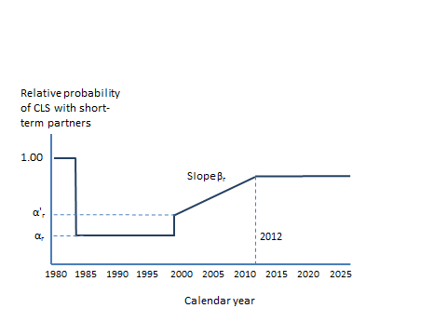Suppl Figure 1a. Parameterization of trend in condomless sex (CLS) with short term partners

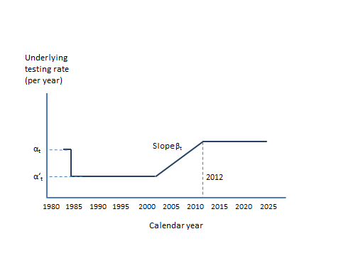
Suppl Figure 1b. Parameterization of trend in HIV testing rate

Suppl Table 1. Fit value used to measure model calibration to observed data, with observed data. Rows in bold are newly added from Phillips et al 2013¹.
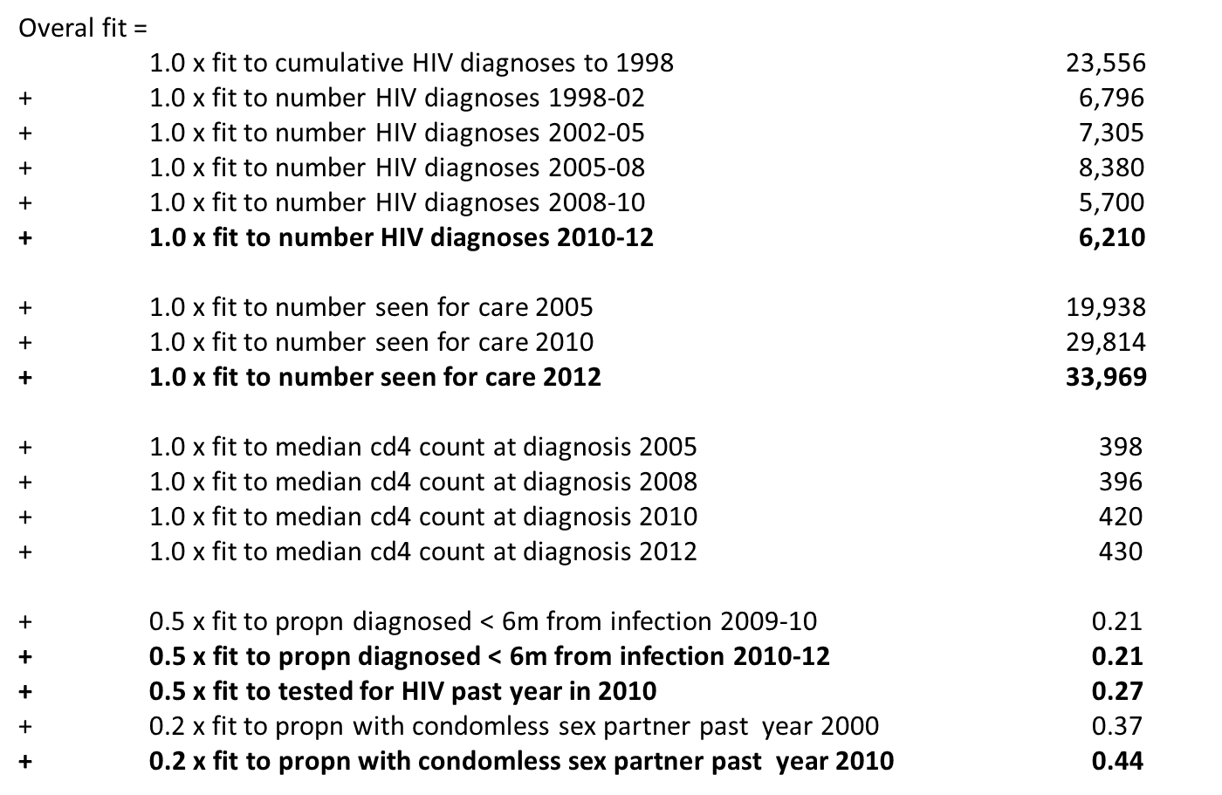
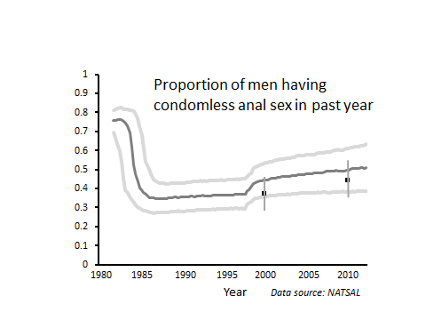Suppl Figure 2. Model outputs and, where available, comparisons with observed data. Dark grey lines are medians over runs with parameter sets with fit score < 1.8. Light grey lines are 90% uncertainty range. Black dots are data.

(a)

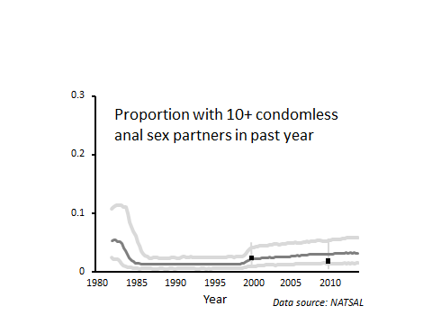

(b)

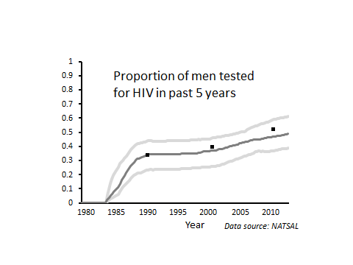

(c)

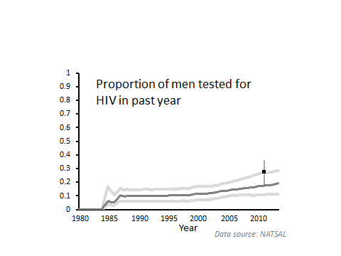(d)

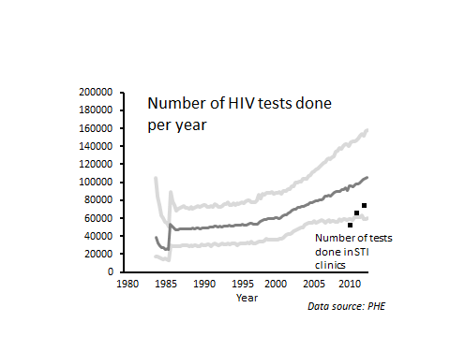

(e)

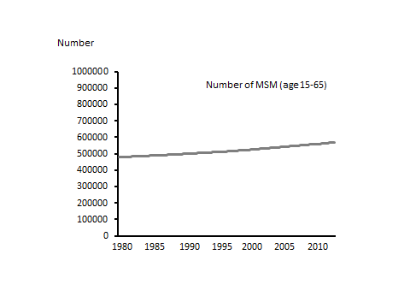

(f)

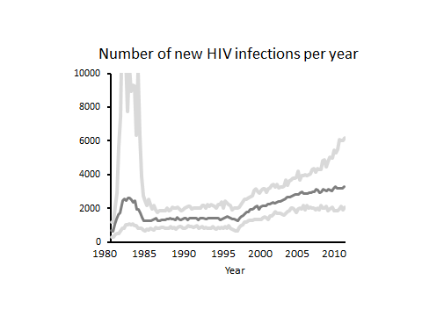(g)

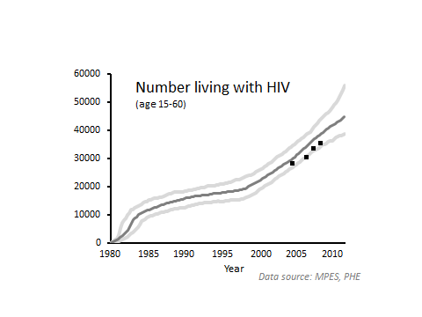

(h)

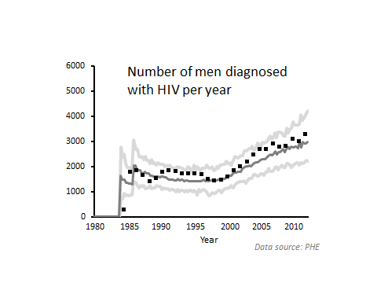

(i)

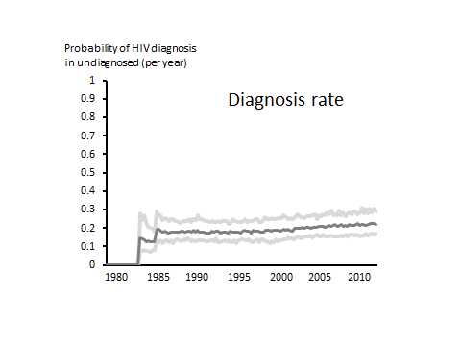(j)

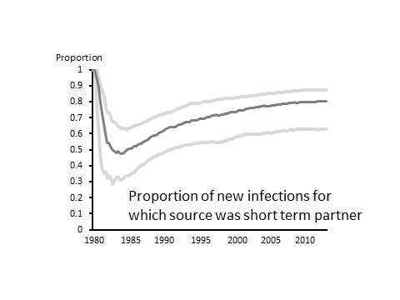

(k)

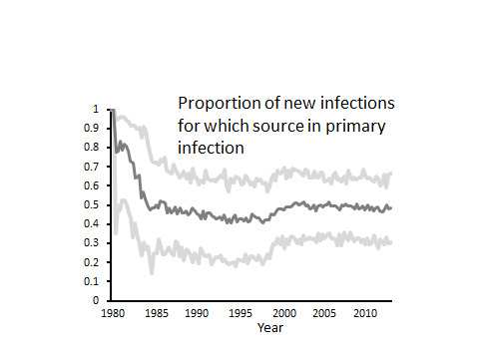

(l)

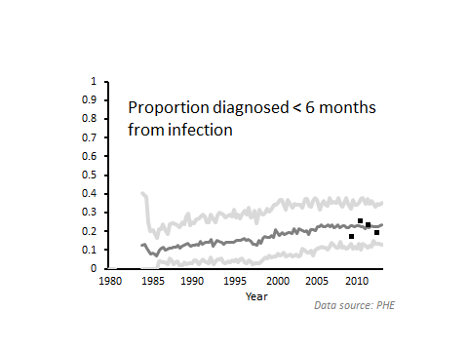(m)

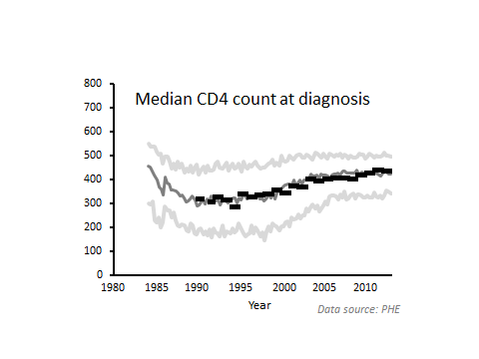

(n)

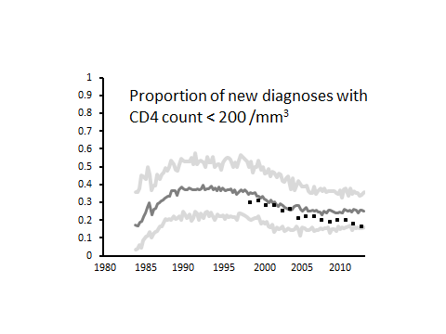

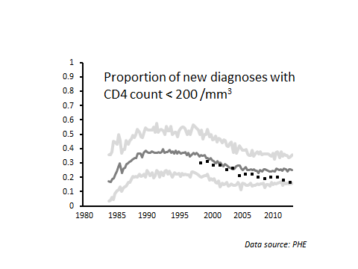
(o)

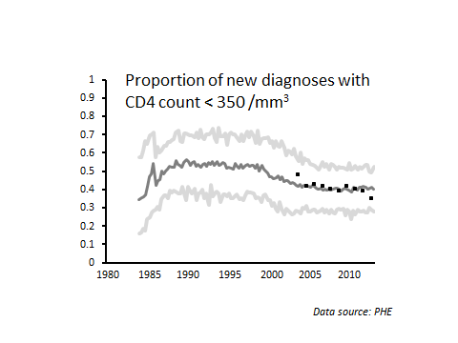(p)

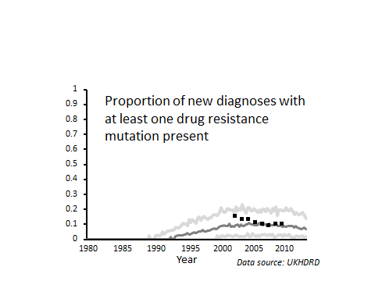

(q)

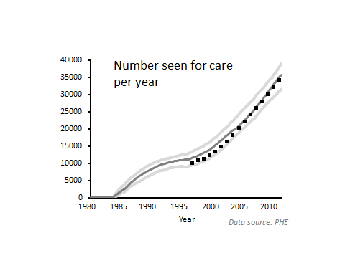

(r)

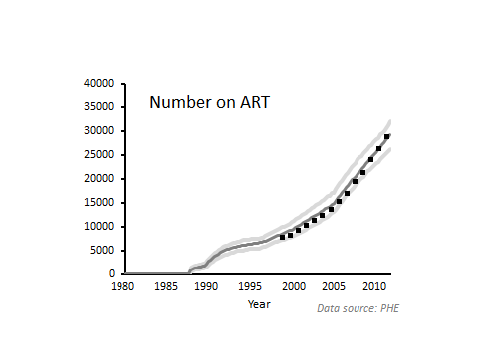(s)

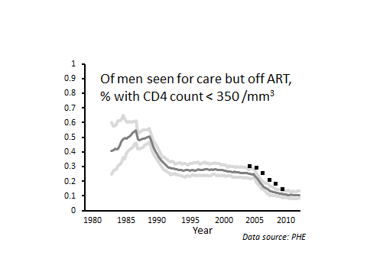

(t)

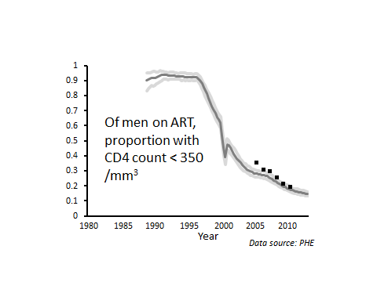

(u)

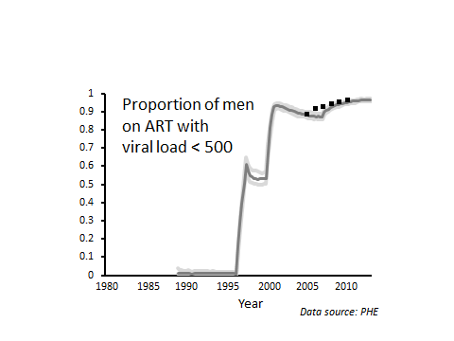(v)

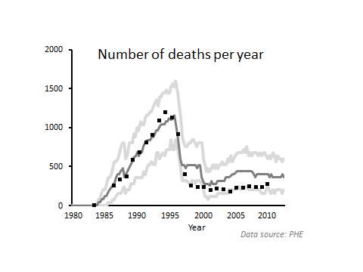
(w)

Note: it is considered that there is some under-ascertainment of deaths. The all cause death rate for in the D:A:D study is 0.9 per 100 person years ¹³ in recent years compared with 1.1 per 100 person years in our model.

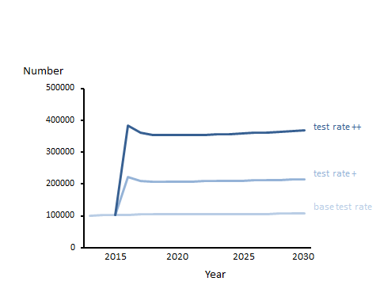Suppl Figure 3. Number of tests done per year, 2015-2030, according to test rate scenario.

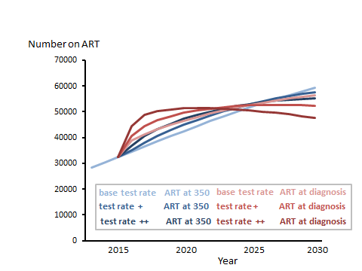Suppl Figure 4. Number on ART 2015-2030, according to test rate and ART initiation strategy.

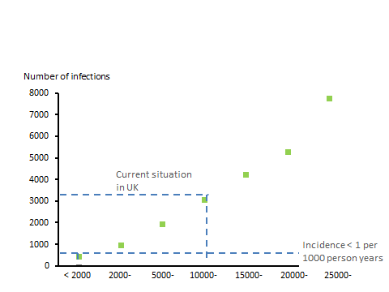Suppl Figure 5. Mean number of new infections 2015-2030 per year according to number of condomless partnerships had by men with VL > 500 in each 3 month period.

Number of condomless partnerships had by men with
VL > 500 in each 3 month period.

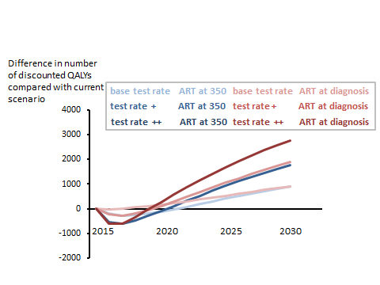Suppl Figure 6. Difference in number of discounted QALYs per year, compared with no change in testing rate or ART initiation strategy.

Suppl Figure 7. Breakdown of total cost of HIV care (discounted), (a) considering full price ART and (b) considering potential reduced ART costs due to use of generic drugs.

(a) 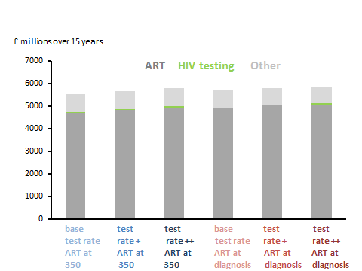

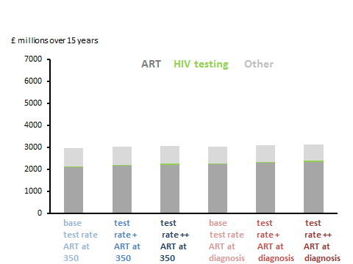 (b)

Suppl Figure 8. Distribution of scenarios with maximum net health benefit by cost effectiveness threshold (generic drug prices).
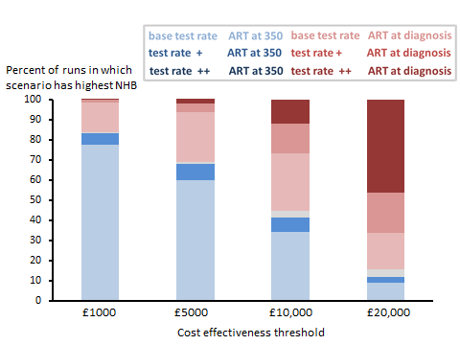

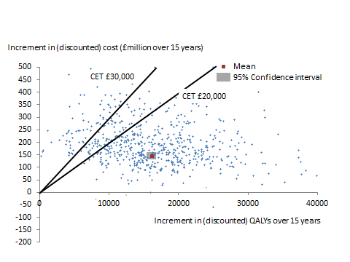Suppl Figure 9. Incremental costs and QALYs for scenario of test rate ++ and ART at diagnosis vs. the current scenario – results from each simulation run plotted separately (generic drug prices). CET = cost effectiveness threshold.

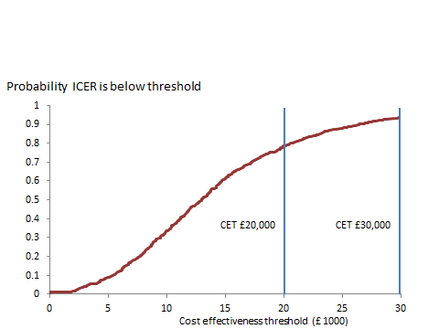Suppl Figure 10. Cost effectiveness acceptability curve for scenario of test rate ++ and ART at diagnosis compared with current situation (generic drug prices).

Suppl Table 2.

Unit costs

AIDS condition (3 months) £5000 ¹⁴*
Other HIV symptoms £100

Non-aids disease (this is for excess £1000 Assumption
non-ADS disease believed to be
caused by HIV)

Clinic Visit £200 ¹⁵ includes blood tests apart from those below

CD4 count £30 ¹⁶
Viral load £70 ¹⁶
Resistance test £240 ¹⁶
HIV test £20 ¹⁷

Specific ART costs (per 3 months) ¹⁸
zidovudine £500, 3TC £500, tenofovir £636, efavirenz £636, lopinavir/r £870, darunavir £1479, raltegravir £1590. When considering generic drugs, we assume a linear decline in drug prices from a current price in 2015 of 30% below the full list price to 80% below the current full list price, reflecting the potential reduction due to use of generic drugs.¹⁹.

* In ¹⁴, costs are in CD4 strata, rather than related to AIDS and CDC B events, but these costs are consistent (Nakagawa; submitted). These costs are consistent with an overall lifetime cost of HV care of £360,800¹⁸

Health Utilities
HIV (diagnosed) 0.90 ²⁰
Current AIDS disease 0.46 ²¹
Current TB 0.60 ²¹
Current other HIV related symptoms 0.78 ²¹
Current drug toxicity 0.85 Assumption

Suppl Table 3. Total QALYs and costs over 15 years 2015-2030, according to test rate and ART initiation strategy.

Total QALYS Total cost (discounted)
----------------------------------------------
Full list drug discounted
prices / generic
prices
--------------------------------------------------------------------------------------------------------------------------------------
Base test rate ART at 350 6,393,336 5,535,700 2,953,640
Test rate + ART at 350 6,396,804 5,669,810 3,031,910
Test rate ++ ART at 350 6,401,157 5,783,290 3,110,740
Base test rate ART at diagnosis 6,399,360 5,699,610 3,026,060
Test rate + ART at diagnosis 6,403,889 5,801,290 3,097,380
Test rate ++ ART at diagnosis 6,409,430 5,842,660 3,152,170
--------------------------------------------------------------------------------------------------------------------------------------

REFERENCES for Supplementary material
- Phillips AN, Cambiano V, Nakagawa F, Brown AE, Lampe F, Rodger A, et al. Increased HIV Incidence in Men Who Have Sex with Men Despite High Levels of ART-Induced Viral Suppression: Analysis of an Extensively Documented Epidemic. PLOS ONE 2013;8(2). http://www.plosone.org/article/info%3Adoi%2F10.1371%2Fjournal.pone.0055312

- Rodger A, Bruun T, Cambiano V, Lundgren J, et al. HIV Transmission Risk Through Condomless Sex If HIV+ Partner On Suppressive ART: PARTNER Study. Conference on Retroviruses and Opportunistic Infections (CROI 2014). Boston, March 3-6. Abstract 153LB.

- Phillips AN, Sabin C, Pillay D and Lundgren JD (2007) HIV in the UK 1980-2006: reconstruction using a model of HIV infection and the effect of antiretroviral therapy. HIV Med 8:536-546.

- Bansi LK, Sabin C, Delpech V, Hill T, Fisher M, Walsh J, et al (2009) Trends over calendar time in antiretroviral treatment success and failure in HIV clinic populations. HIV Medicine 11: 432-438.

- Nakagawa F, Lodwick RK, Smith CJ, Smith R, Cambiano V, Lundgren JD, et al. Projected life expectancy of people with HIV according to timing of diagnosis. AIDS 2012; 26: 335-343 DOI: 10.1097/QAD.0b013e32834dcec9

- Mercer CH, Fenton KA, Copas AJ, Wellings K, Erens B, McManus S, et al (2004) Increasing prevalence of male homosexual partnerships and practices in Britain 1990-2000: evidence from national probability surveys. AIDS 18:1453-1458.

- Sonnenberg P,Clifton S, Beddows S, Field N, Soldan K, Tanton C,et al. Prevalence, risk factors, and uptake of interventions for sexually transmitted infections in Britain: fi ndings from the National Surveys of Sexual Attitudes and Lifestyles (Natsal). Lancet 2013; 382: 1795–806

- COHERE collaboration. Factors associated with short-term changes in HIV viral load and CD4(+) cell count in antiretroviral-naive individuals. AIDS 2014; 28: 1351-6

- Castro H, Pillay D, Cane P, Asboe D, Cambiano V, Phillips AN, Dunn D. Persistence of HIV-1 Transmitted Drug Resistance Mutations. J Infect Dis 2013; 208: 1459-1463.

- Lathouwers E, Kambili C, Haddad M, Paquet A, De Meyer S, Baugh B. Trends in darunavir resistance-associated mutations and phenotypic resistance: US, 2006 to 2012. 20th Conference on Retroviruses and Opportunistic Infections. March 3-6, 2013. Atlanta. Abstract 590. In: 2014.
- Orkin C, DeJesus E, Khanlou H, Stoehr A, Supparatpinyo K, Lathouwers E, et al. Final 192-week efficacy and safety of once-daily darunavir/ritonavir compared with lopinavir/ritonavir in HIV-1-infected treatment-naïve patients in the ARTEMIS trial. HIV Med 2013; 14(1):49-59.

- Stochastic Simulation of Outcomes of People with HIV in Europe (SSOPHIE) Working Group. A method to estimate the size and characteristics of HIV-positive populations using an individual-based stochastic simulation model (submitted for publication).

- Smith CJ, Ryom L, Weber R, et al. Trends in underlying causes of death in people with HIV from 1999 to 2011 (D:A:D): a multicohort collaboration. Lancet 2014; 384: 241–48

- Beck EJ, Mandalia S, Sangha R, Sharott P, Youle M, Baily G, et al. The Cost-Effectiveness of Early Access to HIV Services and Starting cART in the UK 1996-2008. PLoS ONE 2011; 6(12):e27830.

- Department of Health. Reference costs 2012-13 https://www.gov.uk/government/uploads/system/uploads/attachment_data/file/261154/nhs_reference_costs_2012-13_acc.pdf accessed 11 Sep 2014

- DH Gateway Reference 15869: HIV Adult Outpatient Services Financial Data Analysis (2009/10)

- Time to test for HIV: Expanding HIV testing in healthcare and community services in England. http://www.bhiva.org/documents/Publications/Time_to_test_final_report__Sept_2011.pdf (accessed 7 Sep 2014).

- Nakagawa F, Miners A, SmithC, et al. Projected lifetime healthcare costs associated with HIV infection. (submitted for publication).

- Hill A et al. Predicted saving to the UK National Health Service from switching to generic antiretrovirals: 2015-2019. International Congress of Drug Therapy in HIV Infection, abstract 0-216, Glasgow, 2014.

- Salomon JA, Vos T, Hogan DR, et al. Common values in assessing health outcomes from disease and injury: disability weights measurement study for the Global Burden of Disease Study 2010. Lancet 2012; 380: 2129–43.

- Miners A, Phillips AN, Kreif N, et al. Health-Related Quality-of-Life of People with HIV in the Era of Combination Antiretroviral Treatment: a Comparison with the General Population. Lancet HIV 2014.

