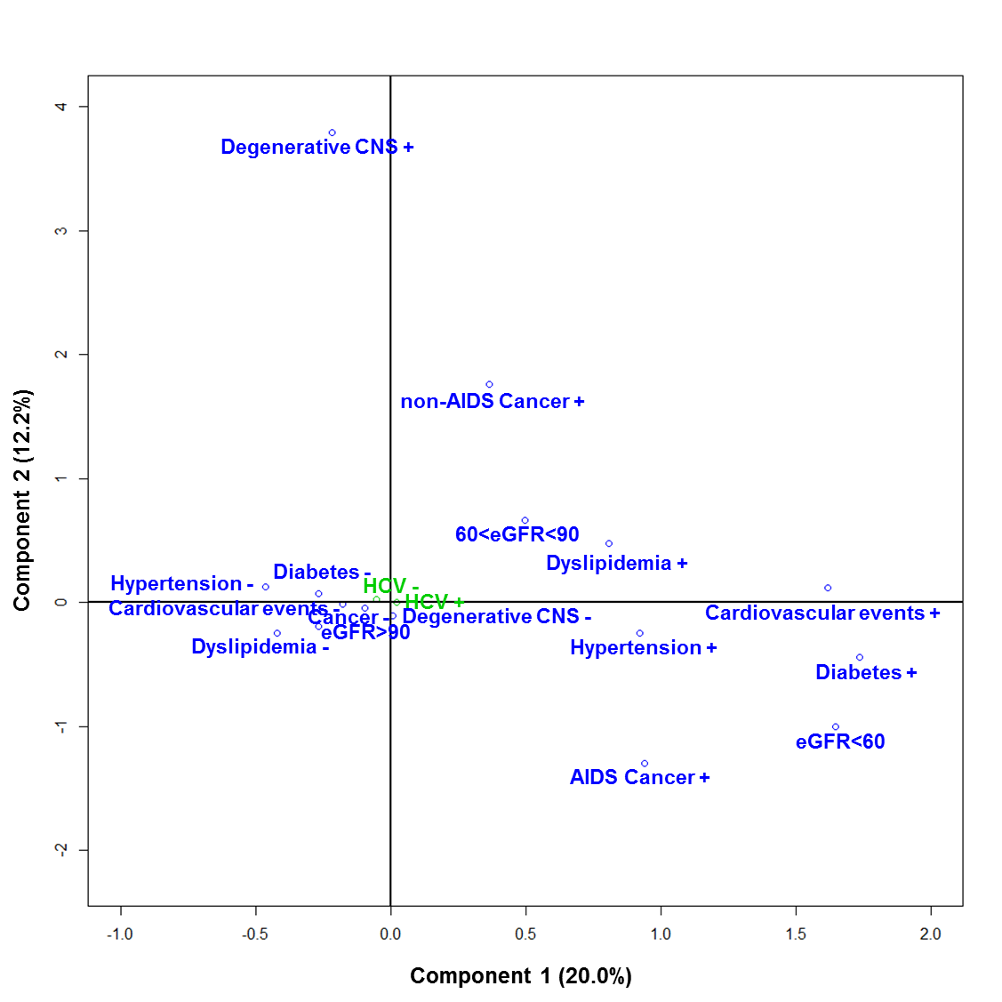

Figure 1: Relationship between comorbidities projected on the first two components based on multiple correspondence analyses. Legend: CNS: central nervous system; AIDS: Acquired immunodifienciency syndrome; HCV: Hepatitis C virus; eGFR: estimated glomerular filtration rate in mL/min. +: comorbidity present; - comorbidity not present.

Table 1a: Description of activation, maturation and senescence markers expressed on CD4 positive and CD8 positive T lymphocytes.

Immune markers | Median (IQR*)
CD4+, VA | 579 (429 ; 759)
CD4+, % | 34 (27 ; 40)
CD4+DR+ among CD4+, % | 14 (10 ; 19)
CD4+DP among CD4+, % | 5 (3 ; 6)
CD4+CD57+CD28- among CD4+, % | 3 (1 ; 7)
CD4+CD28- among CD4+, % | 3 (1 ; 8)
CD4+TN among CD4+, % | 40 (28 ; 51)
CD4+TEMRA among CD4+, % | 1 (0 ; 3)
CD8+, VA | 671 (485 ; 922)
CD8+, % | 39 (33 ; 47)
CD8+DR+ among CD8+, % | 35 (26 ; 46)
CD8+DP among CD8+, % | 13 (9 ; 20)
CD8+CD57+CD28- among CD8+, % | 27 (17 ; 36)
CD8+CD28- among CD8+, % | 39 (28 ; 51)
CD8+TN among CD8+, % | 38 (29 ; 48)
CD8+TEMRA among CD8+, % | - 16 ; 36)
Legend: *Interquartile Range; TN: T naïve; TEMRA: terminally differentiated T cells.
 |  | CD4+  DR+ among CD4+, % | CD4+  DP among CD4+, % | CD4+  CD57+  CD28- among CD4+, % | CD4+  CD28- among CD4+, % | CD4+  TN among CD4+, % | CD4+  TEMRA among CD4+, % | CD8+  DR+ among CD8+, % | CD8+  DP among CD8+, % | CD8+  CD57+  CD28- among CD8+, % | CD8+  CD28- among CD8+, % | CD8+  TN among CD8+, % | CD8+  TEMRA among CD8+, %
CD4+DR+ among CD4+, % | r | 1.00
 | P | -
CD4+DP among CD4+, % | r | 0.80 | 1.00
 | P | <0.0001 | -
CD4+CD57+CD28- among CD4+, % | r | 0.47 | 0.31 | 1.00
 | P | <0.0001 | <0.0001 | -
CD4+CD28- among CD4+, % | r | 0.49 | 0.33 | 0.99 | 1.00
 | P | <0.0001 | <0.0001 | <0.0001 | -
CD4+TN among CD4+, % | r | -0.56 | -0.37 | -0.34 | -0.35 | 1.00
 | P | <0.0001 | <0.0001 | <0.0001 | <0.0001 | -
CD4+TEMRA among CD4+, % | r | 0.38 | 0.24 | 0.81 | 0.81 | -0.19 | 1.00
 | P | <0.0001 | <0.0001 | <0.0001 | <0.0001 | <0.0001 | -
CD8+DR+ among CD8+, % | r | 0.63 | 0.51 | 0.29 | 0.31 | -0.22 | 0.25 | 1.00
 | P | <0.0001 | <0.0001 | <0.0001 | <0.0001 | <0.0001 | <0.0001 | -
CD8+DP among CD4+, % | r | 0.44 | 0.61 | 0.22 | 0.23 | -0.10 | 0.19 | 0.71 | 1.00
 | P | <0.0001 | <0.0001 | <0.0001 | <0.0001 | 0.0022 | <0.0001 | <0.0001 | -
CD8+CD57+CD28- among CD8+, % | r | 0.28 | 0.24 | 0.59 | 0.58 | -0.13 | 0.46 | 0.38 | 0.34 | 1.00
 | P | <0.0001 | <0.0001 | <0.0001 | <0.0001 | <0.0001 | <0.0001 | <0.0001 | <0.0001 | -
CD8+CD28- among CD4+, % | r | 0.38 | 0.33 | 0.60 | 0.61 | -0.16 | 0.49 | 0.55 | 0.48 | 0.90 | 1.00
 | P | <0.0001 | <0.0001 | <0.0001 | <0.0001 | <0.0001 | <0.0001 | <0.0001 | <0.0001 | <0.0001 | -
CD8+TN among CD8+, % | r | -0.47 | -0.31 | -0.47 | -0.48 | 0.54 | -0.24 | -0.48 | -0.30 | -0.60 | -0.64 | 1.00
 | P | <0.0001 | <0.0001 | <0.0001 | <0.0001 | <0.0001 | <0.0001 | <0.0001 | <0.0001 | <0.0001 | <0.0001 | -
CD8+TEMRA among CD8+, % | r | 0.33 | 0.23 | 0.61 | 0.62 | -0.13 | 0.59 | 0.43 | 0.36 | 0.82 | 0.85 | -0.52 | 1.00
 | P | <0.0001 | <0.0001 | <0.0001 | <0.0001 | <0.0001 | <0.0001 | <0.0001 | <0.0001 | <0.0001 | <0.0001 | <0.0001 | -
Table 1b: Correlation matrix between activation, maturation and senescence immune markers expressed on CD4 positive and CD8
positive T lymphocytes.

Legend: r: Spearman correlation coefficient; P: p-values; TN: T naïve; TEMRA: terminally differentiated T cells.

Table 2: HIV related characteristics associated with the presence of at least three comorbidities (Univariable analysis)
Variables |  | OR (CI95%) | P-value | AIC
Sex (female vs. male) |  | 0.4 (0.2-0.7) | 0.0014 | 688.2
Age (years)* |  | 2.7 (2.2-3.4) | <0.0001 | 605.7
Contamination |  | 1.0 | 0.4866 | 701.7
 | MSM (vs. Heterosexual) | 1.0 (0.6-1.5) | . | .
 | Drug users (vs. Heterosexual) | 0.7 (0.4-1.4) | . | .
 | Others (vs. Heterosexual) | 1.4 (0.7-2.7) | . | .
Duration since first reported seropositivity (years)* |  | 1.3 (1.1-1.6) | 0.0073 | 692.7
CDC classification |  | 1.0 | <0.0001 | 681.2
 | B (vs. A) | 1.4 (0.9-2.4) | . | .
 | C (vs. A) | 2.9 (1.9-4.6) | . | .
Patients on cART |  | 1.0 | 0.0406 | 694.502
 | 2 NRTI + 1 PI/r (vs. Others) | 0.6 (0.4-0.9) | . | .
 | 2 NRTI + 1 NNRTI (vs. Others) | 0.6 (0.4-1.0) | . | .
Time since the first cART (years)* |  | 1.6 (1.3-2.0) | <0.0001 | 679.1
Duration of viral suppression (years)* |  | 1.2 (1.0-1.5) | 0.0443 | 696.2
CD4+ nadir (cells/mm3)* |  | 0.8 (0.7-1.0) | 0.0351 | 695.6
Time from CD4+ nadir (years)* |  | 1.3 (1.1-1.6) | 0.0051 | 692.3
Last CD4+ count (cells/mm3)* |  | 1.0 (0.8-1.2) | 0.6350 | 699.9
Last CD4/CD8 ratio * |  | 0.9 (0.7-1.1) | 0.1891 | 698.3
Positive CMV serology (yes vs. no) |  | 0.8 (0.4-1.6) | 0.6080 | 578.5
Hepatitis B virus infection (yes vs. no) |  | 0.8 (0.3-1.7) | 0.5077 | 686.1
Hepatitis C virus infection (yes vs. no) |  | 0.7 (0.4-1.2) | 0.1997 | 687.5
Legend: * odds-ratio given for a one standard deviation increase; CDC: center for disease control, cART: combination antiretroviral therapy, CMV: cytomegalovirus, NRTIs: Nucleoside Reverse Transcriptase Inhibitors, PI/r: ritonavir boosted protease Inhibitors, NNRTI: Non-Nucleoside Reverse Transcriptase Inhibitor. OR: Odds ratio; CI: confidence intervals; IRP: Immune risk profile; AIC: Akaike information criterion.

Table 3: Immunological markers associated with the presence of at least three comorbidities (Univariable analysis)
Variables | OR (CI95%) | P-value | AIC
CD4+DR+ among CD4+, %* | 1.4 (1.1-1.6) | 0.0004 | 688.2
CD4+DP among CD4+, %* | 1.2 (1.0-1.4) | 0.0870 | 697.4
CD4+CD57+CD28- among CD4+, %* | 1.3 (1.1-1.5) | 0.0025 | 691.7
CD4+CD28- among CD4+, %* | 1.3 (1.1-1.5) | 0.0027 | 691.9
CD4+TN among CD4+, %* | 0.6 (0.5-0.7) | <0.0001 | 672.9
CD4+TEMRA among CD4+, %* | 1.1 (0.9-1.3) | 0.2099 | 698.7
CD8+DR+ among CD8+, %* | 1.4 (1.2-1.7) | 0.0001 | 685.8
CD8+DP among CD4+, %* | 1.1 (0.9-1.3) | 0.2058 | 698.6
CD8+CD57+CD28- among CD8+, %* | 1.2 (1.0-1.5) | 0.0346 | 695.7
CD8+CD28- among CD4+, %* | 1.3 (1.1-1.6) | 0.0083 | 693.2
CD8+TN among CD8+, %* | 0.5 (0.4-0.7) | <0.000 | 669.1
CD8+TEMRA among CD8+, %* | 1.3 (1.1-1.6) | 0.0042 | 692.0
CIADIS score * | 1.7 (1.4-2.1) | <0.0001 | 674.1
VACS index <35 (yes vs. no) | 3.7 (2.3-5.7) | <0.0001 | 671.3
IRP score ≤ 2 (yes vs. no) | 2.2 (1.4-3.4) | 0.0006 | 566.2
Legend: *odds-ratio given for a one standard deviation increase; OR: Odds ratio; CI: confidence intervals; IRP: Immune risk profile; AIC: Akaike information criterion; VACS: Veterans Aging Cohort Study; IRP: immune risk profile.

Table 4a: Veterans Aging Cohort Study index (VACS index) calculated in the 876 patients included in CIADIS substudy of the ANRS CO3 Aquitaine cohort
Variables |  | n (%) | VACS index points
Age (years) | <50 | 414 (47.3) | 0
 | 50-64 | 379 (43.3) | 12
 | ≥ 65 | 83 (9.5) | 27
CD4 (cells/mm3) | ≥ 500 | 566 (64.6) | 0
 | 350-499 | 188 (21.5) | 6
 | 200-349 | 89 (10.2) | 6
 | 100-199 | 26 (3.0) | 10
 | 50-99 | 5 (0.6) | 28
 | <50 | 2 (0.2) | 29
Hemoglobin (g/dL) | ≥14 | 564 (64.4) | 0
 | 12-13.9 | 264 (30.1) | 10
 | 10-11.9 | 42 (4.8) | 22
 | <10 | 6 (0.7) | 38
FIB-4 | <1.45 | 535 (61.5) | 0
 | 1.45-3.25 | 292 (33.6) | 6
 | >3.25 | 43 (4.9) | 25
eGFR (mL/min) | ≥60 | 819 (96.5) | 0
 | 45-59.9 | 23 (2.7) | 6
 | 30-44.9 | 2 (0.2) | 8
 | <30 | 5 (0.6) | 26
Hepatitis C virus infection |  | 203 (23.5) | 5
Legend: eGFR: estimated glomerula filtration rate. FIB-4 is a non-invasive marker of liver fibrosis calculated based on the age, AST levels, ALT levels and platelet count (Sterling RK, Lissen E, Clumeck N, et. al. Development of a simple noninvasive index to predict significant fibrosis patients with HIV/HCV co-infection. Hepatology 2006;43:1317-1325.).

Table 4b: Distribution of the VACS index in the CIADIS substudy of the ANRS CO3 Aquitaine cohort
VACS index score | n (%)
<35 | 723 (85.8)
35-50 | 90 (10.7)
50-70 | 24 (2.8)
≤70 | 6 (0.7)

Table 5a: Immune risk profile score calculated in patients included in CIADIS substudy of the ANRS CO3 Aquitaine cohort (n=714)
Variables | n (%) | IRP points
Last CD4/CD8 ratio <1 | 338 (61.4) | 1
Positive CMV serology* | 638 (89.4) | 1
CD4+CD57+CD28- among CD4+, % > Q3 | 220 (25.1) | 1
CD4+TN among CD4+, %< Q1 | 219 (25.0) | 1
CD4+TEMRA among CD4+, %> Q3 | 218 (24.9) | 1
CD8+CD57+CD28- among CD4+, % > Q3 | 220 (25.1) | 1
CD8+TN among CD4+, %< Q1 | 220 (25.1) | 1
CD8+TEMRA among CD4+, %> Q3 | 217 (24.8) | 1
Legend: CMV serology was only available for 714 patients. Q3, Third quartile; Q1, first quartile

Table 5b: Distribution of the Immune risk profile score of patients included in CIADIS substudy of the ANRS CO3 Aquitaine cohort

IRP score | N (%)
0 | 30 (4.2)
1 | 146 (20.4)
2 | 179 (25.1)
3 | 101 (14.1)
4 | 90 (12.6)
5 | 66 (9.2)
6 | 62 (8.7)
7 | 27 (3.8)
8 | 13 (1.8)

Table 6: Factors associated with the presence of at least three comorbidities adjusted for HIV related characteristics (Multivariable analysis)
 | Model 1 (n=876)  AIC = 591.2  AUC = 0.790 |  | Model 2 (n=876)  AIC = 592.9  AUC = 0.790 |  | Model 3 (n=714)  AIC = 484.9  AUC = 0.798 |  | Model 4 (n=714)  AIC = 485.4  AUC = 0.800 |  | Model 5 (n=876)  AIC = 596.7  AUC = 0.784
 | OR  (95% CI) | P | OR  (95% CI) | P | OR  (95% CI) | P | OR  (95% CI) | P | OR  (95% CI) | P
CIADIS score* | 1.3 (1.1-1.7) | 0.0169 | 1.3 (1.1-1.7) | 0.0176 | - | - | - | - | - | -
IRP score ≤ 2  (yes vs. no) | - | - | - | - | 1.6 (1.0-2.6) | 0.0777 | 1.5 (0.9-2.5) | 0.0952 | - | -
VACS score <35  (yes vs. no) | - | - | 1.2 (0.6-2.1) | 0.5993 | - | - | 1.5 (0.8-2.9) | 0.2180 | 1.2 (0.7-2.1) | 0.5500
Age (years)* | 2.4 (1.9-3.1) | <0.0001 | 2.3 (1.8-3.1) | <0.0001 | 2.5 (2.0-3.3) | <0.0001 | 2.3 (1.7-3.1) | <0.0001 | 2.5 (1.9-3.3) | <0.0001
Duration since seropositivity (years) | 1.2 (0.9-1.5) | 0.1310 | 1.2 (1.0-1.5) | 0.1242 | 1.3 (1.0-1.7) | 0.0674 | 1.3 (1.0-1.7) | 0.0544 | 1.2 (0.9-1.5) | 0.1922
Gender  (F vs. M) | 0.6 (0.3-1.1) | 0.1137 | 0.6 (0.3-1.1) | 0.1019 | 0.5 (0.2-1.0) | 0.0385 | 0.5 (0.2-0.9) | 0.0266 | 0.5 (0.3-0.9) | 0.0219
Stage A | 1.0 | 0.0048 | 1.0 | 0.0053 | 1.0 | 0.0112 | 1.0 | 0.0143 | 1.0 | 0.0078
Stage B  (vs. stage A) | 1.2 (0.7-2.0) |  | 1.2 (0.7-2.0) |  | 1.2 (0.7-2.2) |  | 1.2 (0.6-2.1) |  | 1.2 (0.7-2.1)
Stade C  (vs. stage A) | 2.2 (1.3-3.7) |  | 2.2 (1.3-3.6) |  | 2.3 (1.3-3.9) |  | 2.2 (1.3-3.9) |  | 2.1 (1.3-3.5)
Legend: *odds-ratios given for a one standard deviation (SD) increase (SD of CIADIS score: 2.0; SD of age: 10.0; SD of duration since seropositivity: 7.0); OR: Odds ratio; CI: confidence intervals; IRP: Immune risk profile; AIC: Akaike information criterion; AUC: area under the receiver operator curve.

