Supplemental Digital Content

Supplemental Table 1. Treatment-Emergent Adverse Events of Importance by Preferred Term and System Organ Class
Nervous System Disorders | Psychiatric Disorders |  | Rash Events
Amnesia  Convulsion  Disturbance in attention  Dizziness  Headache  Hypoaesthesia  Neuropathy peripheral  Paraesthesia  Somnolence  Stupor  Tremor  Vertigo | Abnormal dreams  Affect lability  Aggression  Agitation  Anxiety  Completed suicide  Confusional state  Depressed mood  Depression  Dysphoria  Euphoric mood  Hallucination | Insomnia  Major depression  Mood altered  Nervousness  Paranoia  Sleep disorder  Suicidal ideation  Suicide attempt | Blister  Dermatitis allergic  Eosinophilic pustular folliculitis  Erythema  Flushing  Photosensitivity reaction  Pruritus  Rashª  Rash erythematous  Rash generalized  Rash macular | Rash maculo-papular  Rash papular  Rash pruritic  Rash pustular  Rash vesicular  Skin exfoliation  Urticaria
ª Preferred term Rash was used when a more specific type of rash was not indicated by the Investigator.

Supplemental Table 2. Most Frequently Reported (≥2 Participants in Either Group) Treatment-Emergent Serious Adverse Events by System Organ Class and Preferred Term (Safety Population)
System Organ Class  Preferred Term | RPV/FTC/TDF  (N=394) | EFV/FTC/TDF  (N=392)
Any TESAE | 36 (9.1) | 48 (12.2)
Gastrointestinal Disorders | 4 (1.0) | 5 (1.3)
Rectal hemorrhage | 0 | 2 (0.5)
General Disorders and Administration Site Conditions | 3 (0.8) | 2 (0.5)
Chest pain | 2 (0.5) | 0
Pyrexia | 0 | 2 (0.5)
Infections and Infestations | 8 (2.0) | 14 (3.6)
Appendicitis | 2 (0.5) | 0
Neurosyphilis | 0 | 2 (0.5)
Injury, Poisoning and Procedural Complications | 6 (1.5) | 4 (1.0)
Concussion | 2 (0.5) | 0
Nervous System Disorders | 3 (0.8) | 5 (1.3)
Convulsion | 0 | 2 (0.5)
Psychiatric Disorders | 7 (1.8) | 8 (2.0)
Depression | 2 (0.5) | 2 (0.5)
Suicide attempt | 1 (0.3) | 3 (0.8)
Major depression | 2 (0.5) | 1 (0.3)
Suicidal ideation | 2 (0.5) | 1 (0.3)
Renal and Urinary Disorders | 2 (0.5) | 1 (0.3)
Nephrolithiasis | 2 (0.5) | 1 (0.3)
All values expressed as n (%).
EFV/FTC/TDF indicates efavirenz/emtricitabine/tenofovir disoproxil fumarate; incl., including; RPV/FTC/TDF, rilpivirine/emtricitabine/tenofovir disoproxil fumarate; TESAE, indicates treatment-emergent serious adverse event.

Supplemental Table 3. Resistance Analysis Through Week 96
Note: Full report on resistance data has been published separately (Porter DP et al, HIV Clin Trials, 2015;16(1):30-8)

Resistance Development Category | RPV/FTC/TDF  (n=394) |  | EFV/FTC/TDF  (n=392)
 | Baseline –  Week 48 | Baseline –  Week 96 | Baseline –  Week 48 | Baseline –  Week 96
Resistance Analysis Population (RAP) | 20 (5.1%) | 24 (6.1%) | 7 (1.8%) | 9 (2.3%)
Participants with Data | 20 | 24 | 7 | 9
Developed Resistance Mutations to Study Drugs | 17 (4.3%; 85% of RAP) | 21 (5.3%; 88% of RAP) | 3 (0.8%; 43% of RAP) | 4 (1.0%; 44% of RAP)
Baseline Viral Load  ≤100,000 copies/mL | 5/260 (1.9%) | 9/260 (3.5%) | 2/250 (0.8%) | 3/250 (1.2%)
Baseline Viral Load  >100,000 copies/mL | 12/134 (9.0%) | 12/134 (9.0%) | 1/142 (0.7%) | 1/142 (0.7%)
Any NNRTI-R | 16 (4.1%) | 20 (5.1%) | 3 (0.8%) | 4 (1.0%)
Key NNRTI-R | E138K/Q (n=6) | E138K/Q (n=10) | K103N (n=1) | K103N (n=1)
 | Y181C/I (n=8) | Y181C/I (n=8) | Y188H/L (n=1) | Y188H/L (n=1)
 | V90I (n=6) | V90I (n=8) | G190E/Q (n=1) | G190E/Q (n=1)
 | K101E (n=5) | K101E (n=5) |  | M230L (n=1)
Any NRTI-R | 16 (4.1%) | 20 (5.1%) | 1 (0.3%) | 2 (0.5%)
Key NRTI-R | M184V/I (n=15) | M184V/I (n=19) | M184V/I (n=1) | M184V/I (n=2)
 | K65R/N (n=3) | K65R/N (n=3)
EFV/FTC/TDF, efavirenz/emtricitabine/tenofovir disoproxil fumarate; NRTI, nucleoside reverse transcriptase inhibitor; NNRTI, non-nucleoside reverse transcriptase inhibitor; PI, protease inhibitor; RPV/FTC/TDF, rilpivirine/emtricitabine/tenofovir disoproxil fumarate. --, not applicable.

Discontinuation Due to Adverse Event: Participant Narrative
Subject: GS-US-264-0110 2825-9180

Treatment Group: Arm 2, single tablet regimen of efavirenz/emtricitabine/tenofovir DF (EFV/FTC/TDF) QHS

Adverse Event: Proteinuria (proteinuria), Hypoproteinemia (hypoproteinaemia)

Subject is a 47-year-old black male with HIV-1 infection. Participant was naïve to antiretroviral medication prior to study enrollment. The subject was randomized to Arm 2 and started EFV/FTC/TDF QHS on 11-MAY-2011. Participant had HIV-1 RNA <50 copies/ml from Weeks 4-96, including at early discontinuation on Day 512.

The participant’s medical history included arrhythmias, hypertension, chronic sinus congestion, fatigue, hypogonadism, hepatitis B antibody positive, hematospermia, cytomegalovirus antibody positive, headaches, frequent premature ventricular contractrions, hypovitaminosis D, anxiety, recurrent bilateral arm scattered dermatitis, erectile dysfunction, and right ankle pain.
Concomitant medications included ibuprofen, testosterone, colecalciferol, ginkgo biloba, iron with vitamins NOS, tocopherol, sildenafil citrate, cetirizine, linum usitatissimum seed oil, caladryl topical, diphenhydramine, hydrocortisone, loperamide, culturelle, vardenafil, calamine, lisinopril, azithromycin, and ceftriaxone sodium.
The subject discontinued EFV/FTC/TDF QHS on 01-OCT-2012 (Day 510) due to an adverse event of proteinuria that started on 10-APR-2012 (Day 336 of study) and hypoproteinemia that started on 28-JUN-2012 (Day 415 of study); both were considered related to study drug by the Investigator. Treatment included discontinuation of study drug. Concurrent adverse events included diarrhea (start 12-MAY-2011/stop 05-OCT-2012), dizziness (start 12-MAY-2011/stop 08-OCT-2012), daytime drowsiness (start 07-JUN-2011/stop 08-OCT-2012), hyperhidrosis (start 18-FEB-2012/continuing), bilateral ankle edema (start 27-MAY-2012/stop 13-NOV-2012), bilateral lower leg edema (start 19-JUL-2012/stop 13/NOV-2012), rash on ankles (start 14-AUG-2012/stop 22-SEP-2012), itching from insect bites (start 17-AUG-2012/stop 11-SEP-2012), folliculitis on back of neck (start 04-NOV-2012/stop 11-NOV-2012), cholinergic urticaria (start 23-NOV-2012/stop 03-DEC-2012), and urethral gonorrhea (start 02-MAR-2013/stop 07-MAR-2013). Laboratory results showed trace urine protein at screening and baseline and +3 at Week 48 through early discontinuation on Day 512) and low serum albumin at Week 48 (3.0 g/dL) and at early discontinuation (2.7 g/dL) with the lowest measurement at Week 60 (2.2 g/dL). The participant discontinued EFV/FTC/TDF QHS and was started on an ARV regimen of abacavir/lamivudine and rilpivirine on 27-NOV-2012. The adverse events of proteinuria and hypoproteinemia were ongoing as of 13-MAR-2013, the last point of contact with the subject within the study.

Supplemental Figure 1. Proportion of Participants Reporting Symptoms at Week 96 (HIV SIQ; Safety Population)
RPV/FTC/TDF: ■ No Change From Baseline EFV/FTC/TDF: ■ No Change From Baseline
■ Gain of Symptom ■ Gain of Symptom
■ Loss of Symptom ■ Loss of Symptom
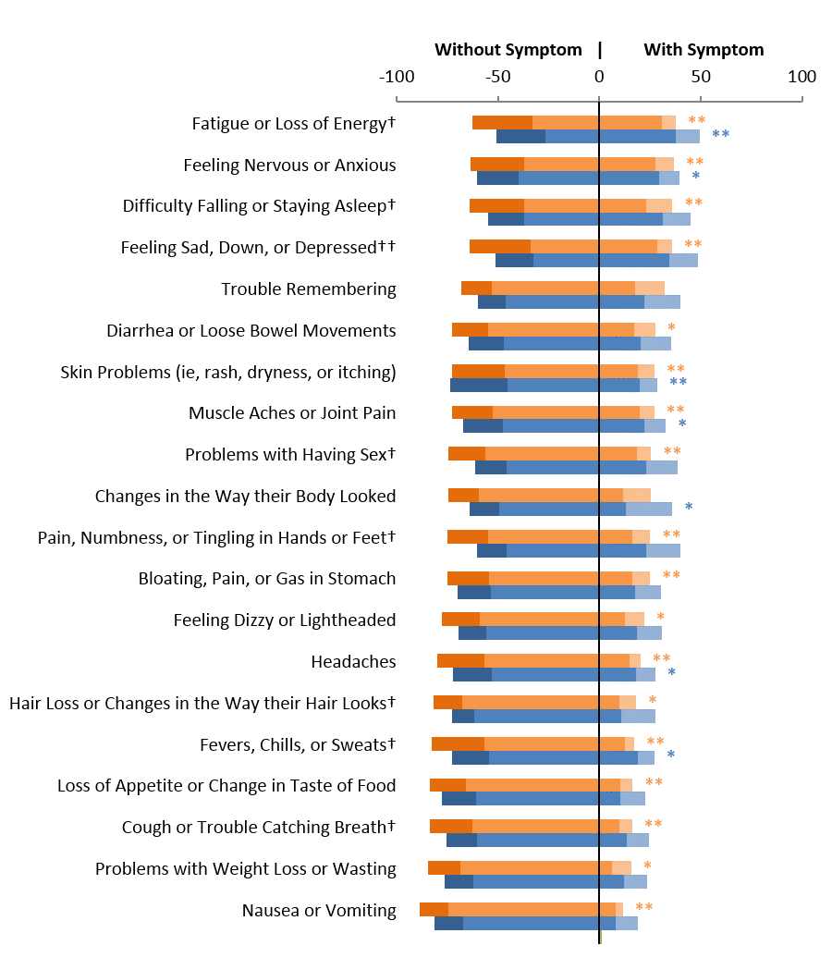
*P≤0.05, **P≤0.001 vs baseline
†P≤0.05, ††P≤0.001 RPV/FTC/TDF vs EFV/FTC/TDF
EFV/FTC/TDF indicates efavirenz/emtricitabine/tenofovir disoproxil fumarate; RPV/FTC/TDF, rilpivirine/emtricitabine/tenofovir disoproxil fumarate; SIQ, symptom index questionnaire.

