Supplemental Digital Content 1.docx
Withdrawal criteria for confirmed virologic failure or inadequate virologic response. (Original criteria that were changed are indicated by italics and are followed by the updated criteriaª)
Virologic failure or non-response defined as an HIV-1 RNA level (confirmed within 14 days^{b} of the original failing viral load) that met any of the following criteria:
HIV-1 RNA <1 log₁₀ c/ml below baseline at week 4, unless the viral load is <50 c/ml
HIV-1 RNA >1 log₁₀ c/ml above nadir value after week 4
HIV-1 RNA >400 c/ml at any time on or after week 12
HIV-1 RNA >50 c/ml at any time on or after week 24
Protocol amendment: HIV-1 RNA >50 c/ml at any time on or after week 24 and with HIV-1 RNA >400 c/ml at the second (confirmatory) visit
HIV-1 RNA ≥50 c/ml after suppression to <50 c/ml on two consecutive visits
Protocol amendment: HIV-1 RNA ≥50 c/ml after confirmed suppression to <50 c/ml and with HIV-1 RNA >400 c/ml at the second (confirmatory) visit
c/ml, copies/ml; FDA, Food and Drug Administration.
ªOriginal withdrawal criteria was changed (Protocol Amendment #6) prior to unblinding by the sponsor, following FDA agreement and concurrence of the Data Monitoring Committee.
^{b}Prior to protocol amendment, it was defined as ‘7–14 days’.

Supplemental Digital Content 2.eps
Screening and subject disposition in the study (CONSORT diagram)
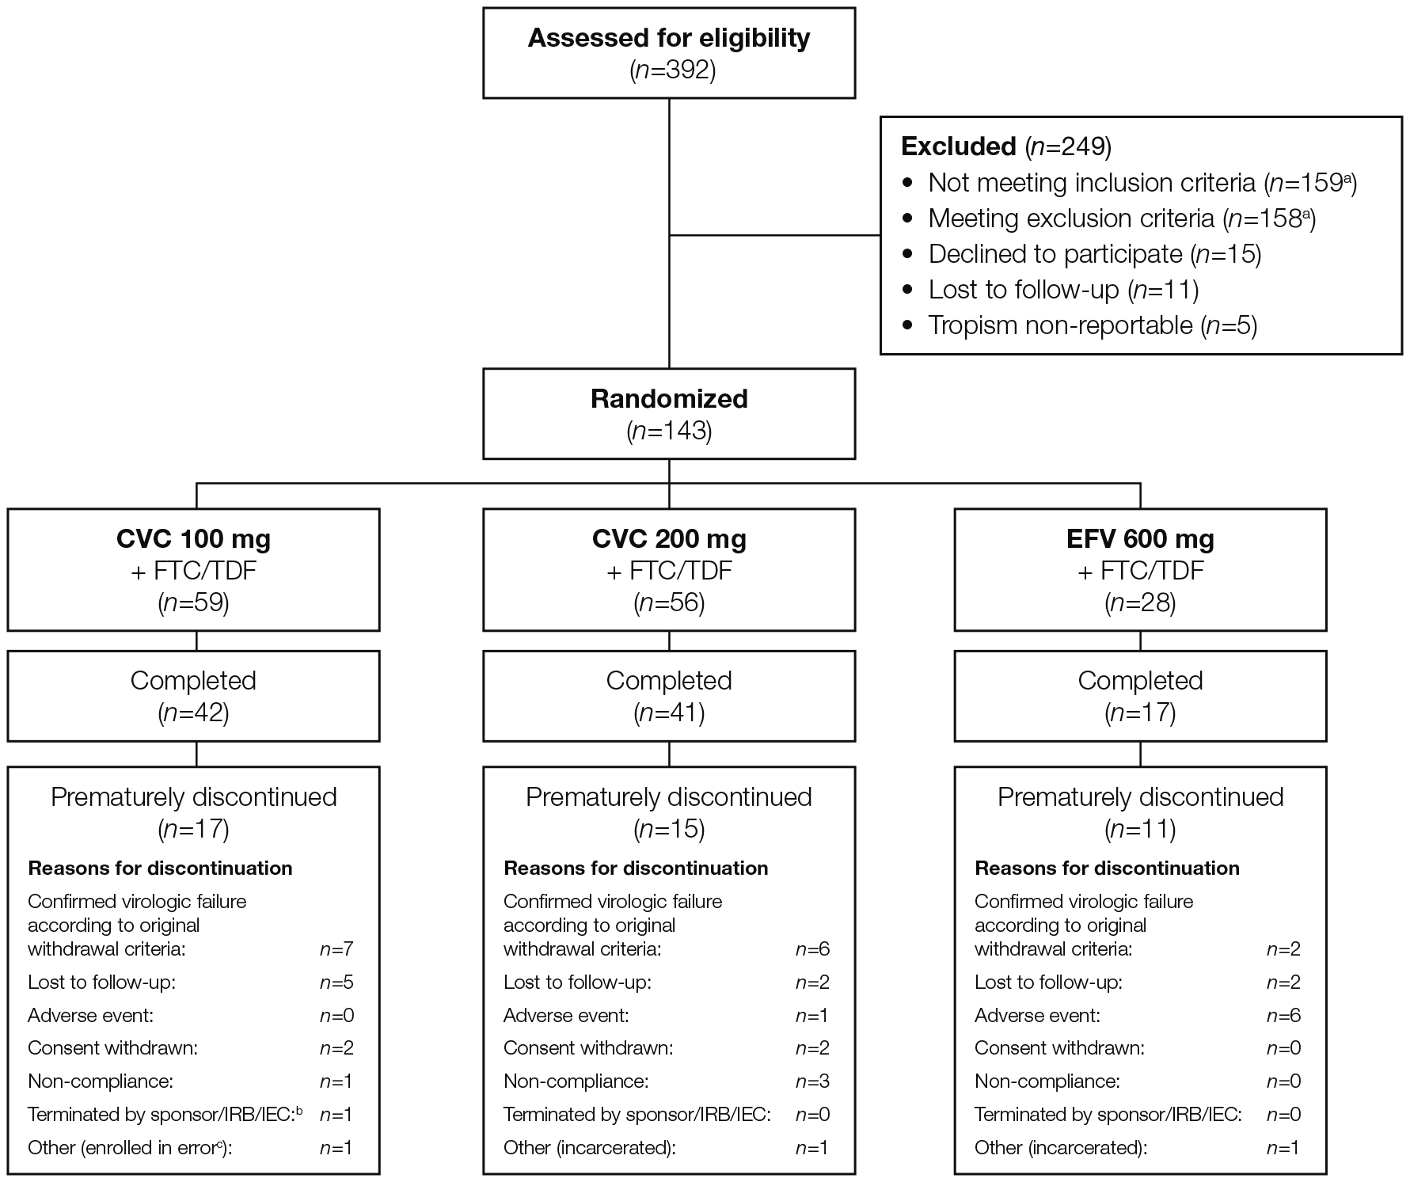

CONSORT, CONsolidated Standards Of Reporting Trials; CVC, cenicriviroc; EFV, efavirenz; FTC, emtricitabine; IEC, Independent Ethics Committee; IRB, Institutional Review Board; TDF, tenofovir disoproxil fumarate.
ª99 subjects did not meet entry criteria.
^{b}Subject took CVC 200 mg due to dispensing of incorrect treatment kit. The subject discontinued study medication on day 9 as instructed by the sponsor, due to an exclusionary entry criterion (history of an abnormal electrocardiogram).
^{c}Subject took prohibited medication.

Supplemental Digital Content 3.eps
Proportion of subjects with HIV-1 RNA <50 c/mlª in each treatment group up to week 48
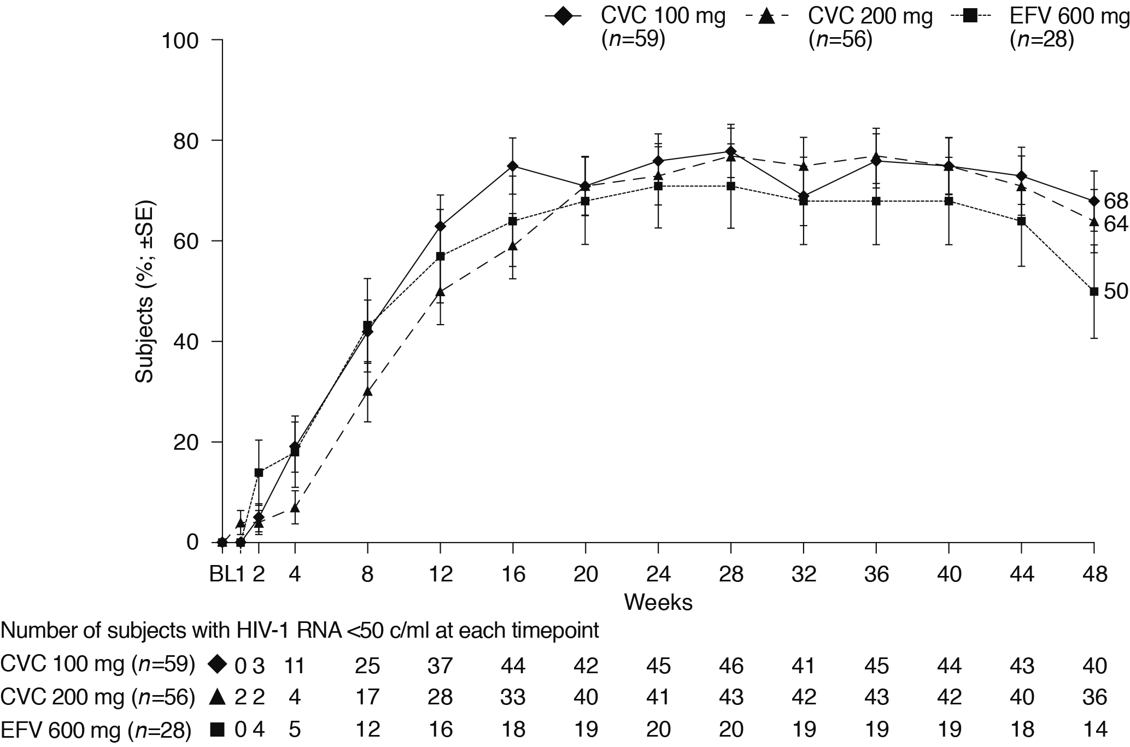
BL, baseline; c/ml, copies/ml; CVC, cenicriviroc; EFV, efavirenz; SE, standard error.
ªSubjects considered to have HIV-1 RNA <50 c/ml, if the last on-treatment HIV-1 RNA value in the window was <50 c/ml and the subject did not have a protocol-excluded change in antiviral therapy prior to that value.

Supplemental Digital Content 4.eps
Change from baselineª in CD4+/CD8+ cell ratio in each treatment group up to week 48

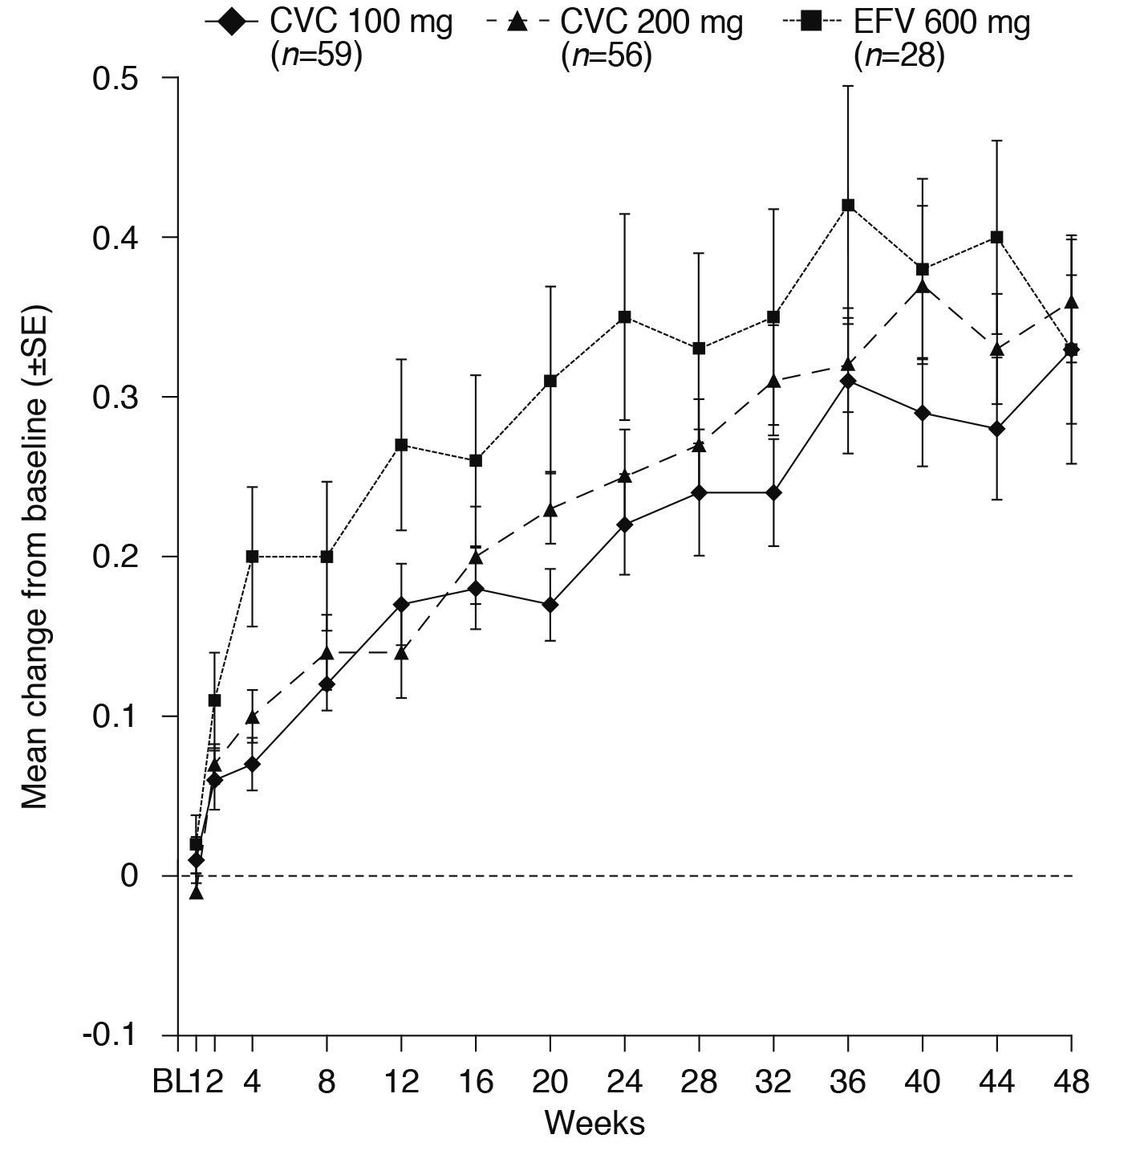

BL, baseline; CVC, cenicriviroc; EFV, efavirenz; SE, standard error.
ªBaseline defined as the average of the baseline and screening visit 2 values. If only one value existed, this was considered the baseline.

Supplemental Digital Content 5.docx
Graded laboratory abnormalities observed during the study in each treatment group
n (%) | CVC 100 mg (n=58) | CVC 200 mg  (n=57) | EFV 600 mg  (n=28) | P valueª
Any graded abnormality | 51 (88) | 55 (96) | 25 (89) | 0.227
Grade 1 | 21 (36) | 16 (28) | 13 (46)
Grade 2 | 23 (40) | 27 (47) | 8 (29)
Grade 3 | 4 (7) | 9 (16) | 3 (11)
Grade 4 | 3 (5) | 3 (5) | 1 (4)
Grade ≥3 laboratory abnormalities | 7 (12) | 12 (21) | 4 (14) | 0.409
Creatine phosphokinase increased | 3 (5) | 9 (16) | 2 (7) | 0.141
Grade 3 | 2 (3) | 6 (11) | 2 (7)
Grade 4 | 1 (2) | 3 (5) | 0 (0)
Aspartate aminotransferase increased | 1 (2) | 0 (0) | 0 (0) | 0.481
Grade 3 | 1 (2) | 0 (0) | 0 (0)
Grade 4 | 0 (0) | 0 (0) | 0 (0)
Phosphate decreased | 2 (3) | 2 (4) | 1 (4) | >0.999
Grade 3 | 2 (3) | 2 (4) | 1 (4)
Grade 4 | 0 (0) | 0 (0) | 0 (0)
Prothrombin time/international normalized ratio increased | 1 (2) | 0 (0) | 0 (0) | 0.481
Grade 3 | 0 (0) | 0 (0) | 0 (0)
Grade 4 | 1 (2) | 0 (0) | 0 (0)
Fibrinogen decreased | 0 (0) | 2 (4) | 0 (0) | 0.219
Grade 3 | 0 (0) | 2 (4) | 0 (0)
Grade 4 | 0 (0) | 0 (0) | 0 (0)
Hemoglobin decreased | 1 (2) | 0 (0) | 0 (0) | 0.481
Grade 3 | 0 (0) | 0 (0) | 0 (0)
Grade 4 | 1 (2) | 0 (0) | 0 (0)
Neutrophils decreased | 2 (3) | 0 (0) | 1 (4) | 0.365
Grade 3 | 2 (3) | 0 (0) | 0 (0)
Grade 4 | 0 (0) | 0 (0) | 1 (4)
CVC, cenicriviroc; EFV, efavirenz.
ªThe P values were assessed using a Cochran–Mantel–Haenszel test for differences between treatment groups in number of subjects with the given toxicity.

Supplemental Digital Content 6.eps
Change from baselineª in fasting glucose parameters (a) HbA1c (b) HOMA-IR in each treatment group up to week 48 (safety population)
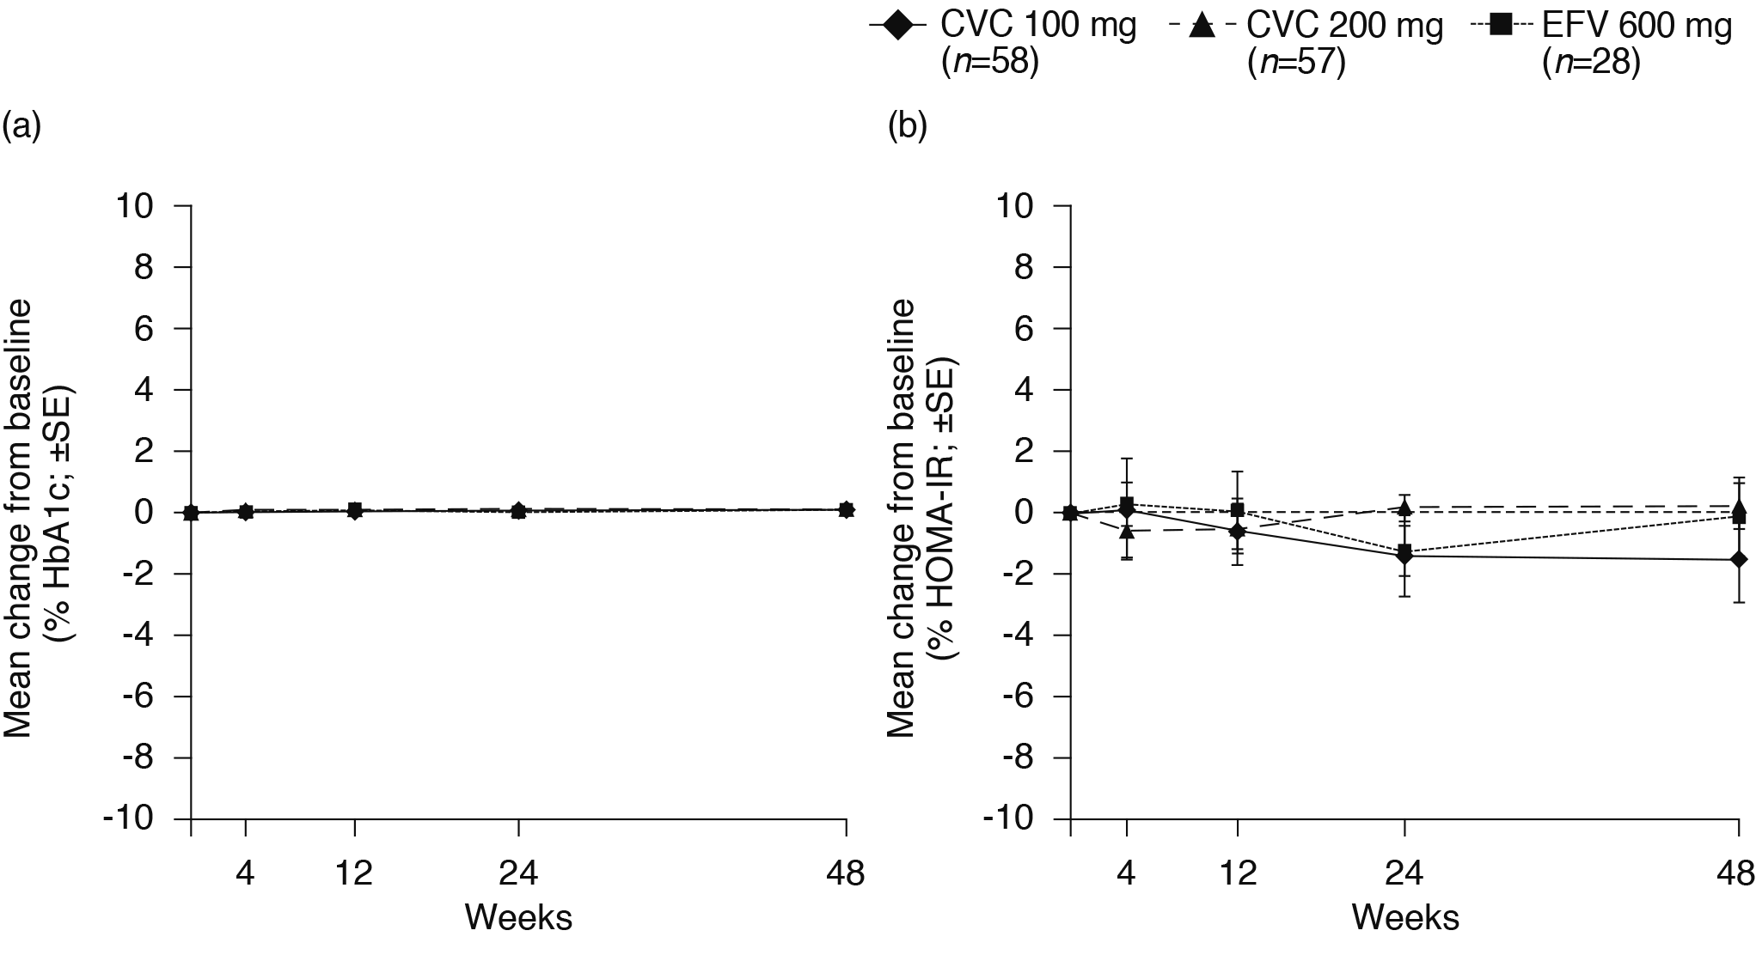

CVC, cenicriviroc; EFV, efavirenz; HbA1c, hemoglobin type A1c; HOMA-IR, homeostasis model of assessment; SE, standard error.
ªDefined as the last non-missing assessment prior to initiation of study treatment.

Supplemental Digital Content 7.eps
Change from baselineª in inflammation biomarkers (a) MCP-1 and (b) sCD14^{b} in each treatment group up to week 48 (ITT population)
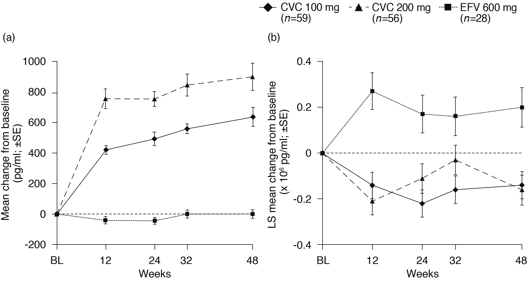

BL, baseline; CVC, cenicriviroc; EFV, efavirenz; ITT, intention to treat; LS, least squares; MCP-1, monocyte chemotactic protein-1; sCD14, soluble CD14; SE, standard error.
ªDefined as the last non-missing assessment prior to initiation of study treatment.
^{b}The samples were originally tested in two separate batches; however, a reanalysis of sCD14 was performed in one single batch for consistency in analysis across time points. To adjust for the effects of covariates, LS means were calculated from a linear mixed model that included treatment, baseline sCD14 value, baseline HIV-1 RNA, visit, and treatment by visit interaction as fixed effects.

Supplemental Digital Content 8.eps
Change from baseline in sCD14 vs. HIV-1 RNA (log₁₀) at week 48
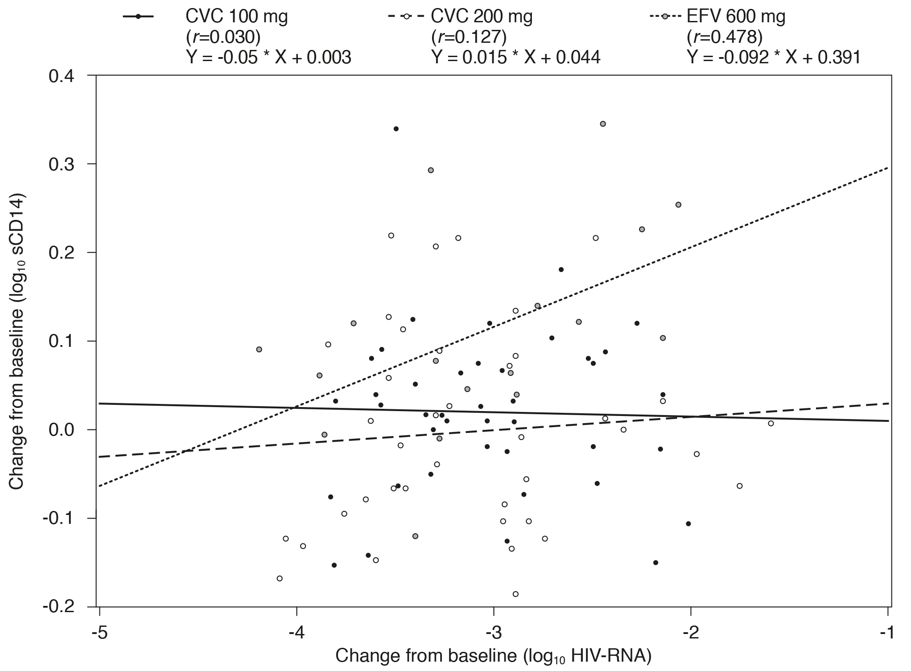
CVC, cenicriviroc; EFV, efavirenz; sCD14, soluble CD14.

Supplemental Digital Content 9.eps
Pharmacokinetic/pharmacodynamic modeling at weeks 24 and 48.
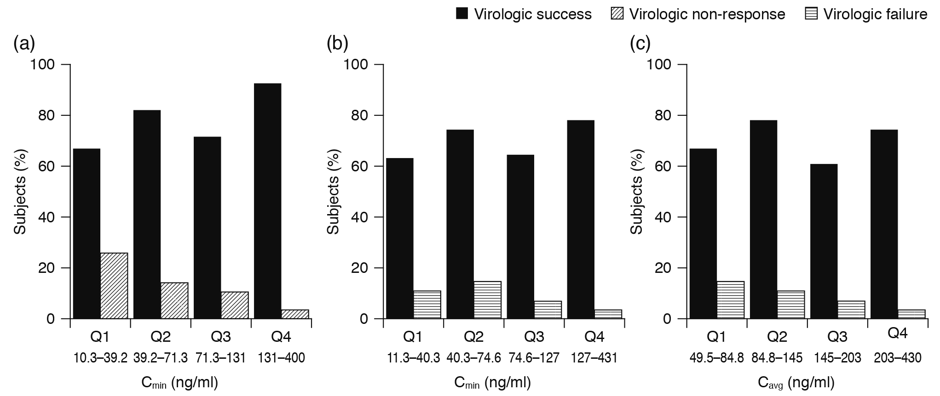
Relationship between the number of subjects with (a) virologic non-response and C_{min} at week 24 (b) virologic failure and C_{min} at week 48 (c) virologic failure and C_{avg} at week 48
C_{avg}, average plasma concentration; C_{min}, minimum plasma concentration.

