Supplementary Text

Mitigating HIV in People Who Inject Drugs is impossible without targeting recently-infected: what we learned from Russia and Ukraine

Tetyana I VASYLYEVAª, MS, Samuel R FRIEDMAN^{b}, PhD, Jose LOURENCOª, PhD, Sunetra GUPTAª, PhD, Angelos HATZAKIS^{c}, PhD, Oliver G PYBUSª, DPhil, Aris KATZOURAKISª, PhD, Pavlo SMYRNOV^{d}, MS, Timokratis KARAMITROS^{a,c}, PhD, Dimitrios PARASKEVIS^{c}, PhD, Gkikas MAGIORKINIS, PhD^{a, *}

a – Department of Zoology, University of Oxford, South Parks Road, OX1 3PS, Oxford, United Kingdom
b - National Development and Research Institutes, Inc, New York, New York 10010, USA
c - Department of Hygiene, Epidemiology, and Medical Statistics, Athens University Medical School, 75, M. Asias Street, Athens 115 27, Greece
d – International HIV/AIDS Alliance in Ukraine, 5 Dilova str., Kyiv 03680, Ukraine

*To whom correspondence should be addressed:
Dr. Gkikas Magiorkinis, MD, PhD, FRCPath
South Parks Road,
OX1 3PS,
Oxford,
United Kingdom
gkikas.magiorkinis@zoo.ox.ac.uk

Table of Contents Page

PHYLOGENETICS…………………………………………………………………..3
Nucleotide sequences…………………………………………………………3
Phylogenetic analysis…………………………………………………………4
ESTIMATES OF EPIDEMIOLOGICAL PARAMETERS…………………….…….4
Parameters derivations……………………………………………………...…4
Results and interpretations of epidemiological parameters calculations……...6
COMPARTMENTAL MODELLING……………………………………..….………6
Model description……………………………………………...………………6
SENSITIVITY AND LIMITATIONS……………………………….…………..……9
Sensitivity analyses………………………………………………………...….9
Limitations-Assumptions on network effects……………………………......10
SUPPLEMENTARY FIGURES………………….………………………………….11
Suppl. Fig.1……………….………………………………………………….11
Suppl. Fig.2……………….………………………………………………….12
Suppl. Fig.3……………….………………………………………………….13
Suppl. Fig.4……………….………………………………………………….14
Suppl. Fig.5……………….………………………………………………….15
Suppl. Fig.6……………….………………………………………………….16
Suppl. Fig.7……………….………………………………………………….17
REFERENCES……………………………….…………………………………...….18Supplementary Table 1……………….………………………………………………20
Supplementary Table 2……………….………………………………………………22

PHYLOGENETICS
Nucleotide sequences
We compiled three HIV-1 sequence alignment datasets from the Los Alamos HIV sequence database (http//:hiv.lanl.gov). Firstly, a reference dataset A of 2199 (all available) sequences of minimal length of 300 nucleotides (nt) from the pol region of HIV genome (nt 6225-8795) accessed in 2011 from HIV sequence database (sequence names are in the Suppl. Table 2). Sequences came from 36 countries (Afghanistan, Albania, Azerbaijan, Burkina Faso, Burundi, Benin, Democratic Republic of Congo, Chad, Congo, Cameroon, Cuba, Cyprus, Czech Republic, Ethiopia, France, Gabon, Georgia, Ghana, Equatorial Guinea, Kenya, Kazakhstan, Latvia, Mali, Nigeria, Russia, Rwanda, Sudan, Slovenia, Senegal, Togo, Tanzania, Ukraine, Uganda, Uzbekistan) sampled in 1985-2010. We aligned the sequences using MEGA 6.0 software [1] and then manually edited. We constructed phylogenetic trees with Mega 6.0 with simple evolutionary models to reduce computational complexity (i.e. assuming uniform rates among sites, using neighbour-joining approach with Tamura-Nei model and same parameters were kept for other phylogenetic trees constructed during these analyses). Interestingly, the strains that were isolated from countries of the former Eastern block clustered together with high bootstrap support (>0.9). Given that previously published data suggested that the epidemic in Russia and Ukraine started in Odessa, Ukraine and then expanded through the whole region [2, 3], the following analysis was conducted for sequences from Russia and Ukraine together as coming from the same HIV epidemic. Consequently, all sequences from Russia and Ukraine from the pol region were sub-sampled from dataset A and sequences available from later years were added. This formed dataset B with 418 pol sequences from Russia and Ukraine sampled in 1997-2013.
Further, 92 sequences from Russia and Ukraine from the env region sampled in 1993-2011 were downloaded from the same database and formed the dataset C. Alignments were performed in Mega 6.0 and manually edited. Only one sequence from each patient was included: if there was evidence that two sequences come from the same person (based on the sequence names or the absence of genetic distance between two sequences), one of them was deleted from the dataset. Accession numbers of all sequences are in the Suppl. Table 2.
Both of the phylogenetic trees (constructed with env and pol alignments) suggested that the subtype A epidemic in Russia and Ukraine was introduced once for both of these countries and thus allowed us to run all further analyses considering them to be part of the same epidemic.

We run population dynamics analyses using Bayesian Evolutionary Analysis Sampling Trees (BEAST) 1.8.1 software [4]. Initially, we analysed dataset C (env) creating a subgroup of sequences that had both env and pol genes. We estimated the time to most recent common ancestor (TMRCA) for this group and used it as a prior on TMRCA to inform the analysis of dataset B (pol). We used the GTR nt substitution model and assumed sites heterogeneity with Gamma distribution with 4 invariant sites. We applied uncorrelated relaxed clock model to reconstruct population dynamics [5], and subsequently constructed a Bayesian Skyline plot to get the product of an effective population size (N_{e}, the size of an idealized population that has the same population dynamic properties as actual population of interest) and a generation time (T, the expected time from acquiring infection to onward transmission) and construct the coalescent phylogenetic tree.
We ran a Markov chain Monte Carlo (MCMC) for the datasets B and C separately: 100,000,000 generations for the dataset C with env sequences (burn-in 20 x 10⁶ generations), and two separate 100,000,000 generations runs for the dataset C with pol sequences (burn-in 20 x 10⁶ and 40 x 10⁶ generations). Trees were sampled every 1000 generations. We used the LogCombiner program from the BEAST 1.8.1 package to combine the two runs from pol region, and the program Tracer from the same package to check for convergence and determine whether appropriate mixing of the MCMC sampler had been achieved in the posterior target distribution (effective sample size>100).
We obtained yearly estimates of HIV prevalent cases for all the available years (1990-2011) from the UNAIDS website [6].

Phylogenetic analysis
The phylogenetic tree, which included globally representative subtype A reference strains, shows that the strains from the epidemic in Russia, Ukraine and other countries of the former Eastern bloc formed a distinct clade within the global HIV-1 epidemic (Suppl.Fig.5). This supports the previous report that an introduction of HIV-1 subtype A to Odessa, Ukraine, seeded the epidemic in Ukraine and Russia [2, 3], suggesting that the Russian and Ukrainian epidemics were isolated from the rest of the world but spread as a joint epidemic. We, thus integrated molecular and epidemiological data from these areas and analysed them as a single epidemic.
The skyline plot estimated from the pol sequences showed a dramatic drop and rebound in N_{e}×T around 2002-03 (Fig.1). The drop was significant given the 95% highest posterior density (HPD) intervals (Suppl.Fig.6) and appeared in Skyline plots reconstructed from all three random sub-samples of pol sequences (data not shown); it was not, however, apparent in the skyline plot estimated from env sequences. We concluded that the discordance among env and pol skylines could be attributed to their geographic distribution, with sequences from pol being more representative of the Russian and Ukrainian PWID population than sequences from env (19 vs 7 geographic regions, respectively, see map on Fig.1).
We estimated the PTP to be 421.5 (95% CI 248.6-594.4) through a linear regression of the estimated number of prevalent cases for Ukraine and Russia over the median N_{e}×T. We then used PTP together with the changes in the effective population size to calculate the R₀ and generation time T as described below and previously reported [7].

ESTIMATES OF EPIDEMIOLOGICAL PARAMETERS
Parameters derivations
We estimated the number of secondary infections per primary infection in a completely susceptible population assuming that the population is large enough to follow a deterministic Susceptible-Infected-Removed model [8]:

(1) 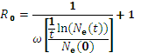
where N_{e}(t) is the effective population size at time t (N_{e}×T was estimated from the skyline plot reconstructed from env sequences), N_{e}(0) is the effective population size at the baseline of the exponential growth phase, and ω is the average removal rate.
For our model we estimated the average removal rate as:

(2) 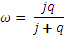
where j is the rate of progression from the recent to long-term phase of infection (1/0.5 a year, 2.0), q is the overall mortality rate of HIV infected individuals (in the absence of prevention assumed to average 1/10 years, 0.1). Thus, the number of secondary infections per primary infection in our model is described as:

(3) 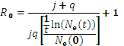

Further, N(t) is the estimate of HIV prevalence at time t. We obtained yearly HIV number of prevalent cases estimates for all the available years (1990-2011) from the UNAIDS website [6]. The ratio N(t)/N_{e}(t) represents the variation in offspring numbers among individuals [9, 10]:

(4) 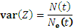

where var(Z) is the variation in the number of secondary infections per individual (R₀).
We have previously introduced [7] the phylodynamic transmission parameter (PTP) as a value that reflects the transmissions within a population by integrating generation time (T) and the variance in the number of secondary infections (var(Z)):

(5) 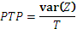

thus, using equations (4) and (5) we get:

(6) 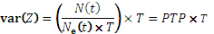

As we have previously shown [7] in a system where a proportion u transmits while the rest (1 - u) is not transmitting, the distribution of the number of secondary infections Z in the whole population (transmitters and non-transmitters; PWID and general population in our case) can be assumed to be approximated by a zero-inflated Poisson distribution such as the mean number of secondary infections per transmitter (R_{0,a}) (per an injector) is related to the overall mean (expected) number of secondary infections in the population (R₀) by:

(7)

while the variance of secondary infections would be provided by:

(8)

Thus, from equations (6) and (8) we estimate the generation time T (the expected time from initial HIV infection to transmission to other individuals) to be

(9) 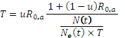

We used the exponential phase of the epidemic growth for calculations of generation time as it expected to be nearly constant over this period. According to both the skyline plot and the estimated HIV prevalent cases curve the exponential phased of the epidemic began around 1995 and ended around 2005 (Fig.1).
All parameters and their explanations are in the Supplementary Table 1.

Results and interpretations of epidemiological parameters calculations
We calculated R_{0,a} using different values of the duration of infectivity p (5-15 years), where 1/p=q is the overall mortality rate of untreated HIV infected PWID (Suppl. Fig. 2, A). R_{0,a} estimates changed from 6 for p=5 to 14 for p=15. Since HAART was introduced in 1996, treatment coverage of PWID in Russia and Ukraine remained low (only 2% of HIV infected PWID received treatment in early 2000s [11]). Thus, a plausible duration of infectivity for an untreated HIV-infected PWID at that time is unlikely to be more than 8-10 years [12], suggesting that the epidemic in PWID had an R₀ in the range 8-10.
We assumed that the majority of sexual (including both homosexual and heterosexual) transmissions among non-PWID gave rise to a negligibly low number of secondary infections compared to PWID. Heterosexual transmissions were mostly through the sex trade, which is highly correlated with drug use in Russia and Ukraine [13]. It is difficult to quantify the homosexual transmission since homosexuality was highly stigmatized in Russia and Ukraine and was underreported in the surveillance system: in 1990s infections attributed to both homosexual and heterosexual contacts were coded and reported together [14]. We considered T<10 days as biologically implausible (viral load is undetectable) [15].
One hypothesis for the explosive growth of the HIV epidemic in Russia and Ukraine is that a particular practice—using blood as a buffer/purifier in the process of domestic drug production—was popular among some PWID [13]. Contamination of large quantities of drugs could facilitate the spread of infection and would allow transmission to multiple recipients generated by a small proportion of PWID. This would translate, within our model framework, into a small proportion of transmitters (those “supplying” blood) driving an epidemic characterised by a very long generation time (around a year, Suppl. Fig.2, B). Translating these dynamics in real-life data means that single individuals should be providing blood for 1 year to purify drugs that were used by 70 PWID. Such a scenario is clinically unlikely due to the large amount of blood that a single individual would need to provide within a long period of time.
Thus we suggest that the most plausible scenario for this HIV epidemic is one characterised by a very short generation time (<1 month), a large proportion of transmitters (70%) and a high number of secondary infections (7 new infections per infected individual). This is compatible with the hypothesis that unsafe injections practiced by a large proportion of PWID (40-90% of Russian/Ukrainian PWID shared instruments or front/backloaded syringes in 1995-2005 [16-18]) may have forced the rapid epidemic spread, which also agrees with our previously reported findings [19]. The fact that a very short generation time was accompanied by a very high value of R₀ is also biologically plausible, since the first month after the infection is the period of the highest infectivity.

COMPARTMENTAL MODELLING
Model description
We used compartmental Susceptible-Recently Infected-Chronically Infected (Susceptibles – individuals that are not infected, but are at risk of infection; Recently Infected – individuals that acquired infection within the last 6 months; Chronically Infected – individuals that acquired infection longer than 6 months ago) model to describe dynamics of HIV epidemic among PWID in Russia and Ukraine. We used R-project software to estimate epidemiologic parameters given different rates of moving from one compartment to another. Deterministic compartmental modelling has been shown to be effective for epidemiological parameters estimation for epidemics with R₀>1 and large susceptible populations [20], which is the case for our settings. In our model we acknowledge different infectivity during a “recent” (within the first six months after infection) and a “long-term” (after the first six months after HIV acquisition) infectivity periods.
First, we constructed a compartmental model of a natural epidemic without treatment option available (Suppl.Fig.1). This model predicts the number of infected and susceptible individuals over the natural course of the epidemic, for 20 years after HIV introduction into a population of PWID and is described by the following differential equations:
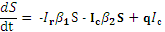
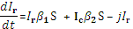
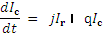
where S is the proportion of individuals susceptible to HIV in the PWID population, I_{r} is the proportion of recently infected individuals (<6 months since infection), I_{c} is the proportion of long-term infected individuals(>6 months since infection). is a transmission rate coefficient that determines virus transmissibility from individuals recently infected with HIV, whilst determines virus transmissibility from individuals who have been infected for at least 6 months; j is a rate of progression from the recent to long-term phase of infection (if c is the duration of recent phase and c=0.5 years, then j=1/c=1/0.5=2); q is a removal rate that indicates overall mortality of HIV infected PWID with untreated infection (if p is the duration of infectivity and p=10 years, then q=1/p=1/10=0.1).
We have calculated the R(t) which is the number of secondary infections per infected individual from the natural epidemic model using next-generation matrix [21]. The eigenvalue λ of the matrix FV⁻¹ represents the R₀ for the model. In this approach the matrix F represents the rate of appearance of new infections in a compartment, which for our model can be described by the matrix:

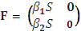

Similarly, the matrix V represents the rate of transfer of individuals into a compartment by other means (i.e, recently-infected individuals transfer to chronically-infected compartment after 6 months) and is described as:

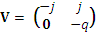

Knowing the F and V allowed us to estimate the reproduction number in our population as:
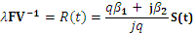

where S(t) is the change in the compartment of susceptible individuals over time. We have used the value of R_{0,a} estimated from the genetic data (10.11 for 10 years of infectivity (p, q=1/p=0.1) and 6 months duration of the recent phase (c, j=1/c=2)) to estimate the transmission rate coefficients (). We have also used the data from another study that showed that transmission hazard during the recent period is 5.3 (95% CI 0.79-57) times higher compared to the long-term infection period () [22]. This estimate comes from a study of an epidemic driven by sexual transmissions among heterosexual individuals, but was used in our model as there is no similar estimate for PWID transmissions. To estimate the uncertainty of our model we have estimated the credibility intervals for the model compartments using the 95% credibility intervals from the skyline plot estimated from the env sequences (Suppl. Fig. 3). We have also conducted sensitivity analysis on the difference in (Suppl.Fig.4).
To get the estimates of different compartments of the population throughout time we used rates known from the literature. The removal rate q is calculated by the infectivity period p (assuming the natural history of HIV infection in absence of treatment the time to AIDS/death p ~10 years, thus 10 years from the moment of infection to removal, j=1/10) and the transition rate j is calculated by the duration of recent infection phase c ~ 0.5 years, j=1/0.5=2)
We have also assumed that the removal rate (infected individual dying from any cause) is equal to the rate at which individuals become susceptible (start drug use in this case); consequently, we assumed that population size is constant throughout time. As the input parameters for the first model, we assumed that the proportion of recently infected individuals in the population at initial time point was 0.0001, consequently, the proportion of susceptibles was 0.9999.
We further advanced this model to include the compartment of treated individuals (highlighted with a red dotted line in Suppl. Fig.1). This model predicts the impact of treatment provided to individuals at different stages of disease (this model was applied to a new epidemic/outbreak and also to an established epidemic) and is described as:
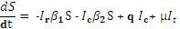
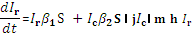
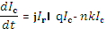
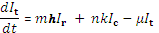
where S is the proportion of individuals susceptible to HIV in the population, I_{r} is the proportion of recently HIV infected individuals, I_{c} is the proportion of long-term infected individuals, I_{t} is the proportion of individuals on treatment. is a transmission rate coefficient that determines virus transmissibility from individuals recently infected with HIV, whilst determines virus transmissibility from individuals who have been infected for more than 6 months; j is the rate of progression from recent to long-term phase of infection; q is a removal rate that indicates overall mortality of HIV infected PWID with untreated infection; m is the rate with which recently infected individuals are engaged into treatment; n is the rate with which long-term infected individuals are engaged into treatment; h is the proportion of recently infected individuals on treatment; k is the proportion of long-term infected individuals on treatment; is the rate at which HIV individuals on treatment die.
For the model with treatment compartment is calculated assuming that the life expectancy of an HIV-infected person with suppressed viral load would be similar to the general population in Russia and Ukraine in 1990s (70 years, =1/70). To simplify, we also assume that those individuals that enter a treatment program, stay in treatment, have undetectable viral load and do not infect susceptible individuals. In reality individuals might drop the antiretroviral treatment program or the efficiency of the antiretroviral treatment might be suboptimal. Here we do not explore the effect of treatment drop-outs and virological failures in interventions; thus, the treatment coverage that we are modelling is the ideal scenario. Current HAART regimens achieve virological response in 80-90% of the individuals in treatment in developing countries [23-25], thus we would normally expect higher than the modelled coverage to be required in real-life interventions (i.e, 56-63% instead of 50% in the current model) to observe the dynamics suggested by the model.
We modelled several scenarios for a new epidemic/outbreak (Fig. 2, panels A-D) and for a well-established epidemic (Fig. 2, panels E-H). First, we have compared scenarios when none of the recently infected individuals are on treatment (h=0) and 50% of long-term infected individuals receive treatment within the first 4 years after they got infected (n=0.25, k =0.5) (Fig. 2 A and E) with the scenario when 25% of recently infected individuals and 50% of long-term infected individuals receive treatment (within the first 3 months and the first 4 years, respectively; h=0.25, m=4.0, n=0.25, k=0.5) (Fig. 2 B and F). As the initial parameters, for the settings with a new epidemic/outbreak, we assumed that the proportion of recently infected individuals in the population was 0.0001 and the proportion of susceptible was 0.9999. For the scenario of advanced epidemic we assumed that the PWID population consists of 0.01% of recently infected, 10% of individuals on treatment, 20% of long-term infected individuals not on treatment, and the rest 69.99% are susceptible. Then we also introduce a scenario, when the R(t) is reduced by 60% through the introduction of preventive interventions (Fig. 2 C,D and G,H), thus, reducing the by 60%.
For all the scenarios we have conducted sensitivity analysis on the proportion of individuals on treatment.

SENSITIVITY AND LIMITATIONS
Sensitivity analyses
We conducted sensitivity analyses to test the robustness of our estimates against assumptions on infectivity and the difference in transmission rate coefficients ( in Suppl. Fig.1). The infectivity period p influenced the estimates significantly changing R_{0,a} from around 6 secondary infections per infected individual assuming p=5 years to around 14 secondary infections per infected individual for p=15 years (Suppl. Fig.2, A). We chose p=10 years as the most plausible scenario of natural history of progression towards AIDS for settings with lack of prevention and limited treatment options (as Russia and Ukraine in late 1990s) [12]. Additionally, p<5 years resulted in a biologically implausible generation time (10 days or less) given that the proportion of transmitters was more than 70%. For the compartmental modelling, we also tested for sensitivity against assumptions on the infectivity period and it was not sensitive for p≥4 years. Furthermore, the sensitivity analysis on the changes of the transmission rate coefficients throughout the infectivity period showed that even if the transmission rate coefficient during the recent phase of infection is only slightly higher or equal to the rate coefficient throughout the remainder of infectivity period, the proportion of new infections attributable to recently infected individuals stabilized at around 5% after 15 years (see Suppl.Fig.4). As expected, the proportion of transmitters changed the estimates of generation time: the bigger the proportion of transmitters – the lower the generation time (Suppl. Fig. 2, B).
Additionally, we have tested a renewal of the PWID population in the compartmental model (Suppl. Fig. 7). More specifically we have modelled a scenario where individuals in antiretroviral treatment quit drug injection with a rate of 1 every 20 person-years. We then add new injectors to the compartment of “Susceptibles” at the same rate. In this scenario, 0% of recently infected individuals and 50% of long-term infected individuals are provided with treatment while no other preventive programs are introduced, similarly to scenario presented in the Fig.2 A. In this case, the dynamics and prevalence stay the same, but the proportion of people in compartments of “Infected” and “Treated” changes. Thus, after 20 years 52% of PWID are expected to be in treatment; 28% of them chronically and 2% recently-infected, not receiving ART; summing up the overall prevalence in the population at 82%, compared to 83% (CI 73-87%) in our original scenario with no drug injection quitting rate.

Limitations-Assumptions on network effects
One of the basic assumptions of compartmental modelling is that it assumes panmictic populations – populations with random mixing within compartments, such that individuals have no preferences when choosing partners and establishing connections that can lead to transmissions. However, it is well documented that populations of PWID have network structure and a social network approach might provide a more realistic description of the epidemic dynamics of spread among PWID [26]. In our modelling we assume constant rate at which recent and long-term infected individuals come in contact with susceptible individuals over time. The long-term infected individuals after some time have lower infectiousness, which under a panmictic model reduces the transmission rate as the probability of contact between a susceptible and a highly infectious recently infected is reduced, creating a suboptimal saturation/protection of the epidemic spread. Under some network settings this might however not be true. Some network structures might allow only contact between susceptibles and long-term infected individuals and, thus, prevent susceptible individuals from contact with the highly infectious acutely infected creating a “firewall” effect [27-29].
We believe that this effect is less likely to bias estimates that come from a very large nation-wide epidemic that involves more than 1,000,000 individuals, as higher and/or lower transmission rates would be averaged over a large sample. However, further research is needed that will aim at accounting for the network structure of a population when using this method to describe HIV transmission dynamics in PWID.

SUPPLEMENTARY FIGURES

Suppl.Fig.1 Suppl. Fig.1. Compartmental model that describes natural HIV progression with and without a treatment compartment (the treatment compartment is highlighted with a red dotted line in the figure). Each box represents compartments within a hypothetical PWID population. β_{1,} β₂ – HIV transmission rate coefficients for transmissions from recently and long-term infected individuals, respectively. Other symbols stand for rates with which individuals move from one group (compartment) to another: j – rate of progression from recently infected to long-term phase of infection; q, – removal rates that indicate mortality of HIV infected individuals with untreated and treated HIV infection, respectively; m, n – rates of involvement in treatment of recently and long-term infected individuals respectively.

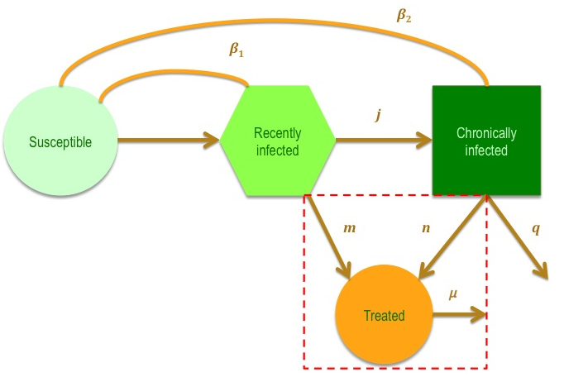

Suppl. Fig.2 Suppl. Fig.2. Estimates of the epidemiologic parameters. A) Estimates of the range of R_{0,a} values given different duration of infectivity. B) Estimates of the range of generation time values given different proportion of transmitters, assuming the duration of infection to be 10 years and R_{0,a} to be 10.1.

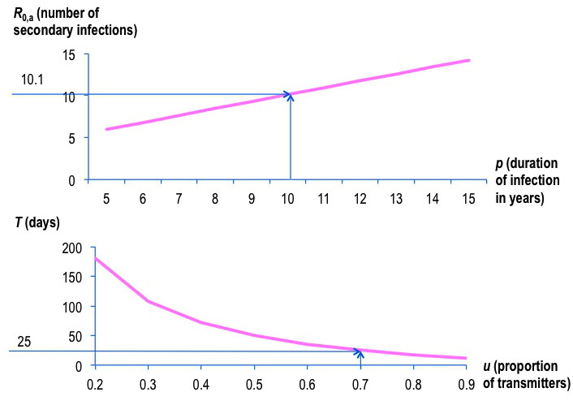

Suppl. Fig. 3 Suppl. Fig. 3. The results of the natural epidemic model: A) The dynamics in the compartments of Susceptible and Chronically infected; B) The dynamics in the compartment of recently infected. For the initial parameters, we assumed that the proportion of recently infected individuals in the population was 0.0001 and the proportion of susceptibles was 0.9999. The credibility intervals estimated from the Bayesian skyline plot estimated from the env sequences.

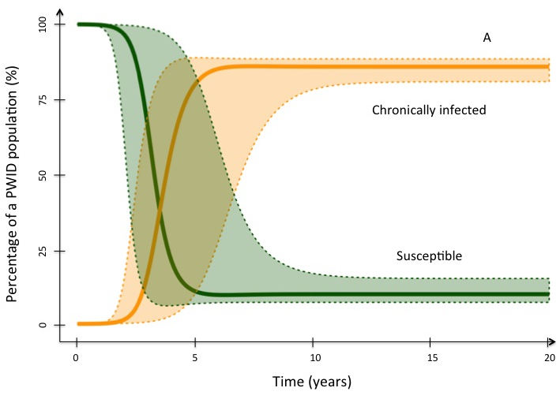
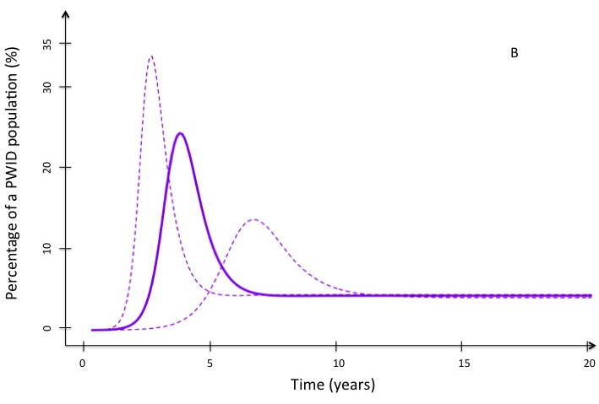

Suppl. Fig.4 Suppl.Fig.4. Proportion of new HIV infections in the population attributed to recently infected individuals in natural epidemic model. We assumed different transmission rates: from the same transmission rate during the recent and the long-term phase of the infection to the 6 times higher transmission rate during the recent phase. In our model we assumed that the transmission rates is 5.3 times higher during recent infection.

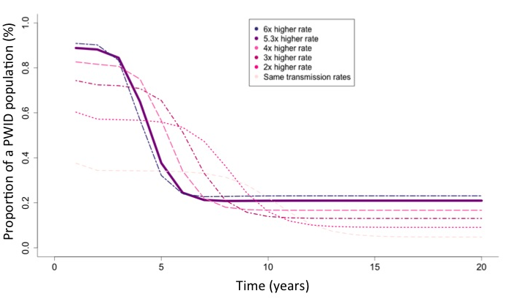

Suppl. Fig.5 Suppl.Fig.5. The phylogenetic tree constructed using the reference dataset A of pol sequences.

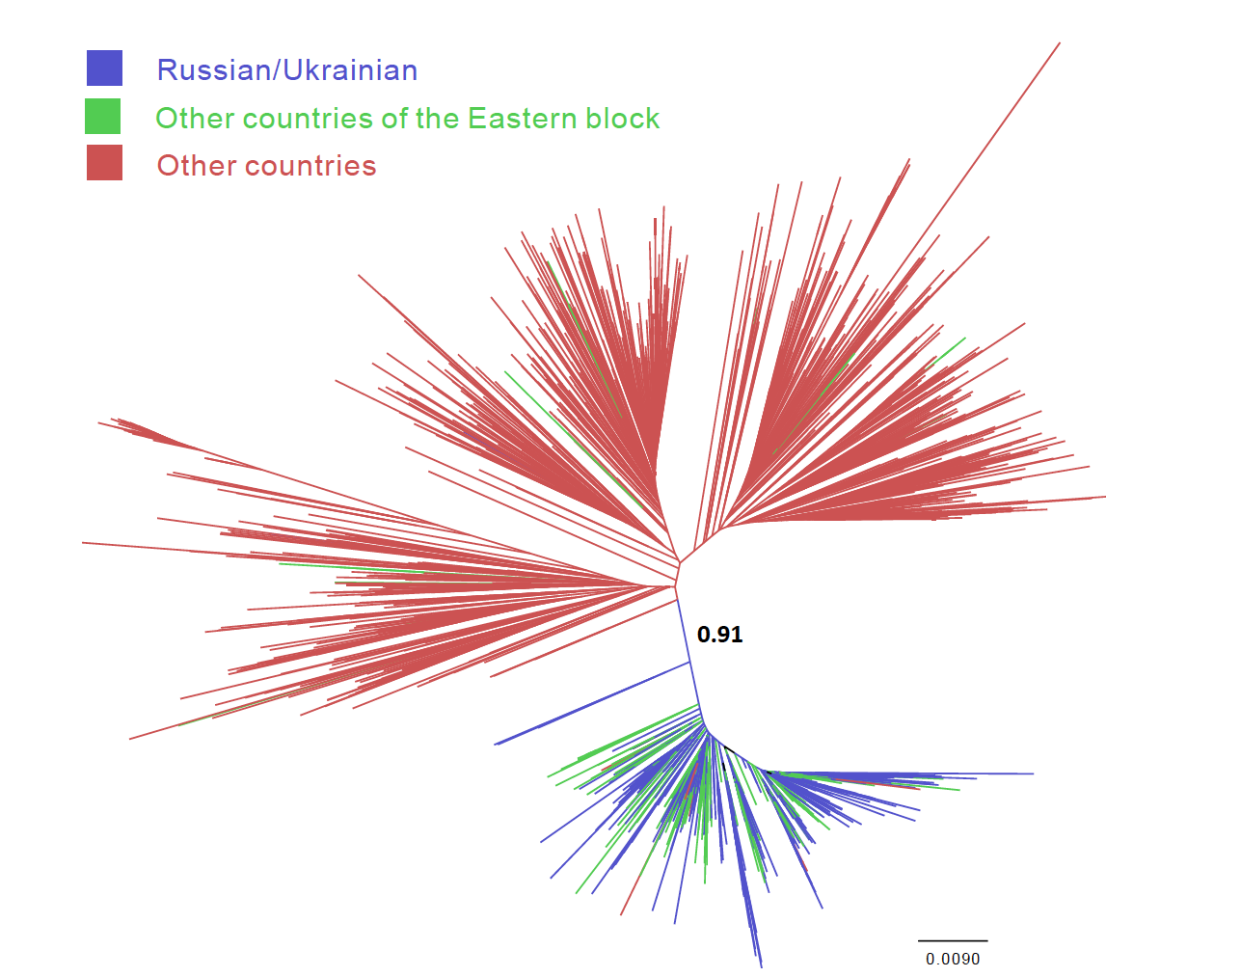

Suppl.Fig.6 Suppl.Fig.6 Skyline plots reconstructed using partial nucleotide sequences from pol (A) and env (B) genes. Red lines represent the 95% highest posterior density (HPD) intervals.

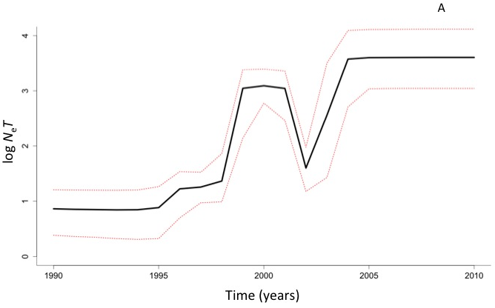
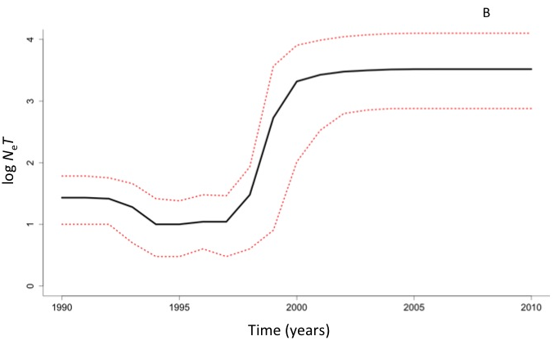

Suppl. Fig. 7 Suppl.Fig.7. Results of the compartmental model representing HIV spread under a treatment scenario when the PWID population is renewed (quit under antiretroviral and recruit in the Susceptibles). In this scenario, 0% of recently infected individuals and 50% of long-term infected individuals (similar scenario to Fig.2 A) are provided with treatment while no other preventive programs are introduced. Additionally, the susceptible PWID population is renewed as a result of quitting injection whilst on antiretroviral treatment: a) PWID quit injecting when introduced and sustained in antiretroviral treatment with a rate of 1 PWID quitting every 20 person-years of treatment, b) susceptible injectors are recruited with the same rate.

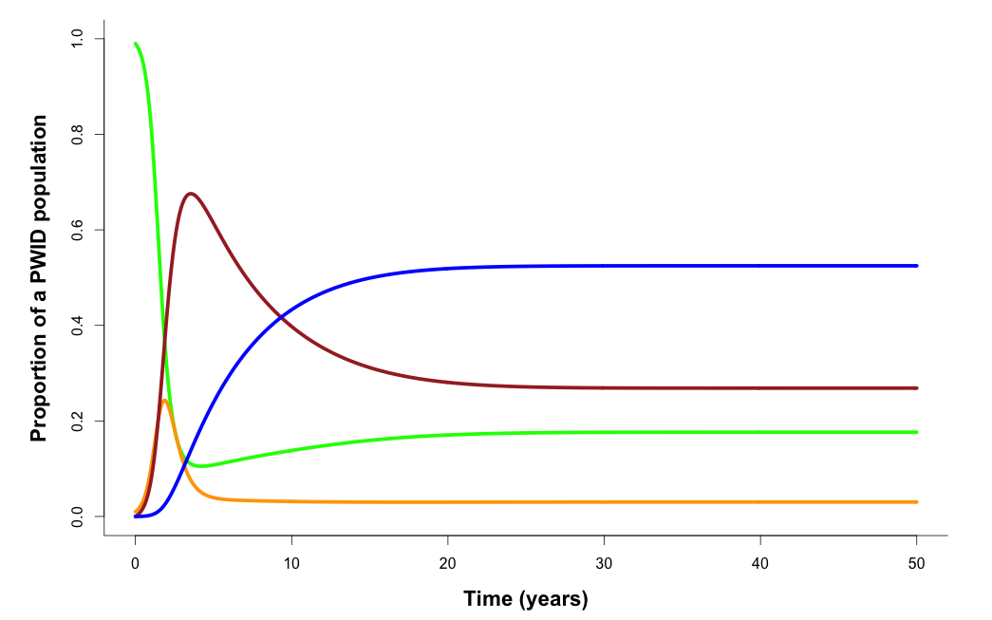

REFERENCES

1. Tamura K, Stecher G, Peterson D, Filipski A, Kumar S. MEGA6: Molecular Evolutionary Genetics Analysis version 6.0. Mol Biol Evol 2013,30:2725-2729.
2. Saad MD, Shcherbinskaya AM, Nadai Y, Kruglov YV, Antonenko SV, Lyullchuk MG, et al. Molecular epidemiology of HIV Type 1 in Ukraine: birthplace of an epidemic. AIDS Res Hum Retroviruses 2006,22:709-714.
3. Nabatov AA, Kravchenko ON, Lyulchuk MG, Shcherbinskaya AM, Lukashov VV. Simultaneous introduction of HIV type 1 subtype A and B viruses into injecting drug users in southern Ukraine at the beginning of the epidemic in the former Soviet Union. AIDS Res Hum Retroviruses 2002,18:891-895.
4. Drummond AJ, Rambaut A. BEAST: Bayesian evolutionary analysis by sampling trees. BMC Evol Biol 2007,7:214.
5. Drummond AJ, Ho SY, Phillips MJ, Rambaut A. Relaxed phylogenetics and dating with confidence. PLoS Biol 2006,4:e88.
6. HIV/AIDS. JUNPo. UNAIDS: Indicator registry. In. Geneva, Switzerland: Joint United Nations Programme on HIV/AIDS; 2015.
7. Magiorkinis G, Sypsa V, Magiorkinis E, Paraskevis D, Katsoulidou A, Belshaw R, et al. Integrating phylodynamics and epidemiology to estimate transmission diversity in viral epidemics. PLoS Comput Biol 2013,9:e1002876.
8. Keeling Mj RP. Modeling Infectious Diseases in Humans and
Animals. Princeton, New Jersey: Princeton University Press; 2008.
9. Tavare S, Balding DJ, Griffiths RC, Donnelly P. Inferring coalescence times from DNA sequence data. Genetics 1997,145:505-518.
10. Kingman J. On the genealogy of large populations. J Appl Probability 1982,19:27-43.
11. Mathers BM, Degenhardt L, Ali H, Wiessing L, Hickman M, Mattick RP, et al. HIV prevention, treatment, and care services for people who inject drugs: a systematic review of global, regional, and national coverage. Lancet 2010,375:1014-1028.
12. Longini IM, Jr., Clark WS, Byers RH, Ward JW, Darrow WW, Lemp GF, et al. Statistical analysis of the stages of HIV infection using a Markov model. Stat Med 1989,8:831-843.
13. Artyuh O.R. BOM, Bochkova L.V., Galych Y.P., Halustyan Y.M., Dikova-Favorska D. M., Zlobina O.G., Levchuk N.M., Lyutyi V.P., Marcynovska V.A., Mykytyuk T.P., Morozov V.F., Petrovskyi O.M., Shamota T.S., Yaremenko O.O. Analytical report. Monitoring of behavior of injecting drug users as a component of second generation epidemiological surveillance. In. Kyiv: International HIV/AIDS Alliance in Ukraine; 2005.
14. Beyrer C, Wirtz AL, Walker D, Johns B, Sifakis F, Baral SD. The Global HIV Epidemics among Men Who Have Sex with Men Introduction. Global Hiv Epidemics among Men Who Have Sex with Men 2011:1-4.
15. McMichael AJ, Borrow P, Tomaras GD, Goonetilleke N, Haynes BF. The immune response during acute HIV-1 infection: clues for vaccine development. Nat Rev Immunol 2010,10:11-23.
16. Booth RE, Lehman WE, Dvoryak S, Brewster JT, Sinitsyna L. Interventions with injection drug users in Ukraine. Addiction 2009,104:1864-1873.
17. Grund J-PC. A Candle Lit from Both Sides: The Epidemic of HIV Infection in Central and Eastern Europe. Westport, Ct. USA: Greenwood Press; 2001.
18. Rhodes T, Lowndes C, Judd A, Mikhailova LA, Sarang A, Rylkov A, et al. Explosive spread and high prevalence of HIV infection among injecting drug users in Togliatti City, Russia. AIDS 2002,16:F25-31.
19. Magiorkinis G. PD, Pybus OG., Karamitros T., Vasylyeva T., Bobkova M., Hatzakis M. HIV-1 epidemic in Russia: an evolutionary epidemiology
analysis. In: Lancet. Online; 2014.
20. Popinga A, Vaughan T, Stadler T, Drummond AJ. Inferring epidemiological dynamics with Bayesian coalescent inference: the merits of deterministic and stochastic models. Genetics 2015,199:595-607.
21. Diekmann O, Heesterbeek JA, Roberts MG. The construction of next-generation matrices for compartmental epidemic models. J R Soc Interface 2010,7:873-885.
22. Bellan SE, Dushoff J, Galvani AP, Meyers LA. Reassessment of HIV-1 Acute Phase Infectivity: Accounting for Heterogeneity and Study Design with Simulated Cohorts. PLoS Med 2015,12:e1001801.
23. Mosha F, Ledwaba J, Ndugulile F, Ng'ang'a Z, Nsubuga P, Morris L, et al. Clinical and virological response to antiretroviral drugs among HIV patients on first-line treatment in Dar-es-Salaam, Tanzania. J Infect Dev Ctries 2014,8:845-852.
24. Ugbena R, Aberle-Grasse J, Diallo K, Bassey O, Jelpe T, Rottinghaus E, et al. Virological response and HIV drug resistance 12 months after antiretroviral therapy initiation at 2 clinics in Nigeria. Clin Infect Dis 2012,54 Suppl 4:S375-380.
25. Abdissa A, Yilma D, Fonager J, Audelin AM, Christensen LH, Olsen MF, et al. Drug resistance in HIV patients with virological failure or slow virological response to antiretroviral therapy in Ethiopia. BMC Infect Dis 2014,14:181.
26. Friedman SR, Neaigus A, Jose B, Curtis R, Goldstein M, Ildefonso G, et al. Sociometric risk networks and risk for HIV infection. Am J Public Health 1997,87:1289-1296.
27. Friedman SR, Kottiri BJ, Neaigus A, Curtis R, Vermund SH, Des Jarlais DC. Network-related mechanisms may help explain long-term HIV-1 seroprevalence levels that remain high but do not approach population-group saturation. Am J Epidemiol 2000,152:913-922.
28. Khan B, Dombrowski K, Saad M, McLean K, Friedman S. Network Firewall Dynamics and the Subsaturation Stabilization of HIV. Discrete Dyn Nat Soc 2013,2013:720818.
29. Dombrowski K, Curtis R, Friedman S, Khan B. Topological and Historical Considerations for Infectious Disease Transmission among Injecting Drug Users in Bushwick, Brooklyn (USA). World J AIDS 2013,3:1-9.

Supplementary Table 1
Parameter | Explanation | Page; MT - main text,  ST - supplementary text
c | Duration of recent phase | ST 6
F | Matrix that represents the rate of appearance of new infections in a compartment in the model | ST 6
h | Proportion of recently infected individuals on treatment | ST 7
I_{c} | Proportion of long-term infected individuals (>6 months since infection) | ST 6
I_{r} | Proportion of recently infected individuals (<6 months since infection) | ST 6
I_{t} | Proportion of individuals on treatment | ST 7
j | Rate of progression from the recent to long-term phase of infection | MT 5, ST 3
k | Proportion of long-term infected individuals on treatment | ST 7
m | Rate with which recently infected individuals are engaged into treatment | ST 7
n | Rate with which long-term infected individuals are engaged into treatment | ST 7
N(t) | Estimate of HIV prevalence at time t | ST 4
N_{e}(0) | Effective population size at the baseline of the exponential growth phase | MT 5, ST 3
N_{e}(t) | Effective population size at time t | MT 5, ST 3
p | Duration of infectivity | MT 7, ST 5
PTP | Phylodynamic transmission parameter | ST 4
q | Overall mortality rate of HIV infected individuals | MT 5, ST 3
R₀ | Number of secondary infections | MT 5, ST 3
R_{0,a} | Mean number of secondary infections per transmitter (per an injector) | MT 5, ST 4
S | Proportion of individuals susceptible to HIV in a PWID population | ST 6
T | Generation time | MT 6, ST 3
u | Proportion of transmitters in HIV-infected population | MT 5, ST 4
V | Matrix that represents the rate of transfer of individuals into a compartment by other means | ST 6
var (Z) | Variation in the number of secondary infections per individual | ST 4
 | Transmission rate coefficient that determines virus transmissibility from individuals recently infected with HIV | ST 6
 | Transmission rate coefficient that determines virus transmissibility from individuals who have been infected for at least 6 months | ST 6
λ | Eigenvalue of a matrix | ST 6
μ | Rate at which HIV individuals on treatment die | ST 7
ω | Average removal rate in a population | ST 3

Supplementary Table 2

Dataset A
97CDKTB48
FJ822055
FJ822064
FJ822065
EU345595
EU345596
FJ822066
FJ822067
FJ822068
FJ822069
FJ822070
FJ822071
FJ822072
FJ822073
FJ822056
FJ822074
FJ822076
FJ822077
FJ822078
FJ822080
FJ822082
FJ822083
FJ822057
FJ822084
FJ822085
FJ822086
FJ822087
FJ822090
FJ822091
FJ822092
FJ822093
FJ822058
FJ822094
FJ822095
FJ822096
FJ822097
FJ822098
FJ822100
FJ822101
FJ822102
FJ822059
FJ822104
FJ822105
FJ822106
FJ822107
FJ822108
FJ822109
EU345598
FJ822110
FJ822111
FJ822113
FJ822060
FJ822115
FJ822116
FJ822117
FJ822118
FJ822119
FJ822120
FJ822121
FJ822122
FJ822123
FJ822061
FJ822124
FJ822125
FJ822126
FJ822127
FJ822129
FJ822130
FJ822131
FJ822132
FJ822133
FJ822062
FJ822134
EU345599
EU345600
EU345601
FJ822063
EU345602
EU345603
EU345604
EU345606
EU345841
EU345842
EU345844
GQ867609
GQ867624
GQ867605
GQ867628
GQ867630
GQ867635
GQ867618
GQ867616
GQ867632
GQ867633
GQ867620
GQ867627
GQ867608
GQ867629
GQ867631
GQ867606
GQ867607
GQ867614
GQ867612
GQ867604
GQ867636
GQ867617
GQ867626
GQ867619
GQ867615
GQ867625
GQ867623
GQ867621
GQ867597
GQ867610
GQ867611
GQ867599
GQ867634
GQ867622
GQ867603
GQ867602
GQ867601
GQ867598
GQ867600
EU345614
EU345615
EU345616
EU345617
EU345618
EU345619
EU345620
EU345621
EU345622
EU345623
EU345624
EU345625
EU345626
EU345627
EU345628
EU345629
EU345630
EU345631
EU345632
EU345633
EU345634
EU345635
EU345636
EU345637
EU345638
EU345639
EU345640
EU345641
EU345642
EU345643
EU345644
EU345645
EU345646
EU345647
EU345648
EU345649
EU345650
EU345651
EU345652
EU345653
EU345654
EU345655
EU345656
EU345657
EU345658
EU345659
EU345660
EU345661
EU345662
EU345663
EU345664
EU345665
EU345666
EU345667
EU345668
EU345669
EU345670
EU345671
EU345673
EU345674
EU345675
EU345676
EU345677
EU345678
EU345679
EU345680
EU345681
EU345682
EU345683
EU345684
EU345685
EU345686
EU345687
EU345688
EU345689
EU345690
EU345691
EU345692
EU345693
EU345694
EU345700
EU345701
EU345847
EU345702
EU345703
EU345704
EU345705
EU345706
EU345848
EU345707
EU345708
EU345709
EU345711
EU345713
EU345714
EU345715
EU345716
EU345718
EU345719
EU345721
EU345722
EU345852
EU345723
EU345725
EU345726
EU345727
EU345728
EU345729
EU345730
EU345731
EU345732
EU345733
EU345734
EU345735
EU345736
EU345737
EU345738
EU345739
EU345740
EU345741
EU345743
EU345744
EU345745
EU345746
EU345747
EU345748
EU345749
EU345750
EU345751
EU345752
EU345753
EU345754
EU345755
EU345756
EU345758
EU345759
EU345760
EU345761
EU345762
EU345763
EU345764
EU345765
EU345766
EU345767
EU345770
EU345771
EU345773
FJ009713
FJ009714
FJ009715
FJ009716
FJ009717
FJ009718
FJ009719
FJ009720
FJ009721
FJ009722
FJ009723
FJ009724
FJ009725
FJ009726
FJ009727
FJ009728
FJ009729
FJ009730
FJ009731
FJ009732
FJ009733
FJ009734
FJ009735
FJ009736
FJ009737
FJ009738
FJ009739
FJ009740
FJ009741
FJ009742
FJ009743
FJ009744
FJ009745
FJ009746
FJ009747
FJ009748
FJ009749
FJ009750
FJ009751
FJ009752
FJ009753
FJ009754
FJ009755
FJ009756
FJ009757
FJ009759
FJ009760
FJ009762
FJ009763
FJ009764
FJ009765
FJ009766
FJ009767
FJ009768
FJ009770
FJ009772
FJ009773
FJ009758
EU345780
EU345781
EU345784
EU345785
EU345854
EU345786
EU345855
EU345787
EU345858
EU345788
EU345859
EU345789
FJ009775
FJ009777
FJ009778
EU345791
EU345866
EU345867
EU345868
EU345869
EU345870
EU345792
EU345871
EU345872
EU345873
EU345874
EU345875
EU345876
EU345794
EU345877
EU345878
EU345879
EU345880
EU345795
EU345881
EU345882
EU345796
EU345883
EU345797
EU345884
EU345885
EU345886
EU345887
EU345888
EU345889
EU345890
EU345891
EU345892
EU345893
EU345894
EU345799
EU345800
EU345895
EU345896
EU345801
EU345897
EU345898
EU345899
EU345802
EU345900
EU345901
EU345803
EU345902
EU345903
EU345904
EU345905
EU345921
EU345806
EU345924
EU345925
EU345926
EF545110
EU345936
EU345940
EU345943
FJ009783
FJ009784
FJ009786
FJ009789
FJ009790
FJ009791
FJ009792
FJ009793
FJ009794
FJ009795
FJ009796
FJ009797
FJ009798
FJ009799
FJ009800
FJ009801
FJ009802
FJ009803
FJ009804
FJ009805
FJ009806
FJ009807
FJ009808
FJ009809
FJ009811
FJ009812
FJ009813
EU345807
EU345808
EU345809
EU345810
EU345811
EU345812
EU345813
EU345814
EU345815
EU345816
EU345817
EU345818
EU345819
EU345820
EU345821
EU345822
EU345823
EU345824
EU345825
EU345826
EU345827
EU345828
EU345829
EU345830
SP811s2004
00051s2000
SP812s2004
02KZYUZ300408
02KZYUZ300412
02KZYUZ300413
02KZYUZ300414
02KZYUZ300415
02KZYUZ300418
02KZYUZ300420
02KZYUZ300421
02KZYUZ300425
02KZYUZ300426
02KZKAR300435
02KZKAR300438
02KZKAR300439
02KZKAR300441
02KZKAR300442
02KZKAR300443
02KZKAR300444
02KZKAR300445
02KZKAR300446
02KZKAR300449
02KZKAR300451
02KZKAR300453
02KZKAR300454
02KZKAR300455
02KZKAR300457
02KZKAR300459
02KZKAR300460
02KZKAR300462
02KZKAR300464
02KZKAR300465
02KZKAR300466
02KZKAR300467
02KZPAV300480
02KZPAV300484
02KZPAV300487
02KZPAV300493
02KZPAV300497
02KZPAV300502
03KZALM300210
03KZ300215
03KZALM300216
03KZALM300219
03KZALM300220
03KZALM300230
03KZMAN300232
03KZ300235
03KZ300243
03KZVOS300245
03KZVOS300246
03KZVOS300248
03KZVOS300249
03KZVOS300254
03KZVOS300255
03KZVOS300256
03KZVOS300259
03KZVOS300260
03KZVOS300261
03KZVOS300262
03KZVOS300263
03KZVOS300264
03KZVOS300265
03KZVOS300267
03KZYUZ300273
03KZYUZ300278
03KZYUZ300279
03KZYUZ300280
03KZYUZ300281
03KZYUZ300282
03KZYUZ300283
03KZYUZ300284
03KZYUZ300285
03KZYUZ300287
03KZYUZ300288
03KZYUZ300290
03KZYUZ300291
03KZYUZ300292
03KZYUZ300293
03KZYUZ300296
03KZYUZ300300
03KZYUZ300302
01UADN110
01UADN113
01UADN114
01UADN116
01UADN119
01UADN121
01UADN127
01UADN128
01UADN129
01UADN136
01UADN137
01UADN139
01UADN141
01UADN145
01UADN147
01UADN149
01UADN180
01UADN216
01UADN220
01UADN222
01UADN224
01UADN228
01UAKV099
01UAKV108
01UAKV172
01UAKV178
01UAKV248
01UAKV254
01UAKV269
01UAOD008
01UAOD010
01UAOD025
01UAOD027
01UAOD028
01UAOD035
01UAOD040
01UAOD041
01UAOD049
01UAOD051
01UAOD069
01UAOD070
01UAOD072
01UAOD089
01UAOD095
01UAOD096
01UAOD098
01UAOD102
01UAOD103
01UAPol279
01UAPol286
01UAPol288
01UAPol289
01UAPol290
01UAPol291
01UAPol293
01UAPol295
01UAPol296
01UAPol297
01UAPol298
01UAPol299
01UAPol300
01UAPol302
01UAPol303
01UAPol304
01UAPol310
01UAPol311
01UAPol313
01UAPol314
02UACR001
02UACR002
02UACR003
02UACR004
02UACR005
02UACR006
02UACR007
02UACR008
02UACR009
02UACR010
02UACR011
02UACR012
02UACR014
02UACR015
02UACR016
02UACR018
02UACR020
02UACR021
02UAKV005
02UAKV107
02UAKV114
02UAKV115
02UAKV117
02UAKV121
02UAKV131
02UAKV145
02UAKV149
02UAKV150
02UANK022
02UAKV178
02UAKV187
02UAKV180
02UAKV179
02UAKV176
02UAKV156
02UAKV152
02UAKV175
02UAKV182
01UAOD10
01UAOD35
01UAOD89
02UZ816
02UZ817
02UZ818
02UZ824
02UZ825
02UZ827
02UZ831
02UZ833
02UZ834
02UZ835
02UZ837
02UZ838
02UZ840
02UZ841
02UZ842
02UZ843
02UZ844
02UZ847
02UZ848
03UZ001
03UZ002
03UZ003
03UZ004
03UZ005
03UZ006
03UZ007
03UZ010
03UZ012
03UZ013
03UZ015
03UZ016
03UZ018
03UZ019
03UZ020
03UZ021
03UZ022
03UZ023
03UZ029
03UZ030
03UZ033
03UZ034
03UZ036
03UZ038
03UZ039
03UZ041
03UZ043
03UZ044
03UZ046
03UZ047
03UZ049
03UZ051
03UZ057
03UZ068
03UZ069
03UZ072
03UZ073
03UZ076
02UZ652
02UZ654
02UZ659
02UZ660
02UZ661
02UZ663
02UZ664
02UZ665
02UZ667
02UZ668
02UZ669
02UZ670
02UZ671
02UZ672
02UZ676
02UZ679
02UZ680
02UZ687
02UZ691
02UZ693
02UZ695
02UZ696
02UZ698
02UZ702
02UZ703
02UZ707
02UZ771
02UZ708
02UZ713
02UZ723
02UZ724
02UZ725
02UZ726
02UZ727
02UZ729
02UZ730
02UZ732
02UZ733
02UZ734
02UZ737
02UZ740
02UZ741
02UZ742
02UZ744
02UZ745
02UZ747
02UZ750
02UZ752
02UZ754
02UZ755
02UZ756
02UZ757
02UZ761
02UZ762
02UZ773
02UZ774
02UZ775
02UZ776
02UZ778
02UZ784
02UZ801
02UZ803
02UZ807
02UZ814
GQ477451
GQ477450
GQ477449
GQ477448
GQ477447
GQ477446
GQ477445
GQ477444
GQ477443
GQ477442
GQ477441
EF158043
EF158042
EF158041
EF158040
01AZ001
01AZ003
01AZ004
01AZ006
01AZ009
01AZ014
01AZ025
01AZ026
01AZ030
01AZ031
01AZ036
01AZ038
02AZ005
02AZ007
02AZ015
02AZ018
02AZ020
02AZ023
02AZ024
02AZ025
02AZ028
02AZ034
02AZ037
02AZ038
02AZ050
02AZ054
02AZ058
02AZ060
02AZ062
02AZ066
02AZ069
02AZ077
02AZ080
02AZ083
02AZ089
02AZ093
02AZ098
98GEMZ005
98GEMZ007
98GEMZ008
99GEMZ011
99GEMZ011(2)
99GEMZ012
99GEMZ013
03GEMZ002
03GEMZ003
03GEMZ007
03GEMZ008
03GEMZ009
03GEMZ011
03GEMZ012
03GEMZ014
03GEMZ016
03GEMZ017
03GEMZ020
03GEMZ021
03GEMZ022
03GEMZ024
03GEMZ027
03GEMZ030
03GEMZ031
03GEMZ032
03GEMZ034
03GEMZ035
03GEMZ036
03GEMZ038
03GEMZ040
GU945074
GU945075
GU945077
GU945079
GU945080
GU945082
GU945090
CB_155
CB_156
CB_599
GU945091
GU945092
GU945096
GU945101
GU945102
GU945106
GU945107
GU945108
GU945109
GU945113
GU945127
GU945132
GU945140
GU945141
GU945142
GU945143
GU945160
GU945161
GU945162
GU945163
GU945164
GU945165
GU945166
GU945169
GU945170
GU945173
GU945174
GU945175
GU945189
GU945190
GU945194
44
UG273
65
164
180
401
419
429
440
441
453
496
503
542
574
584
599
604
608
622
623
646
649
652
653
660
687
702
704
718NT6W
734
742
792
807
841
13
173
185
444
879
522
532
534
545
577
592
699
710
790
847
871
UG275
96CM_MP512
97CM_MP582
97CM_MP640
98CM_MP1019
98CM_MP1094
98CM_MP1173
00GAB_LBV02_08
00GAB_LBV18_08
00GAB_01B
00GAB_03
00GAB_04B
00GAB_14M
00GAB_18N
00SN_69HPD_4_9_00
97CD_KCC2
97CD_KTB13
02CD_KTB035
02CD_KS035
02CD_LBS024
02CD_KSS013
02CD_KIST061
02BU_U1808
02BU_U2226
02BU_U2929
02BU_U3121
02BU_U0706
02BU_U1524
02BU_U1617
02BU_U1803
97CM_MP812
99CM_MP1370
99CM_MP1433
99CM_MP1411
DDI579
DDJ360
DDJ369
02_1354KP
03_9073NR
01_300NG
03_9146NM
01_1378MJ
03_9410NS
03_9366WG
03_9412NS
03_9538NG
03_9456KM
999_7NM
04_0567NR
TC025104
cm1657
cm1672
cm2bb
cm8bb
cm10bb
cm161bb
BKO_1037
SGO_08
SGO_27
SGO_47
SGO_71
SGO_86
ARV26
CHU12
HXB2-LAI-IIIB-BRU
445_124360B
UG031
UG029
92RW008
92UG037
ETH_G_079
92RW025A
93RW037A
UG275
Q23_17
94RW13
97TZ02_AF361872
97TZ03_AF361873
113913U
115106J
123208J
123793K
123898B
125636U
126533T
130526D
132074M
132318B
132591A
132685M
134248P
136677C
137499Q
138162O
138430V
138904N
139177O
140727Y
141601A
142181Q
144449S
145027T
145484O
146922V
147521R
148838K
150014T
151848F
KER2008
KER2009
KER2012
KNH1088
KNH1135
KNH1144
KNH1199
KNH1207
KNH1209
KNH1211
KSM4021
KSM4024
KSM4030
MSA4069
MSA4070
MSA4072
MSA4076
MSA4079
NKU3005
99UGA07072
99UGG03379
98UG57134
98UG57135
98UG57136
98UG57142
ML170_1986
98SN_15HALD
98SN-69HPD
99SN_61HPD_15_10_99
98SN_5hald_20_7_98
CK2_75
CK22_50
MKK248
SU478
SU238
119758j_185
124727i_164
97CIRMF21
22
54
A173
A341
ML013_10
ML013_2
ML605_3
ML752
667
850
842
22
45
51
185
164
180
401
429
453
485
545
584
534
532
604
623
599
596
667
652
704
687
801
742
790
807
816
841
847
850
879
871
14
4
31
46
34
32
57
85
69
58
157
97
192
225
175
162
252
204
209
231
199
228
221
253
408
421
407
460
439
446
415
451
403
508
437
458
488
514
445
427
487
520
551
576
560
589
651
562
572
582
573
635
614
619
659
661
662
697
701
686
679
684
580
672
674
690
725
737
731
507
761
754
757
744
771
726
776
798
820
821
838
845
811
819
866
839
877
861
869
881
882
A_122_335
A_140_223
A_161_287
A_194_793
A_225_706
A_264_615
A_264_643
A_326_642
A_ABB08
A_ABB102
A_ABB165
A_ABB213
97KE104
97KE173
98KE178
99KE432
96KE449
00KE561
99KE579
02ZA_DR17
93RW_024
92UG_029
111186L
111740R
111976H
112979I
114892W
121635E
121766I
121874N
122286N
122530R
122742D
122744X
123114S
123768V
126151S
126721B
126951L
128124P
128315G
128375T
129324I
132590N
133395E
133592I
133725L
135274M
136075T
136579G
136668K
137067Y
138829X
139277H
139330R
141070V
141906R
142114X
142425V
144857P
144963H
145058J
146342V
147272W
147418O
147572M
148095P
148639N
148882I
149254I
149594A
150205H
KER2008_patent
TC029004
TC026104
TC025204
TC024604
TC023504
TC022504
TC022404
TC022204
TC021904
TC021704
TC021404
TC021204
TC020504
TC011303
TC010603
TC009903
TC009003
TC008903
TC007803
QC890
QB424
QB596
QB670
04ZASK162B1
CM_01_133
CM_01_568
P0034_090205
P0054_020305
P0060_070305
P0079_160305
P0110_120405
P0185_130605
P0218_130705
P0289_140905
MBA1021_170805
MBA1025_180805
MBA1028_230805
MBA1037_060905
MBA1053_201005
MBAR005_120405
MBAR007_120405
MBAR016_020505
MBAR017_030505
004_106665H
014_108422Z
022_109985S
031_106897U
032_109180U
034_109734M
044_110390I
045_109688N
046_110300R
051_110961Y
057_110308G
097_117239C
180_118080i
199_114660F
225_119778C
401_120082s
403_123871S
407_124279Q
408_125049Q
421_125042G
427_125290E
429_125330t
439_126157P
440_126149o
446_126268V
458_126651R
466_124362l
476_126649x
485_127960U
487_126068K
496_127964E
503_127844l
508_128740N
514_128712J
522_128205c
534_129066r
542_129863t
551_129563G
560_129773M
562_128605K
572_131039B
574_130458m
576_131187D
577_131301I
580_130747L
582_130283Q
584_131489e
592_129775v
608_131002r
614_133371R
622_133749h
623_134023j
635_134512Y
638_134023j
646_133038m
649_134513d
651_135200J
652_133291l
653_134024g
661_135234B
662_135975N
667_136472S
672_135604H
674_137072A
679_137708Q
684_134386Y
686_137213K
690_138008N
697_138073B
699_136283t
701_138581J
702_136536A
704_138427k
725_138071W
726_138858J
731_138858J
734_140160a
737_140207H
742_139543x
744_140410S
754_140838E
757_139187G
141262J
771_140407R
776_141841G
792_142856n
798_141839U
801_143188S
802_142555O
805_143343E
807_141911f
811_145165P
819_144897T
820_144896A
821_144894D
838_145431G
839_146276F
841_146190g
842_144505j
850_145864u
861_146980X
866_147223K
869_147440T
871_146977m
876_147573X
877_147575W
879_147225s
881_147226R
117948S
129779W
133750R
139830I
ML752
ML1901
ML1945
ML1990
ML2014
ML1901PCR2
ML1990PCR
GH_007
GH_142
GH_182
GH_243
GH_244
TBK002
TBK004
TBK005
TBK011
TBK017
TBK018
TBK023
TBK024
TBK037
TBK039
TBK040
TBK045
TBK048
TBK056
TBK060
TBK064
TBK067
TBK090
TBK095
TBK099
TMS001
TMS002
TMS006
TMS007
TMS011
TMS016
TMS018
TMS025
TMS103
TMS108
TMS115
TMS121
TMS123
TMS124
TMS127
TMS131
TMS134
TMS137
TMS141
TMS142
TMS147
TMS206
TMS218
TMS301
TMS305
TMS306
TMS314
TMS319
TMS320
TMS336
TMS337
TMS341
TMS343
IAEAM003
IAEAM004
IAEAM007
IAEAM012
IAEAM013
IAEAM014
IAEM017
IAEAM019
IAEM022
IAEM028
IAEM031
IAEM033
IAEM038
IAEM039
IAEM041
IAEM043
IAEM045
IAEM049
IAEM050
IAEM054
IAEM056
IAEM060
IAEM065
IAEM067
IAEM078
BKO_902
BKO_1023
BKO_1047
SGO_49
335346R
341741Y
349844H
361358A
362363H
363290D
326163_M
365770P
366975Y
367927_J
369096E
377986_M
380521_H
387519_L
390900V
394901B
400177E
400196E
409924L
413282X
413433L
415189_B
417659J
430066A
460471T
476384H
289005
SK162
07_156895
07_156927
07_156928
07_156929
07_156944
07_156948
07_156956
07_156961
07_156967
07_156976
07_156979
07_156997
07_156998
07_157001
08_101504
08_101507
08_101510
08_101518
08_101521
08_101544
08_101577
08_102864
08_102868
08_102902
TR178
TR185
TR257
06KECst_006
06KECst_007
06KECst_021
06KECst_019
06KECst_028
06KECst_009
06KECst_005
06KECst_020
06KECst_016
06KECst_022
06KECst_013
06KECst_025
06KECst_001
06KECst_017
TV239
TV314
Cameroon_20
Cameroon_55
ZZP625
ZZP628
ZZP649
ZZP671
ZZP877
ZZP963
ZZQ675
ZZQ946
ZZR40
ZZQ955
ZZQ956
ZZR160
ZZR475
06TGHT045
06TGHT055
06TGHT077
06TGHT085
06TGHT126
08GQ182
08GQ508
08GQ281
114HALD
337HALD
61HPD
935hald
1700_hald
A1_07CD1246
A1_07CD0509
A1_07CD0444
A1_07CD3665
A_07CD3012
A_07CD3729
URF_A_CRF22_07CD3407
A_07CD0050
A_07CD2110
A_07CD4292
A_07CD1425
A_07CD1525
URF_A_A3_A_07CD2084
A_07CD3373
A1_07CD3784
A_07CD0335
A_07CD0040
A1_07CD2974
A_07CD2657
A_07CD3537
A_07CD3191
A_07CD4078
13020D_P1
13228D_P1
13240D_P1
13263D_P1
13305D_P1
13354D_P1
13929D_P1
14006D_P1
14275D_P1
14324D_P1
14411D_P1
14493D_P1
14888D_P1
15017D_P1
15460D_P1
15545D_P1
15710D_P1
15712D_P1
15911D_P1
16079D_P1
16182D_P1
16455D_P1
16712D_P1
17219D_P1
DT0016_05_P1
DT0971_05_P1
DT1515_04_P1
DT1745_05_P1
DT2172_05_P1
DT2373_05_P1
DT2794_05_P1
DT2829_05_P1
DT2986_05_P1
DT3165_05_P1
DT3282_05_P1
DT3441_05_P1
DT3482_05_P1
DT3513_05_P1
DT3516_05_P1
DT3736_05_P1
DT3793_05_P1
DT3994_05_P1
DT4014_05_P1
DT3340_05_P1
301V03000895
301V03000981BM
301V03000985
301V04000057BM
301V04000184
301V04000665BM
301V04000684
301V04000864
301V04000900BM
301V04000911BM
301V04002129
301V04002157BM
301V04002594
301V04002668BM
301V04003339BM
301V04003358
301V04003475BM
301V04003479
301V04003733
301V04003895
301V04003959BM
301V04004030BM
301V04004298
301V04004337BM
301V04004694
301V04004804BM
301V04005655
301V04005698BM
301V04005942
301V04005975BM
CYV75
CYR20
CYV085
CYR028
CYN851
CYN732
CDL80
SRCDD0242
HG_0857
HG_0943
HG_0130
HU_0017
SK_0004
CK1_1
CK1_20
CK1_46
CK1_45
CK1_40
CK1_25
CK1_47
VP_LT_111
VP_SW_2
VP_SW_1
VP_SW_11
ORAV279
ORAV280
ORAV271
07ZA17579
CM04_073
CM04_094
CM04_096
CM04_064
SN756HALD
SN826HALD
SN2720HALD
320024_A
320208_V
322176_A
337194_A
337314_Y
337373_S
338325_D
341569_X
341815_K
348121_H
350052_R
384132_R
436546_P
436547_D
439208_K
439552_J
440672_L
317296_E
318244_S
318883_Z
319763_R
320477_T
321288_A
321541_D
326455_J
328958_W
332768_D
337081_S
338135_K
338796_K
341279_H
362487_R
370903_R
371850_K
385463_H
385494_T
393958_V
404615_W
413614_D
427986_C
430253_Z
436063_G
393250_S
393405_H
416275_M
425113_S
431730_B
519810_R
521684_A
529392_J
482043_M
503727_G
504080_C
509635_D
516673_E
CP076300084
CP076300141
CP076300688
1_0212_KiBS_V7
1_066_KiBS_V5
1_0517_KiBS_V5
1_0360_KiBS_V3
1_0472_KiBS_V5
1_0457_KiBS_V3
1_0496_6_KiBS_V3
0_0158_KiBS_V16
0_0472_KiBS_V16
1_0437_KiBS_V5
1_0357_KiBS_V5
1_0289_KiBS_V5
TZ_10_002026_A1
TZ_08_014497_A1
TZ_09_032657_A1
TZ_09_006010_A1
TZ_09_032639_A1
TZ_10_003313_A1
TZ_09_001336_A1
TZ_08_017180_A1
TZ_08_022112_A1
TZ_08_014496_A1
TZ_08_023282_A1
TZ_08_017177_A1
TZ_08_017190_A1
TZ_10_002029_A1
TZ_08_023280_A1
TZ_08_017183_A1
TZ_10_003320_A1
TZ_10_003309_A1
TZ_09_032646_A1
TZ_09_006021_A1
TZ_10_003314_A1
TZ_08_017174_A1
TZ_08_023285_A1
TZ_09_006015_A1
TZ_08_017187_A1
TZ_08_017178_A1
TZ_09_032655_A1
TZ_09_001326_A1
TZ_08_029745_A1
C435S_J0
C455S_J0
D344T_J0
D375T_J0
NTCPS729
AICPS434
AICPS399
NTCPS726
NTCPS724
NTCPS720
NTCPS719
NTCPS731
NTCPS717
NTCPS716
AICPS335
AICPS107
AICPS435
AICPS438
AICPS495
AICPS432
NTCPS733
AICPS157
AICPS336
AICPS303
AICPS283
AICPS225
AICPS216
AICPS180
NTCPS709
NTCPS707
NTCPS702
NTCPS701
AICPS165
AICPS158
AICPS106
AICPS005
AICPS001
AICPS006
AICPS009
AICPS035
UGNTC737
07NG_SN022
07NG_SN305
07NG_SN223
07NG_SN077
07NG_SN277
07NG_SN132
07NG_SN157
SK6031_M18
SK6039_M24
SK9037_PI
SK6074_PI
SK3015_PI
SK8040_PI
SK5010_PI
SK9027_PI
SK5013_PI
0765HR
2917HR
3132HR
3272HR
3445HR
4668HR
6356HR
6699HR
7475HR
7518HR
7672HR
3083HR
4834HR
3153HR
3635HR
3683HR
6891HR
U455_U455A
97CDKFE4
02CD_KBS187
02CD_KSS004
A2_225_692
QA779
QA284
01CM_1445MV
P32_16_1a10
P32_16_1b3
P32_16_1b4
P32_16_1b5
P32_16_1b7
P32_16_1c2
P32_16_1c5
P32_16_1c7
P32_16_1e5
P32_16_1f1
P32_16_1f3
P32_16_1f2
P32_16_2a6
P32_16_2b3
P32_16_2c7
P32_16_2c8
P32_16_2d2
P32_16_2d6
P32_16_2e1
P32_16_2e9
P32_16_4a2
P32_16_4a4
P32_16_4b6
P32_16_4b7
P32_16_4b11
P32_16_4c12
P32_16_4d4
P32_16_4d6
P32_16_4d7
P32_16_4e6
P32_16_4e8
P32_16_4f4
P32_24_2e7
P32_24_1a3
P32_24_1a5
P32_24_1a8
P32_24_1b9
P32_24_1c7
P32_24_1c8
P32_24_1e8
P32_24_2a10
P32_24_2b7
P32_24_2b12
P32_24_2c6
P32_24_2e2
P32_24_2e4
P32_24_2f6
P32_24_2f9
P32_24_3a2
P32_24_3a8
P32_24_3d4
P32_24_3d11
P32_24_3e9
P32_24_3f8
P32_24_4a3
P32_24_4a4
P32_24_4a12
P32_24_4b5
P32_24_4b9
P32_24_4b10
P32_24_4c4
P32_24_4c12
P32_24_4f8
P32_44_1a8
P32_44_2a3
P32_44_2a8
P32_44_2c8
P32_44_2d3
P32_44_3a1
P32_44_3a4
P32_44_3a12
P32_44_3c5
P32_44_3d3
P32_44_3f8
P32_44_3f10
71377PL10
A57
A58
A41
A44
A46
A51
A55
A56
A63
A69
A71
A72
A52
A54
A42
A43
A62
A5
A3
A61
A65
A21
A26
A31
A19
A25
A28
A29
A70
A73
A33
A22
A24
A32
A39
A40
A48
94CY017_41
CY008
CY009
CY012
CY015
CY057
CY058
CY111
CY112
CY153
CY169
CY170
CY171
CY173
CY178
CY021
CY022
CY023
CY051
CY064
CY106
CY121
CY140
CY164
CY182
CY185
CY196
CY207
CY208
CY209
CY213
CY218
CY230
CY231
CY235
CY236
CY243
CY255
67429PL12
85344PL1
71264PL11
87516PL1
89629PL1
89794PL1
71372PL14
75925PL8
82472PL1
75925PL9
SL17852PL1
94275PL1
95074PL1
95310PL1
94412PL1
95314PL1
94412PL2
94389PL1
75925PL10
97023PL1
94412PL3
88882PL1
88662PL1
88372PL1
89160PL1
89161PL1
88518PL1
88723PL1
98821PL1
75925PL11
99255PL1
99517PL1
99925PL1
99772PL1
100614PL1
72193PL19
102032PL1
94412PL5
101297PL1
75925PL12
102766PL1
102620PL1
94412PL6
89160PL3
104198PL1
104100PL1
103562PL1
103995PL1
103880PL1
104103PL1
103887PL1
104589PL1
94412PL8
76153PL5
105739PL1
71264PL12
98821PL2
106804PL1
94412PL10
75925PL14
108393PL1
109856PL1
76153PL6
111637PL1
111640PL1
112522PL1
112688PL1
113058PL1
114213PL1
113727PL1
114099PL1
114942PL1
115520PL1
115989PL1
76153PL7
116508PL1
116214PL1
116928PL1
116880PL1
117167PL1
117345PL1
111863PL1
117052PL1
107836PL4
119984PL1
117058PL1
120094PL1
107836PL6
121001PL1
71164PL14
122395PL1
121653PL1
122644PL1
SI4037_02

Dataset B

EU345825
EU345824
EU345823
EU345822
EU345821
EU345820
EU345819
EU345818
EU345817
EU345815
EU345803
EU345802
EU345801
EU345800
EU345799
EU345773
EU345771
EU345770
EU345767
EU345766
EU345765
EU345763
EU345762
EU345761
EU345760
EU345722
EU345721
EU345719
EU345718
EU345716
EU345715
EU345714
EU345713
EU345711
EU345709
EU345905
EU345904
EU345903
EU345902
EU345901
EU345900
EU345899
EU345898
EU345897
EU345895
EF545110
EF545109
AY500393
FJ864679
FJ822134
FJ822133
FJ822132
FJ822131
FJ822130
FJ822129
FJ822128
FJ822127
FJ822126
FJ009813
FJ009812
FJ009811
FJ009809
FJ009808
FJ009807
FJ009806
FJ009805
FJ009804
FJ009803
GQ867635
GQ867631
GQ867630
GQ867628
GQ867627
GQ867625
GQ867624
HQ161930
HQ161929
HQ161928
HQ161927
HQ161926
HQ161925
HQ161924
HQ161923
HQ161921
HQ130000
HQ129999
HQ129998
HQ129997
HQ129996
HQ129995
HQ129994
HQ129993
HQ129991
HQ129990
HQ129989
HQ449403
HQ449402
HQ449398
HQ449397
HQ449395
HQ449393
HQ896679
HM345560
HM345558
HM345554
HM345536
HM345579
HM345575
HM345569
HM345565
HM345553
HM345551
HM345539
HM345537
JN673405
JQ292898
JQ292896
JQ292894
JQ292899
JQ292895
JQ292893
JX141227
JX141225
JX141223
JX141221
JX141219
JX141217
JX141215
JX141213
JX141211
JX141209
JX141226
JX141224
JX141222
JX141220
JX290238
JX290236
JX290234
JX290232
JX290230
JX290228
JX290226
JX290224
JX290222
JX290218
JX500694
KC156532
KC156533
KC254612
KC254643
KC254641
KC254639
KC254637
KC254635
KC254633
KC254631
KC665939
KC665938
KC665937
KC665936
KC665934
KC665933
KC665932
KC665931
KC665930
KC665929
KC665928
KF257884
KF257882
KF257881
KF257880
KF257879
KF257878
KF257877
KF257876
KF257875
KF257874
KF257873
KF257870
KF374888
KF374887
KF374886
KF374885
KF374884
KF374883
KF374882
KF374881
KF374880
KF374879
KF374878
KF374877
KF374876
KF374875
KF374872
KF374871
KF374870
KF374869
KF374868
KF374867
KF374866
KF374865
KF374864
KF374863
KF374862
KF374861
KF374860
KF374859
KF374858
KF374857
KF374856
KF374855
KF374854
KF374853
KF374852
KF374851
KF971945
KF971938
KF971937
KF971936
KF971933
KF971929
KF971926
KF971920
KF971919
KJ499635
KJ499634
KJ499633
KJ499632
KJ499631
KJ499630
KJ499628
KJ499626
KJ499625
KJ499622
KJ499621
KJ499620
KJ499619
KJ499618
KJ499617
KJ499616
KJ499615
KJ499614
KJ499612
KJ499611
KJ499610
KJ499609
KJ499592
KJ499591
KJ499590
EU345703
EU345738
FJ009725
FJ009731
FJ009736
FJ009750
FJ009751
FJ009754
FJ009768
FJ009774
FJ822080
KF716492
KF716491
JX500695
JX500696
KJ499563
KJ499562
KJ499561
KJ499560
KJ499559
KJ722123
KJ722122
KJ722121
KJ722120
KJ722119
KJ722118
KJ722117
KJ722116
KJ722115
KJ722114
KJ722113
KJ722109
KJ722075
KJ722074
KJ722073
KJ722072
KJ722071
KJ722070
KJ197223
KJ197220
KJ197218
EU345840
EU345839
EU345838
EU345837
EU345836
EU345835
EU345834
EU345833
EU345832
EU345831
DQ823367
DQ823366
DQ823365
DQ823361
DQ823360
DQ823359
DQ823358
DQ823357
DQ823356
DQ055315
DQ055313
DQ055310
DQ055308
DQ055307
DQ055306
DQ055304
DQ055303
DQ055302
DQ055301
DQ055299
DQ055298
DQ055297
DQ055295
DQ055293
DQ055291
DQ055290
DQ055289
DQ055288
DQ055285
DQ055283
DQ055282
DQ055281
DQ055279
DQ055278
DQ055277
DQ055276
DQ055274
DQ055273
DQ055272
DQ055271
DQ055270
DQ055269
DQ055268
DQ055267
DQ055266
DQ055265
DQ055264
DQ055263
DQ055262
DQ055261
DQ055260
DQ055259
DQ055257
DQ055256
DQ055255
DQ055254
DQ055253
DQ055252
DQ055251
DQ055248
DQ055247
DQ055246
DQ055245
DQ055244
DQ055243
DQ055242
DQ055241
DQ055240
DQ055239
DQ055238
DQ055235
DQ055234
DQ055233
DQ055232
DQ055231
DQ055230
DQ055229
DQ055225
DQ055224
DQ055223
DQ055221
DQ055219
DQ055210
DQ055206
DQ055204
DQ055199
DQ055196
DQ055195
DQ055194
DQ055193
DQ055192
DQ055191
DQ055190
DQ055189
DQ055188
DQ055187
DQ055186
DQ055184
DQ055183
DQ055182
DQ055181
DQ055180
DQ055178
DQ055177
DQ055176
DQ055175
DQ055174
AF413987
HQ161910
HQ161909
HQ161908
HQ161907
HQ161906
HQ115075
HQ115071
HQ115070
HQ115068
HQ115067

Dataset C

DQ823367
DQ823366
DQ823365
DQ823361
DQ823360
DQ823359
DQ823358
DQ823357
DQ823356
AF413987
AF025596
AF025595
AF025594
AF025593
AF025592
AF025591
AF025590
AF025589
AF025588
AF025587
AF025586
AF025585
AF025584
AF025583
AF025582
AF025581
AF025580
AF082486
U93676
U93665
AF100939
AF100934
AF098953
EF545108
AY500393
FJ864679
GU481683
GU481660
GU481635
GU481589
GU481565
GU481536
GU481518
GU481471
GU481420
GU481391
GU481370
GU481328
GU481276
GU481253
GU481202
GU481155
HQ385842
HQ385840
HQ385839
HQ385838
HQ385837
HQ385830
HQ385820
HQ385819
HQ385818
HQ385817
HQ338117
HQ338113
HQ338112
HQ338111
HQ616096
HQ616092
HQ616084
HQ616085
HQ616083
JF327807
JF430896
JQ292900
JQ292898
JQ292896
JQ292892
JQ292897
JQ292895
HQ834965
HQ896492
HQ896489
JF952017
JF952015
JF952013
JF952018
JF952016
JF952014
JF952012
JX500695
JX500696
JX500694

