**Mathematical modelling of the Influence of serosorting on the population-level HIV transmission impact of pre-exposure prophylaxis**

Appendix

Linwei Wang, MSc**1**\*, Nasheed Moqueet, PhD1*, Anna Simkin, PhD1, Jesse Knight, MSc1, Huiting Ma, MSc1, Nathan J. Lachowsky, PhD2, Heather L. Armstrong, PhD3,4, Darrell H. S. Tan, MD1,5,6, Ann N. Burchell, PhD1,7, Trevor A. Hart, PhD7,8, David M. Moore, MD3,9, Barry D. Adam, PhD10, Derek R. MacFadden, MD5,11, Stefan Baral, MD12, Sharmistha Mishra, PhD1,5,6,13.

*Contributed equally.

**Affiliations**: 1MAP-Centre for Urban Health Solutions, St. Michael's Hospital, Unity Health Toronto, Toronto, ON, Canada; 2Institute of Medical Sciences, University of Toronto, Toronto, ON, Canada; 3School of Public Health and Social Policy, University of Victoria, Victoria, BC, Canada; 4British Columbia Centre for Excellence in HIV/AIDS, Vancouver, BC, Canada; 5School of Psychology, University of Southampton, Southampton, England; 6Department of Medicine, University of Toronto, Toronto, ON, Canada; 7Institute of Health Policy, Management, and Evaluation, University of Toronto, Toronto, ON, Canada; 8Department of Family and Community Medicine, University of Toronto, Toronto, ON, Canada; 9Dalla Lana School of Public Health, University of Toronto, Toronto, ON, Canada; 10Department of Psychology, Ryerson University, Toronto, ON, Canada; 11Department of Medicine, Division of Infectious Disease, University of British Columbia, Vancouver, BC, Canada; 12Department of Sociology, Anthropology, and Criminology, University of Windsor, Windsor, ON, Canada; 13Department of Epidemiology, Johns Hopkins University, Baltimore, MD, USA.

Contents

1 Literature review 4

Appendix-1 Table S1.1 4

2 Model 5

2.1 Overview 5

*Figure S2.1* 6

*Table S2.1* 6

2.2 Force of infection 7

2.2.1 Probability of transmission per serodiscordant partnership 7

2.2.2 Sexual mixing patterns 7

2.3 PrEP intervention 8

2.3.1 PrEP initiation 8

2.3.2 Reduction in HIV transmission probability 8

2.3.3 Sexual mixing patterns post-intervention 8

3 Parameterization 12

3.1 Overview 12

Table S3.1 12

3.2 High and low activity groups parameters 13

3.2.1 Partner number in a ‘low’ activity group 13

3.2.2 Ratio of partner number in ‘high’ vs. ‘low’ activity groups 14

3.2.3 Fraction of population in a ‘high’ activity group 14

Figure S3.2 14

3.3 Condom use 14

3.4 Annual HIV testing rate 15

3.5 Annual ART initiation rate and dropout rate 15

3.6 PrEP-specific parameters 16

3.6.1 PrEP adherence and effectiveness 16

Table S3.6.1 16

3.6.2 PrEP coverage 17

4 Model calibration 18

4.1 Overview 18

4.2 Calibration targets 18

4.2.1 HIV prevalence 18

Figure S4.2.1 19

4.2.2 Annual rate of new HIV diagnoses 19

Figure S4.2.2 20

4.2.3 ART coverage 20

Figure S4.2.3 20

4.2.4 Population-level serosorting patterns 20

4.3 Calibration and model fitting procedures 22

4.3.1 Calibration of *Model 1* with serosorting 22

4.3.2 Calibration of *Model 2* with sero-proportionate mixing 22

5 Model analyses 24

6 Supplementary results 25

Appendix-6 Table S6.1A 25

Appendix-6 Table S6.1B 25

Appendix-6 Table S6.1C 25

Appendix-6 Figure S.6.2 27

Appendix-6 Figure S.6.3 28

Appendix-6 Figure S.6.4 29

Appendix-6 Figure S.6.5 30

Appendix-6 Table S6.2. 32

7 References 33

# Literature review

We searched PubMed for full-text journal articles published between Jan 1, 2010, and Dec 31, 2017, using the MeSH terms “pre-exposure prophylaxis (PrEP)” and “homosexuality, male” and using key words (“pre-exposure prophylaxis” or “preexposure prophylaxis” or “PrEP”) and (“men who have sex with men” or “MSM”) in titles and abstracts. Search results (520 records) were reviewed to identify publications which examined the population-level HIV transmission impact or population-level cost-effectiveness of PrEP in high-income settings. We identified a total of 18 modelling studies of PrEP impact among men who have sex with men (MSM) and four studies (**Table S1.1**, (1-4)) were based on the same model with minor variations (thus only the most recent one (2) was included). Among the 15 unique models of PrEP impact, three included serosorting. A total of nine models have assessed the individual-level behaviour change among those on PrEP and its influence on the transmission impact of PrEP. Specifically, the models examined increases in number of partners and reductions in condom use. Most models predicted that realistic increases in partner number or decreases in condom use would not fully offset, but could weaken, PrEP’s impact on reducing HIV transmission. We did not identify any study that examined the influence of serosorting patterns on the estimated transmission impact of PrEP at the population-level, or what could happen to HIV incidence if the use of PrEP changes serosorting patterns.

Appendix-1 Table S1.1 **Publications which examined the population-level HIV transmission impact or population-level cost-effectiveness of pre-exposure prophylaxis in high-income settings.**

|  |  |  |  |  |
| --- | --- | --- | --- | --- |
| **Number** | **Study citation** | **Adapted from the same model** | **Modelled assortative sexual mixing by HIV status** | **Modelled risk compensation due to pre-exposure prophylaxis** |
| 1 | (5) | No | Yes | Yes |
| 2 | (6) | No | Yes | Yes |
| 3 | (7) | No | No | Unclear |
| 4 | (8) | No | No | Yes |
| 5 | (9) | No | No | Yes |
| 6 | (10) | No | No | No |
| 7 | (11) | No | No | No |
| 8 | (12) | No | No | No |
| 9 | (13) | No | No | No |
| 10 | (14) | No | No | Yes |
| 11 | (15) | No | No | Yes |
| 12 | (16) | No | No | No |
| 13 | (17) | No | No | Yes |
| 14 | (18) | No | No | Yes |
| 15 | (1) | Yes; publications 15-18 are all based on the same model. | Yes | Yes |
| 16 | (2) | Yes; publications 15-18 are all based on the same model. | Yes | No |
| 17 | (3) | Yes; publications 15-18 are all based on the same model. | Yes | Yes |
| 18 | (4) | Yes; publications 15-18 are all based on the same model. | Yes | No |

# Model

## Overview

We developed a deterministic dynamic compartmental model to simulate sexual HIV transmission between men who have sex with (MSM). The model is a set of coupled ordinary differential equations, which are solved numerically using Euler integration. The model is implemented in MATLAB (version 9.6) and is available at: https://github.com/mishra-lab/prep-serosort. The model considers 5 compartments defined by HIV status and the use of HIV pre-exposure prophylaxis (PrEP) and antiretroviral therapy (ART) as illustrated in **Figure S2.1**. Individuals in each compartment were stratified into two levels of sexual activity, denoted by $a∈$ [low, high], representing different sexual partner change rates. We denote susceptible individuals by $S_{a}$, individuals on PrEP by $P_{a}$, individuals living with undiagnosed HIV by $U_{a}$, individuals living with diagnosed HIV by $D_{a}$, individuals on ART by $T_{a}$, and the total number of individuals in the model by $N_{a}$. We modeled a simplified version of HIV progression (i.e. we did not distinguish HIV disease stages) as we did not intend to examine the historical trajectory of the local HIV epidemic or to evaluate the impact of ART and elements along the HIV care continuum.

Susceptible individuals enter the model into susceptible health state ($S_{a}$) at onset of sexual activity at a rate of $μ\left(t\right)$, which increases linearly over time ($μ\left(t\right)= μ_{0}(1+gt)$) to reﬂect population growth at g=1% per year,(19) where $μ_{0}$ is the baseline entry rate. Individuals in the susceptible compartment may acquire HIV at a rate of $λ_{a}\left(t\right)$ (force of infection) and transition to the undiagnosed HIV ($U_{a}$) state until they are diagnosed at a rate of $ψ$ and transition into $D_{a}$. Susceptible individuals initiate PrEP at a rate of $σ\left(t\right)$, and are assumed to remain on PrEP once initiated.

Individuals taking PrEP ($P_{a}$) acquire HIV at a rate of $λ_{a}^{P}\left(t\right)$, and are assumed to be diagnosed immediately due to high rate of HIV testing while on PrEP. Diagnosed individuals ($D_{a}$) initiate ART at a rate of $κ$, and individuals on ART ($T_{a}$) discontinue treatment at a rate of $θ$. Individuals exit model due to death or cessation of sexual activity at a baseline exit rate of $ν$, which includes exit rate due to cessastion of sexual activity ($ν-ν_{0}$) and baseline mortality if an individual is not living with HIV ($ν_{0}$). Individuals living with HIV experience a higher rate of all-cause mortality ( $ν_{HIV}$ for those living with HIV but not on ART; or $ν_{HIV,T}$ for those living with HIV and on ART) than individuals not living with HIV ($ν_{0}$), thus exit the model at an additional rate of $ν_{HIV}-ν_{0}$ for individuals living with HIV but not on ART and ${ ν}_{HIV,T}-ν_{0}$ for individuals on ART. The state transitions are summarized in **Figure S2.1** and in the following differential equations. Parameter definitions and symbols are given in **Table S2.1,** and described in detail in **Section 3 Parameterization**.

|  |  |
| --- | --- |
| $$\frac{d}{dt}S_{a}\left(t\right)=μ\left(t\right)N_{a}^{0}-\left[λ_{a}\left(t\right)+σ+ν\right]S_{a}\left(t\right)$$ | (1) |
| $$\frac{d}{dt}P_{a}\left(t\right)=σS_{a}\left(t\right)-\left[λ_{a}^{P}\left(t\right)+ν\right]P_{a}\left(t\right)$$ | (2) |
| $$\frac{d}{dt}U_{a}\left(t\right)=λ_{a}\left(t\right)S_{a}\left(t\right)-\left[ψ+ν+ν_{HIV}\right]U_{a}\left(t\right)$$ | (3) |
| $$\frac{d}{dt}D_{a}\left(t\right)=λ_{a}^{P}\left(t\right)P_{a}\left(t\right)+ψU_{a}\left(t\right)+θT_{a}\left(t\right)-\left[κ+ν+ν_{HIV}\right]D_{a}\left(t\right)$$ | (4) |
| $$\frac{d}{dt}T_{a}\left(t\right)=κD_{a}\left(t\right)-\left[θ+ν+ν_{HIV,T}\right]T_{a}\left(t\right)$$ | (5) |
| $$N_{a}\left(t\right)=S_{a}\left(t\right)+ P_{a}\left(t\right)+ U_{a}\left(t\right)+ D_{a}\left(t\right)+ T_{a}\left(t\right)$$ | (6) |

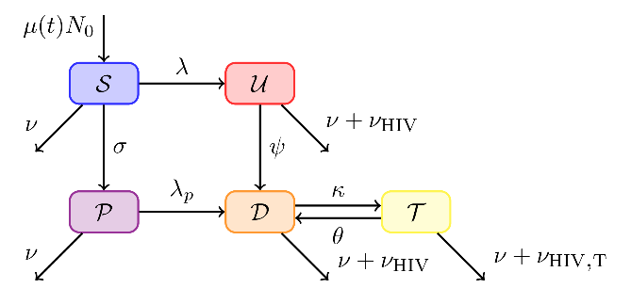

Figure S2.1 **Schematic of the HIV transmission model structure with state transitions.** S: susceptible, P: on pre-exposure prophylaxis, U: undiagnosed HIV, D: diagnosed HIV, T: on HIV antiretroviral treatment. See **Table S2.1** for definitions of parameters and their symbols shown in **Figure S2.1**. Activity level not shown.

Table S2.1 **Model parameter symbols.**

|  |  |
| --- | --- |
| **Parameters** | **Symbol** |
| **Entry and exit rate** |  |
| Baseline entry rate (person-1 year-1) |  |
| Baseline exit rate (person-1 year-1) |  |
| Population annual growth rate (year-1) |  |
| **All-cause mortality** |  |
| No HIV infection (person-1 year-1) |  |
| HIV infected, not on ART (person-1 year-1) |  |
| HIV infected, on ART (person-1 year-1) |  |
| **Sexual behavioural parameters** |  |
| Number of concurrent sexual partners for low sexual activity MSM (person-1 year-1) |  |
| Ratio: number of partners for high sexual activity MSM to number of partners for low sexual activity MSM | $$\frac{C_{2}}{C_{1}}$$ |
| Proportion of high sexual activity MSM | $$x_{_h}$$ |
| Number sex acts (partnership-1 year-1) |  |
| Proportion of insertive anal sex acts, seroconcordant partnerships | $α_{ss^{'}}$ $(s=s’)$ |
| Proportion of insertive (HIV-negative perspective) anal sex acts, serodiscordant partnerships | $α_{ss^{'}}$ $(s≠s’)$ |
| Condom use in serodiscordant partnerships | $$π_{ss^{'}} (s≠s^{'})$$ |
| Relative condom use in sero-concordant vs. discordant partnerships | $${RR}_{π}$$ |
| Condom efficacy | $$ξ$$ |
| **Sexual mixing parameters** |  |
| *Model 1* -serosorting | $$ε$$ |
| *Model 2* – sero-proportionate mixing | $$ε$$ |
| **Per act HIV transmission probability** |  |
| Insertive sex act (per anal sex act-1) |  |
| Receptive sex act (per anal sex act-1) |  |
| **Testing, treatment, PrEP parameters** |  |
| Rate of HIV testing (person-1 year-1) |  |
| Rate of ART initiation (person-1 year-1) |  |
| Rate of ART drop-out (person-1 year-1) |  |
| Proportion of viral suppression among individuals on ART | *prop* |
| PrEP coverage | $$Γ$$ |
| Rate of PrEP initiation (person-1 year-1) |  |
| PrEP effectiveness in reducing HIV transmission | $$ω$$ |

Abbreviations: NA, not applicable; ART, antiretroviral therapy; MSM, men who have sex with men; PrEP, HIV pre-exposure prophylaxis; HIRI: HIV Incidence Risk Index.

## Force of infection

We modelled HIV transmission via anal sex only. We did not consider vertical transmission as it was very rare – for example, in 2017, only 3 out of 2402 new HIV diagnoses in Canada were attributed to mother-to-child transmission(20). Data in the North America setting show that 4%-12% of MSM also inject drugs(21) , however we did not consider transmission via injection drug use because our study focuses on the serosorting in the context of sexual partner selection. Approximately 13% of MSM self-identified as bisexual in Montreal, Canada(22), however, we did not consider transmission via vaginal sex for model simplification, and because data on serosorting patterns from the perspective of bisexual men’s female partners are not available.

The force of infection $λ_{a}$ is the risk of acquiring HIV for a susceptible individual not on PrEP. When defining $λ_{a}$, an individual’s activity ( $a∈$ [low, high]) and perceived HIV serostatus ( $s∈$ [perceived HIV negative, perceived HIV positive]) are distinguished from those of their sexual partners by a prime (i.e. $a^{'}$, $s^{'}$). The force of infection depends on the following parameters as defined in equation (7): average number of male sexual partners per year, $C_{a}$; probability of partnership formation between the individual ($a$, $s$) and the partner ($a^{'}$, $s^{'}$), $ρ_{asa^{'}s^{'}}$; the proportion of partners who are infectious ($I_{a^{'}s^{'}}/N_{a^{'}s^{'}}$); and the transmission probability per serodiscordant partnership per year ($β_{ss^{'}}$).

|  |  |
| --- | --- |
| $$λ_{a}\left(t\right)=C_{a}\sum_{a^{'}=1}^{2}{\sum_{s^{'}=1}^{2}{ρ_{asa^{'}s^{'}}β_{ss^{'}}\left(\frac{I_{a^{'}s^{'}}\left(t\right)}{N_{a^{'}s^{'}}\left(t\right)}\right)}}$$ | (7) |

### Probability of transmission per serodiscordant partnership

The probability of HIV transmission per serodiscordant partnership per year ($β_{ss^{'}}$) depends on: the biological probability of transmission per insertive act $B_{i}$ and per receptive act $B_{r}$, the total number of sex acts per partnership per year $n$, the proportion of sex acts which are insertive from the perspective of HIV-negative men $α_{ss^{'}}$, the proportion of sex acts in which condoms are used $π_{ss^{'}}$, and the efficacy of condoms at reducing transmission $ξ$. Considering these parameters, $β_{ss^{'}}$ is defined using the accumulation of the probability of escaping infection across all sex acts in the partnership (binomial model):

|  |  |
| --- | --- |
| $$β_{ss^{'}}=1-\left(\begin{aligned} {\left[1-\left(1-ξ\right)B_{i}\right]}^{ n \left(π_{ss^{'}}\right)\left(α_{ss^{'}}\right)} ×{\left[1-B_{i}\right]}^{ n \left(1-π_{ss^{'}}\right)\left(α_{ss^{'}}\right)} \\ ×{\left[1-\left(1-ξ\right)B_{r}\right]}^{ n \left(π_{ss^{'}}\right)\left(1-α_{ss^{'}}\right)}×{\left[1-B_{r}\right]}^{ n \left(1-π_{ss^{'}}\right)\left(1-α_{ss^{'}}\right)}\end{aligned}\right)$$ | (8) |

We assume the same number of sex acts per partnership per year across all partnership types. However, we distinguish the proportion of sex acts which are insertive from the perspective of HIV-negative men ($α_{ss^{'}}$) and the proportion of sex acts in which condoms are used ($π_{ss^{'}}$) by whether or not a partnership is perceived serodiscordant. $π_{ss^{'}}=π_{ss^{'}}$ (if $s≠s^{'}$); $π_{ss^{'}}=π_{ss^{'}} {RR}_{π}$ (if $s=s^{'}$) where $π_{ss^{'}}$ reflects condom use in serodiscordant partnerships and ${RR}_{π}$ reflects relative condom use in seroconcordant vs. serodiscordant partnerships.

### Sexual mixing patterns

The probability of partnership formation between individuals and their partners is summarized in the mixing matrix $ρ_{asa^{'}s^{'}},$ which is defined as the product of independent mixing matrices corresponding to activity levels ($p_{aa^{'}}$) and serostatus ($p_{ss^{'}}$). Therefore, $ρ_{asa^{'}s^{'}}= p_{aa^{'}}p_{ss^{'}}$.

Because our research question focused on on mixing by serostatus, we maintained proportionate sexual mixing by sexual activity level. Thus, we define the probability of partnership formation between an individual of sexual activity level $a$ and a partner of sexual activity level $a^{'}$ ( $p_{aa^{'}})$ as:

|  |  |
| --- | --- |
| $$p_{aa^{'}}=\frac{C_{a^{'}}N_{a^{'}}}{\sum_{a^{'}}{C_{a^{'}}N_{a^{'}}}}$$ | (9) |

We model assortative sexual mixing by perceived HIV serostatus using the approach outlined by Garnett *et al*,27 via a parameter $ε$ which controls the degree of assortative mixing. The value of 0 indicates fully sero-assortative mixing where individuals form partnerships exclusively with those of the same perceived HIV serostatus, and the value of 1 indicates sero-proportionate mixing where individuals select partners proportionally to the total partnerships available by perceived HIV serostatus. Thus, we define the probability of partnership formation between an individual of perceived HIV serostatus $s$ and a partner of perceived HIV serostatus $s^{'}$ ( $p_{ss^{'}}$) as equation (10), where $δ_{s,s'}$ = 1 if $s=s^{'}$ and $δ_{s,s'}$ = 0 if otherwise:

|  |  |
| --- | --- |
| $$p_{ss^{'}}=(1-ε)δ_{s,s'}+\left(ε\right)\frac{C_{s^{'}}N_{s^{'}}}{\sum_{s^{'}}{C_{s^{'}}N_{s^{'}}}}$$ | (10) |

## PrEP intervention

### PrEP initiation

We assume uniform coverage of PrEP by sexual activity level, with a rapid increase in the rate of PrEP initiation ($σ$) (defined in equation 11) yielding a linear increase in coverage during roll-out until specified coverage ($Γ$) was achieved in one year. PrEP coverage remained stable thereafter. We explicitly did not include rates of discontinuing PrEP (as observed in practice28) because our intervention analyses focus on a stable proportion of susceptible individuals on PrEP. Therefore, cessation of PrEP would lead to immediate initiation (or re-initiation) by another susceptible individual, and thus lead to the same mechanism of fewer susceptible individuals at the population-level.

|  |  |
| --- | --- |
| $$σ=S^{-1}\left[\left(S+P\right)\frac{d}{dt}Γ\left(t\right)+\frac{P}{S+P}\left(N_{0} μ-S \left(λ+ν\right)-P \left(λ_{p}+ν\right)\right)+P \left(λ_{p}+μ\right)\right]$$ | (11) |

where: $Γ\left(t\right)$ is the desired PrEP coverage at time $t$; $λ$ is the force of infection among susceptibles $S$, and $λ_{p}$ is the force of infection among PrEP users $P$ (see the next section, 2**.3.2**). After the specified coverage $Γ$ was achieved, we set $\frac{d}{dt}Γ\left(t\right)=0$, but still varied $σ$ instantaneously (in response to epidemic decline) to ensure stable coverage.

### Reduction in HIV transmission probability

Once an individual initiate PrEP, the probability of HIV acquisition during every sex act is reduced by a factor $ω$ (PrEP effectiveness). This was implemented by multiplying the biological probability of transmission per insertive act $B_{i}$ and per receptive act $B_{r}$ by a factor of $\left(1-ω\right)$ in equation (8). Therefore, the probability of HIV acquisition per serodiscordant partnership per year for an individual on PrEP ($β_{ss^{'}}^{P}$) is defined in equation 12. Therefore, we can define the force of infection for PrEP users ($λ_{p}$) using equation 7 by substituting $β_{ss^{'}}$ with $β_{ss^{'}}^{P}$.

|  |  |
| --- | --- |
| $$β_{ss^{'}}^{P}=1-\left(\begin{aligned} {\left[1-\left(1-ξ\right)(1-ω)B_{i}\right]}^{ n \left(π_{ss^{'}}\right)\left(α_{ss^{'}}\right)} ×{\left[1-(1-ω)B_{i}\right]}^{ n \left(1-π_{ss^{'}}\right)\left(α_{ss^{'}}\right)} \\ ×{\left[1-\left(1-ξ\right)(1-ω)B_{r}\right]}^{ n \left(π_{ss^{'}}\right)\left(1-α_{ss^{'}}\right)}×{\left[1-(1-ω)B_{r}\right]}^{ n \left(1-π_{ss^{'}}\right)\left(1-α_{ss^{'}}\right)}\end{aligned}\right)$$ | (12) |

### Sexual mixing patterns post-intervention

#### Maintain serosorting at the pre-intervention level

We define the probability of partnership formation ($p_{zz^{'}}$) following PrEP intervention using a 3x3 mixing matrix in equation (13), where individual’s perceived HIV serostatus and PrEP use $z∈$ [1 = perceived HIV-negative and not on PrEP, 2 = on PrEP, 3 = perceived HIV-positve]; and partner’s perceived HIV serostatus and PrEP use $z'$. For example, $p_{12}$ is the probability of partnership formation between perceived HIV-negative man not on PrEP with another man on PrEP. We use upright font to denote variables indexed by $z$ and $z'$, as compared to italic font for variables indexed by $s$ and $s^{'}$.

|  |  |
| --- | --- |
| $$p_{zz^{'}}=\left[\begin{matrix}p_{11} & p_{12} & p_{13} \\ p_{21} & p_{22} & p_{23} \\ p_{31} & p_{32} & p_{33}\end{matrix}\right]$$ | (13) |

In intervention scenarios in which PrEP does not modify sexual mixing patterns, we assume both PrEP users and men not on PrEP maintain the pre-intervention sexual mixing patterns as described in **2.2.2**. Therefore, $p_{zz^{'}}$ can be defined based on equation (10) as follows. For partnerships with perceived HIV-positive individuals, $p_{z3}$ is equivalent to the corresponding pre-intervention value of $p_{s2}$ from equation (10):

|  |  |
| --- | --- |
| $$p_{13}=p_{23}=\left(ε\right)\frac{C_{3}N_{3}}{\sum_{z^{'}}{C_{z^{'}}N_{z^{'}}}}$$ | (14a) |
| $$p_{33}=\left(1-ε\right)+\left(ε\right)\frac{C_{3}N_{3}}{\sum_{z^{'}}{C_{z^{'}}N_{z^{'}}}}$$ | (14b) |

For partnerships with perceived HIV-negative individuals, $p_{z1}$ and $p_{z2}$ combined represent the corresponding pre-intervention value of $p_{s1}$ from equation (10), with partnership formation probability distributed proportionally among the two elements:

|  |  |
| --- | --- |
| $$p_{11}=p_{21}=\frac{C_{1}N_{1}}{C_{1}N_{1}+C_{2}N_{2}}\left(\left(1-ε\right)+\left(ε\right)\frac{C_{1}N_{1}+C_{2}N_{2}}{\sum_{z^{'}}{C_{z^{'}}N_{z^{'}}}}\right) \\ =\left(1-ε\right)\frac{C_{1}N_{1}}{C_{1}N_{1}+C_{2}N_{2}}+\left(ε\right)\frac{C_{1}N_{1}}{\sum_{z^{'}}{C_{z^{'}}N_{z^{'}}}}$$ | (15a) |
| $$p_{12}=p_{22}=\frac{C_{2}N_{2}}{C_{1}N_{1}+C_{2}N_{2}}\left(\left(1-ε\right)+\left(ε\right)\frac{C_{1}N_{1}+C_{2}N_{2}}{\sum_{z^{'}}{C_{z^{'}}N_{z^{'}}}}\right) \\ =\left(1-ε\right)\frac{C_{2}N_{2}}{C_{1}N_{1}+C_{2}N_{2}}+\left(ε\right)\frac{C_{2}N_{2}}{\sum_{z^{'}}{C_{z^{'}}N_{z^{'}}}}$$ | (15b) |
| $$p_{31}=\frac{C_{1}N_{1}}{C_{1}N_{1}+C_{2}N_{2}}\left(ε\right)\frac{C_{1}N_{1}+C_{2}N_{2}}{\sum_{z^{'}}{C_{z^{'}}N_{z^{'}}}} \\ =\left(ε\right)\frac{C_{1}N_{1}}{\sum_{z^{'}}{C_{z^{'}}N_{z^{'}}}}$$ | (15c) |
| $$p_{32}=\frac{C_{2}N_{2}}{C_{1}N_{1}+C_{2}N_{2}}\left(ε\right)\frac{C_{1}N_{1}+C_{2}N_{2}}{\sum_{z^{'}}{C_{z^{'}}N_{z^{'}}}} \\ =\left(ε\right)\frac{C_{2}N_{2}}{\sum_{z^{'}}{C_{z^{'}}N_{z^{'}}}}$$ | (15d) |

#### PrEP-mediated serosorting

In intervention scenarios with PrEP-mediated serosorting, we consider that:

1. As soon they initiate PrEP, individuals on PrEP no longer serosort and thus select partners proportional to the partnerships available by perceived HIV serostatus;
2. men not on PrEP adapt accordingly when they form partnerships with PrEP users to satisfy partnership balancing;
3. men not on PrEP continue to serosort among themselves (when men not on PrEP form partnerships with another men not on PrEP) at the pre-intervention level of serosorting.

The mathematical solutions to balancing partnerships while satisfying the above assumptions are as follows.

We assume that PrEP users ($z=2$) no longer serosort and choose their partners proportionally to available partnerships by perceived HIV serostatus. Thus, $p_{2z^{'}}$ can be defined as:

|  |  |
| --- | --- |
| $$p_{2z^{'}}=\frac{C_{z^{'}}N_{z^{'}}}{\sum_{z^{'}}{C_{z^{'}}N_{z}}}$$ | (16) |

In order to satisfy partnership balancing as shown in equation 17,

|  |  |
| --- | --- |
| $$p_{zz^{'}}N_{z}C_{z}=p_{z^{'}z}N_{z^{'}}C_{z^{'}}$$ | (17) |

perceived HIV-negative individuals not on PrEP ($z=1$) and perceived HIV-positive individuals ($z=3$) both have to adjust the number of partnerships they form with PrEP users ($z=2$). In particular, the partnership formation probabilities $p_{12}$ and $p_{32}$ are defined using equation (17), yielding:

|  |  |  |
| --- | --- | --- |
| $$p_{12}=p_{21}\frac{C_{2}N_{2}}{C_{1}N_{1}} \\ = \frac{C_{2}N_{2}}{\sum_{z^{'}}{C_{z^{'}}N_{z^{'}}}}$$ | (18a) |  |
| $$p_{32}=p_{23}\frac{C_{2}N_{2}}{C_{3}N_{3}} \\ = \frac{C_{2}N_{2}}{\sum_{z^{'}}{C_{z^{'}}N_{z^{'}}}}$$ | (18b) |

which is equivalent to proportional partnership formation by perceived HIV status and PrEP use. Equations 18a and 18b show that when PrEP users no longer serosort, men not on PrEP adapt accordingly when they form partnerships with PrEP users to satisfy partnership balancing. Indeed, men not on PrEP adapt in away that they select PrEP users as their sexual partners proportional to the availability of partnerships (men not on PrEP no longer serosort with PrEP users, and form sexual partnerships with PrEP users in a sero-proportionate manner ).

We assume men not on PrEP (including perceived HIV-negative individuals not on PrEP ($z=1$) and perceived HIV-positive individuals ($z=3$)) continue to serosort at their pre-intervention level of serosorting ($ε$) when they form partnerships with another men not on PrEP (the remaining partnerships amongst men not on PrEP, with probabilities $p_{11}$, $p_{13}$, $p_{31}$, and $p_{33}$). Thus, we define the probability of partnership formation similar to equation (10), but conditional on the remaining probability mass ($1-p_{z2}$), as shown in equations (19a and 19b). After simplification of equations 19a and 19b, we find that $p_{13}$ and $p_{31}$ under PrEP-mediated changes in serosorting when PrEP users no longer serosort will be equivalent to $p_{13}$ and $p_{31}$ under the scenario when PrEP users continue to serosort, respectively.

|  |  |
| --- | --- |
| $p_{13}=\left(1-p_{12}\right)\left(ε\right)\frac{C_{3}N_{3}}{C_{1}N_{1}+C_{3}N_{3}}$ = $(1-\frac{C_{2}N_{2}}{C_{1}N_{1}+C_{2}N_{2}+C_{3}N_{3}})\left(ε\right)\frac{C_{3}N_{3}}{C_{1}N_{1}+C_{3}N_{3}}=$ $\left(ε\right)\frac{C_{3}N_{3}}{C_{1}N_{1}+C_{2}N_{2}+C_{3}N_{3}}$ | (19a) |

|  |  |
| --- | --- |
| = | (19b) |

Finally, $p_{11}$ and $p_{33}$ can then be determined using:

|  |  |
| --- | --- |
| $$p_{11}=1-p_{12}-p_{13}$$ | (20a) |
| $$p_{33}=1-p_{32}-p_{31}$$ | (20b) |

#### Difference in partnership formation probability between scenarios when PrEP users stopped vs. continued serosorting

In summary, if we define the difference in the probability of partnership formation ($p_{zz^{'}}$) between a) the scenario in which PrEP users no longer serosort (PrEP-mediated changes in serosorting), and b) the scenario in which PrEP users maintained serosorting as $Δ_{zz^{'}}=p_{zz^{'}}^{a}-p_{zz^{'}}^{b}$, we can summarize the changes as follows:

1. When PrEP users no longer serosort (sero-proportionate mixing), the proportion of HIV-positive partners for PrEP users will increase, thus $Δ_{23}>0$;
2. Similarly, the proportion of HIV-negative partners (both on and not on PrEP) for PrEP users will decrease, thus $Δ_{21}<0$ and $Δ_{22}<0$;
3. As shown in equation (18a and 18b), to satisfy partnership balancing, men not on PrEP will adapt to form partnerships with PrEP-users in a sero-proportionate manner; thus for HIV-negative individuals not on PrEP, the proportion of HIV-negative partners on PrEP will decrease $(Δ_{12}<0$); and for HIV-positive individuals, the proportion of HIV-negative partners on PrEP will increase ($Δ_{32}>0$);
4. As shown in equation (19a and 19b), the proportion of HIV-positive partners for HIV-negative individuals not on PrEP will be the same in both scenarios ($Δ_{13}=0$); as will the proportion of HIV-negative not on PrEP for HIV-positive indivdiuals ${ (Δ}_{31}=0$);
5. In order to satisfy partnership balancing overall as per equation (20), the proportion of HIV-negative partners not on PrEP will thus increase for HIV-negative not on PrEP individuals ($Δ_{11}>0$); and the proportion of HIV-positive partners for HIV-positive individuals will decrease ($Δ_{33}<0$).

|  |  |
| --- | --- |
| $\left[\begin{matrix}Δ_{11} & Δ_{12} & Δ_{13} \\ Δ_{21} & Δ_{22} & Δ_{23} \\ Δ_{31} & Δ_{32} & Δ_{33}\end{matrix}\right]$ = $\left[\begin{matrix}+ & - & 0 \\ - & - & + \\ 0 & + & -\end{matrix}\right]$ | (21) |

# Parameterization

## Overview

We summarized the parameter values and their corresponding method of parameterization and references in the main text **Table 1**. We obtained estimates of population growth rate from the census data(19). We reviewed published literature among MSM living in the North American setting for estimates of all-cause mortality specific to HIV status and treatment status(23-25), and biological determinants of HIV transmission(26).We obtained most sexual behavioural parameters from the behavioural and bio-behavioural surveys among MSM in the three urban settings (Montréal, Toronto, Vancouver) in Canada(22, 27, 28); and sourced city, region and provincial disease surveillance reports in addition to bio-behavioural surveys for estimates of calibration targets, and parameters related to health system engagement (HIV testing, ART initiation and dropout, etc.)(22, 27-37). Where data available, city-level data or health region-level data (the health region most overlapped with the city in terms of geographic boundary) was prioritized; followed by data specific to the greater metropolitan area and then provincial-level data. We provided the details of these data sources in **Table S3.1**.

Table S3.1 **Details on the data sources used for model parameterization.**

|  |  |  |  |  |
| --- | --- | --- | --- | --- |
| **Data source type** | **Model parameter or calibration target** | **Details (to be finalized at the end)** | **Setting (specific to analytic sample)** | **Year** |
| **Momentum Health Study:** prospective cohort study of MSM (16 years or older) recruited using respondent driven sampling | | | | |
| Bio-behavioural survey | 1.    HIV prevalence (adjusted for respondent driven sampling) | Section 4.2.1 | The Greater Vancouver | 2012-2014 |
| 2.    Population-level serosorting pattern | Section 4.2.4 |
| 3.    Number of partners for low sexual activity MSM | Main text Table 1; Section 3.2.1 |
| 4.    Proportion of insertive (HIV-negative perspective) anal sex acts in serodiscordant partnerships | Main text Table1 |
| 5.    Condom use in serodiscordant partnerships | Main text Table 1; Section 3.3 |
| 6.    Relative condom use in sero-concordant vs. discordant partnerships | Main text Table 1; Section 3.3 |
| **Engage study:** multi-site (Greater Montreal ,Greater Toronto (but the actual sample was mainly from City of Toronto), Greater Vancouver) prospective cohort study of MSM (16 years or older) recruited usingrespondent-driven sampling | | | | |
| Bio-behavioural survey | 1.   HIV prevalence (adjusted for respondent driven sampling) | Section 4.2.1 | The Greater Montreal | 2017-2018 |
| 2. ART coverage | Section 4.2.3 |
| 3. Population-level serosorting pattern | Section 4.2.4 |
| **Phase I M-Track**: cross-sectional survey of MSM at five sentinel sites across Canada using venue-based sampling | | | | |
| Bio-behavioural survey | 1.    Condom use in serodiscordant partnerships | Main text Table 1; Section 3.3 | Montreal, Toronto, Ottawa, Victoria, Winnipeg | 2005-2007 |
| 2.    Relative condom use in sero-concordant vs. discordant partnerships | Main text Table 1; Section 3.3 |
| **The *Lambda* study**: cross-sectional survey of MSM (16 years or older) recruited using venue-based sampling in Toronto and Ottawa (part of Phase I M-Track) | | | | |
| Bio-behavioural survey | 1.   HIV prevalence | Section 4.2.1 | Toronto | 2006-2007 |
| 2. Number of partners for low sexual activity MSM | Main text Table 1; Section 3.2.1 |
| **The Argus study**: cross-sectional survey of HIV, viral hepatitis and sexually transmitted infections among MSM (18-81 years old) recruited using venue-based sampling (part of Phase I and II M-Track) | | | | |
| Bio-behavioural survey | 1.   HIV prevalence | Section 4.2.1 | Montreal | 2005; 2008-2009 |
| **The ManCount Study**: cross-sectional survey of MSM (18 years and older) recruited using time-space sampling (part of Phase II M-Track) | | | | |
| Bio-behavioural survey | 1.   HIV prevalence | Section 4.2.1 | Vancouver | 2008-2009 |
| **Male Call**: cross-sectional , toll-free telephone survey with a nationally-representative sample of MSM (16-89 years old) in Canada consisting of 1,235 respondents | | | | |
| Behavioural survey | 1. Number of partners for low sexual activity MSM | Main text Table 1; Section 3.2.1 | Canada | 2011-2012 |
| **Hassle Free Clinic survey:** survey among MSM presenting for anonymous point-of-care HIV testing at Hassle Free Clinic (a busy sexually transmittef infection clinic) in downtown Toronto | | | | |
| Clinic-based survey of convenient sample | 1. Number of partners for low sexual activity MSM | Main text Table 1; Section 3.2.1 | Downtown Toronto | 2016 (Wave 4) |
| 2. Proportion of high sexual activity MSM | Main text Table 1; Section 3.2.3 | 2014-2015; 2016 |
| **HIV in British Columbia: Annual Surveillance Report (BC Centre for Disease Control; 2016)** | | | | |
| Provincial disease surveillance report | 1. Number of annual new HIV diagnoses among MSM | Section 4.2.2 | Vancouver Coastal Health Authority | 2013-2016 |
| **Sexually Transmitted and Bloodborne Infections: Communicable Diseases in Toronto (Toronto Public Health; 2013-2017)** | | | | |
| City disease surveillance report | 1. Number of annual new HIV diagnoses among MSM | Section 4.2.2 | Toronto Health Region | 2013-2016 |
| **Surveillance Program for HIV Infection in Quebec Annual Reports (Institut national de santé publique du Québec; 2012; 2015; 2016)** | | | | |
| Provincial disease surveillance report | 1. Number of annual new HIV diagnoses among MSM (triangulated) | Section 4.2.2 | Montreal Health Region | 2013-2016 |
| **HIV Monitoring Quarterly Report For Vancouver Coastal Health (BC Centre for Excellence in HIV/AIDS; 2014-2018 the fourth quarter)** | | | | |
| Regional disease surveillance report | 1. ART coverage among MSM | Section 4.2.3 | Vancouver Coastal Health Authority | 2014-2018 |
| 2. Proportion of viral suppression among MSM on ART | Main text Table 1 |
| 3. ART initiation rate among MSM | Section 3.5 |
| 4. ART dropout rate among MSM | Section 3.5 |
| **HIV Care Cascade in Ontario by Sex, Age and Health region (Ontario HIV Epidemiology and Surveillance Initiative; 2015)** | | | | |
| Provincial disease surveillance report | 1. ART coverage among MSM (triangulated) | Section 4.2.3 | Ontario | 2013-2015 |
| **HIV testing in Ontario, 2016 (Ontario HIV Epidemiology and Surveillance Initiative; 2018)** | | | | |
| Provincial disease surveillance report | 1. Annual number of HIV testing among MSM (triangulated) | Section 3.4 | Toronto Health Region | 2013-2015 |

Depending on the data availability and parameter properties, we used the following five types of method for evidence synthesis (main text **Table 1**): assumption, direct estimation (estimates directly extracted from the reference), indirect estimation (estimates pooled across multiple sources to derive either the average or the range; or extracted from a single source with adjustments), triangulation (estimates triangulated from several other parameters obtained from various sources), and no priors assigned (no priors assigned except its inherent range; e.g., we dynamically calculated the rate of PrEP initiation (>0) to reach pre-defined PrEP coverage). For parameters which were estimated via assumption, direct estimation and no priors assigned, we provided the details of parameterization in the ‘notes’ column of main text **Table 1**. For parameters which were estimated via indirect estimation and triangulation, we provided the details in the main text **Table 1** and sections below.

## High and low activity groups parameters

We considered two levels of sexual activity in our model represented by different rates of partnership formation per year. Therefore, we obtained estimates for the following three parameters: number of partners for low sexual activity group, ratio between high vs. low sexual activity group in number of partners, and proportion of high sexual activity group. We used an HIV Incidence Risk Index (HIRI) score ≥25 to define MSM with high sexual activity levels, a tool previously validated among MSM populations in the US and Canadian settings to identify MSM at higher risk of infection(38-40).

### Partner number in a ‘low’ activity group

We obtained estimates of partner number for the low sexual activity group from MSM reporting 0-5 partners in the previous six months. We calculated pooled average weighted by sample size across four studies (Momentum health study, the Lambda study, Male Call, and Hassle Free Clinic survey)(27, 39, 41, 42). Within each study, whenever estimates for partner number were reported in a categorical format, we obtained the midpoint of each category for calculation of average partner numbers. Our pooled estimates suggest MSM who report 0-5 partners in the previous six months have an average of 2 partners in the previous six month; thus we assume low sexual activity MSM have an average of 4 partners per year (main text **Table 1**).

### Ratio of partner number in ‘high’ vs. ‘low’ activity groups

Instead of direct fits of the partner number in the ‘high’ activity group, it was calculated based on the number of partners in the ‘low’ activity group and the ratio of ‘high’ vs. ‘low’ activity partners. To inform the estimates of this ratio, we calculated the incidence ratio between MSM of high sexual activity level (e.g., those with a HIRI score ≥25) and MSM of low sexual activity level (e.g., those with a HIRI score< 25) using the following steps. First, we obtained a 6-month HIV incidence estimate of 0·278% among 56,008 MSM in Ontario, calculated from an annual incidence rate of 558 per 100,000 MSM in Ontario in 2014(43). Second, we obtained estimates of sensitivity (43·3% (average of two estimates based on two datasets)) and specificity (89·7% (average of two estimates based on two datasets)) in predicting HIV incidence by a HIRI score ≥25 s reported by Smith et al(38). Finally, we derived an incidence ratio of 6 between MSM with a HIRI score ≥25 and MSM with a HIRI score < 25 (calculations shown in Figure S3.2). Similarly, among MSM in the Momentum study in Vancouver, those with a HIRI score >25 had HIV incidence rate of 7.0 per 100 person-years, in comparison to an overall HIV incidence rate of 1.1 per 100 person-years among all MSM in the study(44). HIRI is a composite score, comprising elements including number of sexual partners, age, number of receptive anal sex acts, number of HIV-positive partners, methamphetamine use, and poppers use in the last 6 months(38). If we simply derive the ratio in partner numbers between two groups (HIRI ≥25 vs. <25) without adjusting for the other elements of the index, our modelled incidence ratio between two groups would not necessarily reflect the true incidence ratio between two groups (HIRI ≥25 vs. <25). Therefore, we operationalized the difference between two activity groups via the number of sexual partners in the model, with the high activity group having 6 times as many sexual partners as the low activity group, while assuming all other elements the same between two groups (force of infection equation in section 2.2). This type of model simplification was necessitated due to lack of data to simultaneously distinguish the number of sexual partners, condom use, sex acts, and sexual mixing patterns by sexual activity level while accounting for correlations between these variable.

### Fraction of population in a ‘high’ activity group

We estimated the fraction of population with high sexual activity level via estimation of proportion of MSM with a HIRI score ≥25, in consistent with how we parameterized the ratio of ‘high’ vs. ‘low’ partner numbers outlined in **section 3.2.2**. Based on Smith et al. MSM with a HIRI score ≥25 comprised 10-12% of MSM population in the two US HIV prevention trials of HIV-negative MSM(38). Similarly, Wilton et al. identified that MSM with a HIRI score 26 or higher made up 10% of MSM population who participated in the Hassle Free Clinic survey in Toronto in 2014-2015(39). As both the HIRI datasets in Smith et al study (overall incidence of 2·47%)(38) and participants in the Hassle Free Clinic (1·7% positivity)(39) likely represented a higher-risk population compared to the general MSM population, we set 12% as the upper limit for the range of the prior distribution for the fraction in the “high” activity group and considered a lower limit of 6% for the fraction in the “high” activity group.

|  |  |  |  |  |  |  |
| --- | --- | --- | --- | --- | --- | --- |
|  |  | Total population of MSM in Ontario stratified by HIV serostatus | | |  |  |
|  |  | HIV-positive | HIV-negative | Total population | 6-month HIV incidence | 6-month HIV incidence ratio |
| Stratified by HIRI score | >=25 | =56008*0·00279\***0**·**433** | =56008*(1-0·00279)*(1-0·897) | =56008*0·00279*0·433 + 56008*(1-0·00279)*(1-0·897) | =0·012 | =0·012/0·002=6 |
| <25 | =56008*0·00279*(1-0·433) | =56008*(1-0·00279)\***0**·**897** | =56008*0·00279*(1-0·433) + 56008*(1-0·00279)*0·897 | =0·002 | Reference |
| Total | =56008*0·00279 | =56008*(1-0·00279) | **56008** | **0·00279** | Not applicable |
|  | *Bold indicates input estimates obtained externally for the calculations. | | | |  |  |

Figure S3.2 **Calculation of HIV incidence ratios between MSM with HIRI score greater or equal to 25 and MSM with HIRI score less than 25.**

## Condom use

Based on data from the Momentum Health Study, self-reported HIV-positive men reported condom use in 36% of their sexual encounters with another men who they perceived to be HIV-negative or HIV status-unknown, and 12% of their sexual encounters with another men who they perceived to be HIV-positive(29); self-reported HIV-negative men reported condom use in 54% of their sexual encounters with another men who they perceived with certainty to be HIV-negative, and 57% of their sexual encounters with another men who they perceived otherwise(30).As such, data from the Momentum Health Study suggest condom use of 36%-57% in a serodiscordant partnership, and a relative condom use of 0·3-1 comparing condom use in a seroconcordant to serodiscordant partnership (12%/36% - 54%/57%). We further sourced condom use data reported by phase I M-track: consistent condom use varied from 55% with a regular HIV-positive partner to 96% with a casual HIV-positive partner as reported by self-reported HIV-negative or HIV status-unknown men; consistent condom use varied from 37% with a regular HIV-negative partner to 15% with a casual HIV-negative partner as reported by self-reported HIV-negative or HIV status-unknown men(27). By assuming sexual encounters with a regular partner accounting for 62% of sexual contacts(45), M-track data suggest a condom use of 70% (62%*55%+(1-62%)*96%) within serodiscordant partnerships, and condom use of 29% (62%*37%+(1-62%)*15%) within seroconcordant partnerships(27).

Therefore, based on condom use data reported by both the Momentum Health Study and the M-track, we assumed condom use of 36%-70% in a serodiscordant partnership, and a relative condom use of 0·3-1 comparing condom use in a seroconcordant to serodiscordant partnership. We did not further distinguish condom use by sexual position (insertive or receptive) as uncertainty in the overall condom use without distinguish sexual position captures any potential variation in condom use by position.

## Annual HIV testing rate

We sourced both provincial and city levels data on HIV testing rate among MSM in Canada. Based on HIV testing data from the BC Centres for Disease Control and Prevention, Nosyk et al. derived an annual HIV testing rate of 0·45 in 2010 among MSM in British Columbia(46). We further calculated the annual HIV testing rate among MSM in Toronto using estimates on the annual number of HIV testing as numerator, and the population size of MSM as denominator. For the numerator, we triangulated the annual number of HIV testing among MSM in Toronto using the observed annual number of HIV tests among all adults in Toronto, and the proportion of HIV tests that were among MSM in Ontario, as reported by the Ontario HIV Epidemiology and Surveillance Initiative (OHESI) (2013-2015)(47). For the denominator, we triangulated the MSM population size in Toronto using adult male population size in Toronto as reported by Census Canada(23), and the published estimates of the proportion of adult males who self-reported as gay or bisexual (range 2·9%-6·2%)(48-51). Specifically, the denominator should have been MSM population size, excluding those who had been diagnosed a year ago, therefore including MSM who are true susceptible (MSM population size *(1-HIV prevalence), MSM who are living with HIV but undiagnosed (MSM population size *HIV prevalence *Undiagnosed fraction), and MSM who are newly diagnosed in the last year (MSM population size * annual HIV new diagnoses rate). However, we decided to approximate the denominator using the estimated population size of MSM only for the following reasons: 1) there is a large uncertainty in estimating the population size of MSM on its own (range from 2.9%-6.2%) of adult males; 2) estimating the proportion of MSM diagnosed a year ago requires estimation of several parameters, including HIV prevalence, undiagnosed fraction, new diagnosis rate, each of which has a large uncertainty range, therefore, when combined, would result in a large uncertainty surround the estimate of proportion diagnosed a year ago; 3) e.g., if we assume an HIV prevalence of 16.4%, undiagnosed fraction of 7.9% and new diagnoses rate of 620 per 100,000 MSM (the feature of the example model-simulated epidemic), we would obtain an estimate of the proportion of MSM diagnosed a year ago of 14.5% (calculated as 1-((1-0.164)+0.164*0.079+0.0062); when combined with the estimates of MSM population, it would results in 2.5%-5.2% of the adult male population as denominator, similar to the 2.9%-6.2% range. As such, we obtained an estimate of annual HIV testing rate among MSM in Toronto ranging from 0·23 to 0·78.

## Annual ART initiation rate and dropout rate

We used population-level data on ART initiation and dropout among MSM diagnosed with HIV in the Vancouver Coastal Health Authority (regional data) in British Columbia to estimate the annual ART initiation and dropout rate among MSM in urban settings in Canada(31, 52-55). The annual rate of ART initiation was calculated as -ln(1 – proportion that initiated ART among those diagnosed but not on ART), in which the corresponding proportion that initiated ART per year was calculated as the number of people who initiated ART during one year (numerator) divided by the number of people diagnosed with HIV but not on ART at the end of the previous year (denominator), as reported in the quarterly HIV monitoring reports of the British Columbia Centre for Excellence in HIV/AIDS (BCCFE)(31, 52-55).We first calculated the proportion initiated ART per year, and then used the probability to rate conversion equation (p=1−e−rate) to derive the annual ART initiation rate, as the exact person-time at risk (<=1 year) was unknown for all individuals. The annual rate of ART dropout was calculated as -ln(1 – proportion that dropout of ART among on ART), in which the corresponding proportion that dropout ART per year was calculated as the number of people who were on ART by the end of previous year, plus the number of new ART initiations during the current year, and minus the number of people who were on ART by the end of current year, and then divided by the total number of people who should have been on ART by the end of current year had there was no dropout(31, 52-55). We did not remove death in our calculation because data on death did not distinguish whether the HIV-positive individual died while on ART or after dropped out of ART, and empirical data suggest a very small mortality among those on ART(56). Similarly, we first calculated the proportion dropped out of ART per year, and then used the probability to rate conversion equation (p=1−e−rate) to derive the annual ART dropout rate, as the exact person-time at risk (<=1 year) was unknown for all individuals. For example, at the end of 2016, a total of 4818 MSM were diagnosed with HIV in the Vancouver Coastal Health Authority, among whom 3935 were on ART(52). A total of 356 MSM initiated (both naïve initiation and experienced re-initation) ART in 2017, suggesting an annual ART initiation rate of 0·52 (-ln(1-356/(4818-3935)))(53). At the end of 2017, a total of 3961 MSM were on ART(53), suggesting 330 (3935+356-3961) MSM have dropped out of ART in 2017, reflecting an annual ART dropout rate of 0·08 (-ln(1-330/(3935+356)). Similarly, we first calculated the proportion initiated ART per year, and then used the probability to rate conversion equation (p=1−e−rate) to derive the annual ART initiation rate, as the exact person-time at risk (<=1 year) was unknown for all individuals. We repeated the calculation for each year between 2013-2017: the annual ART dropout rate remained consistent at a rate of 0·08, while the annual ART initiation rate ranged from 0·52-0·84(31, 52-55).

## PrEP-specific parameters

We only considered daily oral PrEP use in our model as other dosing regimens and intermittent use of PrEP has not been approved by Health Canada.

### PrEP adherence and effectiveness

We modelled the use of oral PrEP. We did not explicitly consider PrEP dosing or adherence levels in our model; however, we examined a wide range of evidence-based PrEP effectiveness, reflecting varying dosing and/or adherence levels. We considered a PrEP effectiveness of 86% in our primary analysis, the same as that observed among MSM in France and Canada in the IPERGAY clinical trial(57) and among British MSM in the PROUD study(58). We varied the effectiveness from 44% to 99% in our sensitivity analysis to reflect varying PrEP dosing and/or adherence levels among MSM population as those observed in clinical trials, the Open-Label Extension (OLE) cohort studies, and demonstration studies (**Table S3.6.1**)(57-62). The lower bound of 44% effectiveness was informed by the iPrEX trial(59); and the upper bound of 99% was chosen to reflect a near perfect effectiveness as have been demonstrated in the IPERGAY OLE study(61) and in a pilot study in Toronto, Canada(62).

Table S3.6.1 Effectiveness of oral pre-exposure prophylaxis in high-income settings.

|  |  |  |  |  |  |  |  |
| --- | --- | --- | --- | --- | --- | --- | --- |
| Study name | Study type | Study setting | Study population | Year | Type of PrEP | PrEP effectiveness (confidence interval) | Reference |
| iPrEX trial | Double-blind placebo-controlled trials | Peru, Ecuador, South Africa, Brazil, Thailand, US | 2499 MSM and transgender women who have sex with men | 2007-2009 | Daily TDF/FTC | 44% (15%-63%) | (59) |
| iPrEX open-label extension (OLE) | OLE cohort study | Peru, Ecuador, South Africa, Brazil, Thailand, US | 1603 MSM and transgender women who have sex with men | 2011-2012 | Daily TDF/FTC | 51% (23%-69%) | (60) |
| PROUD trial | Open-label randomized controlled trial | England | 544 MSM | 2012-2014 | Daily TDF/FTC | 86% (64%-96%) | (58) |
| IPERGAY trial | Double-blind placebo-controlled trials | Canada; France | 400 MSM and transgender women | 2012-2014 | ‘On-demand’ TDF/FTC | 86% (40%-98%) | (57) |
| IPERGAY OLE | OLE cohort study | Canada; France | 361 MSM and transgender women | 2014-2015 | ‘On-demand’ TDF/FTC | 97% (81%-100%); one participant who discontinued PrEP acquired HIV infection. | (61) |
| PREPARATORY-5 | Open-label single-arm pilot study | Toronto, Canada | 52 MSM who scored 10 or higher on a validated HIV risk score (HIV Incidence Risk Index for MSM) | 2014 | Daily TDF/FTC | No cases of HIV seroconversion occurred. | (62) |

### PrEP coverage

Once-daily Truvada (tenofovir disoproxil fumarate/emtricitabine) for HIV prevention was approved in 2016 in Canada. Among MSM recruited into the *Engage* study between February 2017 to February 2019, a total of 11%, 21% and 23% of HIV-negative MSM reported PrEP use in the last six months, in Montréal, Toronto, and Vancouver, respectively, after adjusting for the respondent-driven sampling(63).

To anticipate the potential PrEP coverage in the long term, we sourced data on PrEP uptake in urban settings in the US, which have a much longer time of PrEP implementation than any city in Canada (once-daily Truvada for HIV prevention was approved in 2012 in the US). Based on the National HIV Behavioural Surveillance among MSM recruited using venue-based sampling in the 23 urban areas in the US, an average of 25% of HIV-negative MSM reported use of PrEP in the past 12 months in 2017(64). Of the 23 surveyed areas, a total of 8 cities had more than 30% of HIV-negative MSM reporting PrEP use, and the PrEP uptake was the highest (48·6%) in San Francisco(64).

Therefore, we set the PrEP coverage at 30% in our primary analysis to reflect the potential PrEP coverage among MSM in ten years in urban settings in Canada, and examined a range of PrEP coverage (10%, and 50%) in our sensitivity analysis.

# Model calibration

## Overview

We developed a deterministic, compartmental model of HIV transmission to reproduce the epidemiologic features of a stable HIV epidemic among MSM living in the three representative urban settings (Montréal, Toronto, Vancouver) of Canada, where the majority of MSM reside(65). We simulated and calibrated two models, with *Model 1* assuming serosorting and *Model 2* assuming sero-proportionate mixing. For both models, we simultaneously calibrated the models to an equilibrium state (stable (<1% relative change) HIV prevalence and incidence, which produced the following data: HIV prevalence (10·3-30·7%)(22, 27, 28, 32, 33); annual number of HIV new diagnoses per 100,000 MSM (range 194-909)(34-36); and ART coverage among MSM diagnosed with HIV (range 81-98%)(22, 31, 47, 52-55). In addition, we simultaneously calibrated *Model 1* to empirical estimates of two population-level seroconcordance values drawn from the Momentum Health Study and *Engage* study: proportion of perceived seroconcordant partnerships by self-perceived HIV-negative or HIV status-unknown individuals (83·3-95·1%)(22, 30); and proportion of perceived seroconcordant partnerships by HIV-positive individuals (33·9-76·5%)(22, 29). We detailed the data source, estimation of those calibration targets, and calibration procedures in the sections below.

## Calibration targets

### HIV prevalence

We obtained estimates of HIV prevalence among MSM in each of the three urban settings for at least two time points as shown in **Figure S4.2.1**. For Vancouver, we included more recent estimates (23·0% (95% CI: 15·5%-30·7%) after adjusting for respondent-driven sampling) from the Momentum Health study (2012-2014)(28), and earlier estimates (crude: 18·1% (15·9%-20·5%)) from the ManCount study (2008-2009)(32). For Montréal, we obtained estimate of HIV prevalence at three time points: the Argus study estimated a crude HIV prevalence of 12·5% (11·1%-14·1%) in 2005(27), and 13·6% (12·1%-15·3%) in 2008-2009(33); the Engage study estimated an HIV prevalence of 13·9% (10·3%-17·4%) after adjusting for respondent driven sampling(22). For HIV prevalence among MSM in Toronto, we obtained estimates from the Lambda study which suggested a crude HIV prevalence of 23·1% (20·2%-26·2%) in 2006-2007(27). We did not find more recent estimate of HIV prevalence among MSM in Toronto, except for the Engage study, the data collection of which is ongoing, and among the sample of MSM participated in the study between 2017 February and 2018 February, the crude HIV prevalence estimate was 21·9% (16·3%-27·5%)(66).

We summarized the estimates of HIV prevalence in the three urban settings in Canada in **Figure S4.2.1**. In general, the data suggest relatively stable HIV prevalence over time, which supports our assumption of HIV equilibrium under which we carried out analysis. For acceptance-rejection of model fitting and selection, for the lower limit, we used the minimum of the limits from reported 95% confidence intervals, while for the upper limit, we used the maximum value, resulting in a calibration range of 10·3%-30·7%.

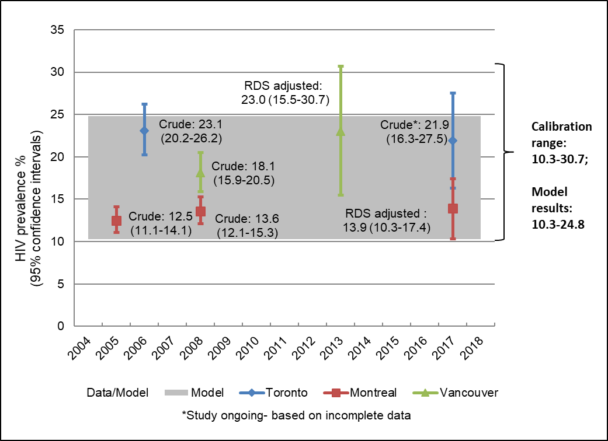

Figure S4.2.1 **Estimates of HIV prevalence in the three urban settings in Canada between 2005 and 2017.**

### Annual rate of new HIV diagnoses

We estimated the HIV diagnoses rate among MSM using the following data sources and calculations. For the numerator, we obtained the reported number of new HIV diagnoses in Toronto (city of Toronto Health Unit)(35, 67-69), Vancouver (Vancouver Coastal Health Authority)(34), and Montréal (Montréal Health Region)(36, 70), where the exposure category included MSM (including MSM who inject drugs (MSM/PWID)). The specific regions were selected given data availability to calculate and approximate the annual HIV diagnoses rate in urban settings in Canada. For the denominator, we triangulated the MSM population size using adult male population size in each of the corresponding regions as reported by Census Canada(23), and the published estimates of the proportion of adult males who self-reported as gay or bisexual (range 2·9-6·2%)(48-51).

For Vancouver Coastal Health Authority, the number of annual new HIV diagnosis cases among MSM and MSM/PWID between 2013-2016 were directly extracted from the BC CDC Annual HIV Reports(34). For Toronto Health Unit, we directly obtained the number of newly diagnosed HIV cases among MSM and MSM/PWID between 2013-2016 from the Toronto Public Health Communicable Disease Reports(35, 67-69). For Montréal Health Region, we first obtained the number of newly diagnosed HIV cases of all risk groups between 2013-2016(36); we then obtained the average proportion of newly diagnosed HIV cases among MSM and MSM/PWID in Montréal between 2002-2010(70); we further explored the proportion of new diagnosis among MSM or MSM/PWID in Quebec between 2005 and 2016, which was comparable to the average proportion in Montréal(36, 70); we therefore obtained maximum and minimum proportions of new diagnoses that were among MSM or MSM/PWID in Quebec to inform the range of proportion estimates to capture uncertainty(36); finally we multiplied the number of new diagnosis of all risk group with the proportion that were among MSM or MSM/PWID to obtain the number of newly diagnosed HIV cases among MSM and MSM/PWID in Montréal Health Region from 2013- 2016. In our calculations, we assumed either (a) missing at random for the upper limit of new diagnoses estimate or (b) all missing were not MSM for the lower limit of new diagnoses estimate, when the exposure category was missing.

We summarized the estimates of annual HIV diagnosis rate in the three urban settings in Canada in **Figure S4.2.2**. For acceptance-rejection of model fitting and selection, for the lower limit, we used the minimum of the lower limits from each region, while for the upper limit, we used the maximum of the upper limits from each region, resulting in a calibration range of 194 to 909 per 100,000 MSM.

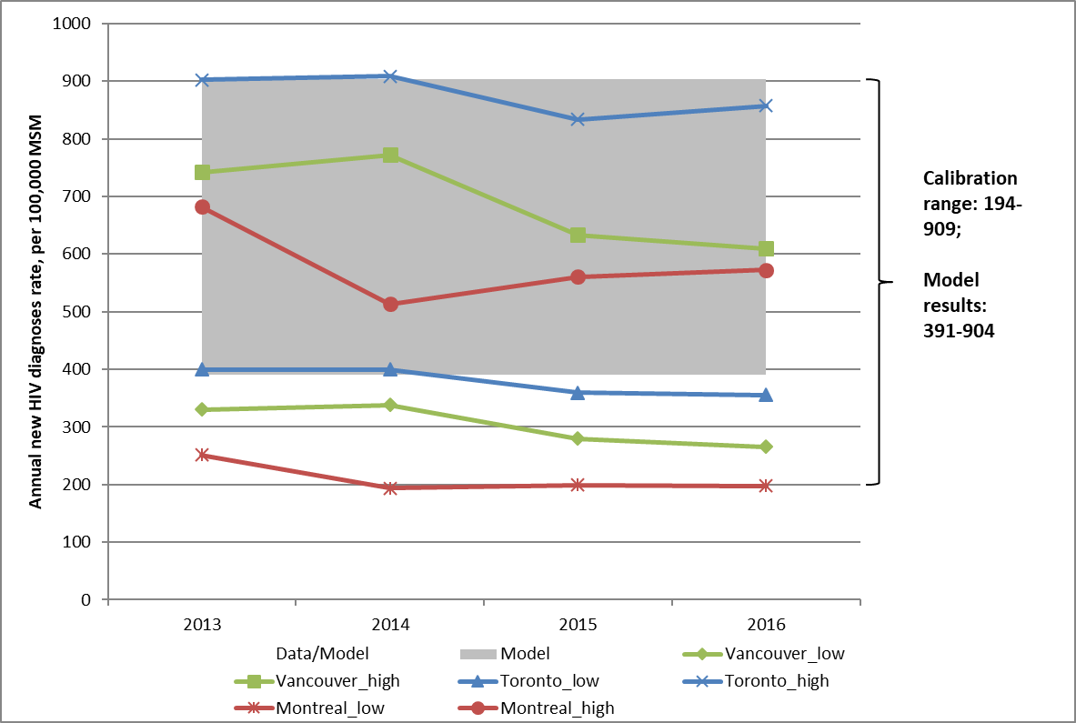

Figure S4.2.2 **Estimates of annual new HIV diagnoses rate in the three urban settings in Canada between 2013 and 2016.**

### ART coverage

We obtained estimates of ART coverage among MSM diagnosed with HIV in Vancouver (Vancouver Coastal Health Authority), Toronto (Toronto Health Region) and Montréal (Greater Montréal) to approximate the ART coverage estimate in the urban setting in Canada.

Using 2014-2018 cascade of HIV data from the quarterly HIV monitoring reports of the BCCFE(31, 52-55), the proportion of diagnosed MSM living with HIV who are on ART (based on the population-level HIV drug treatment program data) ranged from 86%-87% in the Vancouver Coastal Health Authority. Using 2017-2018 biobehavioural survey data of MSM in the Greater Montréal (Engage study), we obtained an estimate of self-reported ART coverage of 98% (95%-100%) among MSM diagnosed with HIV; after adjusting for respondent-driven sample(22). We did not find direct estimate of ART coverage among MSM in Toronto, we therefore triangulated the estimates using the calculations: we obtained estimates on the ART coverage (based on the health administrative data record of documented ART use) among all diagnosed individuals living with HIV in the Toronto Health Region using the 2013-2015 cascade of HIV data from the OHESI report(37), and multiplied by a ratio of 1·06 (ratio of ART coverage comparing MSM to the total population enrolled in the Ontario HIV Treatment Network Cohort Study between 2001-2011)(71) to estimate the ART coverage among MSM in the Toronto Health Region, which ranged from 83%-87%. The estimates on ART coverage among the sample of MSM in the Engage study in Montreal may overestimate the true ART coverage of all MSM in Montreal, for the following reasons: 1) ART coverage was measured by self-report; 2) although the analysis adjusted for the respondent-driven sampling, study participation bias might still exist, with over-representation of individuals who were more likely to engage with the health system thus more likely to participate in the study. Therefore, we used the point estimate, rather than the upper range of the confidence interval of the Montreal estimate, to inform the ART coverage prior. In summary, we calibrated our model to an ART coverage of 81%-98% to reflect recent ART coverage data in the urban settings in Canada (**Figure S4.2.3**).

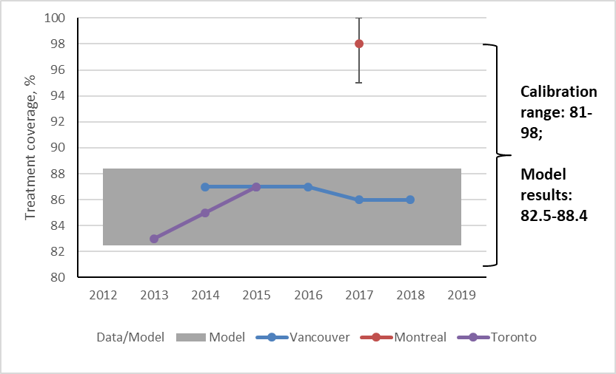

Figure S4.2.3 **Estimates of antiretroviral treatment coverage in the three urban settings in Canada between 2013 and 2018.**

### Population-level serosorting patterns

To reproduce epidemics which reflect patterns of serosorting at the population-level, we simultaneously calibrated the *Model 1* to empirical estimates of two population-level seroconcordance values: proportion of seroconcordant partnerships (including HIV-negative and undiagnosed HIV) by self-perceived HIV-negative individuals (including individuals with undiagnosed HIV); and proportion of seroconcordant (positive) partnerships by HIV-positive individuals. We drew these estimates from the Momentum Health Study(29, 30) and *Engage* study(22). In both studies, partners’ HIV status were based on individuals’ reported perception/knowledge of partners’ HIV status but were not validated against partners’ true HIV status (as partners’ true HIV status was not measured), thus were subject to misclassification errors. To account for the potential misclassification bias, we estimated the proportion of seroconcordant partnerships in two ways: 1) if individuals reported that they did not know about a specific partner’s HIV status, we classified the partner as HIV-negative or undiagnosed; this approach would overestimate the true proportion of seroconcordant partnerships for self-perceived HIV-negative individuals and underestimate the true proportion of seroconcordant partnerships for HIV-positive individuals; 2) we calculated the proportion of seroconcordant partnerships conditional on individuals’ knowing partners’ HIV status; this approach might underestimate the true proportion of seroconcordant partnerships for self-perceived HIV-negative individuals and overestimate the true proportion of seroconcordant partnerships for HIV-positive individuals. We therefore used the estimates from both approaches described above to inform the prior range of population-level seroconcordance values.

Based on the Momentum Health study (2012-2014) of MSM in the Greater Vancouver area, among anal sex with last 5 partnerships in the previous six months, the proportion of perceived seroconcordant partnerships (including partners whom the individuals perceived as HIV-negative and whom the individuals did not know about HIV status) by self-perceived HIV-negative individuals was 92·7% (95%CI: 91·1%-94·1%)(30); and the proportion of perceived seroconcordant partnerships by HIV-positive individuals was 55·9% (95% CI: 51·2%-60·4%)(29). Conditional on knowing partners’ HIV status, the proportion of perceived seroconcordant partnerships by self-perceived HIV-negative individuals was 90·2% (95%CI: 88·0%-92·0%)(30); and the proportion of perceived seroconcordant partnerships by HIV-positive individuals was 71·4% (95% CI: 66·5%-76·0%)(29).Of HIV-positive individuals, 92.9% (82.1%-98.1%) were on ART, and 71.6% (56.6%-81.8%) were virally suppressed (<50 copies.mL)(28). Data were not available to distinguish serosorting patterns by ART use or viral suppression for HIV-positive individuals.

Based on the *Engage* study (2017-2018) of MSM in Montréal, among all anal or oral sex partners in the previous six months, after adjusting for the respondent-driven sampling, the proportion of perceived seroconcordant partnerships (including partners whom the individuals perceived as HIV-negative and whom the individuals did not know about HIV status) by self-perceived HIV-negative or HIV status-unknown individuals was 94·6% (95%CI: 94·0%-95·1%); and the proportion of perceived seroconcordant partnerships by HIV-positive individuals was 36·4% (95% CI: 33·9%-39·0%)(22). Conditional on knowing partners’ HIV status, the proportion of perceived seroconcordant partnerships by self-perceived HIV-negative or HIV status-unknown individuals was 90·7% (95%CI: 89·7%-91·5%); and the proportion of perceived seroconcordant partnerships by HIV-positive individuals was 61·5% (95% CI: 58·1%-64·9%)(22).Of HIV-positive individuals, 97.7% (95.2%-100%) were on ART, and among those on ART, 89.7% (81.9%-97.3%) were virally suppressed (<50 copies.mL)(22). Data were not available to distinguish serosorting patterns by ART use or viral suppression for HIV-positive individuals. The authors of the *Engage* study noted that “we did not simultaneously consider the influence of viral suppression on sexual mixing; only 33 HIV-positive MSM were not virally suppressed in our study, limiting the analytical power” (22).

The *Engage* study also collects data among MSM in Toronto and Vancouver, the data collection of which is still on-going. Based on the existing sample collected between 2017-2018, among all anal or oral sex partners in the previous six months, the proportion of perceived seroconcordant partnerships (including partners whom the individuals perceived as HIV-negative and whom the individuals did not know about HIV status) by self-perceived HIV-negative or HIV status-unknown individuals was 90·5% (95%CI: 89·6%-91·4%) and 92·2% (95%CI: 91·3%-93·0%) for Vancouver, and Toronto, respectively; and the proportion of perceived seroconcordant partnerships by HIV-positive individuals was 46·0% (95% CI: 43·0%-49·1%) and 47·0% (95%CI: 44·4%-49·6%) for Vancouver, and Toronto, respectively(72);. Conditional on knowing partners’ HIV status, the proportion of perceived HIV-negative partnerships by self-perceived HIV-negative or HIV status-unknown individuals was 84·8% (95%CI: 83·3%-86·1%) and 87·1% (95%CI: 85·6%-88·4%) for Vancouver, and Toronto, respectively(72); and the proportion of perceived seroconcordant partnerships by HIV-positive individuals was 73·2% (95% CI: 69·7%-76·5%) and 55·8% (95%CI: 53·0%-58·6%) for Vancouver, and Toronto, respectively(72).

In summary, as there is uncertainty in the measure of population-level serosorting patterns, and in order to capture a reasonably wide range of potential patterns of serosorting, we calibrated our model to the minimum of the limits from reported 95% CIs, while for the upper limit, we used the maximum value, resulting in a calibration range of83·3%-95·1% for the estimates on proportion of seroconcordant partnerships by self-perceived HIV-negative or HIV status-unknown individuals; and a range of 33·9%-76·5% for the estimates on the proportion of seroconcordant partnerships by HIV-positive individuals.

## Calibration and model fitting procedures

We simulated and calibrated two models (with serosorting vs. with sero-proportionate mixing) to address our first objective. For both models, we initialized the model with 50000 individuals distributed into two sexual activity groups, and seeded the epidemic with three individuals living with HIV distributed across three compartments (undiagnosed, diagnosed but not on ART, and on ART) in each risk group at t = 0.

### Calibration of *Model 1* with serosorting

We sampled 2000 sets of priors using Latin hypercube sampling(73), and calibrated the model to an equilibrium state, defined as stable (<1% relative change per year) HIV prevalence and incidence. The following parameters were fitted assuming uniform prior distributions with plausible ranges, as indicated in the main text **Table 1**:

1. Proportion of the population classified as high sexual activity ($x_{_h}$)
2. Condom use in perceived serodiscordant partnerships ($π_{ss^{'}}$)
3. Relative condom use in perceived seroconcordant vs. discordant partnerships (${RR}_{π}$)
4. Levels of serosorting ($ε$)
5. Rate of HIV testing ($ψ$)
6. Rate of ART initiation ($κ$)

We used acceptance-rejection method to select posterior parameter sets which reproduced HIV prevalence, annual HIV new diagnoses rate, ART coverage among MSM diagnosed with HIV and population-level serosorting patterns described in the sections above. A total of 320 sets of calibrated posteriors were selected through *Model 1* fitting.

### Calibration of *Model 2* with sero-proportionate mixing

For each set of fitted parameters from *Model 1,* we aimed to identify a matching set of parameters for *Model 2* which generated comparable (<2% relative difference) calibration targets: HIV prevalence, new annual HIV diagnoses rate, and ART coverage. To do so, we first set the value of $ε$ =1 in *Model 2* reflecting sero-proportionate mixing. We then used fitted posterior parameter set from *Model 1* as fixed parameters for *Model 2*, except for two parameters which we re-fit: condom use between perceived serodiscordant partnerships $π_{ss^{'}}$; and relative condom use in perceived seroconcordant vs. discordant partnerships ${RR}_{π}$. We re-fit the two condom use parameters given the uncertainty in estimating these parameters and because the presence or absence of serosorting would need to be offset by a parameter related to transmission risk in order to generate the same overall HIV prevalence in *Model 2* as in *Model 1*. We re-fit the two condom use parameters within their original prior ranges specified in the main text **Table 1**, so that the equilibrium values of HIV prevalence, HIV new diagnoses rate and ART coverage generated by *Model 2* matched those generated by *Model 1*.This fitting procedure used an optimization algorithm described below. We obtained 244 sets (76% out of 320) of fitted parameters for *Model 2* which each matched an individual epidemic simulated by *Model 1*.

#### Optimization algorithm

The *fminsearch* function in MATLAB uses the Nelder-Mead Simplex Method(74) to minimize an arbitrary user-specified function $J(v)$ of one or more variables $v$. However, fminsearch does not permit bounds on the values of $v$. If bounds are required (such as for a uniform prior distribution), the user-contributed function fminsearchbnd can be used instead(75), which uses a transformation of variables to find a vector $v$ that minimizes $J(v)$, subject to $v$ within the specified bounds, based on the same algorithm as fminsearch. In our case, the fitted variables are $v=[π_{ss^{'}}, {OR}_{π}]$, the bounds are the corresponding prior ranges (main text **Table 1**), and the objective function $J\left(v\right)$ is defined as a weighted sum of squared errors across our three calibration targets:

|  |  |
| --- | --- |
| $$J\left(v\right)=\sum_{r=1}^{3}{{\left(\frac{t_{r}-t_{r}^{*}\left(v\right)}{t_{r}^{*}\left(v\right)}\right)}^{2}}$$ | (22) |

where $t_{r}$ is the equilibrium value of calibration target $r$ from *Model 1*, and $t_{r}^{*}(v)$ is the equilibrium value predicted by *Model 2* given parameters $v$. Weights ${t_{r}^{*}(v)}^{-1}$ ensure each target contributes equally to $J(v)$. The initial values of $v$ for the optimization algorithm are derived from the posterior parameter values from *Model 1*. We ran the optimization for each posterior parameter set from *Model 1*, in an attempt to find a matching parameter set for *Model 2*. Successful convergence of the optimization yields the best possible values of $v$; however this does not necessarily imply that $v$ is satisfactory. Thus, the final step is to ensure each target is individually matched to $<2\%$ difference:

|  |  |
| --- | --- |
|  | (23) |

and only accept the matched parameter set (which include $v$) if equation (23) is satisfied for all three targets.

# Model analyses

We measured the population-level PrEP impact by the relative HIV incidence reduction ten years post to PrEP intervention, a measure often referred to as relative risk reduction (RRR). We denoted the population-level PrEP impact ten years post to PrEP intervention in *Model-1* with serosorting, under the scenario when PrEP did not change sexual mixing patterns (*Scenario-1*) as RRRmodel=1,scenario=1, calculated as (Imodel=1,t=0 – Imodel=1,scenario=1, t=10)/Imodel=1,t=0, where I model=1,t=0 refers tothe HIV incidence at equilibrium prior to PrEP initiation in *Model-1* with serosorting, and Imodel=1, scenario=1, t=10 refers to the HIV incidence ten years post to PrEP initiation, under the scenario when PrEP did not change sexual mixing patterns. Similarly, we denoted the population-level PrEP impact in *Model-2* with sero-proportionate mixing, under the scenario when PrEP did not change sexual mixing patterns (*Scenario-1*) as RRRmodel=2,scenario=1, calculated as (Imodel=2,t=0 – Imodel=2,scenario=1, t=10)/Imodel=2,t=0. Finally, we denoted the population-level PrEP impact in *Model-1* with serosorting, under the scenario when PrEP users stopped serosorting (*Scenario-2*) as RRRmodel=1,scenario=2, calculated as (Imodel=1,t=0 – Imodel=1,scenario=2, t=10)/Imodel=1,t=0, where Imodel=1, scenario=2, t=10 refers to the HIV incidence ten years post to PrEP initiation in model with serosorting, under the scenario when PrEP users stopped serosorting immediately after PrEP initiation.

To quantify the influence of serosorting, we calculated the absolute difference in the population-level PrEP impact between *Model-1* with serosorting vs. *Model-2* with sero-proportionate mixing as RRRmodel=1,scenario=1 -RRRmodel=2,scenario=1. Similarly, to quantify the influence of PrEP-mediated changes in serosorting, we calculated the absolute difference in the population-level PrEP impact between scenarios when PrEP users stopped serosorting vs. continued serosorting as RRRmodel=1,scenario=2 -RRRmodel=1,scenario=1.

# Supplementary results

Appendix-6 Table S6.1A **Results of sensitivity analyses for model parameters affecting the influence of PrEP-mediated changes in serosorting on the population-level HIV transmission impact of PrEP.**

|  |  |  |  |
| --- | --- | --- | --- |
|  | **Partial rank correlation coefficient\*** | | |
| **Parameters** | **Point** | **Lower CI** | **Upper CI** |
| PrEP effectiveness | 0·91 | 0·90 | 0·91 |
| Level of pre-intervention serosorting (0=sero-proportionate; 1=complete serosorting) | -0·76 | -0·77 | -0·75 |
| PrEP coverage | -0·68 | -0·69 | -0·67 |
| HIV prevalence at equilibrium | -0·37 | -0·39 | -0·35 |
| Undiagnosed HIV at equilibrium | 0·05 | 0·01 | 0·07 |
| ART coverage at equilibrium** | 0·003 | -0·03 | 0·03 |

*Partial rank correlation coefficient is a sensitivity measure for nonlinear but monotonic relationships between parameters and the outcome, providing a measure of monotonicity after the removal of the linear effects of all but one variable. Value of partial rank correlation coefficient ranged between -1 and 1, where a positive value indicates positive correlation and negative value indicates negative correlation. Abbreviations: PrEP, pre-exposure prophylaxis; ART, antiretroviral treatment.

**The lack of correlation between ART coverage and the influence of PrEP-mediated changes in serosorting on the population-level HIV transmission impact of PrEP could be explained by: 1) relatively narrow range of ART coverage explored in our analyses; 2) as shown in **Table S6.1B and S6.1C**, ART coverage was negatively associated with difference in incident cases between two scenarios acquired from individuals living with diagnosed HIV, however, was not associated with difference in incident cases between two scenarios acquired from individuals living with undiagnosed HIV. Therefore, the influence of ART coverage on the overall difference in the population-level PrEP impact between two scenarios was diluted as opposed to other parameters.

Appendix-6 Table S6.1B **Results of sensitivity analyses for model parameters affecting the influence of PrEP-mediated changes in serosorting on the incident cases acquired from individuals living with diagnosed HIV but not virally suppressed.**

|  |  |  |  |
| --- | --- | --- | --- |
|  | **Partial rank correlation coefficient\*** | | |
| **Parameters** | **Point** | **Lower CI** | **Upper CI** |
| PrEP effectiveness | -0.98 | -0.98 | -0.98 |
| PrEP coverage) | 0.87 | 0.86 | 0.88 |
| Level of pre-intervention serosorting (0=sero-proportionate; 1=complete serosorting | 0.74 | 0.73 | 0.76 |
| HIV prevalence at equilibrium | 0.57 | 0.54 | 0.59 |
| Undiagnosed HIV at equilibrium | -0.45 | -0.47 | -0.42 |
| ART coverage at equilibrium | -0.19 | -0.21 | -0.15 |

*Partial rank correlation coefficient is a sensitivity measure for nonlinear but monotonic relationships between parameters and the outcome, providing a measure of monotonicity after the removal of the linear effects of all but one variable. Value of partial rank correlation coefficient ranged between -1 and 1, where a positive value indicates positive correlation and negative value indicates negative correlation. Abbreviations: PrEP, pre-exposure prophylaxis; ART, antiretroviral treatment.

Appendix-6 Table S6.1C **Results of sensitivity analyses for model parameters affecting the influence of PrEP-mediated changes in serosorting on the incident cases acquired from individuals living with undiagnosed HIV.**

|  |  |  |  |
| --- | --- | --- | --- |
|  | **Partial rank correlation coefficient\*** | | |
| **Parameters** | **Point** | **Lower CI** | **Upper CI** |
| Level of pre-intervention serosorting (0=sero-proportionate; 1=complete serosorting) | 0.88 | 0.87 | 0.89 |
| HIV prevalence at equilibrium | 0.86 | 0.85 | 0.87 |
| Undiagnosed HIV at equilibrium | 0.43 | 0.39 | 0.46 |
| PrEP coverage | 0.43 | 0.41 | 0.45 |
| PrEP effectiveness | -0.24 | -0.26 | -0.21 |
| ART coverage at equilibrium | -0.02 | -0.06 | 0.02 |

*Partial rank correlation coefficient is a sensitivity measure for nonlinear but monotonic relationships between parameters and the outcome, providing a measure of monotonicity after the removal of the linear effects of all but one variable. Value of partial rank correlation coefficient ranged between -1 and 1, where a positive value indicates positive correlation and negative value indicates negative correlation. Abbreviations: PrEP, pre-exposure prophylaxis; ART, antiretroviral treatment.

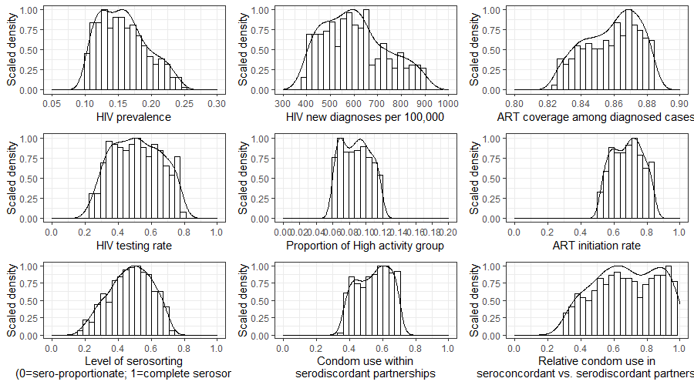Appendix-6 Figure S.6.1 **Kernel density-estimated distribution of calibrated posteriors for models with serosorting using Gaussian kernel approximation.** Abbreviations: ART, antiretroviral treatment.

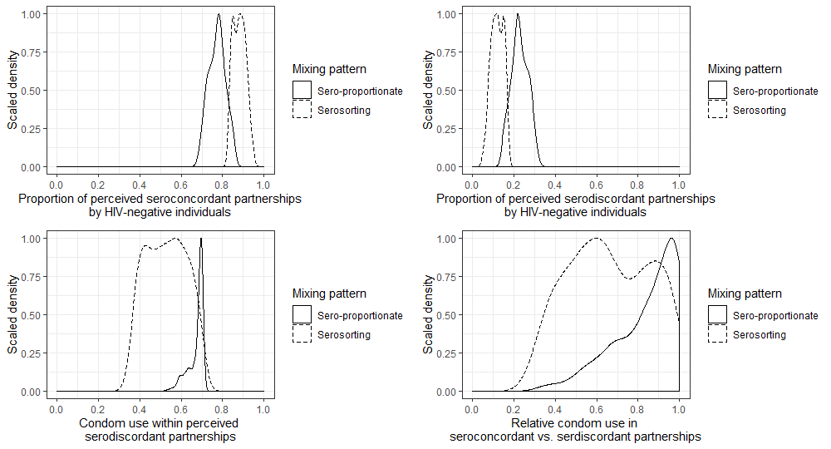

Appendix-6 Figure S.6.2 **Compare the posterior partnership distribution by perceived HIV status, and posterior condom use in models with serosorting vs. models with sero-proportionate mixing.**

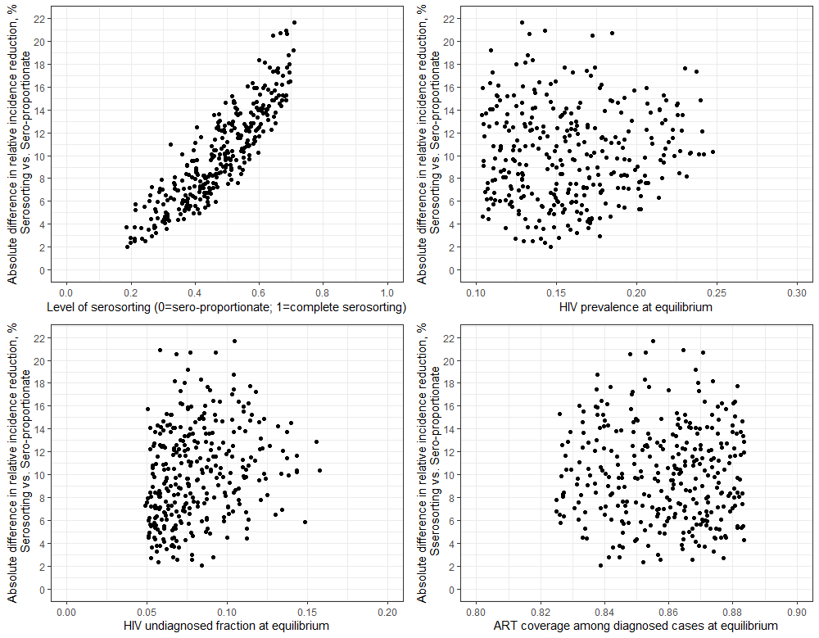

Appendix-6 Figure S.6.3 **Variations in the influence of serosorting on the population-level HIV transmission impact of pre-exposure prophylaxis (PrEP) 10 years after PrEP initiation at 86% effectiveness and 30% coverage, by pre-intervention level of serosorting and epidemiologic features of HIV epidemic at equilibrium.**

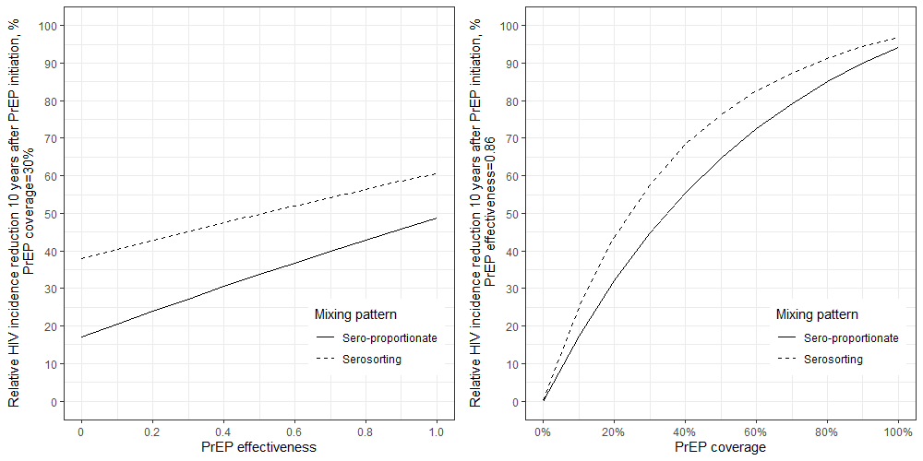 (A) (B)

Appendix-6 Figure S.6.4 **Comparison of relative HIV incidence reduction 10 years after pre-exposure prophylaxis (PrEP) initiation as demonstrated using one example epidemic (HIV prevalence 16·2%; undiagnosis fraction 7·9%) simulated under the model with serosorting vs. model with sero-proportionate mixing, by PrEP coverage and effectiveness.** In order to assess the relationship between PrEP impact with PrEP effectiveness and coverage in the model, respectively, we examined a full spectrum of hypothetical effectiveness (0%, 20%, 40%, 60%, 80%, 100%) and coverage (0%, 20%, 40%, 60%, 80%, 100%) levels, in addition to the evidence-driven levels evaluated in the sensitivity analyses (44%-99% effectiveness; 10%-50% coverage).



(A)



(B)

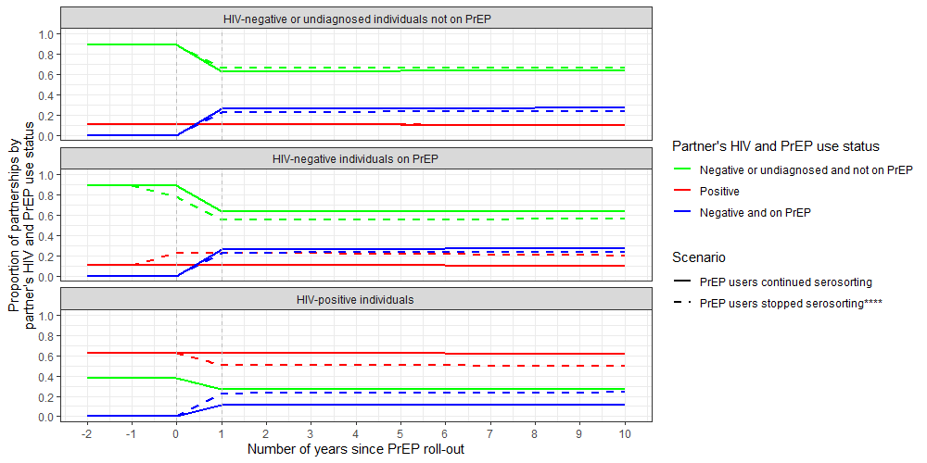

(C)

Appendix-6 Figure S.6.5 **Demonstrating the influence of pre-exposure prophylaxis (PrEP)-mediated changes in serosorting (PrEP users stopped vs. maintained serosorting) on the population-level (A) sexual mixing patterns across all simulated-epidemics, (B) HIV transmission ten years after PrEP initiation for one example simulated-epidemic, and (C) sexual mixing patterns overtime for one example simulated-epidemic. *Minor absolute difference of 0.02% to 0.56%; due to the fact that in scenarios when PrEP users stopped serosorting, the overall incidence reduction was smaller, and thus in the long term, there would be a slightly larger number of HIV-positive individuals, and a slightly smaller number of perceived HIV-negative individuals in the population, leading to a slightly higher proportion of HIV-positive partners, and a slightly lower proportion of perceived HIV-negative partners; **Minor absolute difference of -0.38% to -0.01%; details see notation*; ***Example epidemic reflects HIV prevalence 16.2%, and undiagnosis fraction 7.9%. #Incident cases are from partnerships between HIV-negative respondents and undiagnosed partners; for example, 445 HIV-negative respondents acquired HIV from their partners with undiagnosed HIV in the scenario when PrEP users stopped serosorting; ****We assumed PrEP users immediately stopped serosorting since PrEP initiation.**

Appendix-6 Table S6.2. **Comparing the difference in the population-level pre-exposure prophylaxis (PrEP) impact by sexual activity level among men who have sex with men (MSM) for one example simulated epidemic.\***



* Example epidemic reflects HIV prevalence 16.2%, and undiagnosed fraction 7.9%. Although we did not directly examine how targeted PrEP interventions (e.g., prioritized to high sexual activity MSM) would modify our findings, we demonstrated in **Appendix-6 Table S6.2** that given the same coverage and effectiveness, the PrEP impact on the relative HIV incidence reduction among the high sexual activity group was the same as that among the low sexual activity group. However, the same value of relative HIV incidence reduction could translate into a larger absolute number of infections averted among high sexual activity group than low sexual activity group, due to the higher baseline incidence in the former. As such, if PrEP were targeted to the high sexual activity group, the difference in PrEP impact measured by relative HIV incidence reduction between models with vs. without serosorting, and between scenarios when PrEP users stopped vs. continued serosorting, could translate into a larger difference in the absolute number of infections averted, compared to the uniform PrEP coverage intervention, further supporting the importance in the influence of serosorting and PrEP-mediated changes in serosorting on the PrEP impact.

# References

1. Carnegie NB, Goodreau SM, Liu A, Vittinghoff E, Sanchez J, Lama JR, et al. **Targeting pre-exposure prophylaxis among men who have sex with men in the United States and Peru: partnership types, contact rates, and sexual role**. *J Acquir Immune Defic Syndr* 2015; 69(1):119-125.

2. Goodreau SM, Hamilton DT, Jenness SM, Sullivan PS, Valencia RK, Wang LY, et al. **Targeting human immunodeficiency virus pre-exposure prophylaxis to adolescent sexual minority males in higher prevalence areas of the United States: a modeling study**. *J Adolesc Health* 2018; 62(3):311-319.

3. Jenness SM, Sharma A, Goodreau SM, Rosenberg ES, Weiss KM, Hoover KW, et al. **Individual HIV risk versus population impact of risk compensation after HIV preexposure prophylaxis initiation among men who have sex with men**. *PLoS One* 2017; 12(1):e0169484.

4. Jenness SM, Goodreau SM, Rosenberg E, Beylerian EN, Hoover KW, Smith DK, et al. **Impact of the Centers for Disease Control's HIV preexposure prophylaxis guidelines for men who have sex with men in the United States**. *J Infect Dis* 2016; 214(12):1800-1807.

5. Punyacharoensin N, Edmunds WJ, De Angelis D, Delpech V, Hart G, Elford J, et al. **Effect of pre-exposure prophylaxis and combination HIV prevention for men who have sex with men in the UK: a mathematical modelling study**. *Lancet HIV* 2016; 3(2):e94-e104.

6. Schneider K, Gray RT, Wilson DP. **A cost-effectiveness analysis of HIV preexposure prophylaxis for men who have sex with men in Australia**. *Clin Infect Dis* 2014; 58(7):1027-1034.

7. Drabo EF, Hay JW, Vardavas R, Wagner ZR, Sood N. **A cost-effectiveness analysis of preexposure prophylaxis for the prevention of HIV among Los Angeles County men who have sex with men**. *Clin Infect Dis* 2016; 63(11):1495-1504.

8. Juusola JL, Brandeau ML, Owens DK, Bendavid E. **The cost-effectiveness of preexposure prophylaxis for HIV prevention in men who have sex with men in the United States**. *Ann Intern* 2012; 156(8):541-550.

9. Kessler J, Myers JE, Nucifora KA, Mensah N, Toohey C, Khademi A, et al. **Evaluating the impact of prioritization of antiretroviral pre-exposure prophylaxis in New York**. *AIDS* 2014; 28(18):2683-2691.

10. MacFadden DR, Tan DH, Mishra S. **Optimizing HIV pre-exposure prophylaxis implementation among men who have sex with men in a large urban centre: a dynamic modelling study**. *J Int AIDS Soc* 2016; 19(1):20791.

11. Nichols BE, Boucher CAB, van der Valk M, Rijnders BJA, van de Vijver D. **Cost-effectiveness analysis of pre-exposure prophylaxis for HIV-1 prevention in the Netherlands: a mathematical modelling study**. *Lancet Infect Dis* 2016; 16(12):1423-1429.

12. Robineau O, Velter A, Barin F, Boelle PY. **HIV transmission and pre-exposure prophylaxis in a high risk MSM population: a simulation study of location-based selection of sexual partners**. *PLoS One* 2017; 12(11):e0189002.

13. Ross EL, Cinti SK, Hutton DW. **Implementation and operational research: a cost-effective, clinically actionable strategy for targeting HIV preexposure prophylaxis to high-risk men who have sex with men**. *J Acquir Immune Defic Syndr* 2016; 72(3):e61-67.

14. Supervie V, Garcia-Lerma JG, Heneine W, Blower S. **HIV, transmitted drug resistance, and the paradox of preexposure prophylaxis**. *Proc Natl Acad Sci USA* 2010; 107(27):12381-12386.

15. Cambiano V, Miners A, Dunn D, McCormack S, Ong KJ, Gill ON, et al. **Cost-effectiveness of pre-exposure prophylaxis for HIV prevention in men who have sex with men in the UK: a modelling study and health economic evaluation**. *Lancet Infect Dis* 2018; 18(1):85-94.

16. Kasaie P, Pennington J, Shah MS, Berry SA, German D, Flynn CP, et al. **The impact of preexposure prophylaxis among men who have sex with men: an individual-based model**. *J Acquir Immune Defic Syndr* 2017; 75(2):175-183.

17. Chen A, Dowdy DW. **Clinical effectiveness and cost-effectiveness of HIV pre-exposure prophylaxis in men who have sex with men: risk calculators for real-world decision-making**. *PLoS One* 2014; 9(10):e108742.

18. Ong KJ, Desai S, Field N, Desai M, Nardone A, van Hoek AJ, et al. **Economic evaluation of HIV pre-exposure prophylaxis among men-who-have-sex-with-men in England in 2016**. *Euro Surveill* 2017; 22(42).

19. World Bank. **Population growth**. In.

20. Haddad N LJ, Totten S, McGuire M. **HIV in Canada–Surveillance Report, 2017**. *Can Commun Dis Rep* 2018; 44(12):324-332.

21. Centers for Disease C, Prevention. **Estimated percentages and characteristics of men who have sex with men and use injection drugs--United States, 1999-2011**. *MMWR Morb Mortal Wkly Rep* 2013; 62(37):757-762.

22. Wang L, Moqueet N, Lambert G, Grace D, Rodrigues R, Cox J, et al. **Population-level sexual mixing by HIV status and pre-exposure prophylaxis use among men who have sex with men in Montreal, Canada: implications for HIV prevention**. *Am J Epidemiol* 2019.

23. Statistics Canada. **Table 17-10-0134-01 - Estimates of population (2016 census and administrative data), by age group and sex for July 1st, Canada, provinces, territories, health regions (2018 boundaries) and peer groups.** . In; 2019.

24. Samji H, Cescon A, Hogg RS, Modur SP, Althoff KN, Buchacz K, et al. **Closing the gap: increases in life expectancy among treated HIV-positive individuals in the United States and Canada**. *PLoS One* 2013; 8(12):e81355.

25. Collaborative Group on AIDS Incubation and HIV Survival including the CASCADE EU Concerted Action. **Time from HIV-1 seroconversion to AIDS and death before widespread use of highly-active antiretroviral therapy: a collaborative re-analysis**. *Lancet* 2000; 355(9210):1131-1137.

26. Scott HM, Vittinghoff E, Irvin R, Sachdev D, Liu A, Gurwith M, et al. **Age, race/ethnicity, and behavioral risk factors associated with per contact risk of HIV infection among men who have sex with men in the United States**. *J Acquir Immune Defic Syndr* 2014; 65(1):115-121.

27. Public Health Agency of Canada. **M-Track: enhanced surveillance of HIV, sexually transmitted and blood-borne infections and associated risk behaviours among men who have sex with men in Canada. Phase 1 report.** In; 2011.

28. Moore DM, Cui Z, Lachowsky N, Raymond HF, Roth E, Rich A, et al. **HIV community viral load and factors associated with elevated viremia among a community-based sample of men who have sex with men in Vancouver, Canada**. *J Acquir Immune Defic Syndr* 2016; 72(1):87-95.

29. Lachowsky NJ HT, Cui Z, Sereda P, Rich A, Lal A, Roth EA , Hogg RS, Moore DM. **Prevention strategies during anal intercourse and prevention-related attitudes of HIV-positive gay, bisexual and other MSM in Vancouver, British Columbia**. In: *(IAS 2015) 8th IAS Conference on HIV Pathogenesis, Treatment and Prevention* Vancouver, Canada; 2015.

30. Lachowsky NJ, Tanner Z, Cui Z, Sereda P, Rich A, Jollimore J, et al. **An event-level analysis of condom use during anal intercourse among self-reported human immunodeficiency virus-negative gay and bisexual men in a treatment as prevention environment**. *Sex Transm Dis* 2016; 43(12):765-770.

31. British Columbia Centre for Excellence in HIV/AIDS. **HIV monitoring quarterly report for Vancouver coastal health. Fourth quarter 2018**. In. Vancouver, BC, Canada; 2018.

32. Moore DM, Kanters S, Michelow W, Gustafson R, Hogg RS, Kwag M, et al. **Implications for HIV prevention programs from a serobehavioural survey of men who have sex with men in Vancouver, British Columbia: the ManCount study**. *Can J Public Health* 2012; 103(2):142-146.

33. Institut national de santé publique du Québec (INSPQ). **ARGUS survey of HIV, viral hepatitis, sexually transmitted infections, and associated risk behaviours among Quebec men who have sex with men. Cycle 2008-2009**. In; 2011.

34. BC Centre for Disease Control. **HIV in British Columbia: annual surveillance report 2016**. In; 2018.

35. Toronto Public Health. **Sexually transmitted and bloodborne infections: communicable diseases in Toronto**. In; 2016.

36. Institut national de santé publique du Québec (INSPQ). **Programme de surveillance de l’infection par le virus de l’immunodéficience humaine (VIH) au Québec Rapport annuel 2016**. In; 2017.

37. Ontario HIV Epidemiology and Surveillance Initiative. **HIV care cascade in Ontario by sex, age and health region: linkage to care, in care, on antiretroviral treatment and virally suppressed, 2015**. In; 2018.

38. Smith DK, Pals SL, Herbst JH, Shinde S, Carey JW. **Development of a clinical screening index predictive of incident HIV infection among men who have sex with men in the United States**. *J Acquir Immune Defic Syndr* 2012; 60(4):421-427.

39. Wilton J, Kain T, Fowler S, Hart TA, Grennan T, Maxwell J, et al. **Use of an HIV-risk screening tool to identify optimal candidates for PrEP scale-up among men who have sex with men in Toronto, Canada: disconnect between objective and subjective HIV risk**. *J Int AIDS Soc* 2016; 19(1):20777.

40. British Columbia Centre for Excellence in HIV/AIDS. **Guidance for use of pre-exposure prophylaxis(PrEP) for the prevention of HIV acquisition in British Columbia**. In; 2020.

41. Lachowsky NJ, Lin SY, Hull MW, Cui Z, Sereda P, Jollimore J, et al. **Pre-exposure prophylaxis awareness among gay and other men who have sex with men in Vancouver, British Columbia, Canada**. *AIDS Behav* 2016; 20(7):1408-1422.

42. Male Call. **Male call Canada technical report**. In; 2013.

43. Tan D, Allen V, Burchell A, Bogoch I, Mishra S. **Estimating the number of gay, bisexual and other men who have sex with men (gbMSM) eligible for HIV pre-exposure prophylaxis in Ontario**. In: *CAHR (26th Annual Canadian Conference on HIV/AIDS Research)*. Montreal, Canada; 2017.

44. Lachowsky N CZ, Sereda P, Stephenson K, Rich A, Brown J,. **HIV Incidence Rate and Predictors Among Gay and other Men Who Have Sex With Men (MSM) in Vancouver: Additional Benefit of an Administrative Health Data Linkage**. In: *25th Annual Canadian Conference on HIV/AIDS Research*. Winnepeg, Canada; 2016

45. Wall KM, Stephenson R, Sullivan PS. **Frequency of sexual activity with most recent male partner among young, Internet-using men who have sex with men in the United States**. *Journal Homosex* 2013; 60(10):1520-1538.

46. Nosyk B, Min JE, Lima VD, Hogg RS, Montaner JS, group SHAs. **Cost-effectiveness of population-level expansion of highly active antiretroviral treatment for HIV in British Columbia, Canada: a modelling study**. *Lancet HIV* 2015; 2(9):e393-400.

47. Ontario HIV Epidemiology and Surveillance Initiative. **HIV testing in Ontario, 2016**. In; **2018**.

48. Public Health Agency of Canada. **HIV/AIDS epi updates: national HIV prevalence and incidence estimates for 2011** In; 2014.

49. Rich AJ, Lachowsky NJ, Sereda P, Cui Z, Wong J, Wong S, et al. **Estimating the size of the MSM population in metro Vancouver, Canada, using multiple methods and diverse data sources**. *J Urban Health* 2017.

50. Grey JA, Bernstein KT, Sullivan PS, Purcell DW, Chesson HW, Gift TL, et al. **Estimating the population sizes of men who have sex with men in US states and counties using data from the American Community Survey**. *JMIR Public Health Surveill* 2016; 2(1):e14.

51. Purcell DW, Johnson CH, Lansky A, Prejean J, Stein R, Denning P, et al. **Estimating the population size of men who have sex with men in the United States to obtain HIV and syphilis rates**. *Open AIDS J* 2012; 6:98-107.

52. British Columbia Centre for Excellence in HIV/AIDS. **HIV monitoring quarterly report for Vancouver Coastal Health. Fourth quarter 2016**. In. Vancouver, BC, Canada; 2016.

53. British Columbia Centre for Excellence in HIV/AIDS. **HIV monitoring quarterly report for Vancouver Coastal Health. Fourth quarter 2017**. In. Vancouver, BC, Canada; 2017.

54. British Columbia Centre for Excellence in HIV/AIDS. **HIV monitoring quarterly report for Vancouver Coastal Health. Fourth quarter 2015** In. Vancouver, BC, Canada 2015.

55. British Columbia Centre for Excellence in HIV/AIDS. **HIV monitoring quarterly report for Vancouver Coastal Health. Fourth quarter 2014**. In. Vancouver, BC, Canada; 2014.

56. Wang L, Min JE, Zang X, Sereda P, Harrigan RP, Montaner JSG, et al. **Characterizing Human Immunodeficiency Virus Antiretroviral Therapy Interruption and Resulting Disease Progression Using Population-Level Data in British Columbia, 1996-2015**. *Clin Infect Dis* 2017; 65(9):1496-1503.

57. Molina J-M, Capitant C, Spire B, Pialoux G, Cotte L, Charreau I, et al. **On-demand preexposure prophylaxis in men at high risk for HIV-1 infection**. *N Engl J Med* 2015; 373(23):2237-2246.

58. McCormack S, Dunn DT, Desai M, Dolling DI, Gafos M, Gilson R, et al. **Pre-exposure prophylaxis to prevent the acquisition of HIV-1 infection (PROUD): effectiveness results from the pilot phase of a pragmatic open-label randomised trial**. *Lancet* 2016; 387(10013):53-60.

59. Grant RM, Lama JR, Anderson PL, McMahan V, Liu AY, Vargas L, et al. **Preexposure chemoprophylaxis for HIV prevention in men who have sex with men**. *N Engl J Med* 2010; 363(27):2587-2599.

60. Grant RM, Anderson PL, McMahan V, Liu A, Amico KR, Mehrotra M, et al. **Uptake of pre-exposure prophylaxis, sexual practices, and HIV incidence in men and transgender women who have sex with men: a cohort study**. *Lancet Infect Dis* 2014; 14(9):820-829.

61. Molina JM, Charreau I, Spire B, Cotte L, Chas J, Capitant C, et al. **Efficacy, safety, and effect on sexual behaviour of on-demand pre-exposure prophylaxis for HIV in men who have sex with men: an observational cohort study**. *Lancet HIV* 2017; 4(9):e402-e410.

62. Tan DHS, Schnubb A, Lawless J, Szadkowski L, Grennan T, Wilton J, et al. **Acceptability and tolerability of and adherence to HIV preexposure prophylaxis among Toronto gay and bisexual men: a pilot study**. *CMAJ Open* 2018; 6(4):E611-E617.

63. Hart T, Noor S, Skakoon-Sparling S, Apelian H, Grace D, Cox J, et al. **Substance use, condomless anal sex, and STI outcomes among MSM who do and do not use PrEP: preliminary results from the Engage Study**. In: *Canadian AIDS and HIV Research Conference*. Saskatoon, SK; 2019.

64. Centers for Disease Control and Prevention. **HIV infection risk, prevention, and testing behaviors among men who have sex with men—national HIV behavioral surveillance, 23 U.S. cities, 2017. HIV surveillance special report 22**. In. ; 2019.

65. Public Health Agency of Canada. **Population-specific HIV/AIDS status report: gay, bisexual, two-spirit and other men who have sex with men. Chapter 2. Demographic profile.** In. Ottawa, Canada: Government of Canada. ; 2014.

66. Armstrong HL LN, Wang L, Bacani N, Olarewaju G, Tooley L, Rodrigues R, Messier-Peet M, Noor SW, Mishra S, Scheim A, Hull M, Jollimore J, Lambert G, Cox J, Grace D, Hart TA, Moore DM. **HIV and HIV risk behaviour among gay, bisexual, and other men who have sex with men in Vancouver, Toronto, and Montreal: preliminary Comparisons from the Engage Study**. In: *27th Annual Canadian Conference on HIV/AIDS Research (CAHR)*. Vancouver, British Columbia; 2018.

67. Toronto Public Health. **Sexually transmitted and bloodborne infections: communicable diseases in Toronto**. In; 2013.

68. Toronto Public Health. **Sexually transmitted and bloodborne infections: communicable diseases in Toronto**. In; 2014.

69. Toronto Public Health. **Sexually transmitted and bloodborne infections: communicable diseases in Toronto**. In; 2015.

70. Institut national de santé publique du Québec (INSPQ). **Rapport intégré : épidémiologie des infections transmissibles sexuellement et par le sang au Québec**. In; 2012.

71. Burchell AN, Gardner S, Light L, Ellis BM, Antoniou T, Bacon J, et al. **Implementation and operational research: engagement in HIV care among persons enrolled in a clinical HIV cohort in Ontario, Canada, 2001-2011**. *J Acquir Immune Defic Syndr* 2015; 70(1):e10-19.

72. Nasheed Moqueet SWN, Trevor A. Hart , Heather L. Armstrong , Nathan J. Lachowsky , Ann N. Burchell , Gilles Lambert , Joseph Cox , David M. Moore , Anna Simkin , Estefania R. Vargas , Darrell H. Tan , Sharmistha Mishra,. **Quantifying sexual mixing patterns among gay, bisexual, and other men who have sex with men in Canada: implications for modeling HIV/STI transmission**. In: *The 27th Annual Canadian Conference on HIV/AIDS Research (CAHR)*. Vancouver, BC, Canada; 2018.

73. McKay MD, Beckman RJ, Conover WJ. **A Comparison of Three Methods for Selecting Values of Input Variables in the Analysis of Output from a Computer Code**. *Technometrics American Statistical Association* 1979; 21(2):239-245.

74. Lagarias JC, J. A. Reeds, M. H. Wright, P. E. Wright,. **Convergence properties of the Nelder-Mead Simplex Method in low dimensions**. *SIAM J Optimiz* 1998; 9(1):112-147.

75. D'Errico J. **MathWorks file exchange: fminsearchbnd, fminsearchcon. Bound constrained optimization using fminsearch (version 1.4.0.0)**. In; 2012.