Supplementary Appendix. Sensitivity analyses of HIV test uptake and proportions diagnosed HIV positive among partners of index cases comparing provider referral to passive referral

Figure A1 Uptake of HIV testing among partners assessed with HIV testing and return to clinic – Meta-analysis using locatable partners as denominators

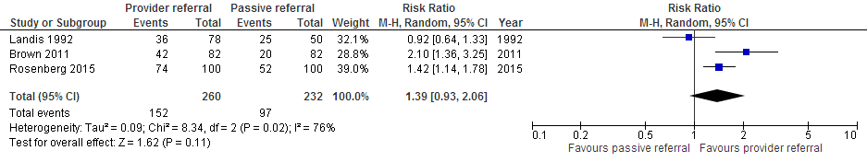

Figure A2. Proportion of partners who tested and were diagnosed HIV positive – Meta-analysis using all locatable partners as the denominator

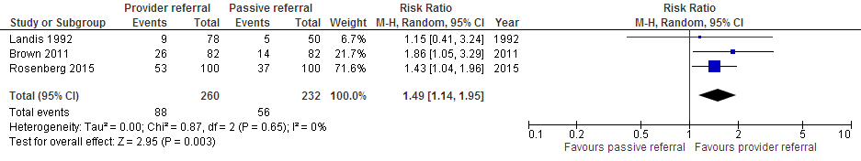

Figure A3. Proportion of partners who were newly diagnosed HIV positive – Meta-analysis using generic inverse variance among locatable partners
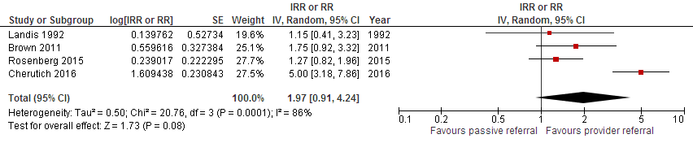

Figure A4. New linkage to care among HIV positive partners – Meta-analysis using generic inverse variance
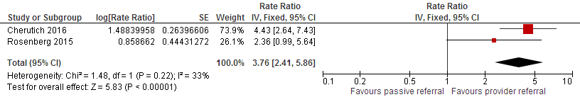

Figure A5. Adverse events assessed with intimate partner violence or abandonment using locatable partners as denominator
