Combinations of interventions to achieve a national HIV incidence reduction goal: Insights from the agent-based Progression and Transmission of HIV/AIDS (PATH 2.0) model
Chaitra Gopalappa, PhD, Stephanie L. Sansom, PhD, Paul G. Farnham, PhD, Yao-Hsuan Chen, PhD
APPENDIX: Description of the Progression and Transmission of HIV/AIDS (PATH 2.0) model- An Agent-based Model to Estimate HIV Transmissions in the United States
PATH 2.0, constructed in Netlogo software, is an agent-based model, which allows the analysis of individual-level disease progression and sexual transmissions for persons living with HIV in the United States. We only model transmissions through sexual contact for men who have sex with men (MSM) and heterosexuals, which accounted for 88% to 91% of infections diagnosed in 2010 through 2014 (1,2); in particular, our model did not include sexual or other transmissions to or from persons who inject drugs. Because the model has been presented elsewhere, (3) here we only provide an overview of the model for simulating the scenarios described in the main manuscript. Year zero of the simulation contained 10,000 persons weighted to represent all persons living with HIV in the US in year 2006 by sex and age, sexual orientation/transmission risk group (heterosexual female, heterosexual male, and men who have sex with men (MSM)), stage of disease (acute versus non-acute), and diagnostic, care, and treatment status (whether the person had diagnosed infection, was in care, was taking an antiretroviral therapy (ART) regimen, and had suppressed viral load) according to surveillance and other published data (Table S1-S2). (4-6) Each month the simulation updated each person’s disease progression and diagnostic, care, and treatment status (disease progression component), and generated transmissions (transmission component), thus projecting the course of the HIV epidemic for years 2007 to 2020. The time unit in the simulation was monthly, except in the acute phase, where it was weekly to accommodate weekly changes in viral load, which are substantially larger than those in the non-acute phase.
Disease Progression Components
Stages of infection
In the disease progression model, each HIV-infected person transitioned through the following disease stages: acute infection, asymptomatic infection, symptomatic infection/AIDS (acquired immune deficiency syndrome), and death. The acute phase of infection was characterized by high HIV viral loads, ranging between 4.4 and 6.2 log₁₀ copies/ml, (7,8) for the first three months of infection (Table S3). We assumed the CD4 count at the time of new infection was between 750 and 900 cells/µL.(9) During the asymptomatic infection phase we assumed there were no AIDS-related symptoms, but the stage was marked by a steady viral load, corresponding to an HIV viral load set point between 4 and 5 log₁₀ copies/ml (10), and declining CD4 count in the absence of treatment. We used estimates of the rate of CD4 count decline for different ranges of HIV viral load reported by Rodriguez et al. (2006).(11) Symptomatic HIV infection or AIDS was characterized by the occurrence of an opportunistic infection (OI), determined by different probabilities, or a drop in CD4 count to below 200 cells/µL. We assumed the probability of having an OI increased with a decline in CD4 count, and we modeled six infections.(12,13)
Mortality
We assumed HIV-infected persons in the model could die from causes either related to HIV/AIDS or other factors. For persons not yet on treatment, we used quarterly probabilities of death (14) that increased as a person’s CD4 count declined. The maximum number of years of life remaining for a person infected with HIV in the PATH model was limited by life expectancy at the age of HIV infection based on the general population as reported in US life tables.(15)

Diagnosis, care, and treatment
We assumed persons could be diagnosed, linked to care, and started on treatment at any time after the acute phase of infection with the exact time determined by the setting being analyzed. We assumed the natural progression of HIV described above was altered upon initiation of treatment with ART, which is associated with suppressed viral load, higher CD4 cell counts, improved life expectancy, and improved quality of life.(16,17) Once suppressed, HIV viral load was assumed to be maintained between 1.0 and 2.7 log₁₀ copies/ml as long as the regimen was effective.(18) When a particular treatment regimen ceased to be effective, we assumed that the HIV viral load rebounded to between 3.1 and 4.5 log₁₀ copies/ml.(19) In accordance with expert opinion and recent clinical trials (20-24), we assumed the probability of initial viral load suppression when taking an ART regimen depended on the CD4 count at the start of treatment. If initial suppression was obtained, the person continued with the regimen for a duration of time until viral rebound occurred, after which the person started on the next line regimen. The duration of time on each regimen was determined by a random number drawn from a geometric distribution. The mean (or rate) of the geometric distribution varied by CD4 count at the start of ART. The rates were derived by calibrating against expected life-expectancies from the Antiretroviral Therapy Cohort Collaboration population (25,26). If there was no initial suppression, the person moved to the next line regimen. We considered three lines of suppressive regimens, which were based on the Department of Health and Human Services (DHHS) guidelines (27) and expert opinion, followed by salvage therapy. The rate of treatment change for the 2nd and 3rd lines of regimen was 1.18 times the rate of the previous regimen. (28) The maximum CD4 count that could be achieved during sustained HIV viral load suppression depended upon the CD4 count at initiation of the first ART regimen.(29) A summary of the disease progression input parameters is provided in Table S3 and a schematic flow is presented in Figure S1.
Transmission Components
To generate transmissions, HIV-infected persons in the model are individually assigned partnerships and characteristics relevant for HIV, such as duration in months (remaining length of partnership), type of partnership (main or casual), number of sex acts per month, and proportion of sex acts protected by condoms. At the end of the partnership (i.e., when partnership duration reaches zero), the above partnership parameters are updated to generate the start of a new partnership. If there is an HIV transmission to an uninfected partner, that partner is only then added to the simulation and his/her partnership network is in turn generated over time. This modified methodology, which was developed because traditional methodologies can be computationally challenging for application to HIV infection in the United States, is presented in (3)
Types and duration of partners and sex acts
We modeled partnerships as main or casual (Table S4). Casual partnerships were defined by the number of contacts - one to three acts per partner within a month. Main partnerships were defined by their duration in time as those occurring over a period of at least a month, data for which was based on survey participants’ reports of their number of partners in the past 12 months. (30) Due to lack of data on heterosexuals’ casual partnerships, we modeled casual partnerships only among men who have sex with men (MSM). The durations of main partnerships were determined using truncated exponential distributions with separate distributions for each age-group. The means of the distributions were an increasing function of age and were estimated using the proportion of persons in the corresponding age group reporting having 1, 2, 3, or 4 partners in the past 12 months in the National Survey of Family Growth. (30) A proportion of these individuals also reported being sexually active but not having any current partners. Based on these data, we modeled the probability of a gap between the end of the previous and the beginning of a new partnership. The number of sex acts per person per year was distributed by age and was randomly selected from between lower and upper bound values. We derived the bounds from National Survey of Sexual Health and Behavior data by taking a weighted average of the lower and upper frequencies under four categories of sexual frequency—a few times a year to monthly, a few times per month to weekly, 2 to 3 times per week, and 4 or more times per week. (31-34) Due to the lack of data on duration and number of sex acts with main partners among MSM in the National Survey of Sexual Health and Behavior, we assumed these variables were the same as those of heterosexual males. This assumption is bolstered by the observation that the median number of main partners in heterosexual male populations (1) matches that in the MSM population.(35)
Multiple partners per time unit (concurrency)
About 52% of MSM reported that their last sex partner had other partners at the same time. (36) Because it is not clear if these were main or casual partners, we assumed 52% of MSM either had i) more than one main partnership that overlapped for at least a month, ii) one main partner and casual partners during same month, or iii) more than one casual partner during the same month. We assumed that 9% of heterosexuals had more than one partner at the same time.
Serosorting
We assumed that 15% of MSM who were HIV-infected and aware of their infection practiced serosorting, i.e., chose partners who also were infected (37-39). The rest of the population chose partners at random, i.e., the probability of a partner also being HIV-infected was equal to the prevalence of HIV in the population. We did not model serosorting in heterosexual couples as there were no data available to indicate serosorting.

Transmission probability
At every time unit, there was a probability of HIV transmission from HIV-infected index persons to their partners based on the index person’s disease stage, the partner’s HIV-status, and partnership’s number of sex acts, type of sex act (anal or vaginal, insertive or receptive), and condom use. The probability was estimated to be higher in the acute phase and lowest when the person was taking an ART regimen with viral load suppressed. The probability of transmission ($p$) was estimated using a Bernoulli process model (40-42)
$p={1-\{[ (1- α_{v})}^{n_{v}(1-c_{v})}{(1- {(1-ε)α}_{v})}^{n_{v}c_{v}}] [{\left(1- α_{a}\right)}^{n_{a}\left(1-c_{a}\right)}{\left(1- {\left(1-ε\right)α}_{a}\right)}^{n_{a}c_{a}}]\}$, where, if the partner was of the opposite sex,
$α_{v}$ or : probability of transmission per vaginal or anal sex act
$α_{v}$ or : number of vaginal or anal sex acts per time-unit (month in chronic phase and week in acute phase)
$α_{v}$ or : proportion of sex acts with condom use
: Effectiveness of condom in reducing transmission per act
If the HIV-infected person was a male who had a male partner, then the subscripts $v$ and $a$ in the above equation represent insertive and receptive anal sex acts, respectively.
The probability of transmission per sex act, under no intervention from ART, varied with change in viral load during the acute phase and remained constant over the chronic phase. We assumed that the per act transmission probability would be highest during weeks 1 through 8 in the acute phase and would be reduced after week 8 when the infection transitioned to the non-acute phase. (43-46) If viral load was suppressed on ART, there was reduction in the probability of transmission. Values for transmission parameters are presented in Table S5.
Simulating partnership concurrency
Concurrency involves a person having more than one partner, either main or casual, during the same time period. We model three types of concurrency (see Figure S2A)- Type 1: an HIV-infected person has concurrent uninfected partners; Type 2: an uninfected partner of an HIV-infected person has another uninfected partner; and Type 3: an uninfected partner of an HIV-infected person has another infected partner. In Figure S2A we present the three concurrency types, and in Figure S2B we depict the methodology of simulating these concurrency types.
We modeled Type 1 concurrency (Figure S2A) similar to the previously described method of simulating sequential partners, i.e., by adding details about both partners P4- and P5- (Figure S2B) as characteristics of the HIV-infected person C+.
Type 2 concurrency (Figure S2A) does not become relevant to the model until the uninfected partner P8- becomes infected (at t=5) and exposes the concurrent partner P9- to the infection. Therefore, at t=5 we simulate this as two sequential events (Figure S2B): E+ infects P8- to become P8+ (event 1); and it is determined, based on a probability of concurrent partnership, that P8+ has a concurrent partner P9-, who is then added as a characteristic of P8+ (event 2). Based on the memoryless property of the exponential distribution, the remaining partnership duration between P8 and P9 is independent of the past duration, and therefore it can be determined at the time that P8 became infected. The concurrent partner P9- is then exposed to P8+ during P8+’s highly infectious acute phase.
In Type 3 concurrency (Figure S2A), the uninfected P3- has two infected partners B+ and F+. However, because PATH tracks only partners of infected persons, it does not model the concurrency of P3- until P3- becomes infected. That is, in Figure S2B, at t=4, P3- is modeled as a partner of B+ and P10- as a partner of F+, without initially making the connection that P3- and P10- are the same person. At t = 5, P10- became infected from F+ to become P10+ (event 1). In event 2, it was determined, based on a probability of concurrent partnership, that P10 has a concurrent partner who is also infected. Based on population mixing probabilities, conditioned on P10+’s age and sexual orientation, the model then determined that P10+ partnered with B+ as P3-. The model then corrected P3-’s status to P3+, thus indicating that P10 and P3 are the same person (t=5, event 2).
Reasons approaches used in the agent-based model would, theoretically, generate results similar to those in models that explicitly include the uninfected
- Population mixing:
PATH: In the beginning of the simulation, PATH determines the characteristics $X_{i}$ (e.g., age, sexual orientation) of an HIV-infected person, e.g.,, to match the distribution of these characteristics among HIV-infected persons in the U.S. as reported by national HIV surveillance data. (47) For the HIV-infected person$i$, PATH determines the characteristics ( $X_{j}$) of a new partner $j$ conditional on the characteristics (e.g., age, sexual orientation) of the HIV-infected person modeled ( $X_{i}$), i.e., $P(X_{j}\left|X_{i}\right), e.g., P(X_{j}=MSM\left|X_{i}=MSM\right).$. Similarly, PATH assigns the behavioral characteristics for a partnership $Y_{ij}$ (e.g., the number of sex acts and the proportion of sex acts covered by condoms) conditional on the characteristics of the HIV-infected person, (i.e., ($(i.e., P(Y_{ij}\left|X_{i}\right))$). These conditional probability distributions can be directly estimated from the survey data because respondents report their immediate partner’s characteristics (i.e., ($(i.e., P(Y_{ij}\left|X_{i}\right))$$i.e., P(X_{j}\left|X_{i}\right)$) and behavior during that partnership ($P(Y_{ij}\left|X_{i}\right)$).By elementary probability theory we can write the conditional probability mass function as $P\left(X_{j} | X_{i}\right)=\frac{P\left(X_{j}∩X_{i}\right)}{P\left(X_{i}\right)}$, or rewriting, $P\left(X_{i}∩X_{j}\right) =P\left(X_{j} | X_{i}\right)P\left(X_{i}\right)$, where $P\left(X_{i}∩X_{j}\right)$ is the joint probability mass function. By the law of large numbers, if we generate a large number of samples of andand perform the necessary multiplication each time (we simulate 10,000 or more people), our estimates should converge to $P\left(X_{i}∩X_{j}\right)$.
Traditional method: Partnerships between two persons $i$and $j$ are determined using the joint probabilities $P\left(X_{i}∩X_{j}\right)$, which is the probability of a partnership forming between persons $i$ and $j$ if their characteristics are and $X_{j}$. Rarely are data available directly as joint probabilities, but they can be calculated using the conditional probability mass function as $P\left(X_{j}∩X_{i}\right)= P\left(X_{j} | X_{i}\right)P\left(X_{i}\right).$
- HIV-status of a new partner:
PATH: When generating new partners for infected persons who are unaware of their infection or who are aware of their infection and who do not serosort, the PATH model assumes that the probability that the new partner was previously infected is equivalent to the prevalence of HIV in the partner’s specific risk group.
Traditional Method: Individual-based models with explicit inclusion of the uninfected: If we were to construct a model with both HIV-infected and uninfected persons using the behavioral data, among all likely partnerships formed between persons who do not serosort, the probability that the partner of an infected person is also infected is based on the randomness of selecting an HIV-infected person from among potential partners of eligible age and risk groups to form that partnership. This is equivalent to the prevalence of HIV among all eligible persons, which is the assumption in PATH.
- Concurrency beyond immediate partner of HIV-infected person:
PATH: PATH does not model extended chains of network configurations. It models HIV-infected persons and their immediate partners, but not subsequent partners of those immediate partners. However, an extended chain could be generated purely based on randomness when newly HIV-infected persons are added to the simulation and their concurrency is determined.
Traditional method: The data available from surveys measure the concurrency behavior of only an immediate partner and not subsequent partners. Thus, the formation of an extended chain of partnership networks would be based on the random probability of such a scenario occurring, which is the assumption in PATH.

Selection of time-unit
We selected a time unit, dt, so that:
, where is very small.
represents the joint probability that transmission from i to j and j to k both occur within a time-period dt (note that transmission from j to k is dependent on transmission from i to j). represents the probability that transmission from i to j and k to j both occur within a period of dt (note transmissions from i to j and k to j are independent events). Applying elementary probability theory:$P\left(A∩B\right)=P\left(A | B\right)P\left(B\right),$if $A$and B are dependent and $P\left(A∩B\right)=P(A)P\left(B\right)$ if A and B are independent:
where, equals the probability that has concurrent partners, is the probability of its complement, and the remaining terms can be calculated using the Bernoulli process model of sexual behavior (including the number of acts per partner, the proportion of acts covered by condoms, the type of sex, and corresponding per act transmission probabilities). Using the upper bounds of these behavioral attributes, we estimated that if the time unit, dt, were a month, the upper bound for the joint probability of transmission would be 0.21% in the first equation and 0.03% in the second equation. The first equation denotes the error in delaying transmission by a month. The second equation denotes the probability of duplicating transmissions, thus over-estimating new infections which accumulate over time.
To quantify the over-estimation in new infections over a thirty-year period, we calculated new infections under two scenarios, one without the error and the other with the error, and we estimated the percent change in new infections at the end of the thirty-year period. In the first scenario, considering a U.S. HIV transmission rate of 4.6% per year (estimated as annual incidence divided by prevalence of HIV, (5,48)), we determined new infections in month t as (Number HIV-infected persons in month t-1)X (1+ 0.046/12), repeating this every month for 30 years. In the second scenario we determined new infections in month t as (Number HIV-infected persons in month t-1)X (1+ 0.046/12 + 0.03% X HIV-prevalence among MSM), using HIV-prevalence as a proxy for the probability that the concurrent partner will also be HIV-infected. At the end of the thirty-year period, the percent difference in new infections between the two scenarios was 1.3%, i.e., our method over-estimated new infections by about 1.3% over a thirty-year period. On the other hand, a weekly time unit, with its even smaller margin of error, is more suitable for the acute phase (approximately the first 3 months of HIV infection), when the per-act transmission probability is high and also changes from week to week. However, using a weekly time unit would require much longer computation time. Therefore, we used a monthly time unit in the non-acute phase and a weekly time unit in the acute phase to accommodate the weekly changes in viral load, which are substantially larger than that in the non-acute phase.
Model setup and projections for years 2006 and future
We initially set up the model to represent a cross-sectional view of persons living with HIV in the US in year 2006. That is, the model was set to initiate with 10,000 persons weighted to represent all persons living with HIV in the US in 2006 by sex and age, sexual orientation/transmission risk group (heterosexual male, heterosexual female, and MSM), stage of disease (acute versus non-acute), and diagnostic, care, and treatment status (whether the person had diagnosed infection, was in care, was taking an ART regimen, and had suppressed viral load, Tables S1 and S2). (4-6,48,49) Because the age distribution of new infections would likely be different from the age distribution of established infections, we identified the proportion of persons in the model living with HIV in 2006 who were newly infected from years 2004 to 2006, and assigned them the published age distributions of new cases from 2006 to 2008.(5,48) We used new infections from 2006 to 2008,(5,48) as approximate values for new infections from 2004 to 2006 because we did not have estimates of new infections in 2004 and 2005.
At the start of the simulation, we assumed that, for those already diagnosed of their infection, their CD4 count at diagnosis matched the reported estimates in the US (Table S1), (50-52) 77% of persons in care had linked to care within 3 months of diagnosis, (53) and persons on ART had an equal probability of being on one of the 3 suppressive ART regimens or salvage therapy.
Age mixing
The age of the initial HIV-infected population was distributed to match the reported age distribution of all people living with HIV in the US in 2006. The age of partners of newly infected persons was determined only when they were infected and added to the simulation. Ages were assigned such that the age distribution of new infections matched that reported in the US. (5,48)
Diagnosis, initiation of care and treatment, and dropping out of and re-entry into care and treatment
During the simulation for years 2006 to 2011, the number of persons with diagnosed infection, linked to care, retained in care, and initiating ART was controlled to match the observed proportions of persons aware of their infection, in-care, and taking an ART regimen (Table S2). That is, we simulated diagnosis, linkage to care and treatment, and dropping out of care and re-entry into care and treatment as follows: Each month, the simulation determined the number of persons with diagnosed infection as equal to the target proportion aware of their infection times the number of persons living with HIV minus the number of persons already aware of their infection. Among those who newly became aware, the target proportions were entered into care immediately and started on an ART regimen. Next, the simulation determined whether the number of persons on an ART regimen was in excess or below the required proportion on an ART regimen. If it was below, the simulation determined the number of persons to move from those not in care into care and treatment. If it was in excess, additional persons were dropped out of care/treatment (randomly picked from those in care not taking an ART regimen and those in care taking a regimen) determined by the target proportion aware and not in care times the number of persons living with HIV minus the number of persons aware and not in care. For persons who dropped out, the simulation kept track of their status at the time of drop-out (i.e., either taking or not taking an ART regimen) and assigned a time for their re-entry such that, when that time arrived, the person would be re-initiated into care or treatment based on their status at drop-out. The time for re-entry was assumed to be within 1 to 2 years for 45% of those who dropped out. (6) Due to lack of data on the remaining 55%, we assumed 40% would re-enter when their CD4 count decreased to 200 cells/µL and 15% when their CD4 count decreased to 40 cells/µL.
Calibration
The one remaining unknown measure for which no data were available is the distribution of sex acts between male and female partners of men who have sex with men and women (MSMW). Therefore, we followed a two-step procedure of validation and calibration. In the first step we validated the model by comparing the overall simulated new infections with surveillance data. In the second step we estimated the unknown measure, i.e., the distribution of sex acts between male and female partners of MSMW, by calibrating to new infections categorized by sexual orientation. The steps are discussed below in further detail.
We initially ran the simulation from 2007 to 2009 assuming no mixing between MSM and heterosexuals, i.e., we assumed that all transmissions from MSMW were to other MSM and not to heterosexual females, as we did not have data on the distribution of sex acts between male and female partners of MSMW. We estimated HIV-transmission rates for MSM, heterosexual males, heterosexual females, and the overall transmission rate across all groups in the simulation. The transmission rate from MSM-to-MSM was estimated as follows: ([# of simulated new infections from MSM-only + # of new infections from MSMW] / [# of MSM-only + # MSMW in the model living with HIV]). The transmission rate from heterosexual females-to-males was estimated as the number of simulated new infections in heterosexual males divided by the number of heterosexual females living with HIV. The transmission rate from heterosexual males-to-females was estimated as the number of simulated new infections in heterosexual females divided by the number of heterosexual males living with HIV (i.e., [# new infections from heterosexual males + # new infections from MSMW] / # heterosexual males). The overall transmission rate was estimated as the total number of new infections divided by the number of persons living with HIV.
This estimated overall transmission rate using simulated new infections and people living with HIV was about 9% higher than the transmission rate estimated using the incidence-prevalence (I/P) method with surveillance data. We believe this is a small margin of error, and hence the simulated number validates well with the surveillance data. The estimated number of new infections in years 2007 to 2009 also fell within the reported number of new infections. (5)
Table S6 shows alternative simulations of the 3-year (2007–2009) annual average of the number of new cases by risk group generated by the model compared to surveillance data. In Simulation 1, we generated infections assuming MSM mixed only with MSM and heterosexuals with heterosexuals, using the model data on heterosexual behaviors. This simulation generated 22% of the new cases among heterosexual females reported in surveillance data, 68% of the cases reported for heterosexual males, and 120% of the cases reported for MSM. The gross underestimation of cases in heterosexual females could occur either from inaccurate assumptions in their risky behavior or exposure to HIV. Therefore, we evaluated each case in Simulations 2 and 3, by setting superficially higher risky behavior than observed in 2 and increasing exposure by assuming mixing between MSMW and women in 3. In Simulation 2, we used the same mixing assumptions as in Simulation 1, but we assumed that heterosexuals on average had riskier behavior than indicated by empirical data: 10 partners per year instead of 2, 50% of sex acts were anal instead of 7%, and 0% of all sex acts were protected by condoms instead of 26%. This superficially high risky behavior still only generated 58% of the new cases reported among heterosexual females, 71% of the new cases reported among heterosexual males, and 121% of the new cases reported among MSM. In Simulation 3, we assumed that 21% of MSM were MSMW (35,54-56), 80% of the MSMW acts were with women, and 50% of those were anal acts. With these calibrated values, the model generated 91% of the new cases reported among heterosexual females, 77% of the new cases reported among heterosexual males, and 98% of the new cases reported among MSM. This was done by fixing 50% of acts as anal, which was a less sensitive parameter, and trying different values for the distribution of partners as MSM or women to find one that best fit incidence in both MSM and women.
These calibrated values, which we used in the model, most closely matched surveillance data. When we originally assumed that all MSMW transmissions were to MSM and not heterosexual females (Simulation 1), we underestimated new infections in women by not simulating transmissions from MSMW, and we overestimated new infections in MSM by assigning all transmissions of MSMW to MSM. Even when assuming more risky behavior by heterosexuals (Simulation 2), we were not able to correctly match the number of new infections by risk group with surveillance data. Only by including transmissions from MSMW to heterosexual females could we approximately match the surveillance data.
Validation
When we compared the model’s simulated number of sexual transmissions in the years 2007, 2008, and 2009 against incidence reported by Prejean et al.,(5) the model’s median estimates in 2007 were between the median published estimate and the lower bound of the 95% confidence interval (Figure S3). The estimates for 2008 and 2009 were close to the median published estimate. Because CDC’s estimates for new infections are statistically calculated, we compared parameters that are collected as part of surveillance including the number of persons with newly diagnosed infection, CD4 cell counts at diagnosis, prevalence of HIV, and an independent estimate of the median number of years from infection to diagnosis (Figure S4). The model’s simulated outcomes matched reasonably well to independent counts or estimates of the annual number of heterosexuals and MSM newly diagnosed with HIV from 2007 to 2011(1,57), the median CD4 count stratum at diagnosis for heterosexuals and MSM in 2012(58) , the number of MSM and heterosexuals living with diagnosed HIV during the years 2009 through 2011(58), and the median number of years, assuming no treatment, from HIV seroconversion to CD4 counts <500, <350, and <200.(59)
Meta-models of key parameters generated on simulated results from PATH
As discussed in the main paper, we used PATH to determine 3 key output parameters—percent reduction in annual infections () , percent reduction in annual diagnoses(), and the CD4 count at diagnosis () for different combinations of 3 input parameters, percentages of PLWH with diagnosed infection () , persons with newly diagnosed HIV who are linked to care within 1 month of diagnosis () and persons living with HIV who have viral load suppression (). As it is impractical to run PATH for all possible combinations of the 3 input parameters, due to long computational time of individual-based simulation models, we selected 40 combinations of based on the Latin hypercube sampling method and applied regression modeling to the simulated results () to generate three meta-models, , one each for the 3 output parameters. To generate each meta-model, we used the MATLAB optimization toolbox to solve for the linear coefficients,, of linear and non-linear terms of , e.g., by minimizing the sum of squared differences in estimations from PATH and the meta-models, i.e., minimize , where,
and are estimates of the output parameters estimated using the meta-models. For we evaluated equations with linear (e.g.,), quadratic (e.g., ), and interaction (e.g., $DV$) terms. As each parameter had a different range of values, before performing the above steps we first scaled the range of all three parameters to values between 0 and 100, as is standard practice in the literature. To determine the equation that best fit the simulated results, we used the p-values corresponding to each term and R-squared values corresponding to each equation. If the p-value was <0.05, we retained the term; otherwise we removed it from the equation. We also confirmed that the resulting equation had a high R-squared value. The p-values associated with linkage to care terms were not significant (p=0.4) for any of the outcomes, so these terms were dropped from all equations. The meta-models that provided the best fits ($R^{2}$ values >0.9) are as follows:
Testing the meta-model: To test the performance of the above meta-models, we randomly selected 40 additional combinations of and generated results for each of these combinations using PATH and the above meta-models. Scatter-plots of meta-model estimations of each of the output parameters plotted against PATH estimations generate a straight line of the form y=x, indicating a good fit, with R-square values of 95%, 93%, and 97% respectively, indicating a good fit (Figure S5) .
Figure S1. Schematic overview of the PATH disease progression model
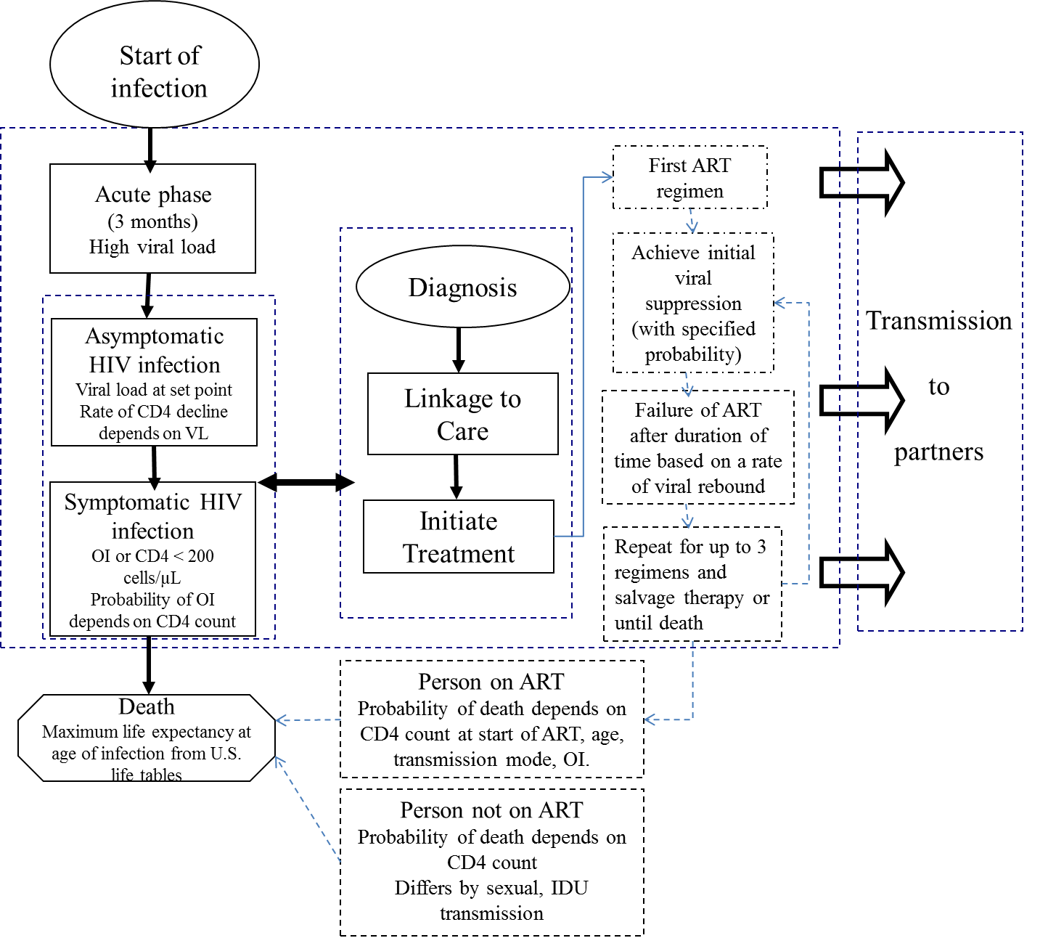

Figure S2: A: Actual partnership concurrency, and B: simulation of these partnership concurrencies in PATH 2.0

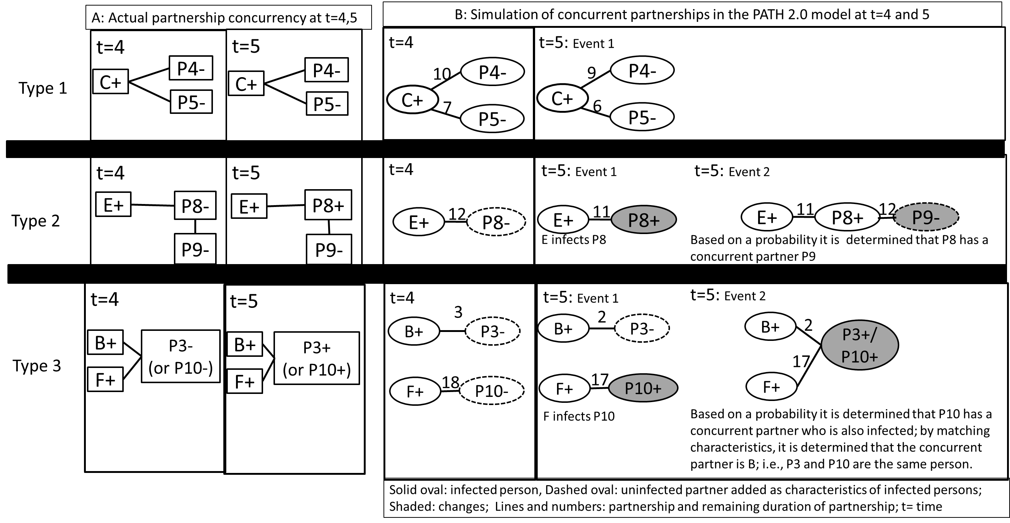

Figure S3: Comparing the simulated and reported* number of new HIV infections from sexual transmissions in the United States, 2007 - 2009

*Reported numbers are from Prejean et al., 2011 (5)

Figure S4: Model validation- Comparing simulated (PATH 2.0) with observed results in surveillance*
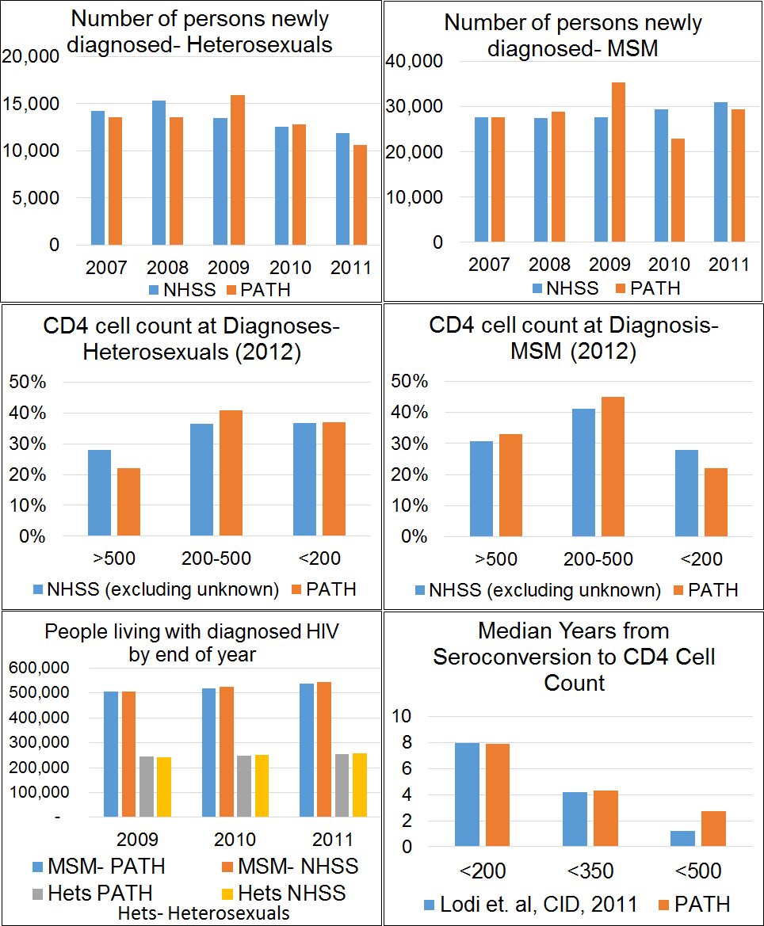
*NHSS (1,57,58) or literature (59)

Figure S5: Testing performance of meta-models by plotting meta-model estimations against PATH estimations for 40 combinations of percentages of PLWH with diagnosed infection (D), persons with newly diagnosed HIV who are linked to care within 1 month of diagnosis (L), and persons living with diagnosed HIV who have viral load suppression (V): all three measures generate a line of the form y=x, thus verifying the fits
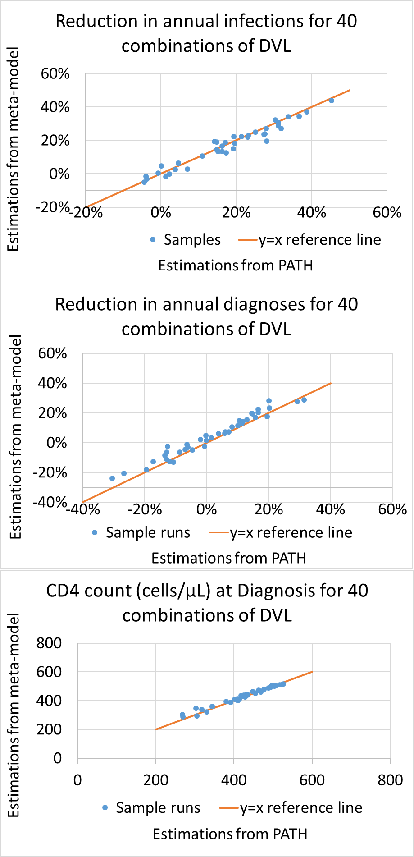
Goodness of fit measured for the above 3 graphs by R-square estimate yielded values of 95%, 93%, and 97%, respectively, indicating the meta-models are a good fit.

Table S1: Distribution of parameters of people living with HIV in the United States in 2006
 | Female | Male | MSM | Source
Distribution of PLWH in year 2006 by stage |  |  |  | (4-6)
Acute-unaware | 0.16% | 0.07% | 0.43%
NonAcute-unaware | 5% | 3% | 14%
NonAcute Aware- No care | 9% | 5% | 24%
NonAcute In care- No ART | 4% | 2% | 10%
NonAcute-On ART- No VLS | 1% | 1% | 3%
NonAcute-On ART-VLS | 5% | 2% | 12%
Total | 24% | 12% | 64%
Age distribution of PLWH in year 2006 | (same for heterosexuals and MSM) |  |  | (5,48)
13-14 |  | 0.20%
15-19 |  | 0.90%
20-24 |  | 3%
25-29 |  | 6%
30-34 |  | 9%
35-39 |  | 15%
40-44 |  | 21%
45-49 |  | 19%
50-54 |  | 13%
55-59 |  | 7%
60-64 |  | 3%
>=65 |  | 3%
Age distribution of new infections each year |  |  |  | (5,48)
13-14 | 0.10% | 0.10% | 0.10%
15-19 | 4% | 4% | 4%
20-24 | 17% | 17% | 21%
25-29 | 15% | 15% | 19%
30-34 | 15% | 15% | 15%
35-39 | 12% | 12% | 12%
40-44 | 11% | 11% | 12%
45-49 | 11% | 11% | 9%
50-54 | 10% | 10% | 7%
55-59 | 5% | 5% | 2%
60-64 | 0% | 0% | 0%
>=65 | 0% | 0% | 0%
Distribution of CD4 cell count (cells/μL) at diagnosis for those aware of infection by year 2006
<50 | 10 | 10 | 10 | (50)
50-200 | 14 | 14 | 14 | (50)
200-500 | 66 | 66 | 51 | (51,52)
>500 | 10 | 10 | 25 | (51,52)

Table S2: Distribution of people living with HIV in years 2006 and 2008 by intervention stage
Intervention Stage | Year 2006 (4,6) | Year 2008 (5,53)
Undiagnosed:  Heterosexual Female  Heterosexual Male  MSM | 21%  27%  23% | 20%  25%  22%
Diagnosed but not in care | 40% | 39%
In care but not on ART | 16% | 5%
On ART | 24% | 36%

Table S3: Disease progression parameters
Variable | Mean Value | Range | Source
Natural Disease Progression
CD4 cell count when infected (cells/µL) | 870 | 750 - 900 | (9)
Acute phase HIV viral load (log₁₀ copies/ml) | 5.3 | 4.4 – 6.2 | (7,8)
HIV viral load set point (log₁₀ copies/ml) | 4.5 | 4.0 – 5.0 | (10,60)
Natural rate of CD4 cell count decline (cells/µL/quarter) as a function of HIV viral load stratum (log₁₀ copies/ml) |  |  | (11)
≤ 2.7 | 5.1 | 2.4 – 7.8
2.7 – 3.3 | 9.9 | 7.2 – 12.3
3.3 – 4.0 | 12.0 | 9.9 – 13.8
4.0 – 4.6 | 14.1 | 11.7 – 16.2
≥ 4.6 | 19.5 | 17.1 – 21.9
Quarterly Probability of Developing an Opportunistic Infection (OI) (%) |  |  | (12,13)
Pneumocystis pneumonia (PCP) | 0.1 – 10.7ª
Mycobacterium avium complex | 0.0 – 3.6
Toxoplasmosis | 0.0 – 0.8
Cytomegalovirus infection | 0.0 – 5.5
Fungal infection | 0.0 – 3.3
Other | 0.1 – 11.4
Cumulative probability for all OIs | 0.3 – 35.3
Quarterly Probability of Death for Antiretroviral Therapy (ART)-Naïve Individuals (%)
Sexual transmission: CD4 cell count (cells/µL) |  |  | (14)
≥ 650 | 0.043
500 – 649 | 0.05
350 – 499 | 0.08
200 – 349 | 0.145
50 – 199 | 0.767
< 50 | 4.9
ART Regimens
Suppressed HIV viral load level (log₁₀ copies/ml) | 1.3 | 1.0 – 2.7 | (18)
Rebound HIV viral load level (log₁₀ copies/ml) | 3.7 | 3.1 – 4.5 | (19)
Maximum number of ART regimens and regimen drug composition | 3 + Salvage Therapy (I. EFV/TDF/FTC;  II. ATV/r+ABC/3TC; III. RAL+TDF/FTC) |  | ^{b}
Probability of virologic suppression in ART regimens: CD4 cell count (cells/µL) at ART initiation |  |  | (20,21)
>200 | 0.84
50 - 200 | 0.79
< 50 | 0.774
Rate of HIV viral load rebound (% experiencing rebound after one year on first regimen) by CD4 cell count (cells/µL) at ART initiation |  |  | (25,26) (estimated by calibrated to match life-expectancy in cited reference)
<100 | 5
100-200 | 2.45
200-300 | 1.83
300-400 | 1.46
400-500 | 1.45
Percent increase in rate of HIV viral load rebound for each successive regimen compared to its previous regimen | 18 |  | (28)
HIV viral load above set-point during salvage therapy (log₁₀ copies/ml) | 0.8 | 0.0 – 1.5 | (61)
HIV viral load above set-point during salvage therapy after onset of AIDS (log₁₀ copies/ml) | 1 | 0.0 – 2.0 | (61)
Quarterly increase in CD4 cell count during HIV viral load suppression (cells/µL/quarter) |  |  | (29)
Quarters 1 – 2 | 68
Quarters 3 – 12 | 40
Quarters 12+ | 0
Maximum CD4 cell count achieved based on CD4 cell count at initiation of ART (cells/µL) |  |  | (29)
< 50 | 410
50 – 200 | 548
201 – 350 | 660
351 - 500 | 780
> 500 | 870
Quarterly Probability of Death After Initiation of ART (%) |  |  | (16,17)
No AIDS symptoms
Age 16 – 29 years | 0.09 – 0.26^{c}
Age 30 – 39 years | 0.12 – 0.32
Age 40 – 49 years | 0.15 – 0.43
Age ≥ 50 years | 0.29 – 0.81
Clinical symptoms of AIDS
Age 16 – 29 years | 0.19 – 0.53
Age 30 – 39 years | 0.25 – 0.69
Age 40 – 49 years | 0.32 – 0.93
Age ≥ 50 years | 0.64 – 1.77

ªThe lower and upper bounds for various types of OIs reflect probabilities for CD4 cell counts of > 500 cells/µL and 0 – 50 cells/µL respectively. Probabilities of an OI at intermediate CD4 cell counts lie within these bounds.
^{b}Expert opinion (2009); EFV/TDF/FTC = efavirenz/tenofovir/emtricitabine, ATV/r = atazanavir/ritonavir, ABC/3TC = abacavir/lamivudine, RAL = raltegravir
^{c}The lower and upper bounds reflect the probability of death for CD4 cell counts ≥ 350 cells/µL and < 25 cells/µL, respectively. Probabilities of death at intermediate CD4 cell counts lie within these bounds.

Table S4: Sexual behavior parameters
Parameter
Main partner for heterosexuals and MSM |  |  |  |  |  |  |  |  |  |  |  |  |  |  |  |  |  |  | Source
Age -group | 13-14 | 15–17 |  | 18–19 | 20–24 | 25–29 |  | 30–34 | 35–39 |  |  | 40–44 | 45-49 | 50-54 | 55-59 |  | 60-64 | 65-70
# main-partners per year ª |  |  |  |  |  |  |  |  |  |  |  |  |  |  |  |  |  |  | (30)
female | 1.75 | 1.75 |  | 1.68 | 1.47 | 1.26 |  | 1.19 |  | 1.09 |  | 1.1 | 1.1 | 1.1 | 1.1 |  | 1.1 | 1.1
HET male | 1.74 | 1.74 |  | 1.86 | 1.69 | 1.45 |  | 1.29 |  | 1.3 |  | 1.21 | 1.21 | 1.21 | 1.21 |  | 1.21 | 1.21
MSM | 1.74 | 1.74 |  | 1.86 | 1.69 | 1.45 |  | 1.29 |  | 1.3 |  | 1.21 | 1.21 | 1.21 | 1.21 |  | 1.21 | 1.21
Average duration of main partnership (months) ^{b} |  |  |  |  |  |  |  |  |  |  |  |  |  |  |  |  |  |  | (30)
HET female | 16 | 16 |  | 18 | 26 | 46 |  | 63 | 133 |  |  | 120 | 120 | 120 | 120 |  | 120 | 120
HET male | 16 | 16 |  | 14 | 17 | 27 |  | 41 | 40 |  |  | 57 | 57 | 57 | 57 |  | 57 | 57
MSM | 16 | 16 |  | 14 | 17 | 27 |  | 41 | 40 |  |  | 57 | 57 | 57 | 57 |  | 57 | 57
Probability gap between partnerships ^{c} |  |  |  |  |  |  |  |  |  |  |  |  |  |  |  |  |  |  | (30)
HET female | 0.13 | 0.13 |  | 0.1 | 0.05 | 0.06 |  | 0.05 | 0.07 |  |  | 0.09 | 0.09 | 0.09 | 0.09 |  | 0.09 | 0.09
HET male | 0.18 | 0.18 |  | 0.12 | 0.07 | 0.06 |  | 0.05 | 0.06 |  |  | 0.09 | 0.09 | 0.09 | 0.09 |  | 0.09 | 0.09
MSM | 0.18 | 0.18 |  | 0.12 | 0.07 | 0.06 |  | 0.05 | 0.06 |  |  | 0.09 | 0.09 | 0.09 | 0.09 |  | 0.09 | 0.09
Number of sex acts per year ª |  |  |  |  |  |  |  |  |  |  |  |  |  |  |  |  |  |  | (31-34)
HET Female | 20-41 | 20-41 |  | 73-127 | 73-127 | 62-108 |  | 51-93 | 51-93 |  |  | 48-86 | 48-86 | 40-73 | 32- 73 |  | 35-62 | 35-62
HET male | 30 - 60 | 30- 60 |  | 68- 119 | 68 - 119 | 63 - 110 |  | 59- 104 | 59- 104 |  |  | 52- 95 | 39-95 | 36- 73 | 36-73 |  | 24-67 | 24-67
MSM | 30 - 60 | 30- 60 |  | 68- 119 | 68 - 119 | 63 - 110 |  | 59- 104 | 59- 104 |  |  | 52- 95 | 39-95 | 36- 73 | 36-73 |  | 24-67 | 24-67
Proportion of acts that are anal |  |  |  |  |  |  |  |  |  |  |  |  |  |  |  |  |  |  | (31-34)
HET Female | 0.07 | 0.07 |  | 0.07 | 0.07 | 0.08 |  | 0.06 | 0.06 |  |  | 0.04 | 0.04 | 0.02 | 0.02 |  | 0.04 | 0.04
HET Male | 0.06 | 0.06 |  | 0.06 | 0.06 | 0.11 |  | 0.07 | 0.07 |  |  | 0.09 | 0.09 | 0.06 | 0.06 |  | 0.05 | 0.05
MSM | 1 | 1 |  | 1 | 1 | 1 |  | 1 | 1 |  |  | 1 | 1 | 1 | 1 |  | 1 | 1
Proportion of acts condom protected^{d} |  |  |  |  |  |  |  |  |  |  |  |  |  |  |  |  |  |  | (62)
HET Female | 0.58 | 0.58 |  | 0.39 | 0.39 | 0.27 |  | 0.18 | 0.18 |  |  | 0.14 | 0.14 | 0.11 | 0.11 |  | 0.09 | 0.09
HET male | 0.79 | 0.79 |  | 0.45 | 0.45 | 0.28 |  | 0.26 | 0.26 |  |  | 0.21 | 0.21 | 0.1 | 0.1 |  | 0.06 | 0.06
MSM | 0.79 | 0.79 |  | 0.45 | 0.45 | 0.28 |  | 0.26 | 0.26 |  |  | 0.21 | 0.21 | 0.1 | 0.1 |  | 0.06 | 0.06
Other parameters for heterosexuals |  |  |  |  |  |  |  |  |  |  |  |  |  |  |  | Source
Reduction in unprotected acts when aware |  |  |  |  |  |  |  |  |  |  | 53% |  |  |  |  | (63)
Proportion with concurrent partners |  |  |  |  |  |  |  |  |  |  | 9%-male  8.3%-female |  |  |  |  | (64,65)
Distribution of duration for concurrency |  |  |  |  |  |  | Duration (months) |  |  |  | Proportion |  |  |  |  | (64,65)
 |  |  |  |  |  |  | <1 |  |  |  | 0.31
 |  |  |  |  |  |  | 1 - 3 |  |  |  | 0.19
 |  |  |  |  |  |  | 4 - 6 |  |  |  | 0.11
 |  |  |  |  |  |  | 7 - 9 |  |  |  | 0.09
 |  |  |  |  |  |  | 10 - 12 |  |  |  | 0.04
 |  |  |  |  |  |  | 13 - 15 |  |  |  | 0.03
 |  |  |  |  |  |  | 16 - 18 |  |  |  | 0.02
 |  |  |  |  |  |  | 19 - 24 |  |  |  | 0.05
 |  |  |  |  |  |  | 25 - 36 |  |  |  | 0.05
 |  |  |  |  |  |  | >=37 |  |  |  | 0.10
Other parameters for men who have sex with men (MSM)
Serosorting if aware |  |  |  |  |  |  |  |  |  |  | 15% |  |  |  |  | (37-39)
Reduction in unprotected acts when aware |  |  |  |  |  |  |  |  |  |  | 53% |  |  |  |  | (63)
Proportion of MSM who have casual partners |  |  |  |  |  |  |  |  |  |  | 56% |  |  |  |  | (35,54)
Proportion of MSM having only main partners |  |  |  |  |  |  |  |  |  |  | 44% |  |  |  |  | (35,54)
Proportion of MSM who have only casual partners and no main partners |  |  |  |  |  |  |  |  |  |  | 41% |  |  |  |  | (35,54)
Min, Median, Max number of casual partners per year |  |  |  |  |  |  |  |  |  |  |  |  |  |  |  | (35,54)
If has both casual and main partner |  |  |  |  |  |  |  |  |  |  | 0, 2, 6
If only casual partner |  |  |  |  |  |  |  |  |  |  | 1, 5,10
Number of sex acts with each casual partner |  |  |  |  |  |  |  |  |  |  | 1 to 4 |  |  |  |  | Assumption
Proportion of anal sex acts insertive (receptive) |  |  |  |  |  |  |  |  |  |  | 50% (50%) |  |  |  |  | Assumption
Proportion of MSM aware of their HIV status using condoms for 100% of sex acts^{e} |  |  |  |  |  |  |  |  |  |  | 0.18 |  |  |  |  | (38)
Proportion of MSM unaware of their HIV status using condoms with their casual partners |  |  |  |  |  |  |  |  |  |  |  |  |  |  |  | (55)
 |  |  |  |  |  |  | Age |  |  |  | Proportion
 |  |  |  |  |  |  | <=24 |  |  |  | 0.57
 |  |  |  |  |  |  | 25-39 |  |  |  | 0.54
 |  |  |  |  |  |  | 40-49 |  |  |  | 0.53
 |  |  |  |  |  |  | >=50 |  |  |  | 0.52
Proportion of HIV-infected MSM who have sex with women (MSMW) |  |  |  |  |  |  |  |  |  |  | 21% |  |  |  |  | (35,54-56)
Proportion of sex acts with female of MSMW |  |  |  |  |  |  |  |  |  |  | 80% |  |  |  |  | calibration
Proportion of anal acts with female of MSMW |  |  |  |  |  |  |  |  |  |  | 50% |  |  |  |  | calibration
Proportion of MSM who have concurrent partners |  |  |  |  |  |  |  |  |  |  | 52% |  |  |  |  | (36)
Distribution of duration for concurrency, MSM |  |  | Duration (months) |  |  |  |  |  |  |  | Proportion |  |  |  |  | Calculated from (64) ^{f}
 |  |  | 1 - 3 |  |  |  |  |  |  |  | 0.28
 |  |  | 4 - 6 |  |  |  |  |  |  |  | 0.16
 |  |  | 7 - 9 |  |  |  |  |  |  |  | 0.13
 |  |  | 10 – 12 |  |  |  |  |  |  |  | 0.06
 |  |  | 13 - 15 |  |  |  |  |  |  |  | 0.04
 |  |  | 16 - 18 |  |  |  |  |  |  |  | 0.03
 |  |  | 19 - 24 |  |  |  |  |  |  |  | 0.07
 |  |  | 25 - 36 |  |  |  |  |  |  |  | 0.07
 |  |  | >= 37 |  |  |  |  |  |  |  | 0.15

ª Number of partners/sex acts were estimated as the average of the reported number of partners/sex acts weighted by the proportion reporting under each category of number of partners/sex acts among those sexually active. For MSM, we used the heterosexual male data as age-distributed data were not available for MSM. Moreover, the median of 1 partner for MSM (35) matched the heterosexual male data. Number of sex acts are uniformly distributed in the given range
^{b} Assuming a person is in a partnership, its remaining duration, that is, the duration before the partnership ends, is determined as a geometrically distributed random number. The mean duration in months was estimated as 12 divided by (number of partners per year - 1).
^{c} Estimated as a geometrically distributed random number using the proportion of persons who have had sex but currently do not have a partner.
^{d} We applied the heterosexual male data to MSM. These data are for the general population (heterosexual and MSM) unaware of their HIV status, and they apply to their main partners.
^{e} The remaining 82% of aware MSM were assumed to reduce unprotected sex acts by 53% (63) with both main and casual partners when they became aware of their infection.
^{f} We use only the duration above 1 month from (64) as we model casual partners whose duration is up to a month.

Note: All data in the table relate to probability distributions of the parameters and for each person random samples are drawn from these distributions as follows. If proportions are for true or false outcomes, we draw a random number u~ Uniform float[0,1], if u <= proportion then it is true else false, e.g., determining if MSM is MSMW. If proportions are for behavior of a specific individual then they are directly used as point estimates, e.g., among all sex acts among MSMW, 80% are assigned to women. If they are from probability distributions such as Uniform (e.g., sex acts), or Geometric (e.g., partnership duration), samples are drawn from this distribution.

Table S5: Transmission probability per sex act

Parameter Value Source
Baseline value: non-acute phase without condom use and not on ART |  | (66-68)
HIV+ female to HIV- male vaginal | 0.0008
HIV+ female to HIV- male anal | 0.0018
HIV+ male to HIV- female vaginal | 0.0008
HIV+ male to HIV- female anal | 0.0082
Male to male: HIV+ person insertive | 0.0082
Male to male: HIV+ person receptive | 0.0018
Acute phase transmission: factor with which to multiply baseline value |  | (43-46)
MSM | [12, 12, 12, 12, 9.6, 7.2, 4.8, 2.4] for week of infection [1 to 8]
HET | [1, 6, 8.5, 8.5, 8.1, 6.5, 4.1, 1.1] for week of infection [1 to 8]
Proportion(%) reduction in transmission probability compared to baseline
With condom use | 0.8 | (69-71)
When on antiretroviral therapy | 0.96 | (72)

Table S6. Model calibration to match number of new cases of HIV in 2007-2009 HIV surveillance data.
Simulation 1  Simulated new infections assuming MSM have sex only with MSM and heterosexuals only with heterosexuals, using empirical data on heterosexual behaviors | Het Female | Het Male | MSM
2007 | 2,361 | 3,043 | 31,525
2008 | 2,286 | 3,262 | 32,516
2009 | 2,187 | 2,858 | 33,463
3-year average | 2,278 | 3,054 | 32,502
Simulation 2
Simulated new infections assuming MSM have sex only with MSM and heterosexuals only with heterosexuals, and heterosexuals on average have riskier behaviors than indicated by empirical data: 10 partners per year instead of 2, 50% of sex acts anal instead of 7%, and 0% condom use instead of 26%.
2007 | 5,836 | 3,128 | 31,718
2008 | 5,777 | 3,065 | 32,917
2009 | 5,812 | 3,042 | 34,196
3-year average | 5,808 | 3,078 | 32,944
Simulation 3
Simulated new infections assuming 21% of MSM have sex with females, 80% of MSMW acts are with females, and 50% of MSMW-females acts are anal.
2007 | 9,069 | 3,436 | 27,043
2008 | 8,745 | 3,386 | 27,077
2009 | 9,255 | 3,156 | 27,685
3-year average | 9,023 | 3,326 | 27,268
New infections as reported by surveillance data (73)
2007 | 11,000 | 4,600 | 30,100
2008 | 9,800 | 4,500 | 26,700
2009 | 8,800 | 3,800 | 27,100
3-year average | 9,867 | 4,300 | 27,967
Simulation 1: 3-year average compared with surveillance data 3-year average | 22% | 68% | 120%
Simulation 2: 3-year average compared with surveillance data 3-year average | 58% | 71% | 121%
Simulation 3: 3-year average compared with surveillance data 3-year average | 91% | 77% | 98%

References
(1) Centers for Disease Control and Prevention. HIV Surveillance Report, 2013; vol. 25. http://www.cdc.gov/hiv/library/reports/surveillance/. Published February 2015. Accessed [December 2015].
(2) Centers for Disease Control and Prevention. Monitoring selected national HIV prevention and care objectives by using HIV surveillance data—United States and 6 dependent areas, 2014. HIV Surveillance Supplemental Report 2016; 21(No. 4). http://www.cdc.gov/hiv/library/reports/surveillance/. Published July 2016. Accessed [October 2016].
(3) Gopalappa C, Farnham PG, Chen YH, Sansom SL. Progression and Transmission of HIV/AIDS (PATH 2.0). Med Decis Making 2017 Feb;37(2):224-233.
(4) Campsmith ML, Rhodes PH, Hall HI, Green TA. Undiagnosed HIV prevalence among adults and adolescents in the United States at the end of 2006. J Acquir Immune Defic Syndr 2010 Apr;53(5):619-24.
(5) Prejean J, Song R, Hernandez A, Ziebell R, Green T, Walker F, et al. Estimated HIV incidence in the United States, 2006-2009. PLoS One 2011;6(8):e17502.
(6) Gardner EM, McLees MP, Steiner JF, Del Rio C, Burman WJ. The spectrum of engagement in HIV care and its relevance to test-and-treat strategies for prevention of HIV infection. Clinical Infectious Diseases 2011 Mar;52(6):793-800.
(7) Schacker TW, Hughes JP, Shea T, Coombs RW, Corey L. Biological and virologic characteristics of primary HIV infection. Ann Intern Med 1998;128(8):613-20.
(8) Schacker TW, Collier AC, Hughes JP, Shea T, Corey L. Clinical and epidemiologic features of primary HIV infection. Ann Intern Med 1996;125(4):257-264 (erratum: Ann Intern Med 1997;126:174).
(9) Turner BJ, Hecht FM, Ismail RB. CD4+ T-lymphocyte measures in the treatment of individuals infected with human immuno deficiency virus type 1: a review for clinical practitioners. Arch Intern Med 1994;154:1561-73.
(10) Herbeck JT, Gottlieb GS, Li X, Hu Z, Detels R, Phair J, et al. Lack of evidence for changing virulence of HIV-1 in North America. PLOS One 2008;2(1-8).
(11) Rodriguez B, Sethi AK, Cheruvu VK, Mackay W, Bosch RJ, Kitahata M, et al. Predictive value of plasma HIV RNA level on rate of CD4 T-cell decline in untreated HIV infection. Jama-J Am Med Assoc 2006 Sep 27;296(12):1498-1506.
(12) Paltiel AD, Weinstein MC, Kimmel AD, Seage III GR, Losina E, Zhang H, et al. Expanded screening for HIV in the United States — An analysis of cost-effectiveness. New England Journal of Medicine 2005;352:586-95.
(13) Weinstein MC, Goldie SJ, Losina E, Cohen CJ, Baxter JD, Zhang H, et al. Use of genotypic resistance testing to guide HIV therapy: Clinical impact and cost-effectiveness. Ann Intern Med 2001 Mar 20;134(6):440-450.
(14) The United Kingdom Collaborative HIV Cohort (CHIC) Study. Rate of AIDS diseases or death in HIV-infected antiretroviral therapy-naive individuals with high CD4 cell count. AIDS 2007;21:1717-1721; 1943.
(15) Arias E. United States Life Tables, 2004. National Vital Statistics Report 2007;56(9):1-40.
(16) Antiretroviral Therapy Cohort Collaboration. Importance of baseline prognostic factors with increasing time since initiation of highly active antiretroviral therapy: collaborative analysis of cohorts of HIV-1-infected patients. Journal of Acquired Immune Deficiency Syndromes 2007;46(5):607-15.
(17) Antiretroviral Therapy Cohort Collaboration. Prognosis of HIV-1-infected patients up to 5 years after initiation of HAART: collaborative analysis of prospective studies. AIDS 2007;21(9):1185-1197.
(18) Raboud JM, Montaner JSG, Conway B, Rae S, Reiss P, Vella S, et al. Suppression of plasma viral load below 20 copies/ml is required to achieve a long-term response to therapy. AIDS 1998;12(13):1619-1624.
(19) The United Kingdom Collaborative HIV Cohort (CHIC) Study. Treatment switches after viral rebound in HIV-infected adults starting antiretroviral therapy: multicentre cohort study. AIDS 2008;22:1943-1950; 1943.
(20) Lennox JL, Dejesus E, Berger DS, Lazzarin A, Pollard RB, Ramalho Madruga JV, et al. Raltegravir versus Efavirenz regimens in treatment-naive HIV-1-infected patients: 96-week efficacy, durability, subgroup, safety, and metabolic analyses. J Acquir Immune Defic Syndr 2010 Sep 1;55(1):39-48.
(21) Lennox JL, DeJesus E, Lazzarin A, Pollard RB, Madruga JV, Berger DS, et al. Safety and efficacy of raltegravir-based versus efavirenz-based combination therapy in treatment-naive patients with HIV-1 infection: a multicentre, double-blind randomised controlled trial. Lancet 2009 Sep 5;374(9692):796-806.
(22) Molina JM, Andrade-Villanueva J, Echevarria J, Chetchotisakd P, Corral J, David N, et al. Once-daily Atazanavir/Ritonavir compared with twice-daily Lopinavir/Ritonavir, each in combination with Tenofovir and Emtricitabine, for management of antiretroviral-naive HIV-1-infected patients: 96-Week efficacy and safety results of the CASTLE study. Jaids-J Acq Imm Def 2010 Mar 1;53(3):323-332.
(23) Molina JM, Andrade-Villanueva J, Echevarria J, Chetchotisakd P, Corral J, David N, et al. Once-daily atazanavir/ritonavir versus twice-daily lopinavir/ritonavir, each in combination with tenofovir and erntricitabine, for management of antiretroviral-naive HIV-1-infected patients: 48 week efficacy and safety results of the CASTLE study. Lancet 2008 Aug 23;372(9639):646-655.
(24) Mills AM, Nelson M, Jayaweera D, Ruxrungtham K, Cassetti I, Girard PM, et al. Once-daily darunavir/ritonavir vs. lopinavir/ritonavir in treatment-naive, HIV-1-infected patients: 96-week analysis. Aids 2009 Aug 24;23(13):1679-1688.
(25) Hogg R, Lima V, Sterne JAC, Grabar S, Battegay M. Life expectancy of individuals on combination antiretroviral therapy in high-income countries: a collaborative analysis of 14 cohort studies. Lancet 2008 Jul 26;372(9635):293-9.
(26) Sterne JA, May M, Costagliola D, de Wolf F, Phillips AN, Harris R, et al. Timing of initiation of antiretroviral therapy in AIDS-free HIV-1-infected patients: a collaborative analysis of 18 HIV cohort studies. Lancet 2009 Apr 18;373(9672):1352-63.
(27) Panel on Antiretroviral Guidelines for Adults and Adolescents. Guidelines for the use of antiretroviral agents in HIV-1-infected adults and adolescents. Department of Health and Human Services. 1–239. 2012. Available at http://www.aidsinfo.nih.gov/ContentFiles/AdultandAdolescentGL.pdf.
(28) Smith CJ, Phillips AN, Dauer B, Johnson MA, Lampe FC, Youle MS, et al. Factors associated with viral rebound among highly treatment-experienced HIV-positive patients who have achieved viral suppression. Hiv Med 2009 Jan;10(1):19-27.
(29) Gras L, Kesselring AM, Griffin JT, van Sighem AI, Fraser C, Ghani AC, et al. CD4 cell counts of 800 cells/mm3 or greater after 7 years of highly active antiretroviral therapy are feasible in most patients starting with 350 cells/mm3 or greater. J Acquir Immune Defic Syndr 2007 Jun 1;45(2):183-92.
(30) Chandra A, Mosher WD, Copen C, Sionean C. Sexual behavior, sexual attraction, and sexual identity in the United States: data from the 2006-2008 National Survey of Family Growth. Natl Health Stat Report 2011 Mar 3(36):1-36.
(31) Herbenick D, Reece M, Schick V, Sanders SA, Dodge B, Fortenberry JD. Sexual behavior in the United States: results from a national probability sample of men and women ages 14-94. J Sex Med 2010 Oct;7 Suppl 5:255-265.
(32) Reece M, Herbenick D, Schick V, Sanders SA, Dodge B, Fortenberry JD. Background and considerations on the National Survey of Sexual Health and Behavior (NSSHB) from the investigators. J Sex Med 2010 Oct;7 Suppl 5:243-5.
(33) Reece M, Herbenick D, Schick V, Sanders SA, Dodge B, Fortenberry JD. Sexual behaviors, relationships, and perceived health among adult men in the United States: Results from a national probability sample. J Sex Med 2010 Oct;7:291-304.
(34) Herbenick D, Reece M, Schick V, Sanders SA, Dodge B, Fortenberry JD. Sexual behaviors, relationships, and perceived health status among adult women in the United States: Results from a national probability sample. J Sex Med 2010 Oct;7:277-290.
(35) Rosenberg ES, Sullivan PS, Dinenno EA, Salazar LF, Sanchez TH. Number of casual male sexual partners and associated factors among men who have sex with men: results from the National HIV Behavioral Surveillance system. BMC public health 2011;11:189.
(36) Oster AM, Wiegand RE, Sionean C, Miles IJ, Thomas PE, Melendez-Morales L, et al. Understanding disparities in HIV infection between black and white MSM in the United States. AIDS 2011 May 15;25(8):1103-12.
(37) Marks G, Millett G, Bingham T, Lauby J, Murrill C, Stueve A. Prevalence and protective value of serosorting and strategic positioning among Black and Latino men who have sex with men. Sexually Transmitted Diseases 2010;37(5):325-7.
(38) McFarland W, Chen YH, Nguyen B, Grasso M, Levine D, Stall R, et al. Behavior, intention or chance? A longitudinal study of HIV seroadaptive behaviors, abstinence and condom use. AIDS Behav 2012 Jan;16(1):121-31.
(39) McFarland W, Chen YH, Raymond HF, Binh N, Colfax G, Mehrtens J, et al. HIV seroadaptation among individuals, within sexual dyads, and by sexual episodes, men who have sex with men, San Francisco, 2008. Aids Care 2011;23(3):261-268.
(40) Pinkerton SD,Abramson P.R. The Bernoulli-process model of HIV transmission. In: Holtgrave D, editor. Handbook of Economic Evaluation of HIV Prevention Programs: Springer; 1998.
(41) Pinkerton SD, Holtgrave DR. A method for evaluating the economic efficiency of HIV behavioral risk reduction interventions. AIDS and Behavior 1998;2(3):189-201.
(42) Pinkerton SD, Holtgrave DR, Leviton LC, Wagstaff DA, Abramsom PR. Model-based evaluation of HIV prevention interventions. Eval Rev 1998 Apr;22(2):155-74.
(43) Pilcher C, Tien H, Joseph J. E,Jr, Vernazza P, Leu S, Stewart P, et al. Brief but efficient: acute HIV infection and the sexual transmission of HIV. The Journal of Infectious Diseases 2004;189(10):1785-1792.
(44) Pilcher CD, Joaki G, Hoffman IF, Martinson FE, Mapanje C, Stewart PW, et al. Amplified transmission of HIV-1: comparison of HIV-1 concentrations in semen and blood during acute and chronic infection. AIDS 2007 Aug 20;21(13):1723-30.
(45) Hollingsworth TD, Anderson RM, Fraser C. HIV-1 transmission, by stage of infection. J Infect Dis 2008 Sep 1;198(5):687-93.
(46) Hughes JP, Baeten JM, Lingappa JR, Magaret AS, Wald A, de Bruyn G, et al. Determinants of per-coital-act HIV-1 infectivity among African HIV-1-serodiscordant couples. J Infect Dis 2012 Feb;205(3):358-365.
(47) HIV prevalence estimates--United States, 2006. MMWR Morb Mortal Wkly Rep 2008 Oct 3;57(39):1073-6.
(48) Centers for Disease Control and Prevention, HIV Surveillance Report, 2008. ;20.
(49) Centers for Disease C, Prevention. HIV surveillance--United States, 1981-2008. MMWR 2011 Jun 3;60(21):689-93.
(50) Hall HI, McDavid K, Ling Q, Sloggett A. Determinants of progression to AIDS or death after HIV diagnosis, United States, 1996 to 2001. Ann Epidemiol 2006 Nov;16(11):824-33.
(51) Buchacz K, Armon C, Palella FJ, Baker RK, Tedaldi E, Durham MD, et al. CD4 cell counts at HIV diagnosis among HIV Outpatient Study participants, 2000-2009. AIDS Res Treat 2012;2012:869841.
(52) Althoff KN, Gange SJ, Klein MB, Brooks JT, Hogg RS, Bosch RJ, et al. Late presentation for human immunodeficiency virus care in the United States and Canada. Clinical Infectious Diseases 2010 Jun 1;50(11):1512-20.
(53) Vital Signs: HIV prevention through care and treatment - United States. MMWR Morb Mortal Wkly Rep 2011 Dec 2;60:1618-23.
(54) Voetsch AC, Lansky A, Drake AJ, MacKellar D, Bingham TA, Oster AM, et al. Comparison of demographic and behavioral characteristics of men who have sex with men by enrollment venue type in the National HIV Behavioral Surveillance System. Sex Transm Dis 2012 Mar;39(3):229-235.
(55) Finlayson TJ, Le B, Smith A, Bowles K, Cribbin M, Miles I, et al. HIV risk, prevention, and testing behaviors among men who have sex with men--National HIV Behavioral Surveillance System, 21 U.S. cities, United States, 2008. MMWR Surveillance Summaries 2011 Oct 28;60(14):1-34.
(56) Friedman MR, Wei C, Klem ML, Silvestre AJ, Markovic N, Stall R. HIV infection and sexual risk among men who have sex with men and women (MSMW): a systematic review and meta-analysis. PLoS One 2014 Jan 30;9(1):e87139.
(57) Centers for Disease Control and Prevention. HIV Surveillance Report, 2010; vol. 22. http://www.cdc.gov/hiv/topics/surveillance/resources/reports/ Published March 2012. Accessed [December 2015].
(58) Centers for Disease Control and Prevention. Monitoring selected national HIV prevention and care objectives by using HIV surveillance data—United States and 6 dependent areas—2011. HIV Surveillance Supplemental Report 2013;18(No. 5). http://www.cdc.gov/hiv/library/reports/ surveillance/. Published October 2013. Accessed November 1st, 2014.
(59) Lodi S, Phillips A, Touloumi G, Geskus R, Meyer L, Thiebaut R, et al. Time from human immunodeficiency virus seroconversion to reaching CD4+ cell count thresholds 200, 350, and 500 Cells/mm(3): assessment of need following changes in treatment guidelines. Clin Infect Dis 2011 Oct;53(8):817-825.
(60) Vo TTN, Ledergerber B, Keiser O, Hirschel B, Furrer H, Battegay M, et al. Durability and outcome of initial antiretroviral treatments received during 2000-2005 by patients in the Swiss HIV Cohort Study. JID 2008;197:1685-94; 1685.
(61) Sanders GD, Bayoumi AM, Sundaram V, Bilir SP, Neukermans CP, Rydzak CE, et al. Cost-effectiveness of screening for HIV in the era of highly active antiretroviral therapy. N Engl J Med 2005 Feb 10;352(6):570-85.
(62) Reece M, Herbenick D, Schick V, Sanders SA, Dodge B, Fortenberry JD. Condom use rates in a national probability sample of males and females ages 14 to 94 in the United States. J Sex Med 2010 Oct;7:266-276.
(63) Marks G, Crepaz N, Janssen RS. Estimating sexual transmission of HIV from persons aware and unaware that they are infected with the virus in the USA. Aids 2006 Jun 26;20(10):1447-1450.
(64) Doherty IA, Schoenbach VJ, Adimora AA. Condom use and duration of concurrent partnerships among men in the United States. Sex Transm Dis 2009 May;36(5):265-72.
(65) Adimora AA, Schoenbach VJ, Doherty IA. Concurrent sexual partnerships among men in the United States. Am J Public Health 2007 Dec;97(12):2230-7.
(66) Baggaley R, White R, Boily M. HIV transmission risk through anal intercourse: systematic review, meta-analysis and implications for HIV prevention. International Journal of Epidemiology 2010;39(4):1048-63.
(67) Boily MC, Baggaley RF, Wang L, Masse B, White RG, Hayes RJ, et al. Heterosexual risk of HIV-1 infection per sexual act: systematic review and meta-analysis of observational studies. Lancet Infect Dis 2009 Feb;9(2):118-29.
(68) Sorensen SW, Sansom SL, Brooks JT, Marks G, Begier EM, Buchacz K, et al. A mathematical model of comprehensive test-and-treat services and HIV incidence among men who have sex with men in the United States. PloS one 2012;7(2):e29098.
(69) Pinkerton SD, Abramson PR. Effectiveness of condoms in preventing HIV transmission. Soc Sci Med 1997 May;44(9):1303-12.
(70) Davis KR, Weller SC. The effectiveness of condoms in reducing heterosexual transmission of HIV. Family planning perspectives 1999;31(6):272-279.
(71) Weller SC, Davis-Beaty K. Condom effectiveness in reducing heterosexual HIV transmission (review). The Cochrane Library 2009(1).
(72) Cohen MS, Chen YQ, McCauley M, Gamble T, Hosseinipour MC, Kumarasamy N, et al. Prevention of HIV-1 infection with early antiretroviral therapy. N Engl J Med 2011 Aug 11;365(6):493-505.
(73) Centers for Disease Control and Prevention. Estimated HIV incidence in the United States, 2007– 2010. HIV Surveillance Supplemental Report 2012;17(No. 4). http://www.cdc.gov/hiv/pdf/statistics_hssr_vol_17_no_4.pdf. Published December 2012. [Accessed: December 2015].

