Appendix

Should We Report the Proportion of Late HIV Diagnoses?

Why the proportion of late diagnoses remains stable?
eFigure 1 shows the number and proportion of undiagnosed HIV infections by duration of infection, and the number and proportion of diagnosed HIV infections by duration of infection under two HIV testing scenarios, one without improvement in HIV testing and one with. When HIV testing improves, the number of late diagnoses increases, but at the same time the number of non-late diagnoses also increases, making the proportion of late diagnoses literally unchanged.

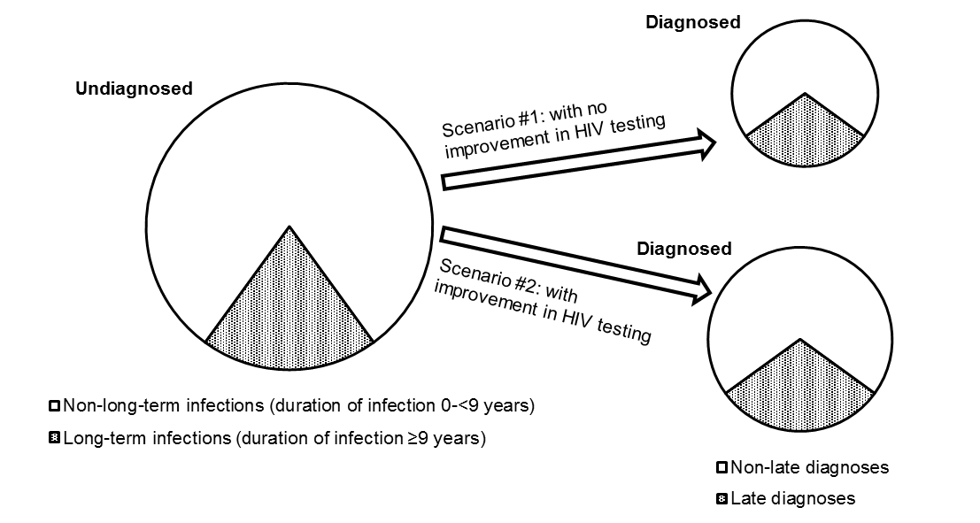

eFigure 1. Number of undiagnosed HIV infections and number of diagnosed HIV infections under two testing scenarios

In theory, it is possible that an improvement in HIV testing can increase the number of non-late diagnoses faster than the number of late diagnoses causing a decrease in the proportion of late diagnoses. However, in reality, it is not the case, because HIV testing has been promoted for decades and an improvement in HIV testing is unlikely to have a dramatic impact on the number of new diagnoses. The stableness of the proportion of late diagnoses has been observed in the United States and across Europe, and predicted by a mathematical model [1-5].

Can we use the proportion of late diagnoses to guide HIV testing efforts?
Studies have reported that some populations, such as people of color, heterosexuals, infection drug users, and migrants, had a significantly higher proportion of late diagnoses and were more likely to be diagnosed late after HIV infection, and recommended targeting HIV testing in these populations [1, 2, 6-8]. Actually, the proportion of late diagnoses cannot be used to guide HIV testing because the following two reasons.

First, as we demonstrated earlier, the proportion of late diagnoses does not measure the risk of being diagnosed late, and a higher proportion of late diagnoses does not necessarily mean a higher risk of being diagnosed late. An excellent example to demonstrate this comes from Eastern and Western European countries. The proportion of late diagnoses was lower in Eastern European countries than it in Western European countries [4, 9]. No evidence suggests that HIV testing was better in Eastern European countries than Western European countries. The lower proportion of late diagnoses in Eastern European countries was actually caused by an increasing HIV incidence in these countries with a larger proportion of new infections entering the undiagnosed pool and then being diagnosed as non-late diagnoses and included in the denominator of the proportion of late diagnoses [10].

Second, these studies recommended targeting HIV testing in populations with a higher proportion of late diagnoses, such as heterosexuals and migrants, but the correct measure that we should use to guide HIV testing efforts is the prevalence of undiagnosed HIV infection [11]. A higher proportion of late diagnoses does not necessary mean higher prevalence of undiagnosed HIV infection. For example, men who have sex with men (MSM) had higher prevalence of undiagnosed HIV infections, but a lower proportion of late diagnoses than heterosexuals [1, 2, 7, 8]. The guidelines recommend targeting MSM for HIV testing, not heterosexuals [11].

Additional limitations of the proportion of late diagnoses
There are a number of additional, although not major, limitations of the measure of the proportion of late diagnoses. First, determining whether a person is diagnosed late should be based on the duration of infection between the time when a person acquired infection and the time when he was diagnosed (e.g., duration ≥9 years: late diagnosis; duration <9 years: non-late diagnosis), but because in most of the cases it is impossible to determine when a person acquired HIV infection, the measure of the proportion of late diagnoses has to depend on the clinical status at diagnosis of a newly diagnosed person (e.g., CD4 count <200 cells/mm³: late diagnosis; CD4 count ≥200 cells/mm³: non-late diagnosis). On average, undiagnosed HIV infections develop AIDS in 10 years after infection, but time varies by individual [12]. Those who develop AIDS earlier than the average will be misclassified as late diagnoses, and those who develop AIDS later than the average will be misclassified as non-late diagnoses. These two groups of misclassification may offset each other in some populations, but unlikely in all, causing an overestimation in some populations and underestimation in the others and making the proportion incomparable across populations [13, 14].

Second, the status of late diagnosis, late or non-late, should be determined at the time of diagnosis, but because in practice it is determined during a follow-up period, what happens during the follow-up period can affect the estimation of the number of late diagnoses. For example, a person who is diagnosed late can be misclassified as a non-late diagnosis if he does not develop AIDS during the follow-up period because of immediate ART after diagnosis.

Third, the current cross-sectional study design includes age at diagnosis in the analysis and reports being old is a risk factor of being diagnosed late, but the correct variable should be age at the time when a person acquired HIV infection [1, 2]. Using the current method, a teenager would never be diagnosed late, because when he is diagnosed late, he will be in his 20s and counted as a late diagnosis in his 20s.

Median CD4 count at HIV diagnosis
Another measure, median CD4 count at HIV diagnosis, has also been widely used to monitoring HIV testing, but it suffers the same limitations [10, 15, 16]. Like the proportion of late diagnoses, median CD4 count at diagnosis measures the Pr(Duration of infection | Being diagnosed), not the Pr(Being diagnosed | Duration of infection). One review article reported a minimal rise of 1.5 cells/mm³/year in median CD4 count in 11 high-income countries from 1992-2011 [3], and the COHERE study reported an even lower rise of 1.2 cells/mm³/year across 34 European countries from 2010 to 2013 [4].

References
1. Tang JJ, Levy V, Hernandez MT. Who are California's late HIV testers? An analysis of state AIDS surveillance data, 2000-2006. Public Health Rep 2011,126:338-343.
2. Yang B, Chan SK, Mohammad N, Meyer JA, Risser J, Chronister KJ, et al. Late HIV diagnosis in Houston/Harris County, Texas, 2000-2007. AIDS Care 2010,22:766-774.
3. Lesko CR, Cole SR, Zinski A, Poole C, Mugavero MJ. A systematic review and meta-regression of temporal trends in adult CD4(+) cell count at presentation to HIV care, 1992-2011. Clin Infect Dis 2013,57:1027-1037.
4. Mocroft A, Lundgren J, Antinori A, Monforte A, Brannstrom J, Bonnet F, et al. Late presentation for HIV care across Europe: update from the Collaboration of Observational HIV Epidemiological Research Europe (COHERE) study, 2010 to 2013. Euro Surveill 2015,20:pii=30070.
5. Xia Q, Kobrak P, Wiewel EW, Torian LV. The high proportion of late HIV diagnoses in the United States is likely to stay: findings from a mathematical model. AIDS Care 2015,27:206-212.
6. Jiang H, Yin J, Fan Y, Liu J, Zhang Z, Liu L, et al. Gender difference in advanced HIV disease and late presentation according to European consensus definitions. Sci Rep 2015,5:14543.
7. Schwarcz S, Hsu L, Dilley JW, Loeb L, Nelson K, Boyd S. Late diagnosis of HIV infection: trends, prevalence, and characteristics of persons whose HIV diagnosis occurred within 12 months of developing AIDS. J Acquir Immune Defic Syndr 2006,43:491-494.
8. Leutscher PD, Laursen T, Andersen B, Ostergaard L, Laursen A, Larsen CS. HIV late presenters in Denmark: need for increased diagnostic awareness among general practitioners. Dan Med Bull 2011,58:A4253.
9. Adler A, Mounier-Jack S, Coker RJ. Late diagnosis of HIV in Europe: definitional and public health challenges. AIDS Care 2009,21:284-293.
10. Xia Q, Torian LV, Shepard CW. Limitations of indicators of HIV case finding. Epidemiology 2015,26:e6-e8.
11. Branson BM, Handsfield HH, Lampe MA, Janssen RS, Taylor AW, Lyss SB, et al. Revised recommendations for HIV testing of adults, adolescents, and pregnant women in health-care settings. MMWR Recomm Rep 2006,55:1-17.
12. Kuo JM, Taylor JM, Detels R. Estimating the AIDS incubation period from a prevalent cohort. Am J Epidemiol 1991,133:1050-1057.
13. Ndawinz JD, Costagliola D, Supervie V. New method for estimating HIV incidence and time from infection to diagnosis using HIV surveillance data: results for France. AIDS 2011,25:1905-1913.
14. Supervie V, Ndawinz JD, Lodi S, Costagliola D. The undiagnosed HIV epidemic in France and its implications for HIV screening strategies. AIDS 2014,28:1797-1804.
15. Hall HI, Tang T, Espinoza L. Late diagnosis of HIV infection in metropolitan areas of the United States and Puerto Rico. AIDS Behav 2016,20:967-972.
16. Braunstein SL, Robertson MM, Myers J, Abraham B, Nash D. Increase in CD4+ T-cell count at the time of HIV diagnosis and antiretroviral treatment initiation among persons with HIV in New York City. J Infect Dis 2016,214:1682-1686.

