Appendix
Appendix Table 1. Number of included individuals, number of tests for drug resistance 6 months after ART initiation, number of tests for acquired drug resistance, number of tests where an acquired drug resistance was detected and numbers of virological failure* episodes by cohort. HIV-CAUSAL Collaboration, 2000-2015.
 | Included individuals | Tests for acquired drug resistance |  | Tests detecting acquired drug resistance |  | Virological failure episodes*
Cohort |  | N | Tests/1000 person-years | N | Tests/1000 person-years | N | Episodes/
 |  |  |  |  |  |  | 1000 person-years
AMACS | 4283 | 29 | 2.8 | 25 | 2.5 | 160 | 15.7
ATHENA | 11259 | 305 | 9.3 | 132 | 4.0 | 284 | 8.7
UK CHIC/DRD | 22314 | 1687 | 31.5 | 466 | 8.7 | 876 | 16.3
CoRIS | 6388 | 156 | 12.0 | 50 | 3.8 | 103 | 7.9
UK Register of Seroconverters | 2068 | 173 | 28.5 | 28 | 4.6 | 151 | 24.9
Swiss HIV Cohort Study | 4669 | 322 | 18.9 | 93 | 5.5 | 300 | 17.6
Overall | 50981 | 2672 | 20.1 | 794 | 6.0 | 1874 | 14.1

*Virological failure was defined as the second of two consecutive HIV-RNA≥1000 copies/mL preceded by HIV-RNA≤50 copies/mL.

Appendix Table 2. Examining the potential impact of cohort heterogeneity. Subgroup analyses excluding each cohort in turn. HIV-CAUSAL Collaboration 2000-2015.

Excluded cohort | ART initiation strategy | Risk at 7 years, % (95% CI)
AMACS | Immediate | 3.1 (2.7,3.4)
 | <500 cells/mm³ | 3.0 (2.6,3.2)
 | <350 cells/mm³ | 2.7 (2.4,3.0)
ATHENA | Immediate | 3.7 (3.2,4.1)
 | <500 cells/mm³ | 3.6 (3.1,4.0)
 | <350 cells/mm³ | 3.0 (2.9,3.7)
UK CHIC | Immediate | 2.1 (1.6,2.4)
 | <500 cells/mm³ | 2.0 (1.5,2.2)
 | <350 cells/mm³ | 1.8 (1.4,2.0)
CoRIS | Immediate | 3.4 (2.9,3.7)
 | <500 cells/mm³ | 3.3 (2.8,3.5)
 | <350 cells/mm³ | 3.0 (2.6,3.3)
UK Register of seroconverters | Immediate | 3.2 (2.8,3.5)
 | <500 cells/mm³ | 3.1 (2.7,3.3)
 | <350 cells/mm³ | 2.8 (2.5,3.0)
Swiss HIV Cohort Study | Immediate | 3.1 (2.7,3.4)
 | <500 cells/mm³ | 3.0 (2.6,3.2)
 | <350 cells/mm³ | 2.7 (2.4,3.0)
All cohorts | Immediate | 3.2 (2.8,3.5)
 | <500 cells/mm³ | 3.1 (2.7,3.3)
 | <350 cells/mm³ | 2.8 (2.5,3.0)

Appendix Figure. Cumulative risk of acquired drug resistance and mean of time-varying variables: observed (solid line) and simulated via the parametric g-formula (dashed line).
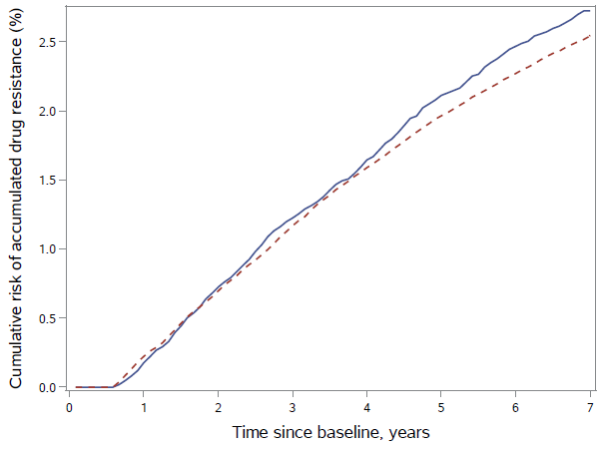 | 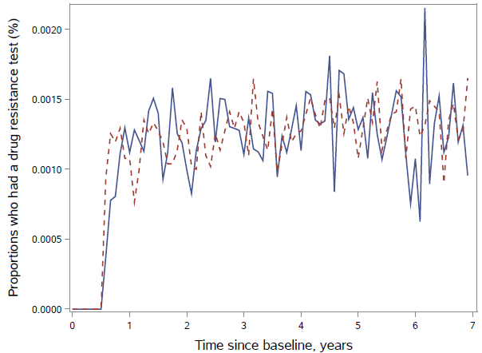
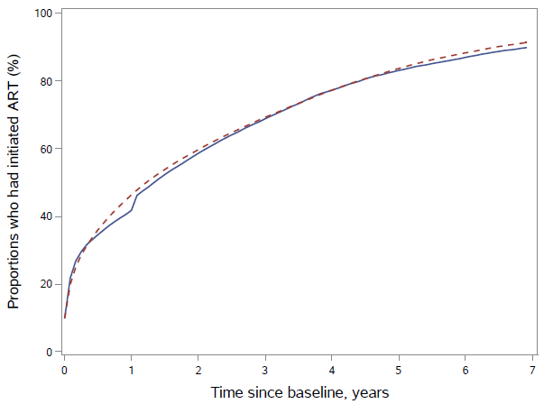 | 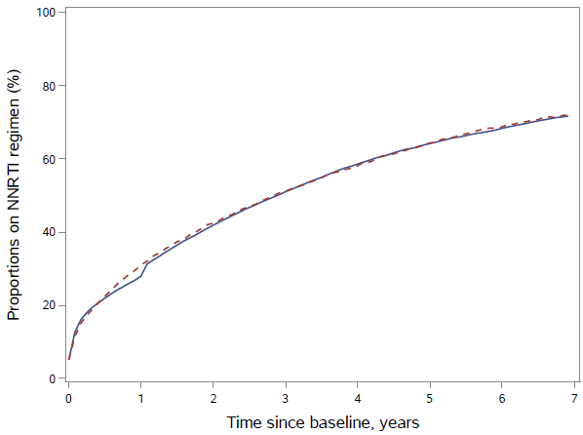
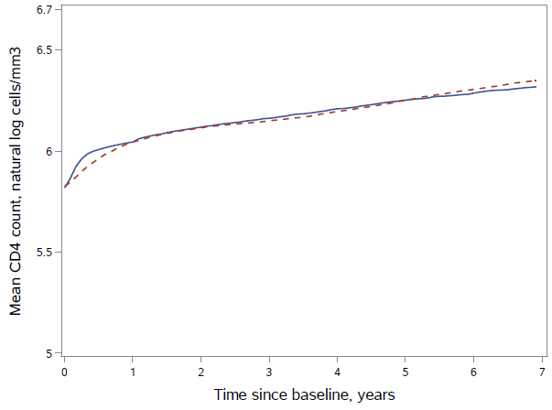 | 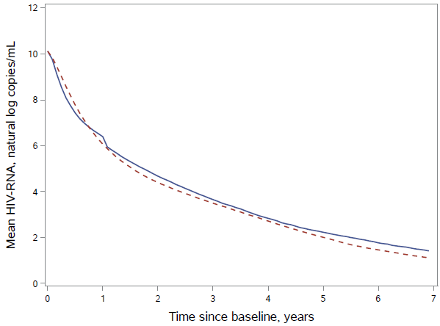
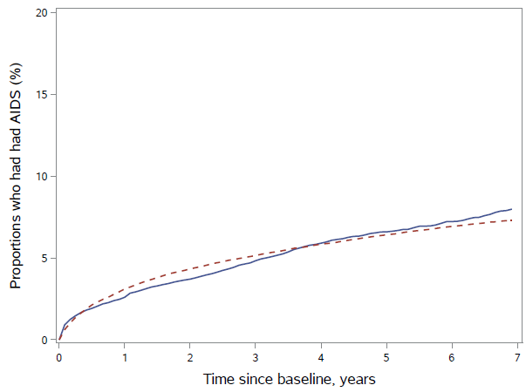 | 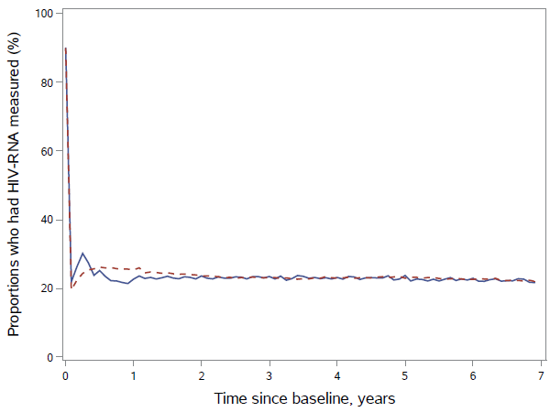

Appendix
Contributors to the HIV-CAUSAL Collaboration – Drug resistance working group

AMACS
Steering Committee: Antoniadou A., Chrysos G., Daikos G., Gargalianos-Kakolyris P., Gogos HA., Katsarou O., Kordossis T., Lazanas M., Nikolaidis P., Panos G., Paparizos V., Paraskevis D., Sambatakou H., Skoutelis A., Touloumi G. (Chair). Coordinating Center: Department of Hygiene, Epidemiology and Medical Statistics, Athens University Medical School, Greece (Touloumi G., Pantazis N., Vourli G., Gountas I., Gioukari V.)
Participating Centers: 4th Dept of Internal Medicine, Athens Medical School, Attikon University Hospital (Antoniadou A, Papadopoulos A, Petrikkos G); Infectious Disease Unit, “Tzaneio” General Hospital of Pireaus (Chrysos G, Paraskeva D, Hatziastros P); 1st Dept of Propedeutic Medicine, Athens University, Medical School “Laikon” General Hopsital (Daikos G, Psichogiou M); 1st Dept of Medicine, Infectious Diseases Unit, "G. Gennimatas" Athens General Hospital (Gargalianos-Kakolyris P, Xylomenos G); 1st Dept of Internal Medicine, Infectious Diseases Section, Patras University Hospital (Gogos HA, Marangos MN, Panos G); Haemophilia Centre, 2nd Blood Transfusion Centre, “Laikon” Athens General Hospital (Katsarou O, Kouramba A, Ioannidou P); AIDS Unit, Dept of Pathophysiology, “Laikon” Athens General Hospital and Athens University, Medical School (Kordossis T, Kontos A); Infectious Diseases Unit, Red Cross General Hospital of Athens (Lazanas M, Chini M, Tsogas N); 1st Dept of Internal Medicine, Infectious Diseases Devision, AHEPA University Hospital, Aristotle University HIV Unit (Nikolaidis P, Kolaras P, Metallidis S); 2nd Internal Medicine Clinic, 1st IKA (Panos G, Haratsis G); AIDS Unit, Clinic of Venereologic & Dermatologic Diseases, Athens University, Medical School, Syngros Hospital (Paparizos V, Leuow K, Kourkounti S); HIV Unit, 2nd Dpt. of Internal Medicine, Athens University, Medical School, Hippokration General Hospital (Sambatakou H, Mariolis I); Infectious Diseases & HIV Division, Dept of Internal Medicine, Evaggelismos Athens General Hospital (Skoutelis A, Papastamopoulos V, Baraboutis I).

ATHENA
The ATHENA database is maintained by Stichting HIV Monitoring and supported by a grant from the Dutch Ministry of Health, Welfare and Sport through the Centre for Infectious Disease Control of the National Institute for Public Health and the Environment.
CLINICAL CENTRES* denotes site coordinating physician: Academic Medical Centre of the University of Amsterdam: HIV treating physicians: J.M. Prins*, T.W. Kuijpers, H.J. Scherpbier, J.T.M. van der Meer, F.W.M.N. Wit, M.H. Godfried, P. Reiss, T. van der Poll, F.J.B. Nellen, S.E. Geerlings, M. van Vugt, D. Pajkrt, W.J. Wiersinga, M. van der Valk, A. Goorhuis, J.W. Hovius. HIV nurse consultants: M.A.H. Bijsterveld, J. van Eden, A.M.H. van Hes, M. Mutschelknauss, H.E. Nobel, F.J.J. Pijnappel, A.M. Weijsenfeld. HIV clinical virologists/chemists: S. Jurriaans, N.K.T. Back, H.L. Zaaijer, B. Berkhout, M.T.E. Cornelissen, C.J. Schinkel, X.V. Thomas. Admiraal De Ruyter Ziekenhuis, Goes: HIV treating physicians: M. van den Berge, A. Stegeman. HIV nurse consultants: S. Baas, L. Hage de Looff. HIV clinical virologists/chemists: B Wintermans, J Veenemans. Catharina Ziekenhuis, Eindhoven: HIV treating physicians: M.J.H. Pronk*, H.S.M. Ammerlaan. HIV nurse consultants: E.S. de Munnik, E. van Beek. HIV clinical virologists/chemists: A.R. Jansz, J. Tjhie, M.C.A. Wegdam, B. Deiman, V. Scharnhorst. Elisabeth-TweeSteden Ziekenhuis, Tilburg: HIV treating physicians: M.E.E. van Kasteren*, A.E. Brouwer. HIV nurse consultants: R. van Erve, B.A.F.M. de Kruijf-van de Wiel, S.Keelan-Pfaf, B. van der Ven. Data collection: B.A.F.M. de Kruijf-van de Wiel, B. van der Ven. HIV clinical virologists/chemists: A.G.M. Buiting, P.J. Kabel, D.Versteeg. Emma Kinderziekenhuis: HIV nurse consultants: A. van der Plas, A.M. Weijsenfeld. Erasmus MC, Rotterdam: HIV treating physicians: M.E. van der Ende*, H.I. Bax, E.C.M. van Gorp, J.L. Nouwen, B.J.A. Rijnders, C.A.M. Schurink, A. Verbon, T.E.M.S. de Vries-Sluijs. HIV nurse consultants: N. Bassant, J.E.A. van Beek, M. Vriesde, L.M. van Zonneveld. Data collection: H.J. van den Berg-Cameron, F.B. Bruinsma-Broekman, J. de Groot, M. de Zeeuw-de Man. HIV clinical virologists/chemists: C.A.B. Boucher, M.P.G Koopmans, J.J.A van Kampen, S.D. Pas. Erasmus MC–Sophia, Rotterdam: HIV treating physicians: G.J.A. Driessen, A.M.C. van Rossum. HIV nurse consultants: L.C. van der Knaap, E. Visser. Flevoziekenhuis, Almere: HIV treating physicians: J. Branger*, A. Rijkeboer-Mes. HIV nurse consultant and data collection: C.J.H.M. Duijf-van de Ven. HagaZiekenhuis, Den Haag: HIV treating physicians: E.F. Schippers*, C. van Nieuwkoop. HIV nurse consultants: J.M. van IJperen, J. Geilings. Data collection: G. van der Hut. HIV clinical virologist/chemist: P.F.H. Franck. HIV Focus Centrum (DC Klinieken): HIV treating physicians: A. van Eeden*. HIV nurse consultants: W. Brokking, M. Groot, L.J.M. Elsenburg. HIV clinical virologists/chemists: M. Damen, I.S. Kwa. Isala, Zwolle: HIV treating physicians: P.H.P. Groeneveld*, J.W. Bouwhuis. HIV nurse consultants: J.F. van den Berg, A.G.W. van Hulzen. Data collection: G.L. van der Bliek, P.C.J. Bor. HIV clinical virologists/chemists: P. Bloembergen, M.J.H.M. Wolfhagen, G.J.H.M. Ruijs. Leids Universitair Medisch Centrum, Leiden: HIV treating physicians: F.P. Kroon*, M.G.J. de Boer, H. Jolink, A.M. Vollaard. HIV nurse consultants: W. Dorama, N. van Holten. HIV clinical virologists/chemists: E.C.J. Claas, E. Wessels. Maasstad Ziekenhuis, Rotterdam: HIV treating physicians: J.G. den Hollander*, K. Pogany, A. Roukens. HIV nurse consultants: M. Kastelijns, J.V. Smit, E. Smit, D. Struik-Kalkman, C. Tearno. Data collection: M. Bezemer, T. van Niekerk. HIV clinical virologists/chemists: O. Pontesilli. Maastricht UMC+, Maastricht: HIV treating physicians: S.H. Lowe*, A.M.L. Oude Lashof, D. Posthouwer. HIV nurse consultants: R.P. Ackens, J. Schippers, R. Vergoossen. Data collection: B. Weijenberg-Maes. HIV clinical virologists/chemists: I.H.M. van Loo, T.R.A. Havenith. MCH-Bronovo, Den Haag: HIV treating physicians: E.M.S. Leyten*, L.B.S. Gelinck. HIV nurse consultants: A.Y. van Hartingsveld, C. Meerkerk, G.S. Wildenbeest. HIV clinical virologists/chemists: J.A.E.M. Mutsaers, S.Q. van Veen. MC Slotervaart, Amsterdam: HIV treating physicians: J.W. Mulder*, S.M.E. Vrouenraets, F.N. Lauw. HIV nurse consultants: M.C. van Broekhuizen, H. Paap, D.J. Vlasblom. HIV clinical virologists/chemists: P.H.M. Smits. MC Zuiderzee, Lelystad: HIV treating physicians: S. Weijer*, R. El Moussaoui. HIV nurse consultant: A.S. Bosma. Medisch Centrum Leeuwarden, Leeuwarden: HIV treating physicians: M.G.A.van Vonderen*, D.P.F. van Houte, L.M. Kampschreur. HIV nurse consultants: K. Dijkstra, S. Faber. HIV clinical virologists/chemists: J Weel. Medisch Spectrum Twente, Enschede: HIV treating physicians: G.J. Kootstra*, C.E. Delsing. HIV nurse consultants: M. van der Burg-van de Plas, H. Heins. Data collection: E. Lucas. Noordwest Ziekenhuisgroep, Alkmaar: HIV treating physicians: W. Kortmann*, G. van Twillert*, J.W.T. Cohen Stuart, B.M.W. Diederen, R. Renckens. HIV nurse consultant and data collection: D. Ruiter-Pronk, F.A. van Truijen-Oud. HIV clinical virologists/chemists: W. A. van der Reijden, R. Jansen. OLVG, Amsterdam: HIV treating physicians: K. Brinkman*, G.E.L. van den Berk, W.L. Blok, P.H.J. Frissen, K.D. Lettinga W.E.M. Schouten, J. Veenstra. HIV nurse consultants: C.J. Brouwer, G.F. Geerders, K. Hoeksema, M.J. Kleene, I.B. van der Meché, M. Spelbrink, H. Sulman, A.J.M. Toonen, S. Wijnands. HIV clinical virologists: M. Damen, D. Kwa. Data collection: E. Witte. Radboudumc, Nijmegen: HIV treating physicians: R. van Crevel*, M. Keuter, A.J.A.M. van der Ven, H.J.M. ter Hofstede, A.S.M. Dofferhoff. HIV nurse consultants: M. Albers, K.J.T. Grintjes-Huisman, M. Marneef, A. Hairwassers. HIV clinical virologists/chemists: J. Rahamat-Langendoen. HIV clinical pharmacology consultant: D. Burger. Rijnstate, Arnhem: HIV treating physicians: E.H. Gisolf*, R.J. Hassing, M. Claassen. HIV nurse consultants: G. ter Beest, P.H.M. van Bentum, N. Langebeek. HIV clinical virologists/chemists: R. Tiemessen, C.M.A. Swanink. Spaarne Gasthuis, Haarlem: HIV treating physicians: S.F.L. van Lelyveld*, R. Soetekouw. HIV nurse consultants: L.M.M. van der Prijt, J. van der Swaluw. Data collection: N. Bermon. HIV clinical virologists/chemists: W.A. van der Reijden, R. Jansen, B.L. Herpers, D.Veenendaal. Medisch Centrum Jan van Goyen, Amsterdam: HIV treating physicians: D.W.M. Verhagen. HIV nurse consultants: M. van Wijk. Universitair Medisch Centrum Groningen, Groningen: HIV treating physicians: W.F.W. Bierman*, M. Bakker, J. Kleinnijenhuis, E. Kloeze, H. Scholvinck, Y. Stienstra, C.L. Vermont, K.R. Wilting. HIV nurse consultants: A. Boonstra, H. de Groot-de Jonge, P.A. van der Meulen, D.A. de Weerd. HIV clinical virologists/chemists: H.G.M. Niesters, C.C. van Leer-Buter, M. Knoester. Universitair Medisch Centrum Utrecht, Utrecht: HIV treating physicians: A.I.M. Hoepelman*, J.E. Arends, R.E. Barth, A.H.W. Bruns, P.M. Ellerbroek, T. Mudrikova, J.J. Oosterheert, E.M. Schadd, M.W.M. Wassenberg, M.A.D. van Zoelen. HIV nurse consultants: K. Aarsman, D.H.M. van Elst-Laurijssen, E.E.B. van Oers-Hazelzet, I. de Kroon. Data collection: M. van Berkel. HIV clinical virologists/chemists: R. Schuurman, F. Verduyn-Lunel, A.M.J. Wensing. VUmc, Amsterdam: HIV treating physicians: E.J.G. Peters*, M.A. van Agtmael, M. Bomers, J. de Vocht. HIV nurse consultants: M. Heitmuller, L.M. Laan. HIV clinical virologists/chemists: C.W. Ang, R. van Houdt, A.M. Pettersson, C.M.J.E. Vandenbroucke-Grauls. Wilhelmina Kinderziekenhuis, UMCU, Utrecht: HIV treating physicians: S.P.M. Geelen, T.F.W. Wolfs, L.J. Bont. HIV nurse consultants: N. Nauta.
COORDINATING CENTRE.Director: P. Reiss. Data analysis: D.O. Bezemer, A.I. van Sighem, C. Smit, F.W.M.N. Wit, T.S. Boender. Data management and quality control: S. Zaheri, M. Hillebregt, A. de Jong. Data monitoring: D. Bergsma, S. Grivell, A. Jansen, M. Raethke, R. Meijering. Data collection: L. de Groot, M. van den Akker, Y. Bakker, E. Claessen, A. El Berkaoui, J. Koops, E. Kruijne, C. Lodewijk, L. Munjishvili, B. Peeck, C. Ree, R. Regtop, Y. Ruijs, T. Rutkens, M. Schoorl, A. Timmerman, E. Tuijn, L. Veenenberg, S. van der Vliet, A. Wisse, T. Woudstra. Patient registration: B. Tuk.

CoRIS/CoRIS-MD
CoRIS is funded by the SPANISH AIDS Research Network (RIS) RD16/0025/0001 project as part of the Plan Nacional R + D + I and cofinanced by ISCIII- Subdirección General de Evaluación y el Fondo Europeo de Desarrollo Regional (FEDER). Steering committee: S Moreno, J del Amo, D Dalmau, ML Navarro, MI González, JL Blanco, F Garcia, R Rubio, JA Iribarren, F Gutiérrez, F Vidal, J Berenguer, J González. Field work, data management, and statistical analyses: P Sobrino, I Jarrín, B Alejos, V Hernando, D Alvarez, C Moreno. Participating centres: Hospital General Universitario de Alicante, Alicante (J Portilla, E Merino, S Reus, V Boix, L Giner, C Gadea, I Portilla, M Pampliega, M Díez, JC Rodríguez, J Sánchez-Payá) ; Hospital Universitari de Bellvitge, Badalona (D Podzamczer, E Ferrer, A Imaz, E Van Den Eyncle, S Di Yacovo, M Sumoy); Hospital Universitario de Canarias, Santa Cruz de Tenerife (JL Gómez, J Hernández, MR Alemán, MM Alonso, MI Hernández, F Díaz-Flores, D García, R Pelazas) ; Hospital Universitario Central de Asturias, Oviedo (V Asensi, E Valle, JA Cartón); Hospital Clínico San Carlos, Madrid (V Estrada, MJ Téllez, J Vergas, E Pérez-Cecila); Hospital Doce de Octubre, Madrid (R Rubio, F Pulido, O Bisbal, M Matarranz, M Lagarde, R Rubio-Martín, A Hernando, L Bermejo, L Dominguez); Hospital Universitario Donostia, San Sebastián (JA Iribarren, J Arrizabalaga, MJ Aramburu, X Camino, F Rodríguez-Arrondo, MÁ von Wichmann, L Pascual, MÁ Goenaga, MJ Bustinduy, H Azkune, M Ibarguren, M Aguado, M Umerez); Hospital General Universitario de Elche, Elche (F Gutiérrez, M Masiá, C López, S Padilla, A Navarro, F Montolio, C Robledano, JG Colomé, A Adsuar, R Pascual, F Carlos, M Martinez, J Llenas, M Fernández, E García); Hospital Germans Trías i Pujol, Badalona (R Muga, J Tor, A Sanvisens); Hospital General Universitario Gregorio Marañón, Madrid (J Berenguer, JC López Bernaldo de Quirós, P Miralles, I Gutiérrez, M Ramírez, B Padilla, P Gijón, A Carrero, T Aldamiz-Echevarría, F Tejerina, FJ Parras, P Balsalobre, C Diez; Hospital Universitari de Tarragona Joan XXIII, IISPV, Universitat Rovira i Virgili, Tarragona (F Vidal, J Peraire, C Viladés, S Veloso, M Vargas, M López-Dupla, M Olona, A Aguilar, JJ Sirvent, V Alba, O Calavia; Hospital Universitario La Fe, Valencia (M Montero, J Lacruz, M Blanes, E Calabuig, S Cuellar, J López, M Salavert) ; Hospital Universitario La Paz/IdiPaz, Madrid (J González, I Bernardino, JR Arribas, ML Montes, JM Peña, B Arribas, JM Castro, FJ Zamora, I Pérez, M Estébanez, S García, M Díaz, NS Alcáriz, J Mingorance, D Montero, A González, MI de José); Hospital de la Princesa, Madrid (I de los Santos, J Sanz, A Salas, C Sarriá, A Gómez-Berrocal, L Garcia-Fraile; Hospital San Pedro-CIBIR, Logroño (JA Oteo, JR Blanco, V Ibarra, L Metola, M Sanz, L Pérez-Martínez) ; Hospital Universitario Miguel Servet, Zaragoza (A Pascual, C Ramos, P Arazo, D Gil); Hospital Universitari Mutua de Terrassa, Terrassa (D Dalmau, A Jaén, M Cairó, D Irigoyen, Q Jordano, M Xercavins, J Martinez-Lacasa, P Velli, R Font, M Sanmartí, L Ibáñez; Complejo Hospitalario de Navarra, Pamplona (M Rivero, MI Casado, JA Díaz, J Uriz, J Repáraz, C Irigoyen, MJ Arraiza); Hospital Parc Taulí, Sabadell (F Segura, MJ Amengual, G Navarro, M Sala, M Cervantes, V Pineda, V Segura, M Navarro, E Antón, MM Nogueras); Hospital Ramón y Cajal, Madrid (S Moreno, JL Casado, F Dronda, A Moreno, MJ Pérez Elías, D López, C Gutiérrez, N Madrid, A Lamas, P Martí, A de Diaz, S Serrrano, L Donat); Hospital Reina Sofía, Murcia (A Cano, E Bernal, Á Muñoz); Hospital San Cecilio, Granada (F García, J Hernández, A Peña, L Muñoz, J Parra, M Alvarez, N Chueca, V Guillot, D Vinuesa, JA Fernández); Centro Sanitario Sandoval, Madrid (J Del Romero, C Rodríguez, T Puerta, JC Carrió, M Vera, J Ballesteros); Hospital de la Santa Creu i Sant Pau, Barcelona (P Domingo, MA Sambeat, K Lamarca, G Mateo, M Gutiérrez, I Fernández); Hospital Universitario Santiago de Compostela, Santiago de Compostela (A Antela, E Losada); Hospital Son Espases, Palma de Mallorca (M Riera, M Peñaranda, M Leyes, MA Ribas, AA Campins, C Vidal, L Gil, F Fanjul, C Marinescu); Hospital Universitari Vall d´Hebron, Barcelona (E Ribera); Hospital Virgen de la Victoria, Málaga (J Santos, M Márquez, I Viciana, R Palacios, I Pérez, CM González); Hospital Universitario Virgen del Rocío, Sevilla (P Viciana, M Leal, LF López-Cortés, N Espinosa); Hospital Universitario de Basurto, Bilbao (J Muñoz, M Zuriñe Zubero, J Mirena, S Ibarra, O Ferrero, J López de Munain, MM Cámara, I López, M de la Peña); Hospital Universitario Infanta Sofía, San Sebastián de los Reyes (I Suárez-García, E Malmierca); Hospital Universitario Costa del Sol, Marbella (J Olalla, A del Arco, J de la Torre, JL Prada, Z Caracuel); Hospital del Poniente, El Ejido (AM Lopez-Lirola, AB Lozano, E Fernández, I Pérez, JM Fernández); Hospital Universitario Santa Lucia, Cartagena (OJ Martínez, FJ Vera, L Martínez, J García, B Alcaraz, A Jimeno); INIBIC-Complejo Hospitalario Universitario de A Coruña, A Coruña (E Poveda, B Pernas, A Mena, M Grandal, A Castro, JD Pedreira); Hospital Clínico Universitario Virgen de la Arrixaca, Murcia (C Galera, H Albendin, A Iborra, A Moreno, MA Campillo, A Vidal); Hospital Marina Baixa, Villajoyosa (C Amador, F Pasquau, J Ena, C Benito, V Fenoll); Complejo Hospitalario de Jaén, Jaén (MO Mohamed-Balghata, MA Gómez); Hospital San Agustín de Avilés, Avilés (MA de Zarraga, ME Rivas); Fundación Jiménez Diaz,Madrid (M Górgolas).

SWISS HIV COHORT STUDY
The Swiss HIV Cohort Study (SHCS) and the SHCS drug resistance database have been supported by the following grants: Swiss National Science Foundation (grants 33CS30_148522 and 320030_159868 to H. F. G.), the SHCS Research Foundation; the Yvonne-Jacob Foundation, Gilead, Switzerland (1 unrestricted grant to the SHCS Research Foundation and 1 unrestricted grant to H. F. G.); and the University of Zurich’s Clinical Research Priority Program (Viral Infectious Diseases: Zurich Primary HIV Infection Study; to H. F. G.).
MEMBERS. Anagnostopoulos A, Battegay M, Bernasconi E, Böni J, Braun DL, Bucher HC, Calmy A, Cavassini M, Ciuffi A, Dollenmaier G, Egger M, Elzi L, Fehr J, Fellay J, Furrer H (Chairman of the Clinical and Laboratory Committee), Fux CA, Günthard HF (President of the SHCS), Haerry D (deputy of "Positive Council"), Hasse B, Hirsch HH, Hoffmann M, Hösli I, Huber M, Kahlert C, Kaiser L, Keiser O, Klimkait T, Kouyos RD, Kovari H, Ledergerber B, Martinetti G, Martinez de Tejada B, Marzolini C, Metzner KJ, Müller N, Nicca D, Paioni P, Pantaleo G, Perreau M, Rauch A (Chairman of the Scientific Board), Rudin C (Chairman of the Mother & Child Substudy), Scherrer AU (Head of Data Centre), Schmid P, Speck R, Stöckle M, Tarr P, Trkola A, Vernazza P, Wandeler G, Weber R, Yerly S.

UK CHIC
UK CHIC is funded by the UK Medical Research Council (Grant numbers G0000199, G0600337, G0900274 and M004236). The views expressed in this manuscript are those of the researchers and not necessarily those of the Medical Research Council.
Steering Committee: Jonathan Ainsworth, Sris Allan, Jane Anderson, Abdel Babiker, David Chadwick, Valerie Delpech, David Dunn, Martin Fisher, Brian Gazzard, Richard Gilson, Mark Gompels, Phillip Hay, Teresa Hill, Margaret Johnson, Sophie Jose, Stephen Kegg, Clifford Leen, Fabiola Martin, Mark Nelson, Chloe Orkin, Adrian Palfreeman, Andrew Phillips, Deenan Pillay, Frank Post, Jillian Pritchard, Caroline Sabin, Achim Schwenk, Anjum Tariq, Roy Trevelion, John Walsh. Central Co-ordination: University College London (Teresa Hill, Sophie Jose, Andrew Phillips, Caroline Sabin); Medical Research Council Clinical Trials Unit at UCL (MRC CTU at UCL), London (David Dunn, Adam Glabay). Participating Centres: Brighton and Sussex University Hospitals NHS Trust (M Fisher, N Perry, S Tilbury, E Youssef, D Churchill); Chelsea and Westminster Hospital NHS Foundation Trust, London (B Gazzard, M Nelson, R Everett, D Asboe, S Mandalia); King’s College Hospital NHS Foundation Trust, London (F Post, H Korat, C Taylor, Z Gleisner, F Ibrahim, L Campbell); Mortimer Market Centre, University College London (R Gilson, N Brima, I Williams); Royal Free NHS Foundation Trust/University College London (M Johnson, M Youle, F Lampe, C Smith, R Tsintas, C Chaloner, S Hutchinson, C Sabin, A Phillips T Hill, S Jose); Imperial College Healthcare NHS Trust, London (J Walsh, N Mackie, A Winston, J Weber, F Ramzan, M Carder); Barts and The London NHS Trust, London (C Orkin, J Lynch, J Hand, C de Souza); Homerton University Hospital NHS Trust, London (J Anderson, S Munshi); North Middlesex University Hospital NHS Trust, London (J Ainsworth, A Schwenk, S Miller, C Wood); The Lothian University Hospitals NHS Trust, Edinburgh (C Leen, A Wilson, S Morris); North Bristol NHS Trust (M Gompels, S Allan); Leicester, University Hospitals of Leicester NHS Trust (A Palfreeman, K Memon, A Lewszuk); Middlesbrough, South Tees Hospitals NHS Foundation Trust, (D Chadwick, E Cope, J Gibson); Woolwich, Lewisham and Greenwich NHS Trust (S Kegg, P Main, Dr Mitchell, Dr Hunter), St. George’s Healthcare NHS Trust (P Hay, M Dhillon); York Teaching Hospital NHS Foundation Trust (F Martin, S Russell-Sharpe); Coventry, University Hospitals Coventry and Warwickshire NHS Trust (S Allan, A Harte, S Clay); Wolverhampton, The Royal Wolverhampton Hospitals NHS Trust (A Tariq, H Spencer, R Jones); Chertsey, Ashford and St.Peter’s Hospitals NHS Foundation Trust (J Pritchard, S Cumming, C Atkinson); Public Health England, London (V Delpech); HIV i-base (R Trevelion).

UK HIV Drug Resistance Database
The UK HIV Drug Resistance Database is funded by the UK Medical Research Council.
Steering Committee: David Asboe, Anton Pozniak (Chelsea & Westminster Hospital, London); Patricia Cane (Public Health England, Porton Down); David Chadwick (South Tees Hospitals NHS Trust, Middlesbrough); Duncan Churchill (Brighton and Sussex University Hospitals NHS Trust); Duncan Clark (Barts Health NHS Trust, London); Simon Collins (HIV i-Base, London); Valerie Delpech (National Infection Service, Public Health England); Samuel Douthwaite (Guy’s and St. Thomas’ NHS Foundation Trust, London); David Dunn, Esther Fearnhill, Kholoud Porter, Anna Tostevin, Ellen White, Oliver Stirrup (Research Department of Infection and Population Health, UCL); Christophe Fraser (University of Oxford); Anna Maria Geretti (Institute of Infection and Global Health, University of Liverpool); Rory Gunson (Gartnavel General Hospital, Glasgow); Antony Hale (Leeds Teaching Hospitals NHS Trust); Stéphane Hué (London School of Hygiene and Tropical Medicine); Steve Kaye (Imperial College, London); Linda Lazarus (Expert Advisory Group on AIDS Secretariat, Public Health England); Andrew Leigh-Brown (University of Edinburgh); Tamyo Mbisa (National Infection Service, Public Health England); Nicola Mackie (Imperial NHS Trust, London); Samuel Moses (King’s College Hospital, London); Chloe Orkin (Barts Health NHS Trust, London); Eleni Nastouli, Deenan Pillay, Andrew Phillips, Caroline Sabin (University College London, London); Erasmus Smit (Public Health England, Birmingham Heartlands Hospital); Kate Templeton (Royal Infirmary of Edinburgh); Peter Tilston (Manchester Royal Infirmary); Ian Williams (Mortimer Market Centre, London); Hongyi Zhang (Addenbrooke’s Hospital, Cambridge).
Coordinating Centre: Research Department of Infection and Population Health, UCL (David Dunn, Keith Fairbrother, Esther Fearnhill, Kholoud Porter, Anna Tostevin, Ellen White, Oliver Stirrup)
Centres contributing data: Clinical Microbiology and Public Health Laboratory, Addenbrooke’s Hospital, Cambridge (Jane Greatorex); Guy’s and St Thomas’ NHS Foundation Trust, London (Siobhan O’Shea, Jane Mullen); PHE – Public Health Laboratory, Birmingham Heartlands Hospital, Birmingham (Erasmus Smit); Antiviral Unit, National Infection Service, Public Health England, London (Tamyo Mbisa); Imperial College Health NHS Trust, London (Alison Cox); King's College Hospital, London (Richard Tandy); Medical Microbiology Laboratory, Leeds Teaching Hospitals NHS Trust (Tracy Fawcett); Specialist Virology Centre, Liverpool (Mark Hopkins); Department of Clinical Virology, Manchester Royal Infirmary, Manchester (Peter Tilston); Department of Virology, Royal Free Hospital, London (Clare Booth, Ana Garcia-Diaz); Edinburgh Specialist Virology Centre, Royal Infirmary of Edinburgh (Lynne Renwick); Department of Infection & Tropical Medicine, Royal Victoria Infirmary, Newcastle (Matthias L Schmid, Brendan Payne); South Tees Hospitals NHS Trust, Middlesbrough (David Chadwick); Department of Virology, Barts Health NHS Trust, London (Duncan Clark, Jonathan Hubb); Molecular Diagnostic Unit, Imperial College, London (Steve Kaye); University College London Hospitals (Stuart Kirk); West of Scotland Specialist Virology Laboratory, Gartnavel, Glasgow (Rory Gunson, Amanda Bradley-Stewart).

UK Register of HIV Seroconverters
The UK Register of HIV Seroconversion is funded by the UK Medical Research Council. Steering Committee: Andrew Phillips (Chair), University College London (UCL), London; Abdel Babiker, MRC CTU, London; Valerie Delpech, Public Health England, London; Sarah Fidler, St. Mary’s Hospital, London; Martin Fisher, Brighton & Sussex University Hospitals NHS Trust, Brighton; Julie Fox, Guys and St Thomas' NHS Trust/ Kings College, London; Richard Gilson, West London Centre for Sexual Health, London; David Goldberg, Health Protection Scotland, Glasgow; David Hawkins, Chelsea & Westminster NHS Trust, London; Anne Johnson, UCL, London; Margaret Johnson, UCL and Royal Free NHS Trust, London; Ken McLean, West London Centre for Sexual Health, London; Deenan Pillay, UCL, London; Frank Post, Kings College, London. Collaborating clinical centres: N Kennedy, Monklands Hospital, Airdrie; J Pritchard , Ashford Hospital, Ashford; U Andrady, Ysbyty Gwynedd, Bangor; N Rajda, North Hampshire Hospital, Basingstoke; C Donnelly, S McKernan, Royal Victoria Hospital, Belfast; S Drake, G Gilleran, D White, Birmingham Heartlands Hospital, Birmingham; J Ross, J Harding, R Faville, Whittall Street Clinic, Birmingham; J Sweeney, P Flegg, S Toomer, Blackpool Victoria Hospital, Blackpool; H Wilding, R Woodward, Royal Bournemouth Hospital, Bournemouth; G Dean, C Richardson, N Perry, Royal Sussex County Hospital, Brighton; M Gompels, L Jennings, Southmead Hospital, Bristol; D Bansaal, Queens Hospital, Burton-upon-Trent; M Browing, L Connolly, Cardiff Royal Infirmary, Cardiff; B Stanley, North Cumbria Acute Hospitals NHS Trust, Carlisle; S Estreich, A Magdy, St. Helier Hospital, Carshalton; C O’Mahony, Countess of Chester Hospital, Chester; P Fraser, Chesterfield & North Derbyshire Royal Hospital, Chesterfield; SPR Jebakumar, Essex County Hospital, Colchester; L David, Coventry & Warwickshire Hospital, Coventry; R Mette, Mayday University Hospital, Croydon; H Summerfield, Weymouth Community Hospital, Dorset; M Evans, Ninewells Hospital, Dundee; C White, University Hospital of North Durham, Durham; R Robertson, Muirhouse Medical Group, Edinburgh; C Lean, S Morris, Western General Hospital, Edinburgh; A Winter, Gartnavel General Hospital & Glasgow Royal Infirmary, Glasgow; S Faulkner, Gloucestershire Royal Hospital, Gloucester; B Goorney, Salford Hope Hospital, Greater Manchester; L Howard, Farnham Road Hospital, Guildford; I Fairley, C Stemp, Harrogate Hospital, Harrogate; L Short, Huddersfield Royal Infirmary, Huddersfield; M gomez, F young, St Mary’s Hospital Isle of Wight; M Roberts, S Green, Kidderminster General Hospital, Kidderminster; K Sivakumar, The Queen Elizabeth Hospital, King's Lynn; J Minton, A Siminoni, Leeds General Infirmary, Leeds; J Calderwood, D Greenhough, J Minton, St. James Hospital, Leeds; C DeSouza, Lisa Muthern, C Orkin, Barts & The London NHS Trust, London; S Murphy, M Truvedi, Central Middlesex Hospital, London; K McLean, Charing Cross Hospital, London; D Hawkins, C Higgs, A Moyes, Chelsea & Westminster Hospital, London; S Antonucci, S McCormack, Dean Street Clinic, London; W Lynn, Ealing Hospital, London; M Bevan, J Fox, A Teague, Guy's & St. Thomas NHS Trust, London; J Anderson, S Mguni, Homerton Hospital, London; F Post, L Campbell, E Wandolo King's College Hospital, London; C Mazhude, H Russell, Lewisham University Hospital, London; R Gilson, G Carrick, C Young Mortimer Market Centre, London; J Ainsworth, A Waters, North Middlesex Hospital, London; P Byrne, M Johnson, Royal Free Hospital, London; London; S Fidler, K Kuldanek, S Mullaney, St. Mary's Hospital, London; V Lawlor, R Melville, Whipps Cross Hospital, London; A Sukthankar, S Thorpe, Manchester Royal Infirmary, Manchester; C Murphy, E Wilkins, North Manchester General Hospital, Manchester; S Ahmad, P Green, Withington Hospital, Manchester; S Tayal, James Cook Hospital, Middlesbrough; E Ong, Newcastle General Hospital, Newcastle; J Meaden, Norfolk & Norwich University Hospital, Norwich; L Riddell, City Hospital, Nottingham; D Loay, K Peacock, George Eliot Hospital, Nunneaton; H Blackman, V Harindra, St. Mary's Hospital, Portsmouth; AM Saeed, Royal Preston Hospital, Preston; S Allen, U Natarajan, East Surrey Hospital, Redhill; O Williams, Glan Clwyd District General, Rhyl; H Lacey, Baillie Street Health Centre, Rochdale; C Care, C Bowman, S Herman, Royal Hallamshire Hospital, Sheffield; S V Devendra, J Wither, Royal Shrewsbury Hospital, Shrewsbury; A Bridgwood, G Singh, North Staffordshire Hospital, Stoke-on-Trent; S Bushby, Sunderland Royal Hospital, Sunderland; D Kellock, S Young, King's Mill Centre, Sutton-in-Ashfield; G Rooney, B Snart, The Great Western Hospital, Swindon; J Currie, M. Fitzgerald, Taunton & Somerset Hospital, Taunton; J Arumainayyagam, S Chandramani, Manor Hospital, Walsall; S Rajamanoharan, T Robinson, Watford General Hospital, Watford; M Roberts, Worcester Royal Infirmary, Worcester; O Williams, Maelor Hospital, Wrexham; B Taylor, Wycombe General Hospital, Wycombe; C Brewer, I Fairley, Monkgate Health Centre, York Hospital NHS Trust, York.

