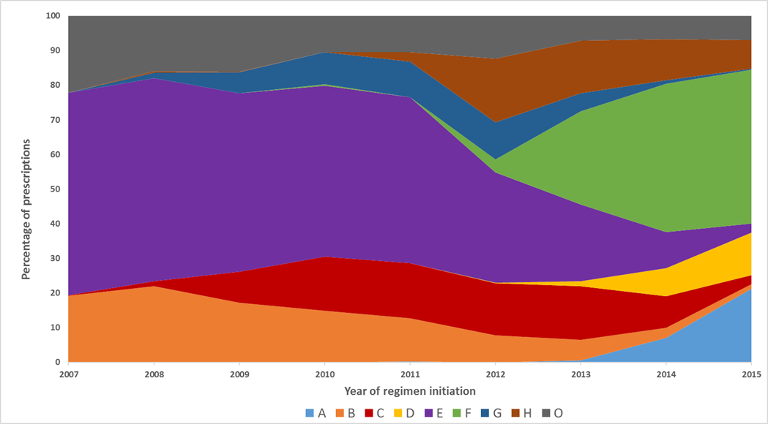
Supplemental Figure. Prescribing patterns for treatment naïve PLWH in the CNICS cohort initiating ART between 2007 – 2015 (Supplemental)

A | Dolutegravir/abacavir/lamivudine
B | Atazanavir/ritonavir/emtricitabine/tenofovir/r
C | Darunavir/ritonavir/emtricitabine/tenofovir
D | Dolutegravir/emtricitabine/tenofovir
E | Efavirenz/emtricitabine/tenofovir
F | Elvitegravir/cobicistat/emtricitabine/tenofovir
G | Raltegravir/emtricitabine/tenofovir
H | Rilpivirine/emtricitabine/tenofovir
O | Other

1. Lundgren, J.D., et al., Initiation of Antiretroviral Therapy in Early Asymptomatic HIV Infection. N Engl J Med, 2015. 373(9): p. 795-807.
2. Cohen, M.S., et al., Antiretroviral Therapy for the Prevention of HIV-1 Transmission. N Engl J Med, 2016.
3. DHHS. Guidelines for the Use of Antiretroviral Agents in HIV-1-Infected Adults and Adolescents.
. [cited 2016 August 10]; Available from: http://aidsinfo.nih.gov/guidelines/html/1/adult-and-adolescent-arv-guidelines/0.
4. Gunthard, H.F., et al., Antiretroviral Drugs for Treatment and Prevention of HIV Infection in Adults: 2016 Recommendations of the International Antiviral Society-USA Panel. Jama, 2016. 316(2): p. 191-210.
5. Clotet, B., et al., Once-daily dolutegravir versus darunavir plus ritonavir in antiretroviral-naive adults with HIV-1 infection (FLAMINGO): 48 week results from the randomised open-label phase 3b study. Lancet, 2014. 383(9936): p. 2222-31.
6. Walmsley, S.L., et al., Dolutegravir plus abacavir-lamivudine for the treatment of HIV-1 infection. N Engl J Med, 2013. 369(19): p. 1807-18.
7. Sax, P.E., et al., Tenofovir alafenamide versus tenofovir disoproxil fumarate, coformulated with elvitegravir, cobicistat, and emtricitabine, for initial treatment of HIV-1 infection: two randomised, double-blind, phase 3, non-inferiority trials. Lancet, 2015. 385(9987): p. 2606-15.
8. Stellbrink, H.J., et al., Comparison of changes in bone density and turnover with abacavir-lamivudine versus tenofovir-emtricitabine in HIV-infected adults: 48-week results from the ASSERT study. Clin Infect Dis, 2010. 51(8): p. 963-72.
9. Wohl, D., et al., Brief Report: A Randomized, Double-Blind Comparison of Tenofovir Alafenamide Versus Tenofovir Disoproxil Fumarate, Each Coformulated With Elvitegravir, Cobicistat, and Emtricitabine for Initial HIV-1 Treatment: Week 96 Results. J Acquir Immune Defic Syndr, 2016. 72(1): p. 58-64.
10. Castillo-Mancilla, J.R., et al., Minorities remain underrepresented in HIV/AIDS research despite access to clinical trials. HIV Clin Trials, 2014. 15(1): p. 14-26.
11. Nieuwkerk, P.T., et al., LImited patient adherence to highly active antiretroviral therapy for hiv-1 infection in an observational cohort study. Archives of Internal Medicine, 2001. 161(16): p. 1962-1968.
12. Al-Dakkak, I., et al., The impact of specific HIV treatment-related adverse events on adherence to antiretroviral therapy: a systematic review and meta-analysis. AIDS Care, 2013. 25(4): p. 400-14.
13. Eaton, E.F., et al., Unanticipated effects of new drug availability on antiretroviral durability: Implications for Comparative Effectiveness Research. 2016: Open Forum Infectious Diseases
14. Sheth, A.N., et al., Antiretroviral regimen durability and success in treatment-naive and treatment-experienced patients by year of treatment initiation, United States, 1996-2011. J Acquir Immune Defic Syndr, 2015.
15. Slama, L., et al., Increases in duration of first highly active antiretroviral therapy over time (1996-2009) and associated factors in the Multicenter AIDS Cohort Study. J Acquir Immune Defic Syndr, 2014. 65(1): p. 57-64.
16. Di Biagio, A., et al., Discontinuation of Initial Antiretroviral Therapy in Clinical Practice: Moving Toward Individualized Therapy. J Acquir Immune Defic Syndr, 2016. 71(3): p. 263-71.
17. Kitahata, M.M., et al., Cohort profile: the Centers for AIDS Research Network of Integrated Clinical Systems. Int J Epidemiol, 2008. 37(5): p. 948-55.
18. Markowitz, M., et al., Rapid and durable antiretroviral effect of the HIV-1 Integrase inhibitor raltegravir as part of combination therapy in treatment-naive patients with HIV-1 infection: results of a 48-week controlled study. J Acquir Immune Defic Syndr, 2007. 46(2): p. 125-33.
19. Arribas, J.R., et al., The MONET trial: week 144 analysis of the efficacy of darunavir/ritonavir (DRV/r) monotherapy versus DRV/r plus two nucleoside reverse transcriptase inhibitors, for patients with viral load < 50 HIV-1 RNA copies/mL at baseline. HIV Med, 2012. 13(7): p. 398-405.
20. McKinnell, J.A., et al., Antiretroviral prescribing patterns in treatment-naive patients in the United States. AIDS Patient Care STDS, 2010. 24(2): p. 79-85.
21. Cotte, L., et al., Effectiveness and tolerance of single tablet versus once daily multiple tablet regimens as first-line antiretroviral therapy - Results from a large french multicenter cohort study. PLoS One, 2017. 12(2): p. e0170661.
22. Robison, L.S., et al., Short-term discontinuation of HAART regimens more common in vulnerable patient populations. AIDS Res Hum Retroviruses, 2008. 24(11): p. 1347-55.
23. Hughes, A.J., et al., Discontinuation of antiretroviral therapy among adults receiving HIV care in the United States. J Acquir Immune Defic Syndr, 2014. 66(1): p. 80-9.
24. Centers for Disease Control and Prevention. Reportable STDs in Young People 15-24 Years of Age, by State. 2013; Available from: https://www.cdc.gov/std/stats/by-age/15-24-all-stds/default.htm.
25. The Centers for Disease Control. HIV in the United States: At A Glance. July 2015 [cited 2016 February 26]; Available from: http://www.cdc.gov/hiv/pdf/statistics_basics_ataglance_factsheet.pdf.

