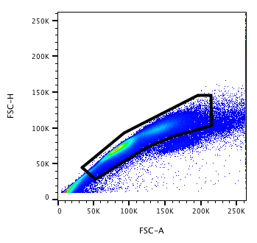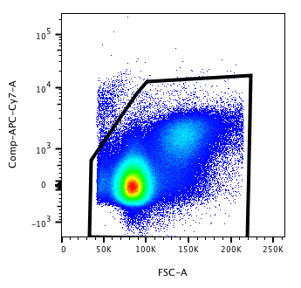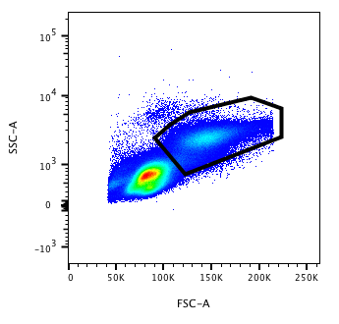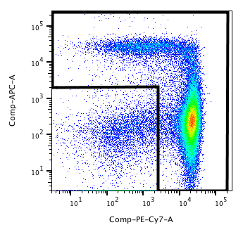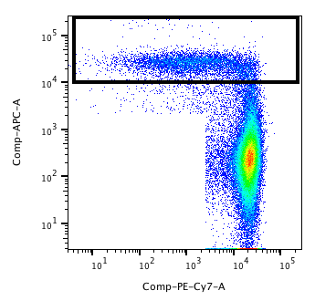0251665408251661312251660288251663360251662336251664384
FSC-H
FSC-A
Live/Dead (Near-IR)
FSC-A
SSC-A
FSC-A
CD14-Pe-Cy7
CD16-APC
CD16-APC
CD14-Pe-Cy7
Supplementary Figure 1. Gating strategy for CD16⁺ monocytes from whole blood or PBMCs. Depicted above is the gating strategy used for identification and quantification of the CD16⁺ monocyte population within whole blood or PBMCs. Within whole blood or PBMCs, viable monocytes were gated based on SSC and FSC-A. Next, the total monocyte population (CD16⁻ and CD16⁺ monocytes) was gated based on CD14 and CD16 expression. Within the monocyte population, cells were gated based on CD16 expression

Patient Information | HIV+MJ- | HIV+MJ-  (N) | HIV+MJ+ | HIV+MJ+  (N) | P
Age (years) | 53.4 (11.7) | 27 | 53.8 (8.93) | 13 | 0.922
BMI | 29.1 (7.3) | 27 | 26 (7.9) | 13 | 0.136
CD4 T-cell Count (cells/μL) | 609.7 (400.1) | 29 | 500.3 (278.2) | 13 | 0.501
CD4/CD8 Ratio | 0.8 (0.55) | 29 | 0.56 (0.43) | 13 | 0.099
Time Infected with HIV (years) | 14.0 (9.3) | 27 | 19.2 (11.9) | 13 | 0.139
% on ART | 100 | 29 | 100 | 13 | -
% with Undetectable Viral Load | 86.2 | 29 | 76.9 | 13 | -
Cigarette Smoking (%) | 31.0 | 29 | 30.8 | 13
Alcohol Use (%) | 51.7 | 29 | 61.5 | 13
Other Drug Use (%) | 0 | 28 | 0 | 12
Supplementary Table 1. HIV-positive patient demographic and immunologic information.
BMI: body mass index; CD4: cluster of differentiation 4; CD8: cluster of differentiation 8; HIV: human immunodeficiency virus; ART: antiretroviral therapy. Age, BMI, CD4 T-cell count, CD4/CD8 ratio and time infected with HIV are expressed as a mean (standard deviation - SD) and either an unpaired t-test or a Mann-Whitney test was performed. The sensitivity of detection for viral load was 50 copies/mL. Other drug use includes cocaine, methamphetamine and heroin. Unequal N values present between rows indicate missing patient information.

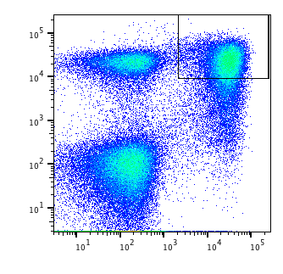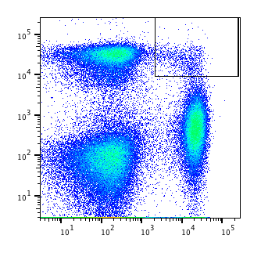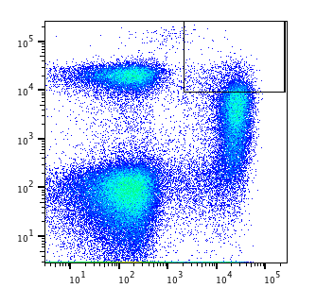0
CD14-Pe-Cy7
CD16-APC
IFNα - 48h
NS - 48h
0h

Supplementary Figure 2. IFNα treatment increases CD16 and CD163 expression on monocytes. PBMCs from HIV-MJ- donors were cultured without stimulation (NS) or with the addition of IFNα (50U/ml) for 48h. Flow cytometry plots represent PBMCs at time 0h, 48h NS and 48h with IFNα. Viable PBMCs were analyzed for CD14 and CD16 expression. The gates set above are monocytes (CD14⁺) expressing CD16 (gate).

