SUPPLEMENTS
Table 1; Characteristics of patients and healthy controls (HC)
Donor | BPNSTª | Gender | Age  (years) | Height  (cm) | Time on ART  (years) | Last CD4 count  (cell/uL) | IEFND^{b}  (per mm²)
Patient 1 | HIV-SN+ | Female | 33 | 158 | 7 | 406 | 1.6
Patient 2 | HIV-SN+ | Female | 33 | 167 | 7.5 | 729 | 9.7
Patient 3 | HIV-SN+ | Male | 34 | 175 | 5 | 714 | 3.0
Patient 4 | HIV-SN+ | Male | 47 | 167 | 6.8 | 284 | 4.6
Patient 5 | HIV-SN+ | Male | 45 | 167 | 3.5 | 300 | 0.8
Patient 6 | HIV-SN- | Male | 38 | 179 | 8.7 | 626 | 6.7
Patient 7 | HIV-SN- | Female | 41 | 150 | 1 | 435 | 6.6
Patient 8 | HIV-SN- | Male | 35 | 165 | 12 | 693 | 5.4
Patient 9 | HIV-SN- | Female | 32 | 165 | 3.6 | 385 | 9.0
Patient 10 | HIV-SN- | Male | 44 | 171 | 2.8 | 84 | 4.0
Patient 11 | HIV-SN- | Male | 36 | 168 | 1 | 566 | 1.3
Patient 12 | HIV-SN- | Male | 25 | 165 | 1.6 | 653 | 14.0
Patient 13 | HIV-SN- | Male | 34 | 166 | 2.2 | 386 | 5.2
Patient 14 | HIV-SN- | Female | 41 | 150 | 1 | 448 | 5.8
HC1 | - | Female | 28 | 158 | - | - | -
HC2 | - | Female | 33 | 162 | - | - | 11.2
HC3 | - | Female | 33 | 151 | - | - | 15.2
HC4 | - | Male | 37 | 169 | - | - | 5.8

ª Brief Peripheral Neuropathy Screening Tool
^{b} Inter Epithelial Nerve Fibre Density

Table 2; Summary of donor characteristics
(BPNST) | N value | Male  (n) | Age  (years) | Height  (cm) | Time on ART  (years) | Last CD4  (cell/uL) | IEFND  (per mm²)
HIV-SN+  HIV-SN-  HC | 5  9  4 | 3  6  1  p=1.0ª | 34 (33-47)  36 (25-44)  33 (28-37)  p=0.84^{b} | 167 (158-175)  165 (150-179)  160 (151-169)  p=0.50 ^{b} | 6.8 (3.5-7.5)  2.2 (1.0-12)  n/a  p=0.14 ^{b} | 406 (284-729)  448 (84-693)  n/a  p=1.0 ^{b} | 3.0 (0.8 – 9.7)  5.8 (1.3 – 14.0)  11.2 (5.8 – 15.2)  p=0.19 ^{b}

Results are presented as median (range); n/a not applicable
ª Fisher's exact test (HIV-SN+ versus HIV-SN-), ^{b} Mann-Whitney test (HIV-SN+ versus HIV-SN-)

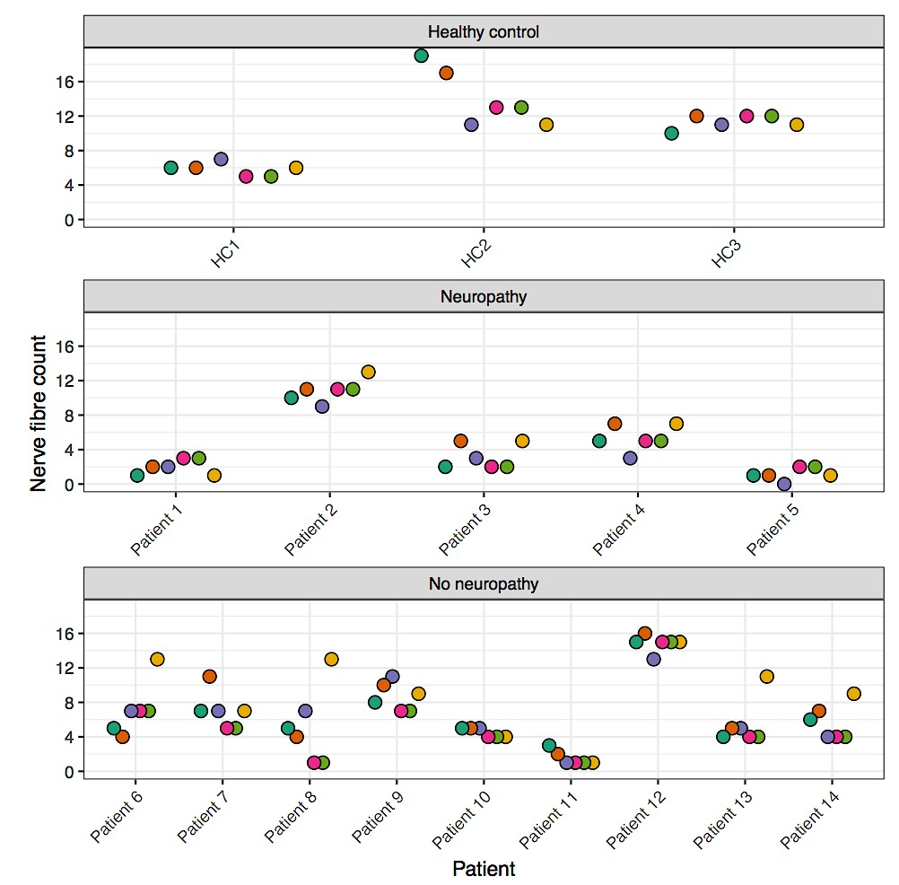
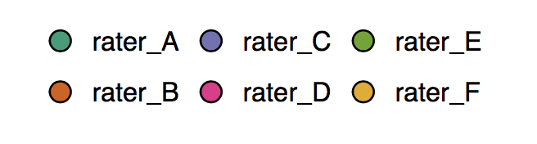
Figure 1. Mean intraepidermal nerve fibre count for each patient as determined by each rater

