Supplement materials
Supplementary tables
Table S1: Antibody responses at different time points in Y, M and O age groups in HIV⁺ and HIV⁻
Geometric mean antibody titer |  |  |  |  | P Values
H1N1 antigen | T0 | T1 | T2 | T3 | T0 vs T1 | T0 vs T2 |  | T0 vs T3 | T1 vsT2 T2 | T1 vs T3 | T2 vs T3
HIV+ Y | 230.93 | 434.47 | 577.98 | 277.25 | 0.0084 | 0.0001 |  | NS | NS | NS | 0.0035
HIV+ M | 191.22 | 423.12 | 457.05 | 276.25 | 0.0001 | <0.0001 |  | NS | NS | NS | 0.0092
HIV+ O | 122.95 | 237.76 | 324.47 | 234.25 | 0.0155 | 0.0003 |  | 0.0479 | NS | NS | NS
HIV⁻ Y | 201.59 | 476.52 | 866.72 | 382.34 | 0.0008 | <0.0001 |  | 0.0112 | 0.0199 | NS | <0.0001
HIV⁻ M | 93.79 | 331.10 | 647.31 | 332.11 | <0.0001 | <0.0001 |  | <0.0001 | 0.0006 | NS | 0.0009
HIV⁻ O | 109.36 | 269.09 | 356.76 | 201.59 | <0.0001 | <0.0001 |  | 0.0133 | NS | NS | 0.0204
B antigen
HIV+ Y | 196.18 | 384.45 | 554.89 | 343.79 | 0.0012 | <0.0001 | 0.0021 |  | NS | NS | NS
HIV+ M | 176.65 | 354.88 | 452.55 | 366.81 | <0.0001 | <0.0001 | <0.0001 |  | NS | NS | NS
HIV+ O | 131.77 | 281.75 | 383.19 | 298.57 | 0.006 | 0.0001 | 0.0011 |  | NS | NS | NS
HIV⁻ Y | 219.83 | 512.99 | 1045.71 | 746.58 | <0.0001 | <0.0001 | <0.0001 |  | 0.0002 | 0.0485 | NS
HIV⁻ M | 147.77 | 334.88 | 632.77 | 458.18 | <0.0001 | <0.0001 | <0.0001 |  | 0.0002 | NS | NS
HIV⁻ O | 155.71 | 320.00 | 455.63 | 241.15 | 0.0014 | <0.0001 | 0.0063 |  | NS | NS | NS
H3N2 antigen
HIV+ Y | 135.92 | 217.23 | 288.99 | 195.67 | 0.0207 | 0.0042 | NS |  | NS | NS | 0.0361
HIV+ M | 123.68 | 229.81 | 289.83 | 206.07 | 0.0091 | 0.0011 | 0.0490 |  | NS | NS | NS
HIV+ O | 98.49 | 176.65 | 274.74 | 205.87 | 0.0083 | 0.0001 | 0.0086 |  | NS | NS | NS
HIV⁻ Y | 128.84 | 280.22 | 403.17 | 206.98 | 0.0026 | <0.0001 | NS |  | 0.0465 | NS | 0.0008
HIV⁻ M | 85.64 | 191.90 | 282.40 | 133.58 | <0.0001 | <0.0001 | 0.0050 |  | NS | NS | 0.0039
HIV⁻ O | 126.99 | 293.44 | 431.53 | 262.51 | 0.0142 | <0.0001 | NS |  | NS | NS | 0.0061
NS: not significant; Y=young, M=middle age, O=old.

Table S2: Comparisons of antibody responses between age groups and between HIV groups
Comparison between Y, M and O age groups for HIV⁺ or HIV⁻ at each time point
 | T0 |  |  | T1 |  |  |  | T2 |  |  | T3
Antigen : group | Y vs M | Y vs. O | M vs. O | Y vs M | Y vs. O |  | M vs. O | Y vs M | Y vs. O | M vs. O | Y vs M | Y vs. O | M vs. O
H1N1: HIV+ | NS | 0.0162 | NS | NS | 0.0164 |  | 0.0166 | NS | 0.0104 | NS | NS | NS | NS
H1N1: HIV⁻ | 0.0053 | 0.0303 | NS | NS | 0.0294 |  | NS | NS | 0.0004 | 0.0182 | NS | 0.0121 | 0.0167
B: HIV+ | NS | NS | NS | NS | NS |  | NS | NS | NS | NS | NS | NS | NS
B: HIV⁻ | 0.0342 | NS | NS | 0.0033 | 0.0183 |  | NS | 0.0011 | <0.0001 | NS | 0.0050 | 0.0023 | NS
H3N2: HIV+ | NS | NS | NS | NS | NS |  | NS | NS | NS | NS | NS | NS | NS
H3N2: HIV⁻ | 0.0145 | NS | 0.0250 | NS | NS |  | 0.0114 | 0.0330 | NS | 0.0084 | NS | NS | NS
Comparison between HIV⁺ vs. HIV⁻ in different age groups at each time point
Age groups | T0 |  |  | T1 |  |  |  | T2 |  |  | T3
 | H1N1 | B | H3N2 | H1N1 | B | H3N2 |  | H1N1 | B | H3N2 | H1N1 | B | H3N2
HIV⁺ vs. HIV⁻: Y | NS | NS | NS | NS | NS | NS |  | NS | 0.013 | 0.038 | 0.0463 | 0.0342 | NS
HIV⁺ vs. HIV⁻: M | 0.0002 | NS | 0.0411 | NS | NS | NS |  | NS | NS | NS | NS | NS | NS
HIV⁺ vs. HIV⁻: O | NS | NS | NS | NS | NS | 0.0280 |  | NS | NS | 0.001 | NS | NS | NS
HIV⁺Y vs. HIV⁻: M | NS | NS | NS | NS | NS | NS |  | NS | NS | NS | NS | NS | NS
HIV⁺Y vs. HIV⁻: O | NS | NS | NS | NS | NS | NS |  | NS | NS | NS | NS | NS | NS
HIV⁺M vs. HIV⁻: Y | NS | NS | NS | NS | NS | NS |  | NS | 0.0026 | NS | NS | NS | NS
HIV⁺M vs. HIV⁻: O | NS | NS | NS | NS | NS | 0.0498 |  | NS | NS | 0.004 | NS | NS | NS
HIV⁺O vs. HIV⁻: Y | NS | NS | NS | 0.0179 | NS | NS |  | 0.0103 | 0.0091 | NS | NS | 0.0072 | NS
HIV⁺O vs. HIV⁻: M | NS | NS | NS | NS | NS | NS |  | 0.0437 | NS | NS | NS | 0.0009 | NS

Table S3: Regression analysis: Contribution to WV titer by individual vaccine antigen titers in young, middle aged and old HIV⁺ groups at T0, T1, T2 and T3.
Measures | β Coefficient | P value | Product Measure
T0: HIV⁺ Y
Intercept | 4.51E-16 | 1 | Total: 0.5374
H1N1_T0 | 0.4466 | 0.00404 | 0.287 (53.5%)
B_T0 | 0.3353 | 0.02586 | 0.1956 (36.3%)
H3N2_T0 | 0.1746 | 0.17874 | 0.0547 (10%)
T0: HIV⁺ M
Intercept | -2.06E-18 | 1 | Total: 0.4777
H1N1_T0 | 0.4349 | <0.0001 | 0.2672 (55.9%)
B_T0 | 0.2891 | 0.0048 | 0.1497 (31.2%)
H3N2_T0 | 0.1432 | 0.1544 | 0.0608 (12.7%)
T0: HIV⁺ O
Intercept | -4.98E-17 | 1 | Total: 0.7097
H1N1_T0 | 0.3154 | 0.0040 | 0.2185 (30.7%)
B_T0 | 0.4293 | 0.0002 | 0.3213(45.2%)
H3N2_T0 | 0.2407 | 0.0389 | 0.1699 (23.8%)
T1: HIV⁺ Y
Intercept | -3.04E-16 | 1 | Total: 0.6388
H1N1_T1 | 0.1526 | 0.2435 | 0.0790 (12.3%)
B_T1 | 0.6880 | <0.0001 | 0.5346 (83.6%)
H3N2_T1 | 0.1129 | 0.3214 | 0.0252 (3.9%)
T1: HIV⁺ M
Intercept | -3.37E-17 | 1 | Total: 0.4955
H1N1_T1 | 0.4767 | <0.0001 | 0.3086 (62.2%)
B_T1 | 0.2311 | 0.0271 | 0.1156 (23.2%)
H3N2_T1 | 0.1522 | 0.1477 | 0.0713 (14.3%)
T1: HIV⁺ O
Intercept | 3.79E-16 | 1 | Total: 0.5954
H1N1_T1 | 0.2183 | 0.0581 | 0.1216 (21.1%)
B_T1 | 0.4103 | 0.0020 | 0.2856 (47.8%)
H3N2_T1 | 0.2912 | 0.0235 | 0.1883 (37.9%)
T2: HIV⁺ Y
Intercept | -1.76E-16 | 1 | Total: 0.6616
H1N1_T2 | 0.3676 | 0.0045 | 0.2300 (34.7%)
B_T2 | 0.5350 | 0.0001 | 0.3919 (59.1%)
H3N2_T2 | 0.1407 | 0.2045 | 0.0397 (5.9%)
T2: HIV⁺ M
Intercept | -3.34E-16 | 1 | Total: 0.3885
H1N1_T2 | 0.5076 | <0.0001 | 0.3056 (78.6%)
B_T2 | 0.1451 | 0.2053 | 0.0607 (15.4%)
H3N2_T2 | 0.0770 | 0.4647 | 0.0223 (57.2%)
T2: HIV⁺ O
Intercept | 2.46E-16 | 1 | Total: 0.6305
H1N1_T2 | 0.2663 | 0.0106 | 0.1460 (23.2%)
B_T2 | 0.3853 | 0.0016 | 0.2664 (42.2%)
H3N2_T2 | 0.3337 | 0.0044 | 0.2181(34.6%)
T3: HIV⁺ Y
Intercept | 5.78E-16 | 1 | Total: 0.4736
H1N1_T3 | 0.3795 | 0.0230 | 0.2081 (43.9%)
B_T3 | 0.3148 | 0.0745 | 0.1709 (35.9%)
H3N2_T3 | 0.2066 | 0.2223 | 0.0946 (19.8%)
T3: HIV⁺ M
Intercept | -9.63E-17 | 1 | Total: 0.3837
H1N1_T3 | 0.4027 | 0.0006 | 0.2080 (54.3%)
B_T3 | 0.3744 | 0.0013 | 0.1866 (48.5)
H3N2_T3 | -0.0402 | 0.7262 | 0.0109 (2.6%)
T3: HIV⁺ O
Intercept | -2.76E-16 | 1 | Total: 0.4225
H1N1_T3 | 0.3669 | 0.0141 | 0.1846 (43.6%)
B_T3 | 0.3648 | 0.0139 | 0.1823 (43.1%)
H3N2_T3 | 0.1237 | 0.4280 | 0.0556 (13%)
Product measures from standardized coefficient (β coefficient) and Pearson correlation coefficient were calculated to identify the proportion of response to each antigen (H1N1, B, H3N2) contributing to variance of WV response. A p value <0.05 considered significant. Values shown in parenthesis indicate the percent product measure for a particular antigen contributing to the total product measure for the whole vaccine.

Table S4; Regression analysis: Contribution to WV titer by individual vaccine antigen titers in young, middle aged and old HIV⁻ groups at T0, T1, T2 and T3.
Measures | β Coefficient | P value | Product Measure
T0: HIV⁻ Y
Intercept | 2.29E-17 | 1 | Total: 0.5787
H1N1_T0 | 0.3935 | 0.0011 | 0.2510 (43.4%)
B_T0 | 0.3746 | 0.0022 | 0.2417 (41.6%)
H3N2_T0 | 0.2111 | 0.0412 | 0.0861 (14.8%)
T0: HIV⁻ M
Intercept | -6.99E-05 | 0.9995 | Total: 0.3678
H1N1_T0 | 0.2026 | 0.0783 | 0.0815 (22%)
B_T0 | 0.4725 | <0.0001 | 0.2670 (72.7%)
H3N2_T0 | 0.1181 | 0.2766 | 0.0192 (5.1%)
T0: HIV⁻ O
Intercept | -7.69E-17 | 1 | Total: 0.6622
H1N1_T0 | 0.4071 | <0.0001 | 0.2447 (36.8%)
B_T0 | 0.3309 | 0.0009 | 0.1941(29.3%)
H3N2_T0 | 0.3824 | 0.0001 | 0.2234 (33.6%)
T1: HIV⁻ Y
Intercept | 3.21E-16 | 1 | Total: 0.6877
H1N1_T1 | 0.4534 | <0.0001 | 0.3161 (45.9%)
B_T1 | 0.4081 | 0.0003 | 0.2913 (42.3%)
H3N2_T1 | 0.1787 | 0.0591 | 0.0804 (11.6%)
T1: HIV⁻ M
Intercept | 0.0156 | 0.871 | Total: 0.3834
H1N1_T1 | 0.2004 | 0.0995 | 0.0865 (20.8%)
B_T1 | 0.4065 | 0.0005 | 0.2078 (54%)
H3N2_T1 | 0.2317 | 0.0493 | 0.0890 (23.2%)
T1: HIV⁻ O
Intercept | 1.71E-18 | 1 | Total: 0.6446
H1N1_T1 | 0.5207 | <0.0001 | 0.3436 (53.2%)
B_T1 | 0.3975 | 0.0002 | 0.2232 (34.6%)
H3N2_T1 | 0.1576 | 0.1292 | 0.0777 (11.9%)
T2: HIV⁻ Y
Intercept | 2.31E-16 | 1 | Total: 0.5204
H1N1_T2 | 0.4603 | 0.0001 | 0.2706 (51.9%)
B_T2 | 0.3728 | 0.0018 | 0.1960 (37.6%)
H3N2_T2 | 0.1357 | 0.2406 | 0.0539 (10%)
T2: HIV⁻ M
Intercept | 0.0367 | 0.7028 | Total: 0.5133
H1N1_T2 | 0.2437 | 0.0198 | 0.0975 (18.9%)
B_T2 | 0.4934 | <0.0001 | 0.2751(53.6%)
H3N2_T2 | 0.2870 | 0.0088 | 0.1407 (27.2%)
T2: HIV⁻ O
Intercept | -4.36E-16 | 1 | Total: 0.6374
H1N1_T2 | 0.5190 | <0.0001 | 0.3579 (56%)
B_T2 | 0.2846 | 0.0053 | 0.1512 (23.5%)
H3N2_T2 | 0.2365 | 0.0224 | 0.1282 (20%)
T3: HIV⁻ Y
Intercept | -2.58E-16 | 1 | Total: 0.4781
H1N1_T3 | 0.2672 | 0.0693 | 0.1338 (27.8%)
B_T3 | 0.4837 | 0.0016 | 0.2886 (60%)
H3N2_T3 | 0.2087 | 0.1182 | 0.0557 (11.5%)
T3: HIV⁻ M
Intercept | 0.0732 | 0.4792 | Total: 0.3843
H1N1_T3 | 0.1763 | 0.1054 | 0.0615 (15.6%)
B_T3 | 0.3501 | 0.0047 | 0.1230 (32%)
H3N2_T3 | 0.4019 | 0.0004 | 0.1998 (49.4%)
T3: HIV⁻ O
Intercept | 4.20E-16 | 1 | Total: 0.4816
H1N1_T3 | 0.5070 | <0.0001 | 0.2694 (55.9%)
B_T3 | 0.4119 | 0.0004 | 0.1872 (38.8%)
H3N2_T3 | 0.1763 | 0.1081 | 0.0250 (5.2%)
Product measures from standardized coefficient (β coefficient) and Pearson correlation coefficient were calculated to identify the proportion of response to each antigen (H1N1, B, H3N2) contributing to variance of WV response. A p value <0.05 considered significant. Values shown in parenthesis indicate the percent product measure for a particular antigen contributing to the total product measure for the whole vaccine.

Table S5: multiple univariant linear regression analysis between titer and age, T0 CD4 count, CD4/CD8 ratio

Titer ~ Age + T0 CD4count + T0 CD4/CD8 ratio | HIV⁻  p value | HIV⁻  R square (%) | HIV⁺  p value | HIV⁺  R square (%)
H1N1 T0 | 0.0066 | 9.1485 | 0.1786 | 1.7847
H1N1 T1 | <0.0001 | 20.8979 | 0.0251 | 6.0787
H1N1 T2 | <0.0001 | 25.0125 | 0.0069 | 8.3793
H1N1 T3 | 0.0073 | 10.7498 | 0.7476 | -1.8458
B T0 | 0.3909 | 0.0360 | 0.5858 | -0.9690
B T1 | 0.3666 | 0.2168 | 0.1754 | 1.9319
B T2 | 0.0001 | 16.9648 | 0.0280 | 5.6903
B T3 | 0.0029 | 12.7429 | 0.5735 | -1.0256
B T3/T0 | 0.0904 | 4.27615 | 0.7819 | -1.9981
Titer ~ Age + T0 CD4count + T0 CD4/CD8 ratio: Formula for linear regression

Supplement figures
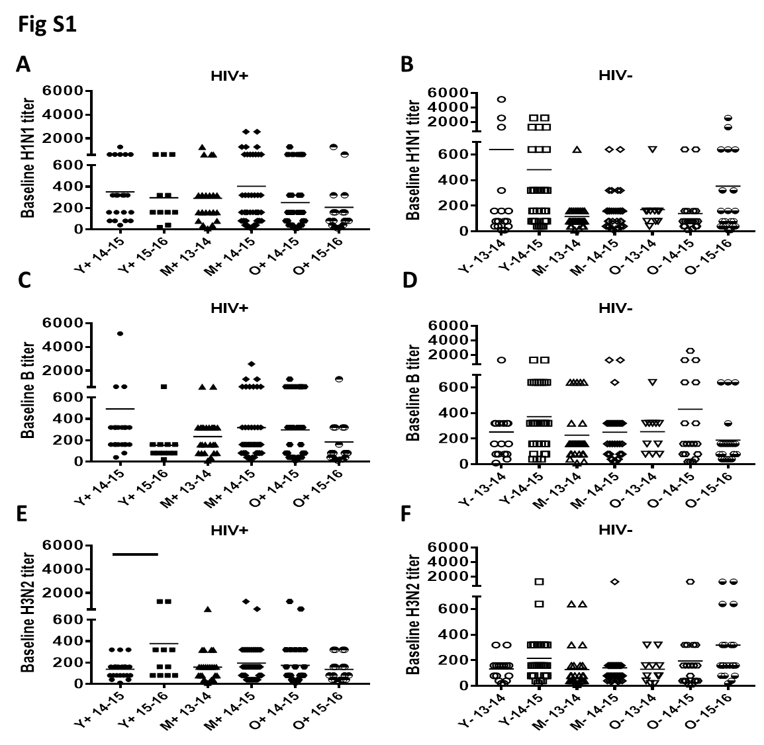
Figure S1: Pre-vaccination Ab responses for H1N1, B and H3N2 did not differ significantly between seasons: Antibody titers at T0 for H1N1, B and H3N2 for each season (2013-2014, 2014-2015 and 2015-2016) were determined by hemagglutination inhibition young (Y), middle aged (M) and old (O) HIV⁺ and HIV⁻ groups. Scatter plots indicate the GMT for HIV⁺ (A, C, E) and HIV⁻ (B, D, F) with error bars showing mean ±SD. P values were calculated using Student’s t-test and significant (p<0.05) differences are indicated by black horizontal bars over 2 groups.
Figure S2: Baseline HAI response inversely correlates with fold change response at T2 over T0 in HIV⁻ and HIV⁺ for H1N1, B and H3N2 antigens: Significant inverse correlation is evident between Log2 HAI responses at T0 with fold changre response at T2 over T0 in HIV⁻ and HIV⁺ for A), H1N1; B), B; C), H3N2. All correlations were performed by Pearson correlation and a p value of <0.05 was considered significant. Closed circles indicate HIV⁺ and open circles indicate HIV⁻

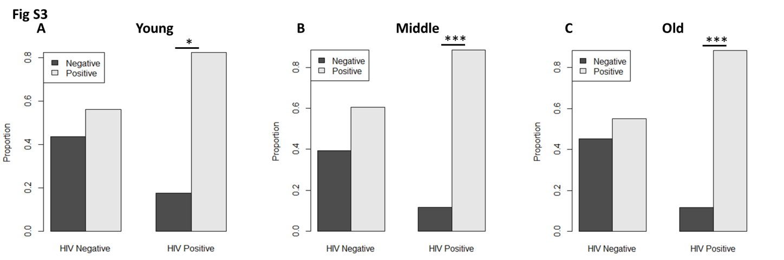
Figure S3: Higher CMV seropositivity in HIV⁺ groups: CMV seropositivity was determined in plasma by ELISA. Proportion of CMV seropositive individuals within HIV⁺ and HIV⁻ A); young, B) middle aged and C); older adults. Data analyzed by Chi-squared test with Yates' continuity correction. * p<0.01; ** p<0.001; ***p<0.0001.

