Appendix 1: Description of model
The intervention effect on the following response variables is studied:
- Endline CD4 cell counts;
- Endline measure of health expenditure (continuous);
- Endline food insecurity (binary);
- Endline sexual behavior measured by the binary variable, use of a condom in last sexual intercourse;
- Endline adherence to three-day adherence recall to antiretroviral therapies (binary).

The following linear model is used to estimate the treatment effect while adjusting for the covariates, two way interactions between treatment and covariates, and baseline measures when available. The model coefficients are estimated using Bayesian methods to allow incorporation of prior information available from previous studies.

(1)
(2)
(3)

where is the observed data that is linked to the continuous latent variable through the appropriate link function . For CD4, a Poisson distribution is used whose intensity is given by Note that, is constrained to be positive in this case. For health expenditure, , and for the binary variables a logistic link function is used. The parameter β₀ is the intercept, β_{a} and β_{g} are the effect of age and gender respectively. The Age is treated continuously and Gender is a binary variable, 1 if female and 0 if male. The main parameter of interest is θ which represents the intervention effect. The binary variable Treatment is 1 if the corresponding patient is in the intervention group and is 0 otherwise. The coefficients β_{at} and β_{gt} show the interaction effect between age and treatment, and gender and treatment, respectively.

Prior specification
A normal prior is used for the main parameter θ,
θ ~ Normal(ν , τ²) (3)
For endline CD4 cell counts an informative prior is used, i.e., the mean is specified as the estimated treatment effect in an available similar study and the standard deviation that allowed 0 (no effect) remain probable under the prior (). Priors were skeptical based on the Kenyan trial by Weiser et al. (25).
Flat priors are assigned for the rest of the model parameters and for the effect of the intervention on the rest of the outcomes.
The analysis was made for the two districts combined as well as separately in each district. The results for the combined data are presented in Figure A1. And the district specific results are presented in Figure A2.

Sensitivity to the prior
Clearly, using an informative prior brings up the question that how much evidence actually there is in the data to support the prior assumptions. In other words, one need to check for possibility of conflict between the data and the prior and avoid situations where the information in the data is overwhelmed by the prior. To address these questions we assess the sensitivity of the results to the amount of information implied by the prior. A sequence of 25 normal prior distributions with the same mean (165) and an increasing sequence of variances is used for this purpose. The posterior probability of a positive treatment effect on change in CD4 cell counts is obtained for each of the prior distributions in the sequence. Figure A3 shows the posterior probability of a positive effect plotted against the prior variance. The vertical red line is drawn at the value of prior variance that is used in the analysis.
The prior sensitivity analysis results suggest that the data agrees with the prior in terms of the direction of the effect estimate. However, the posterior is affected by the degree of information that the prior injects into the model; the posterior probability that there is a positive effect decreases as the prior variance increases, but it stabilizes around 0.70 which is interpreted as the evidence for a positive effect in the data without any additional information incorporated into the model.
Non-Bayesian Analysis
The primary analysis is also performed using non-Bayesian statistical analysis. The same linear models are used but the model is fit to the data using a frequentist approach where model coefficients are estimated using maximum likelihood estimation. No prior information is used in this analysis. The results of the frequentist analysis are provided in Table A.1.
Secondary analysis to estimate the effect of mental planning
In addition to the secondary analysis mentioned in the manuscript, other analyses were performed to estimate the effect of mental planning. In this analysis the T3. Pure Control/T1.Unstructured Grant group are compared to the T2. Mental Planning + Grant/T4. Expectations/Control group. The results are presented in Table A.2 and suggest that mental planning does, in fact, result in a significant increase in CD4 cell counts..We examined whether results would differ according to T1/T2 vs T3 or T4 individually and report results in tables A.3 and A.4.

Figure A1: Results for the two districts combined -- The estimated posterior density of the effect of cash grants on (a) endline measure of CD4 cell counts, (b) health expenditure, and (d) variables indicating sexual behavior, adherence and food security) in the two districts.
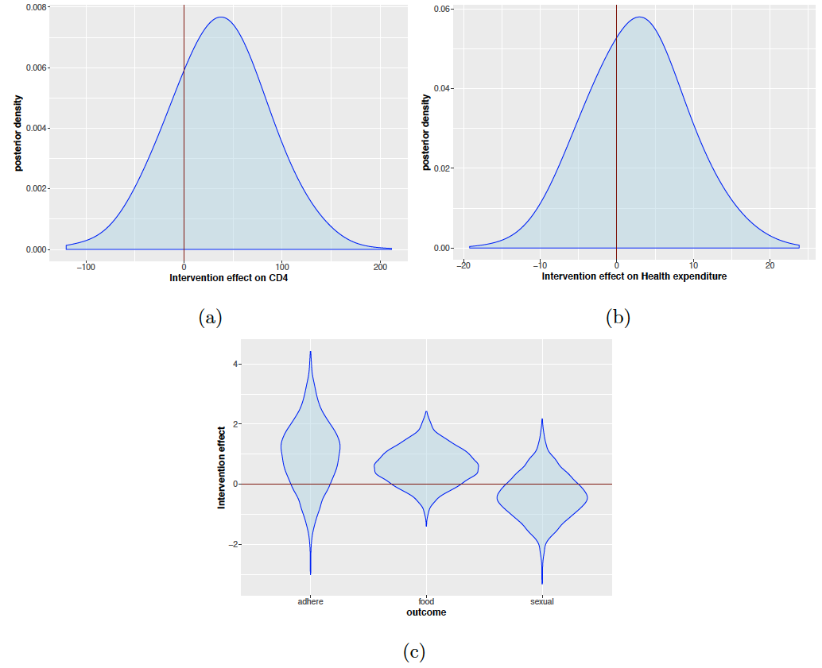

Figure A2: The estimated posterior density of the effect of cash grants on (a) change in CD4 cell counts in Soroti District, (b) endline measure of CD4 cell counts in the two districts, (c) health expenditure, and (d) variables indicating sexual behavior, adherence and food security in the two districts.
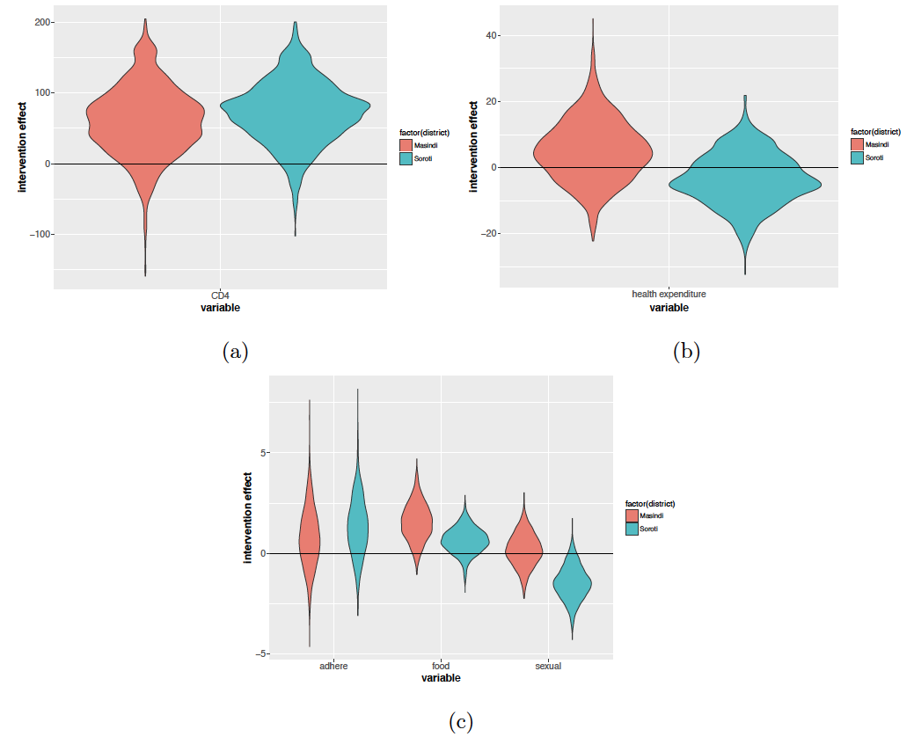

Figure A3: Posterior probability of a positive effect plotted against the standard deviation of the prior distribution over the effect size. The vertical red line shows the used value of the prior standard deviation and the horizontal line shows the approximate value of the probability of positive effect suggested by the data.
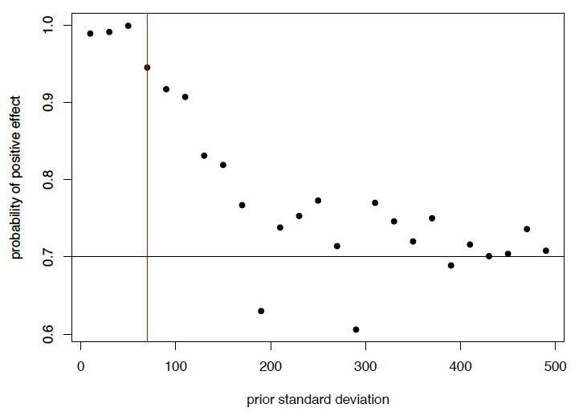

Table A.1: Primary analysis using frequentist methods (T1 + T2 vs T3 + T4)
Variable | Estimate (95% Confidence Interval) | p-value
Endline CD4 cell counts  (mean difference) | 16.15 (-134.77, 167.07) | 0.83
Health expenditure  (mean difference [USD]) | 4.24 (-12.13, 20.60) | 0.61
Food security (NFI) (OR) | 1.23(0.47, 3.22) | 0.67
Adherence (MPB) (OR) | 3.19 (0.56, 18.25) | 0.18
Condom use (LIC) (OR) | 0.46 (0.14, 1.53) | 0.2

Table A.2: Secondary analysis results (T1 + T3 vs T2 + T4)
Variable | Estimate (95% Credible Interval) | Probability of a positive effect
Endline CD4 cell counts  (mean difference) | 104.20 (5.99, 202.16) | 0.98
Health expenditure  (mean difference [USD]) | 9.62 (-2.78, 22.18) | 0.94
Food security (NFI) (OR) | 0.79 (0.32, 2.10) | 0.30
Adherence (MPB) (OR) | 1.99 (0.40, 10.56) | 0.79
Condom use (LIC) (OR) | 1.16 (0.37, 3.88) | 0.60

Table A.3 Secondary analysis results (T1 + T2 vs T3)
Variable | Estimate (95% Credible Interval) | Probability of a positive effect
Endline CD4 cell counts  (mean difference) | 90.29 (-22.84, 199.78) | 0.94
Health expenditure  (mean difference [USD]) | 5.50 (-8.83, 20.45) | 0.76
Food security (OR) | 0.84 (0.24, 2.86) | 0.38
Adherence (OR) | 4.36 (0.50, 36.82) | 0.90
Condom use (OR) | 0.28 (0.05, 1.18) | 0.04

Table A.4 Secondary analysis results (T1 + T2 vs T4)
Variable | Estimate (95% Credible Interval) | Probability of a positive effect
Endline CD4 cell counts  (mean difference) | 4.36 (-107.09, 122.34) | 0.52
Health expenditure  (mean difference [USD]) | -1.12 (-15.79, 13.33) | 0.44
Food security (OR) | 1.84 (0.56, 6.08) | 0.83
Adherence (OR) | 2.64 (0.29, 24.63) | 0.80
Condom use (OR) | 0.68 (0.16, 3.17) | 0.30

Table A.5 Endline outcomes per intervention group
Variable | T.1 Unstructured Grant  n = 537 | T2. Mental Planning + Grant  n = 544 | T3. Pure Control  n = 547 | T4. Expectations/ Control  n = 542
Endline CD4 cell counts (mean) | 528.81 | 523.30 | 542.99 | 556.20
Health expenditure (mean [USD]) | 18.21 | 17.68 | 15.02 | 16.52
Food security (NFI) (proportion) | 0.59 | 0.62 | 0.57 | 0.54
Adherence (MPB) (proportion) | 0.06 | 0.08 | 0.07 | 0.07
Condom use (LIC) (proportion) | 0.57 | 0.61 | 0.59 | 0.62

