**Appendix**

In this appendix, we provide additional details related to our study, including:

* **Figure S1**. Antiretroviral coverage in sub-Saharan Africa, by year
* **Figure S2**. Antiretroviral coverage in sub-Saharan Africa, by year and country
* **Figure S3.** Living arrangements of older adults, by age
* **Figure S4**. Proportion of older adults living without working-age adults, by ART coverage
* **Table S1**. ART coverage and living arrangements of older adults, by study countries and years
* **Table S2**. Living arrangements of older adults and ART coverage, full regression output
* **Table S3.** Living arrangements of older adults and ART coverage, by sex
* **Table S4**. Living arrangements of older adults and ART coverage, using Poisson models
* **Table S5.** Living arrangements of older adults and ART coverage, post-2000 surveys
* **Table S6.** Living arrangements of older adults and ART coverage, using quadratic in age
* **Table S7.** Living arrangements of older adults and ART coverage, weighted by population size
* **Table S8.** Using alternative definitions of an older adult (50 and 70 years old)

Figure S1. Antiretroviral coverage in sub-Saharan Africa, by year

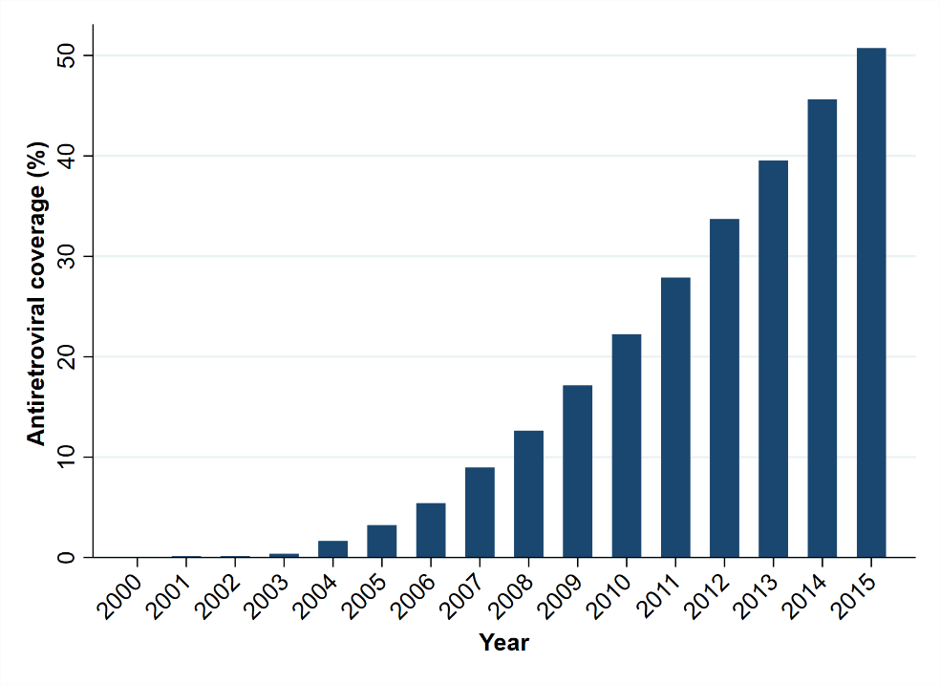

*Notes:* Figure shows average antiretroviral therapy (ART) coverage in sub-Saharan Africa. ART coverage was defined as the percentage of all people living with HIV who are receiving ART. ART coverage increased dramatically from the mid-2000s onwards. Source: annual UNAIDS estimates. Link: <http://aidsinfo.unaids.org/>.

Figure S2. Antiretroviral coverage in sub-Saharan Africa, by year and country

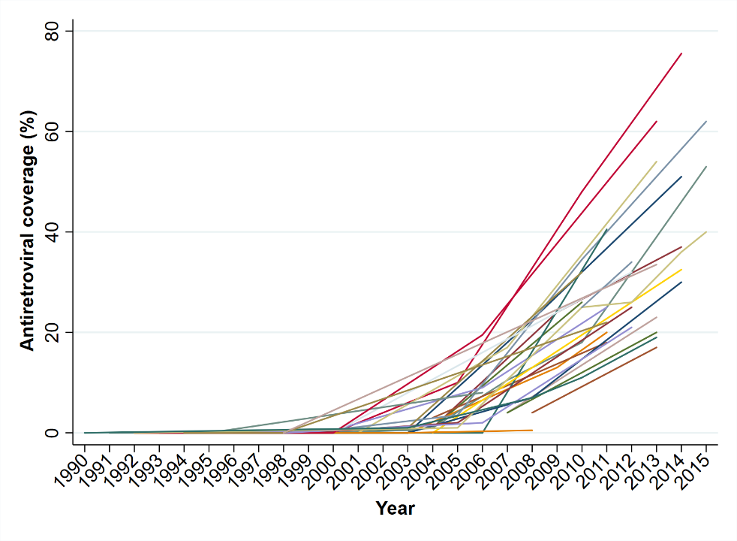

Notes: Figure shows ART coverage in the 28 sub-Saharan African countries included in our analysis in years when a Demographic and Health Survey, AIDS Indicator Survey, and/or Malaria Indicator Survey was conducted. ART coverage was defined as the percentage of all people living with HIV who are receiving antiretroviral therapy. ART coverage for each country-year observation is listed in Table S1. Source: annual UNAIDS estimates. Link: <http://aidsinfo.unaids.org/>.

Figure S3. Living arrangements of older adults, by age

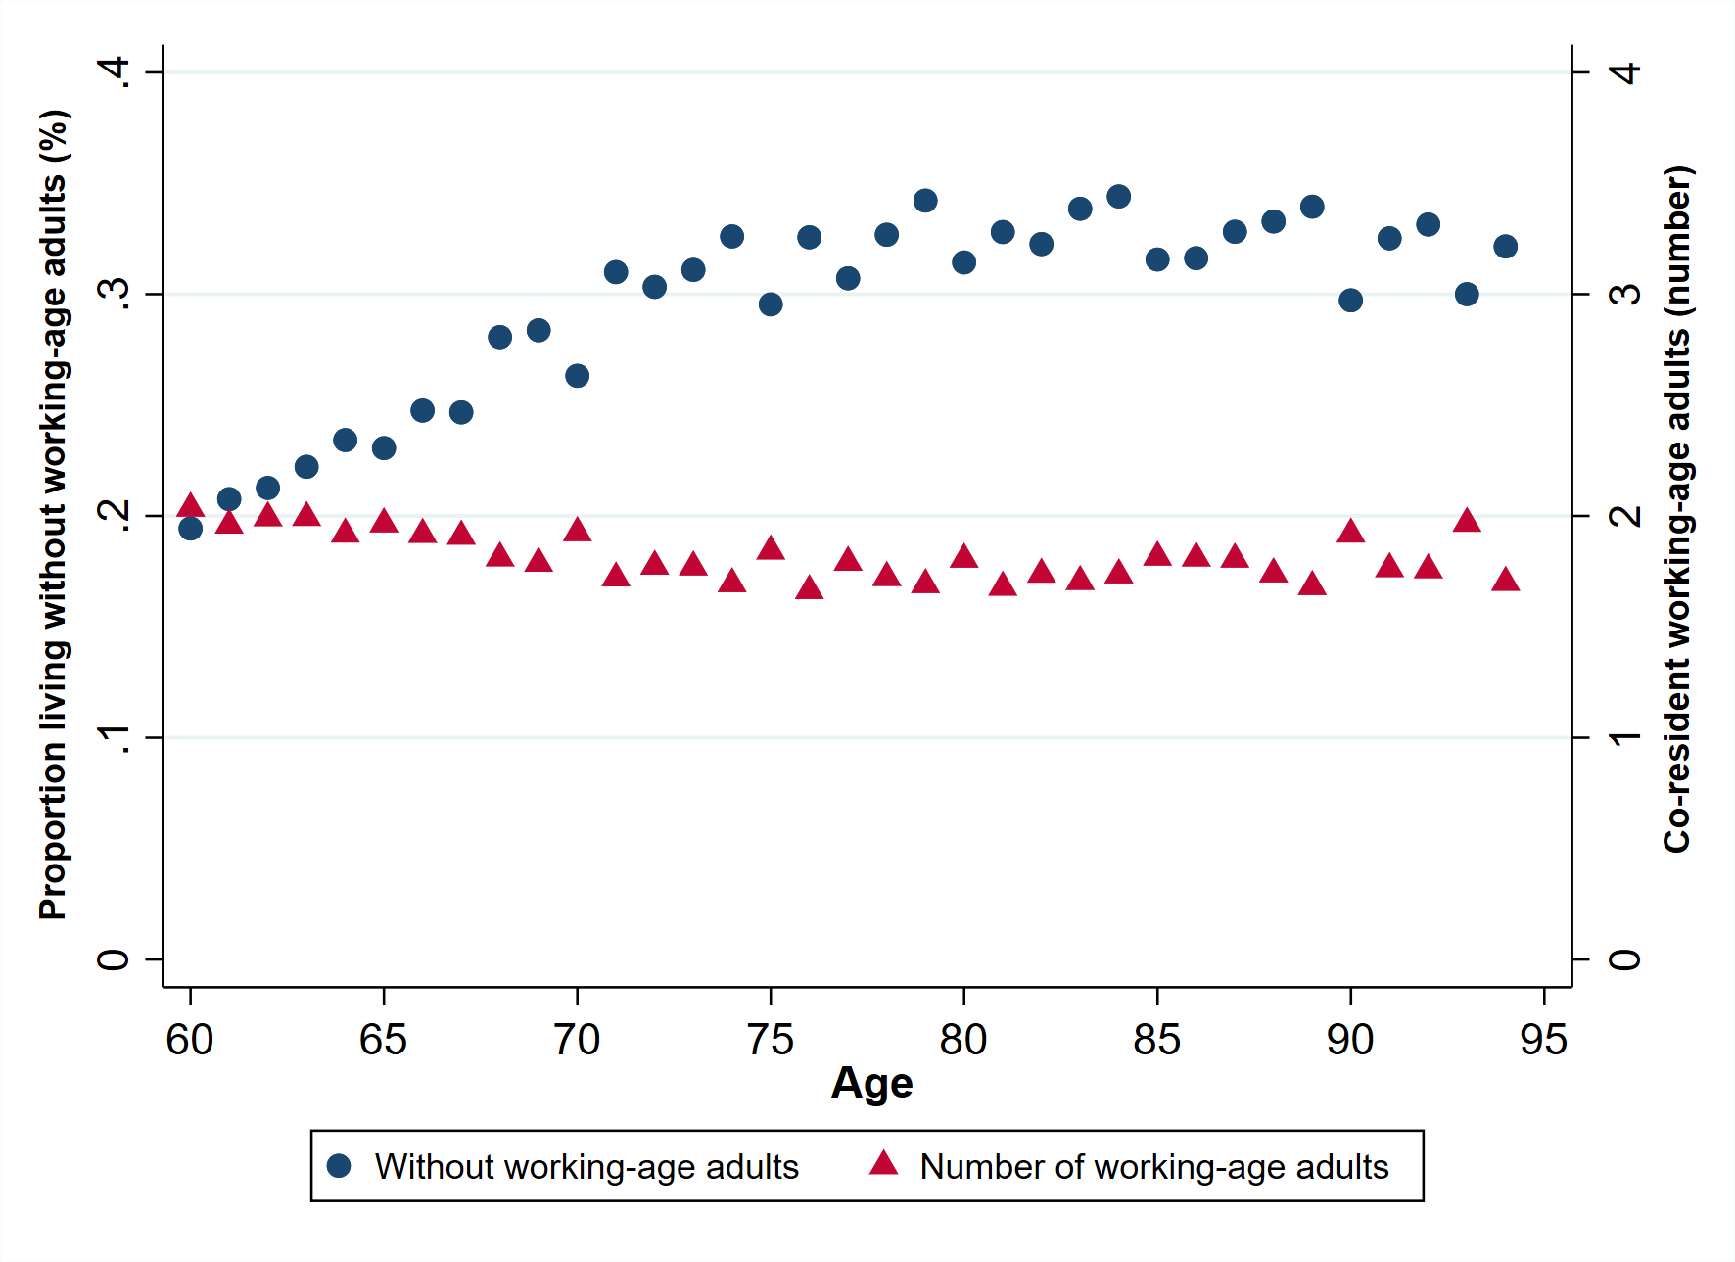

*Notes:* Figure shows (i) the proportion of older adults (ages 60 or higher) living without working-age adults (ages of 18 to 59) (blue circles) and (ii) the number of working-age adults per household where an older adult lives (red triangles), by the age of respondents included in our analytical sample. Source: Demographic and Health Surveys, AIDS Indicator Surveys, and Malaria Indicator Surveys for 28 countries in sub-Saharan Africa, between 1991 – 2015.

Figure S4. Proportion of older adults living without working-age adults and ART coverage

1. pooled sample (*n* = 28 countries*)*

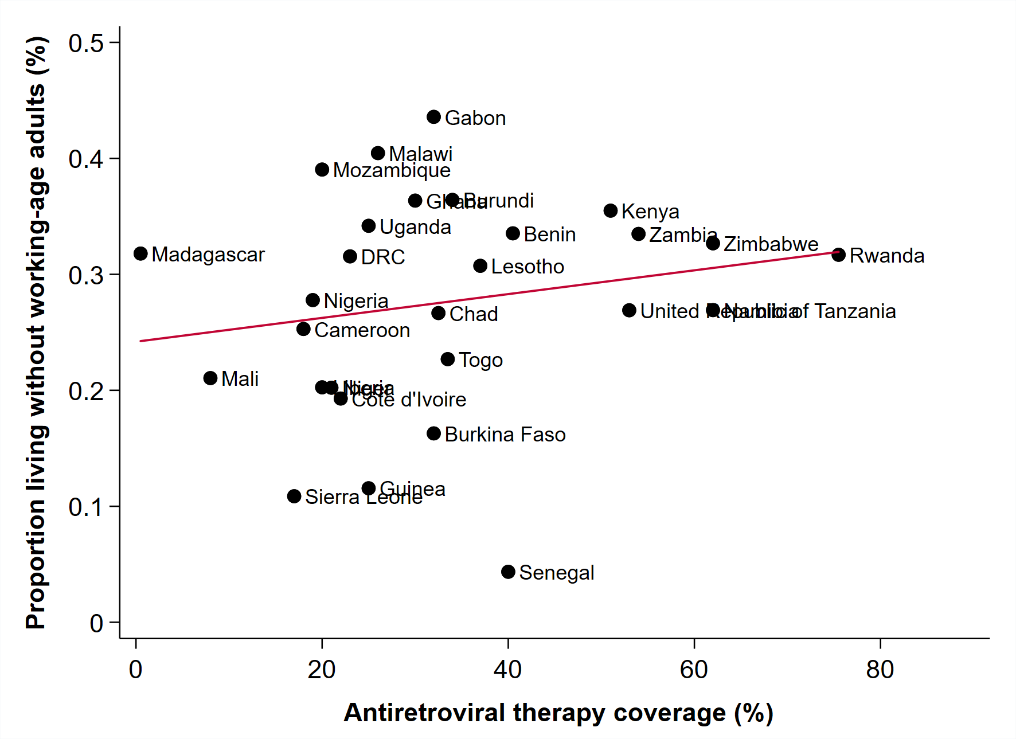

1. country HIV prevalence > 5% (*n* = 8 countries)

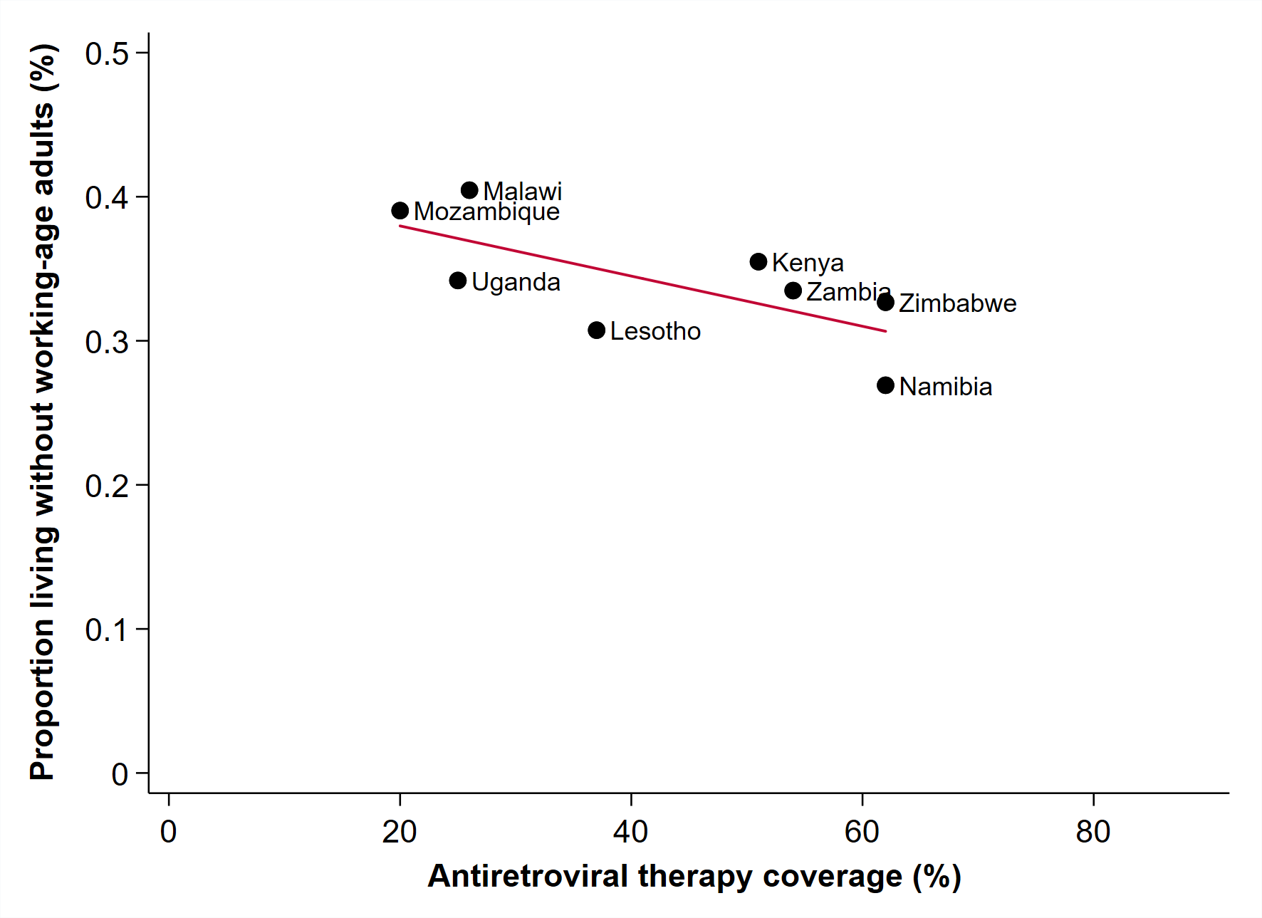

*Notes:* We used the most recently available Demographic and Health Survey, AIDS Indicator Survey, or Malaria Indicator Survey available for each country in our dataset to estimate the proportion of older adults living without working-age adults. ART coverage was defined as the percentage of all people living with HIV who are receiving antiretroviral therapy. ART coverage relates to the year of the most recently available survey. Figure (a) includes all countries and figure (b) includes countries with an HIV prevalence of 5% or higher. Countries are categorized based on adult HIV prevalence (ages 15-49) in 2015 (UNAIDS 2015).

Table S1. ART coverage and living arrangements of older adults, by study countries and years





*Notes:* Sources: 103 Demographic and Health Surveys, AIDS Indicator Surveys, and Malaria Indicator Surveys for 28 countries in sub-Saharan Africa, between 1991 – 2015; annual UNAIDS estimates.

Table S2. Living arrangements of older adults and ART coverage, full regression output



Multivariable probit and OLS models. Regression coefficients reflect the changes in outcome variable given an increase in national ART coverage of 1%. Values from the probit models are marginal effects estimates and those from the ordinary least squares regression are coefficient estimates. All models control for age, sex, residence (urban or rural), education, measures of household wealth, survey year indicators, and country indicators. Countries are categorized based on adult HIV prevalence (ages 15-49) in 2015 (UNAIDS). *** p<0.01, ** p<0.05, * p<0.1. Source: Demographic and Health Surveys, AIDS Indicator Surveys, and Malaria Indicator Surveys for 28 countries in sub-Saharan Africa, between 1991 – 2015.

Table S3. Living arrangements of older adults and ART coverage, by sex



Multivariable probit and OLS models. Regression coefficients reflect the changes in outcome variable given an increase in national ART coverage of 1%. Values from the probit models are marginal effects estimates and those from the ordinary least squares regression are coefficient estimates. All models control for age, residence (urban or rural), education, measures of household wealth, survey year indicators, and country indicators. Countries are categorized based on adult HIV prevalence (ages 15-49) in 2015 (UNAIDS). *** p<0.01, ** p<0.05, * p<0.1. Source: Demographic and Health Surveys, AIDS Indicator Surveys, and Malaria Indicator Surveys for 28 countries in sub-Saharan Africa, between 1991 – 2015.

Table S4. Living arrangements of older adults and ART coverage, using Poisson models



Multivariable Poisson models. Regression coefficients reflect the changes in outcome variable given an increase in national ART coverage of 1%. Values are marginal effects estimates. All models control for age, sex, residence (urban or rural), education, measures of household wealth, survey year indicators, and country indicators. Countries are categorized based on adult HIV prevalence (ages 15-49) in 2015 (UNAIDS). *** p<0.01, ** p<0.05, * p<0.1. Source: Demographic and Health Surveys, AIDS Indicator Surveys, and Malaria Indicator Surveys for 28 countries in sub-Saharan Africa, between 1991 – 2015.

Table S5. Living arrangements of older adults and ART coverage, using post-2000 surveys



Multivariable probit and OLS models. Regression coefficients reflect the changes in outcome variable given an increase in national ART coverage of 1%. Values from the probit models are marginal effects estimates and those from the ordinary least squares regression are coefficient estimates. All models control for age, sex, residence (urban or rural), education, measures of household wealth, survey year indicators, and country indicators. In the subsample of HIV prevalence < 1%, the country variable drops out because of collinearity with few country-year observations. Countries are categorized based on adult HIV prevalence (ages 15-49) in 2015 (UNAIDS). *** p<0.01, ** p<0.05, * p<0.1. Source: Demographic and Health Surveys, AIDS Indicator Surveys, and Malaria Indicator Surveys for 28 countries in sub-Saharan Africa, between 2000 – 2015.

Table S6. Living arrangements of older adults and ART coverage, using quadratic in age



Multivariable probit and OLS models. Regression coefficients reflect the changes in outcome variable given an increase in national ART coverage of 1%. Values from the probit models are marginal effects estimates and those from the ordinary least squares regression are coefficient estimates. All models control for age, age squared, sex, area of residence, education, measures of household wealth, survey year indicators, and country indicators. Countries are categorized based on adult HIV prevalence (ages 15-49) in 2015 (UNAIDS). *** p<0.01, ** p<0.05, * p<0.1. Source: Demographic and Health Surveys, AIDS Indicator Surveys, and Malaria Indicator Surveys for 28 countries in sub-Saharan Africa, between 1991 – 2015.

Table S7. Living arrangements of older adults and ART coverage, weighted by population size



Multivariable probit and OLS models. Regression coefficients reflect the changes in outcome variable given an increase in national ART coverage of 1%. Values from the probit models are marginal effects estimates and those from the ordinary least squares regression are coefficient estimates. All models control for age, sex, residence (urban or rural), education, measures of household wealth, survey year indicators, and country indicators. Countries are categorized based on adult HIV prevalence (ages 15-49) in 2015 (UNAIDS). *** p<0.01, ** p<0.05, * p<0.1. Observations were reweighted with the country population size ages 60+ at the time of the survey. Source: Demographic and Health Surveys, AIDS Indicator Surveys, and Malaria Indicator Surveys for 28 countries in sub-Saharan Africa, between 1991 – 2015.

Table S8. Using alternative definitions of an older adult (50 and 70 years old)



Multivariable probit and OLS models. Regression coefficients reflect the changes in outcome variable given an increase in national ART coverage of 1%. Values from the probit models are marginal effects estimates and those from the ordinary least squares regression are coefficient estimates. All models control for age, sex, residence (urban or rural), education, measures of household wealth, survey year indicators, and country indicators. In Panel A, we defined an older adult to be 70 years of age or older and a working-age adult between the ages of 18 and 69. In Panel B, we defined an older adult to be 50 years of age or older and a working-age adult between the ages of 18 and 49. Countries are categorized based on adult HIV prevalence (ages 15-49) in 2015 (UNAIDS). *** p<0.01, ** p<0.05, * p<0.1. Source: Demographic and Health Surveys, AIDS Indicator Surveys, and Malaria Indicator Surveys for 28 countries in sub-Saharan Africa, between 1991 – 2015.