Supplementary Information:
Supplementary methods

Measurement of CLOCK associated genes by PCR
Each reaction used 12.5uL of SYBR mix (Invitrogen Life technologies), 1uL of cDNA template, 10uM each of forward and reverse primers, and distilled water of 8.5uL, performed in duplicate on Agilent Mx3000P qPCR system (Agilent Technologies, Santa Clara, CA). The reaction conditions were as follows: denaturation at 95˚C for 10 mins, then 40 cycles of 94˚C for 20 seconds, 61˚C for 40 seconds and 72˚C for 40 seconds. CLOCK-associated genes were expressed relative to GADPH expression, by the delta-delta method (1).

Analysis of T-cell subsets, activation and histone acetylation by flow cytometry
Live-dead Fixable Dead Cell Aqua Stain Kit (Invitrogen#L34957) AARD, CD3+ V450 clone UCHT1 (BD#560365), CD4+ PE-TxRed clone S3.5 (Invitrogen#MHCD0417), CD8+ Qdot, CCR7 APC eFluor-780, clone 3D12 (eBioscience#47-1979-42), CD45RA PE-Cy7 clone L48 (BD#337167), CD27 PE-Cy5 (eBioscience #15-0279-42), HLADR FITC clone L243 (BD#347363), and CD38 PE clone HB7 (BD#347687) were used for the CD4+ T-cell subset panel following thawing of frozen peripheral blood mononuclear cells (PBMC). Live-dead stain, acetyl-Histone H3 antibody (Millipore #06-599, rabbit polyclonal), acetylated lysine (Genesearch 9441S) and goat anti-rabbit R-PE antibody (Invitrogen #P2771) were used for the acetylation panel and prepared for flow cytometry as previously described (2).
ArC Amine Reactive Compensation Bead Kit (Invitrogen#A10346) was used as per manufacturer’s instructions and BD CompBeads (Anti-mouse Ig, BD#552843) were used for compensation with fluorescent-minus-one controls. BD Sphero rainbow beads (BD#556291) were used to standardize the experiments. Live CD3+ T-cells were separated for CD4 and CD8 expression, then gated for CD38 and HLADR expression (supplemental figure 1).

Statistical analyses
Operationally, we sought to explain the observed response variable y_{ij} = log₁₀ ((CA-US RNA)_{ij}/N_{ij}) for patient i at visit j, i.e. B1, B2 or B3, taken at time t_{ij}, where N_{ij} is the number of cells in millions used to measure the CA-US HIV RNA. As shown previously [7], all values for CA-US HIV RNA were positive so we could take their logarithm. The first model sought to predict the response variable as a function of visit, time of the blood draw for each individual at each visit i.e., t_{ij}, and a random effect for each individual. Specifically, this is
(1) y_{ij} = μ + α_{i} + β_{j} + γt_{ij} + ε_{ij}
The parameter μ is a constant, and α_{i} is a patient-specific adjustment to the overall mean. We model the latter as realizations from a Gaussian distribution with mean zero and variance τ² . This assumption reduces the number of parameters that need to be estimated. The visit specific parameter β_{j} is a fixed effect to adjust the overall mean to take into account the possible differences among the visits, e.g., more stress at visit B3. To make the set of visit effects β_{j}, j= 1, 2, 3, identifiable, we set β₁=0. As a result, the estimated values of β₂ and β₃ report the average differences between visits B2 and B1, and B3 and B1, respectively. We will make use of that interpretation of the parameters when discussing their estimates. Finally, to account for possible effects of time, we introduced the parameter γ το adjust for the effect of the time of day that the blood was drawn. Given the relatively narrow period of blood draw with 80% of the measurements being collected between 8 am and 12,30 pm, we viewed the term γt_{ij} as a linear approximation of the circadian cycle over that time period. As is standard, ε_{ij}, is an error term assumed to be Gaussian distributed with variance proportional to 1/N_{ij}. If there were no effect of visit or time of blood collection, the constant μ would represent the overall average log ₁₀ CA-US HIV RNA/million cells. Fitting of the mixed effects models used the lme4 function, using the REML algorithm to fit the fix effects. Confidence intervals and p-values were computed using the Gaussian approximation of the appropriate T-statistics. Model comparisons were done using the generalized likelihood ratio test. All estimated fixed parameters in the models we considered were dependent on the data, and hence are intrinsically random. As a result, when we reported estimates we also included its standard deviation, which we also refer to as the standard error. Comparing the size (magnitude) of the estimate to its standard error by taking their ratio, provides a statistical test for the null hypothesis for that parameter to be zero. We rely on the asymptotic normality of the estimate to provide a p-value for that test.
Supplementary figures:
Supplementary Figure 1: Gating strategy for expression of T-cell activation markers on CD4+ T-cells from blood. SSC = side scatter; FSC = forward scatter.

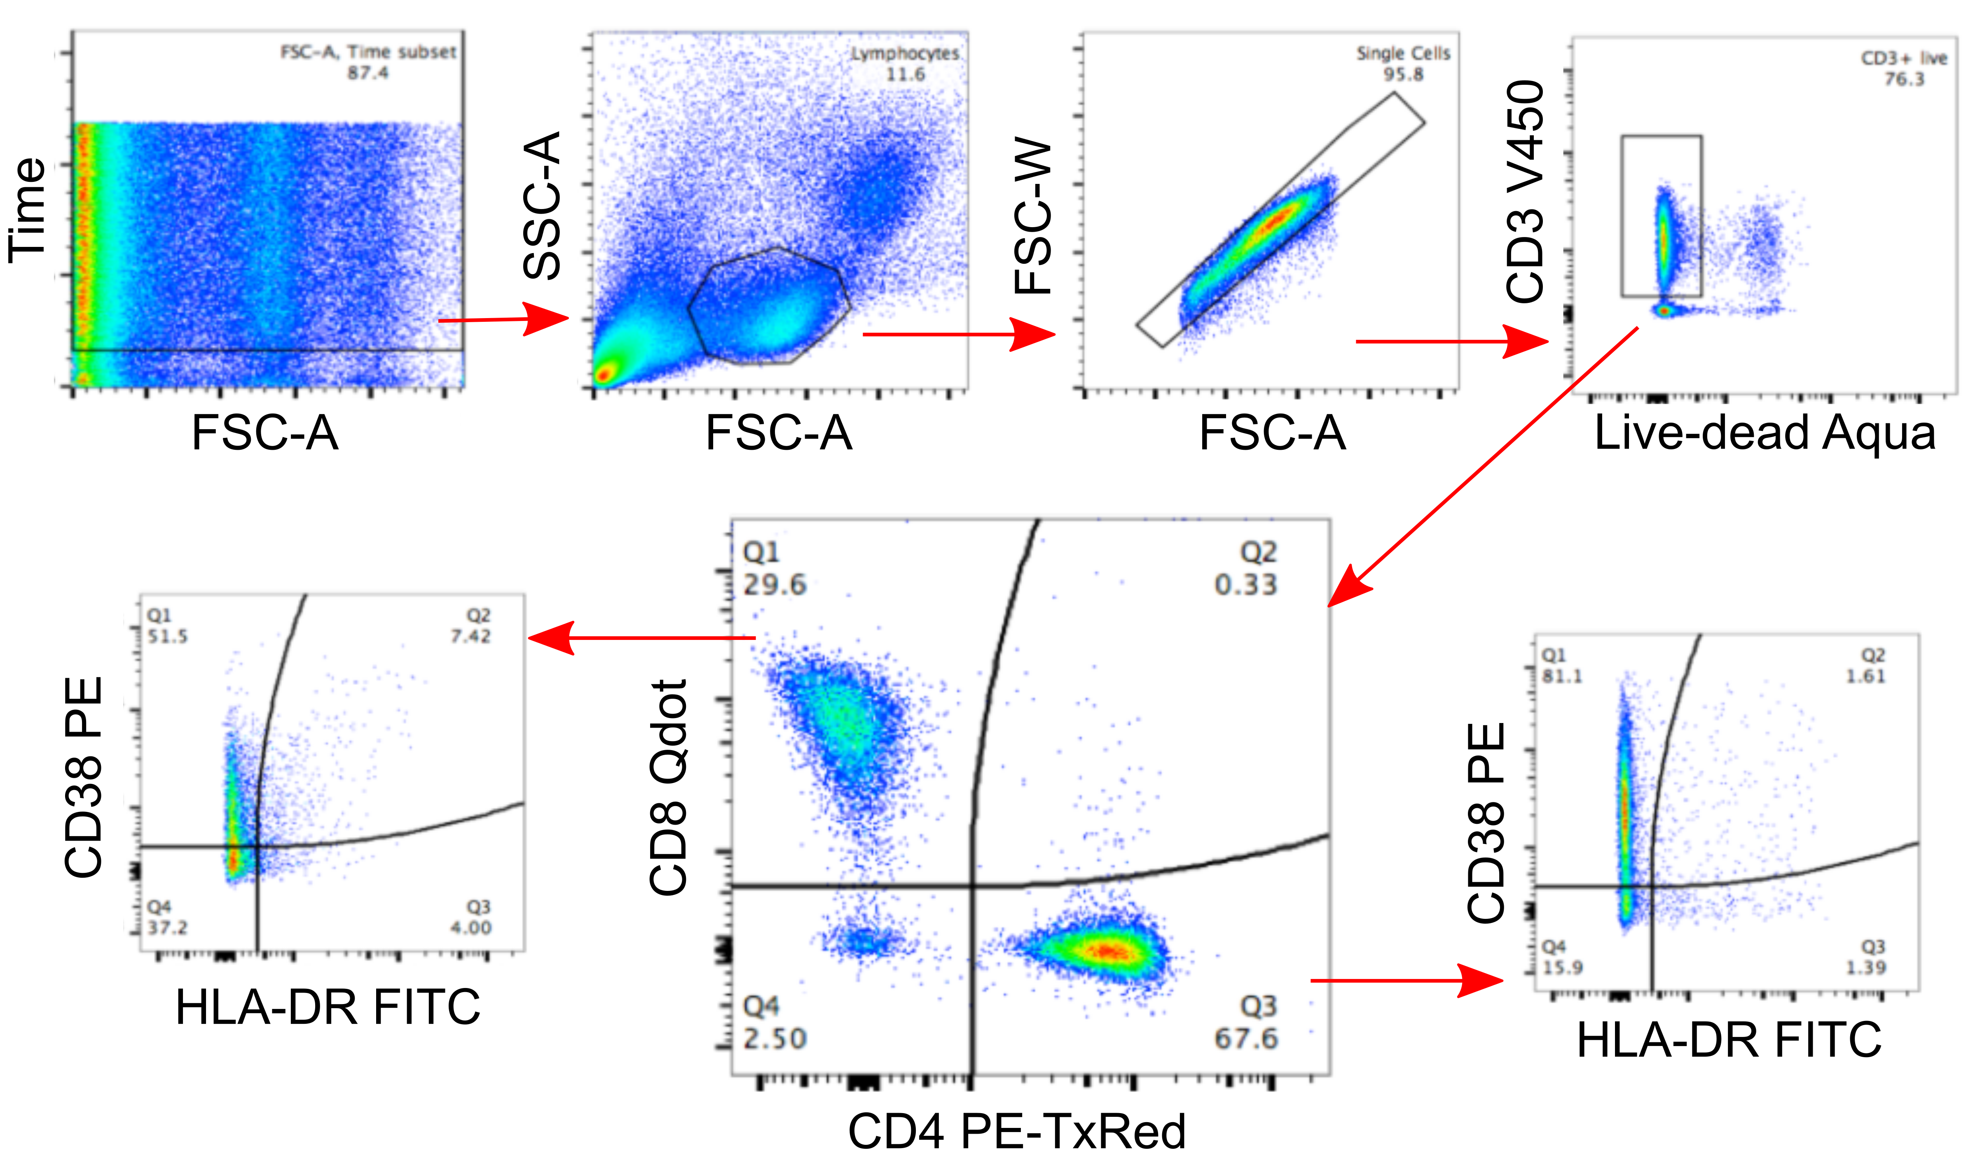

Supplementary Figure 2: Expression of CD38 and HLA-DR on CD8+ T-cells (left panel) and CD4+ T-cells (right panel) at each of the three visits (B1, B2 and B3). Nominal p-values from Wilcoxon matched pairs signed rank tests are shown for significant associations. Bonferroni-corrected p-value for significance p<0.002

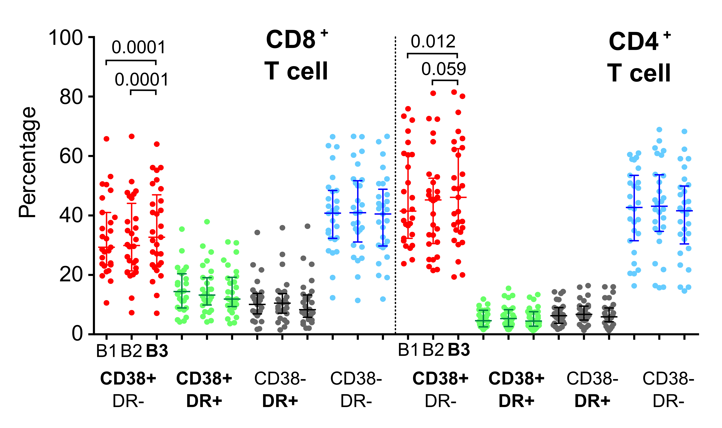

Supplementary Tables
Supplementary Table 1: Primer sequences for CLOCK-associated genes (CLOCK, BMAL1, Per1-3 and Cry1-2) and GADPH as reference gene, and their respective standard curves’ slope and efficiency.
Reference | Primer | Fwd  /Rev | Oligosequence | Slope | Efficiency (%)
Ackerman et al. (3) | CLOCK | Fwd | TTGGCAAAATGTCATGAGCAC | -3.240 | 103.5
 |  | Rev | TTGCCCCTTAGTCAGGAACCT
Ackerman et al. (3) | BMAL1 | Fwd | CCAGAGGCCCCTAACTCCTC | -3.252 | 103.0
 |  | Rev | TGGTCTGCCATTGGATGATCT
Ackerman et al. (3) | Per1  Per1 | Fwd | CAGTGCTCCTGTTCCTGCATC | -3.191 | 105.8
 |  | Rev | CCCGCCAACTGCAGAATCT
Yang et al. (4) | Per2 | Fwd | CTACAGCAGCACCATCGTC | -3.172 | 106.7
 |  | Rev | CCACTCGCAGCATCTTCC
Yang et al. (4) | Per3 | Fwd | TGGTGGTGGTGAATGTAAGAC | -3.213 | 104.8
 |  | Rev | GGCTGTGCTCATCGTTCC
Ackerman et al. (3) | Cry1 | Fwd | TCCGCTGCGTCTACATCCT | -3.209 | 104.9
 |  | Rev | AGCAAAAATCGCCACCTGTT
Yang et al. (4) | Cry2 | Fwd | TGGGCTTCTGGGACTGAG | -3.216 | 104.6
 |  | Rev | GGTAGGTGTGCTGTCTTAGG
Ackerman et al. (3) | GADPH | Fwd | GCACCGTCAAGGCTGAGAAC | -3.270 | 102.2
 |  | Rev | GCCTTCTCCATGGTGGTGAA

Supplementary References
1. Bustin SA, Benes V, Garson JA, Hellemans J, Huggett J, Kubista M, et al. The MIQE guidelines: minimum information for publication of quantitative real-time PCR experiments. Clin Chem. 2009;55(4):611-22.
2. Elliott JH, Wightman F, Solomon A, Ghneim K, Ahlers J, Cameron MJ, et al. Activation of HIV transcription with short-course vorinostat in HIV-infected patients on suppressive antiretroviral therapy. PLoS pathogens. 2014;10(10):e1004473.
3. Ackermann K, Dehghani F, Bux R, Kauert G, and Stehle JH. Day-night expression patterns of clock genes in the human pineal gland. J Pineal Res. 2007;43(2):185-94.
4. Yang SL, Yu C, Jiang JX, Liu LP, Fang X, and Wu C. Hepatitis B virus X protein disrupts the balance of the expression of circadian rhythm genes in hepatocellular carcinoma. Oncol Lett. 2014;8(6):2715-20.

