Supplementary Material
Figure S1. Expression profile of RNA transcripts in PBMCs obtained from HIV-1 negative and HIV-1 positive individuals without HAND or with MND or HAD. Total RNA isolated from PBMCs in the study subjects was profiled using Illumina HT-12 V4 array bead chips and the data were analyzed using genome studio. Multiple probes for a single gene were combined together. A detection cut-off of p <0.01 was used to identify transcripts that were detected consistently in each group. Hierarchical clustering of differentially regulated mRNA in HAD relative to those without HAND was determined. The genes in the clustergram are significantly regulated (2 fold cut-off; q < 0.05). Red indicates high, blue indicates low, and white indicates no change in level of expression. Asterisk on X-axis represent subject group; Y-axis represents the gene symbol. Green asterisk corresponds to MND, red asterisk corresponds to HAD and black asterisk corresponds to subjects without HAND. Gene-E was used to generate the clustergrams.
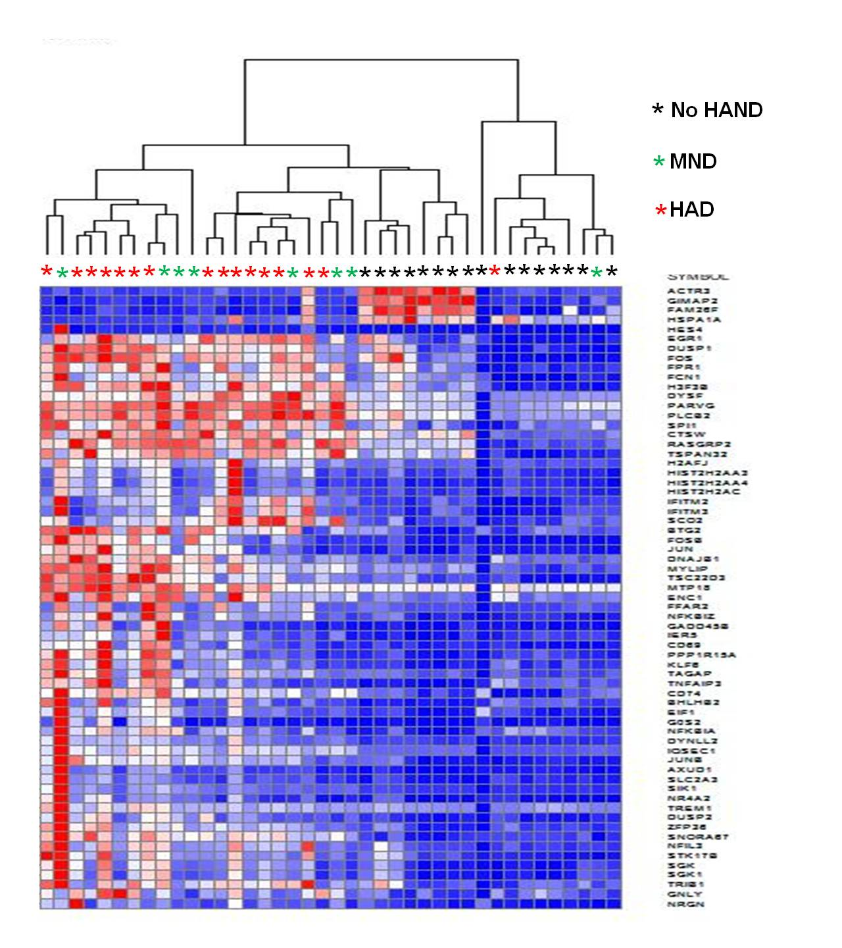

Figure S2: Network analysis of genes related to neurological diseases that were identified as significantly differentially regulated in HAD relative to those without HAND. Red indicates upregulated genes and green represents downregulated genes. The intensity of red and green are relative to the fold change observed in HAD subjects compared to HIV-1 positive subjects without HAND.
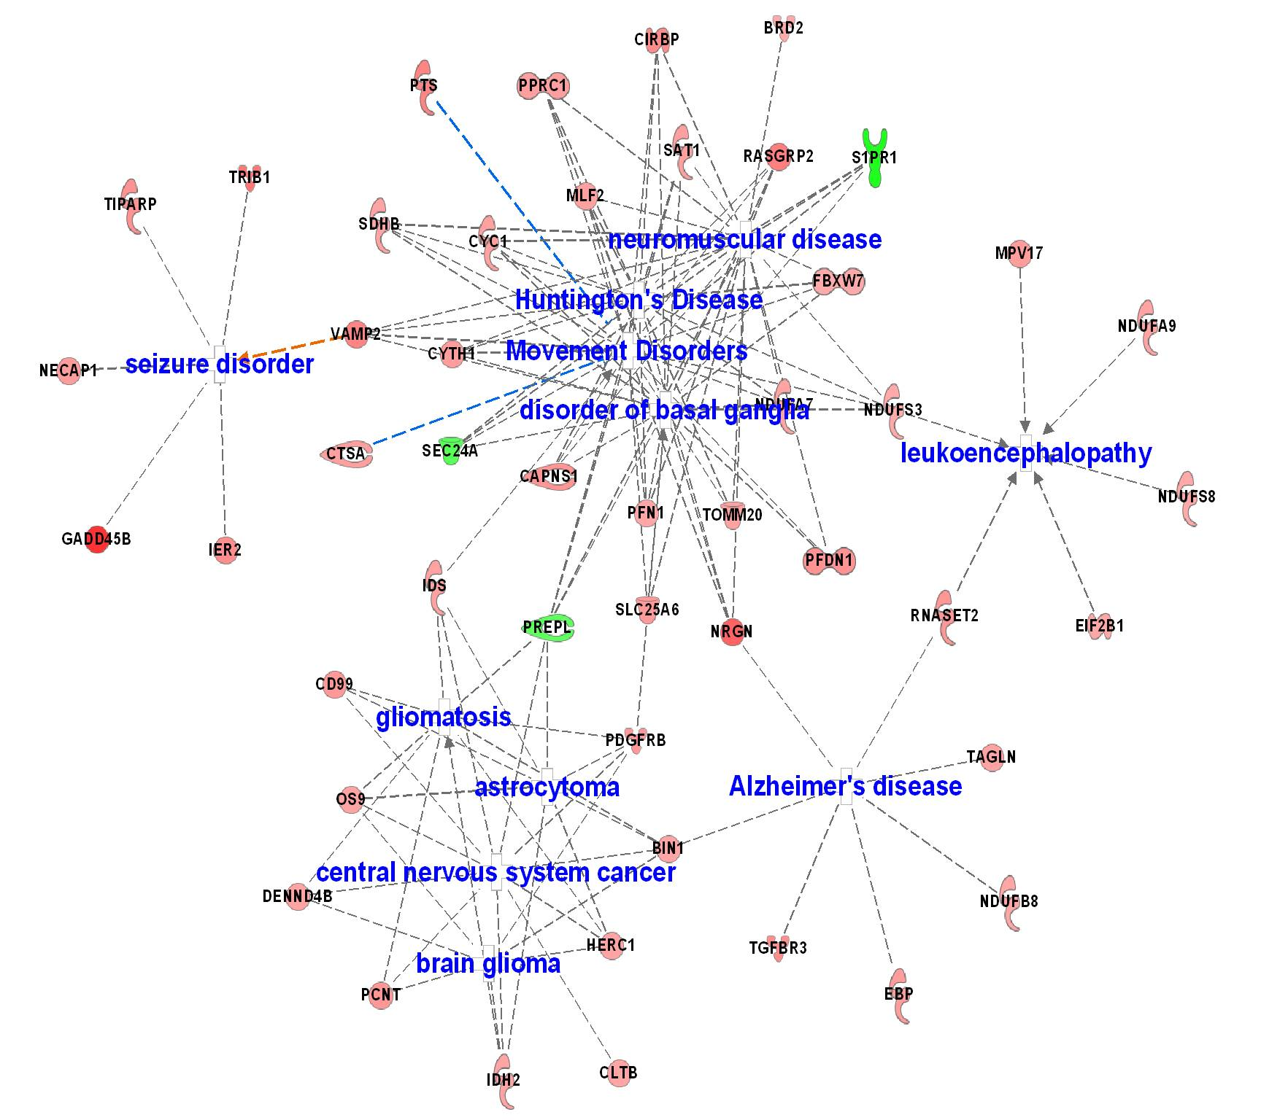

Figure S3: Expression profile of miRNAs in PBMCs obtained from HIV-1 negative and HIV-1 positive individuals without HAND, with MND or HAD. (A) Total RNA isolated from PBMCs from these groups was characterized using human microRNA microfluidic card set v3.0 (Applied Biosystems) and the data were analyzed using Statminer. miRNAs with CT values more than 36 cycles were considered as not detected. (B) miRNA expression were compared between HIV-1 seropositive subjects without HAND or with MND or HAD and HIV-1 seronegative individuals. Pie chart denotes the number of miRNAs consistently detected in more than 75% of the population in both the comparing groups (yellow), or detected only in comparing HIV-1 seropositive individuals (green) or detected only in HIV-1 seronegative individuals (red) or not detected in both the comparing groups (blue). The numbers in red with upward arrow indicates the number of miRNA significantly upregulated and the numbers in green with downward arrow indicates the number of miRNA significantly downregulated (q<0.05) when HIV-1 seropositive individuals with or without HAND were compare to HIV-1 seronegative individuals. (C) Similar analysis of miRNA expression in HIV-1 seropositive individuals with MND and HAD relative to HIV-1 seropositive individuals without HAND, or (D) in HAD group relative to MND group.
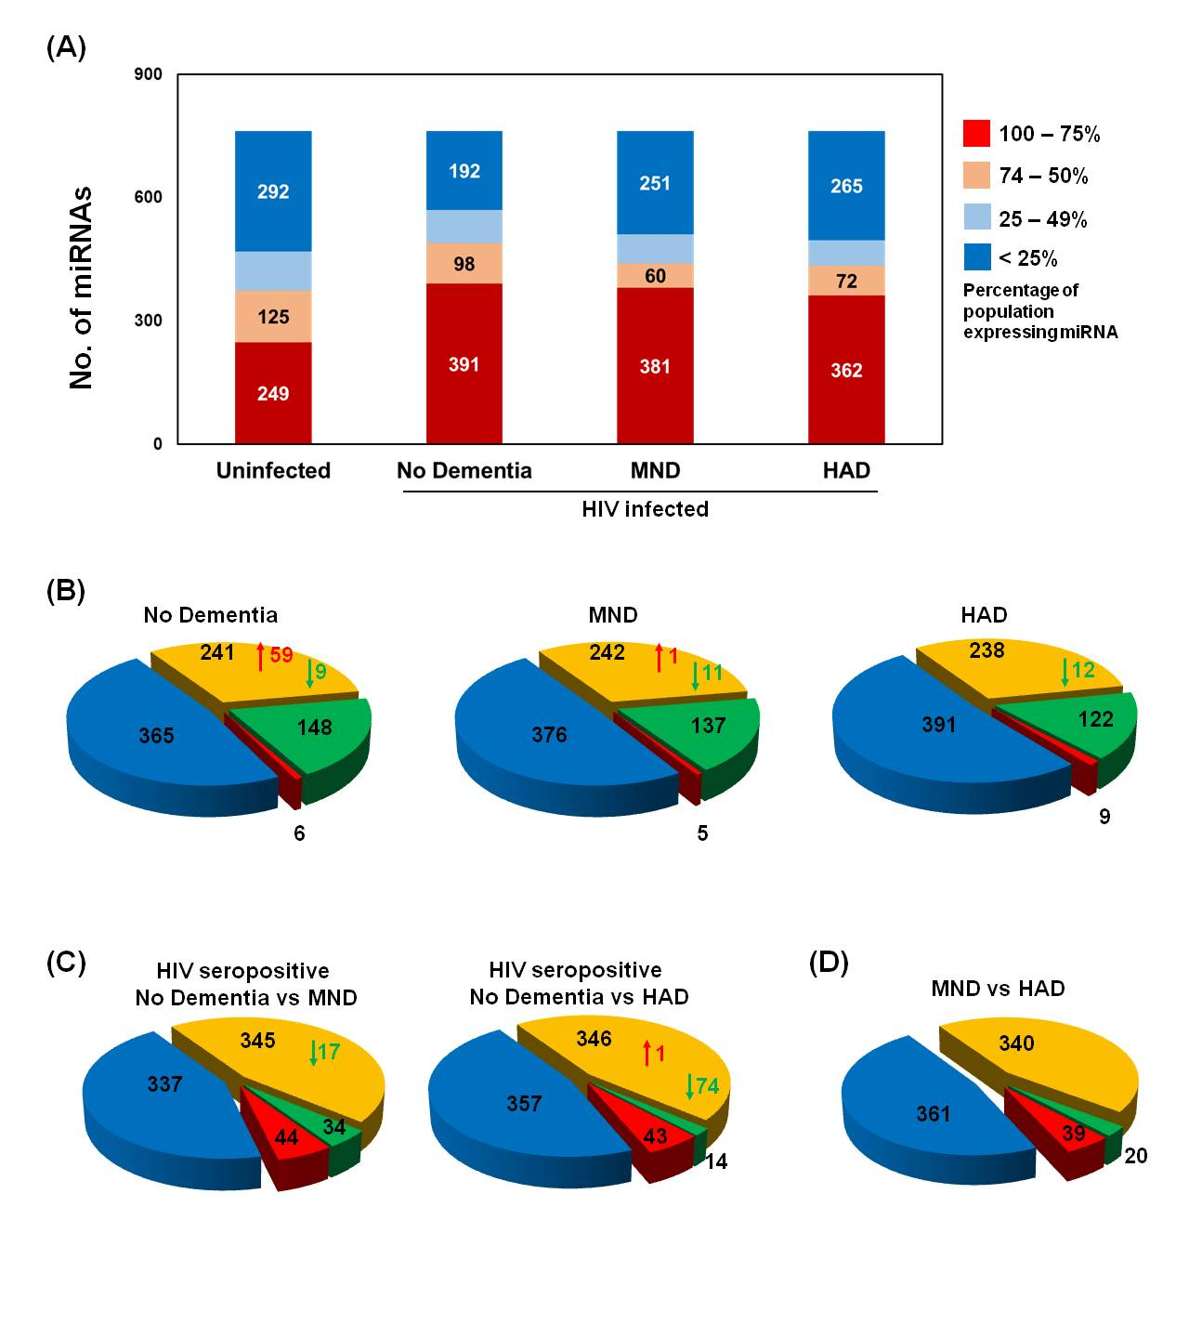

Figure S4. Dynamic signaling and regulatory network for HIV-1 viral proteins in HAND associated changes in PBMCs in HIV-1 positive individuals with no symptoms of HAND, MND and HAD. TimePath was used to construct the dynamic pathways regulated by HIV-1 viral proteins. The complete details of the algorithm and methodology were recently published [29]. Briefly, TimePath attempts to link sources (viral proteins and their host partners) to targets (DE genes) via pathways that are composed of host protein-protein and protein-DNA interactions. This is accomplished by solving an Integer Programming (IP) optimization function that is aimed at reducing the number of paths and intermediate proteins in the model while maximizing the set of targets explained by these paths. HIV-1 viral protein interactions with host proteins were obtained from VirHostNet [44]. Protein-protein interactions was obtained from BIOGRID [46] and HPRD [45] and Post-translational Modification Annotations were also obtained from the HPRD dataset. All the HIV-1 viral proteins were included in the analysis. The PPI part of the combined (static) network was weighted by assigning a probability for every PPI edge [28]. The red nodes represent the HIV-1 proteins (sources). Blue nodes are intermediate signaling proteins and green nodes are the TFs that are predicted to directly up/down-regulate the differential expression of target genes (targets not shown in figure, but the average levels of the regulated targets for each TF is presented by the yellow nodes while the size of each of the yellow nodes indicates how many genes belong to the cluster represented by the node). The figure displays the top predicted proteins for each of the three stages and also demonstrated is the relation to the HIV-1 proteins via the signaling proteins and differentially expressed genes in earlier phases. Note that some intermediate proteins may also be TFs. The functional role in the network figure is based on the location of the protein in the selected paths based on the IP. The data obtained from all the four groups: HIV-1 seronegative individuals, HIV-1 seropositive individuals with no HAND symptoms or MND and HAD were included in the listed order. Additional target constraints were included: If a target (differentially expressed gene) for phase i is present in any earlier phase j, j < i, then the gene is removed as a target for phase i. (TimePath software is available from http://sb.cs.cmu.edu/timepath )

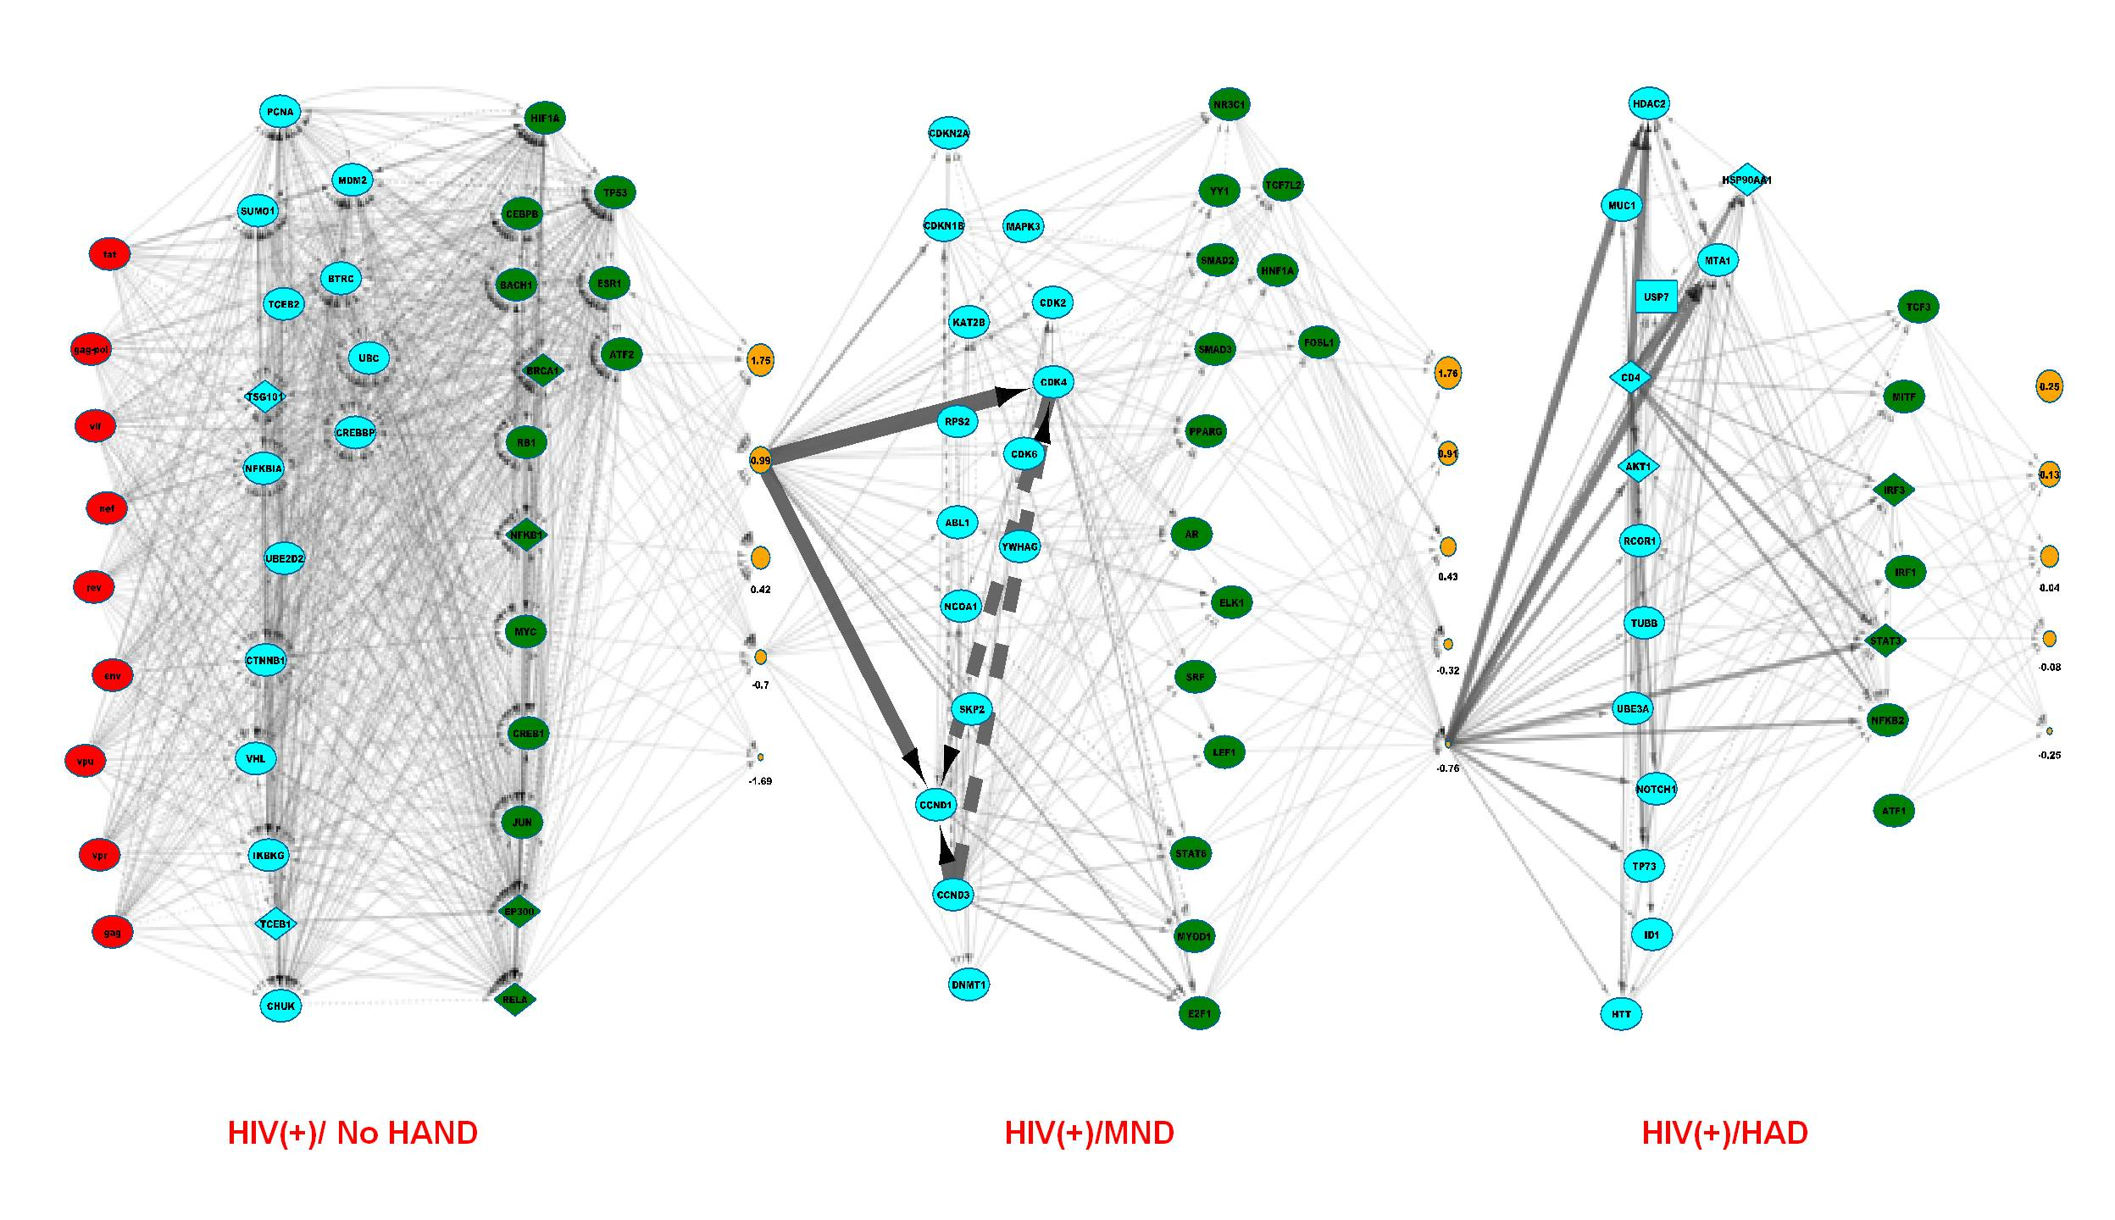
Table S1: Number of genes differentially regulated (q<0.05) in PBMCs obtained from HIV-1 negative and HIV-1 positive individuals without HAND or with MND or HAD.

 | Total number of genes | Number of genes with known function | Up (q<0.05) | Down  (q<0.05) | Range of Fold change
No HAND | 2500 | 1977 | 444 | 1533 | 8.3 to -6.0
MND | 1454 | 1129 | 545 | 584 | 11.6 to -25.8
HAD | 2909 | 2300 | 1195 | 1105 | 17.5 to -26.4

Only genes that were detected in both the comparing groups (p>0.01) were included in the analysis. Total genes denote all the genes including LOC and open reading frames (orf); genes with known function include genes that have been identified to have a role in cellular function. Illumina custom model was included along with multiple testing corrections using Benjamini and Hochberg False Discovery Rate to identify differentially regulated genes and genes with q<0.05 were identified as significant. The fold change for a specific gene transcript was determined by comparing the Average signal between the comparing groups.

Table S2: List of genes differentially regulated in PBMCs obtained from HIV-1 positive individuals with HAD relative to HIV-1 positive individuals with no HAND symptoms.

SYMBOL | HAD /no HAND  (q value) | HAD / no HAND  (Fold change)
SNORA67 | 1.58E-11 | 2.403348
PARVG | 1.74E-10 | 2.122467
IQSEC1 | 5.58E-09 | 2.071365
MYLIP | 1.41E-07 | 2.364093
ZFP36 | 2.08E-07 | 2.651985
DYNLL2 | 2.74E-07 | 2.114358
PLCB2 | 8.92E-07 | 2.224578
JUNB | 9.33E-07 | 2.554802
DUSP2 | 2.38E-06 | 3.442211
ENC1 | 3.83E-06 | 2.284405
FOSB | 4.13E-06 | 9.820623
SIK1 | 5.76E-06 | 2.450594
DNAJB1 | 6.91E-06 | 2.658615
H3F3B | 9.98E-06 | 2.192931
DUSP1 | 1.47E-05 | 2.847167
DYSF | 1.67E-05 | 2.390743
SPI1 | 2.30E-05 | 2.173779
SLC2A3 | 3.07E-05 | 2.4491
IFITM2 | 3.97E-05 | 2.613935
JUN | 4.02E-05 | 5.927778
AXUD1 | 4.07E-05 | 2.864303
CD74 | 4.14E-05 | 2.092512
IER5 | 4.48E-05 | 2.086878
SCO2 | 8.23E-05 | 2.356372
RASGRP2 | 9.03E-05 | 2.01294
CTSW | 1.01E-04 | 2.0841
EIF1 | 1.10E-04 | 2.086502
BTG2 | 1.32E-04 | 2.338737
EGR1 | 1.39E-04 | 2.781608
KLF6 | 1.45E-04 | 2.18253
C7orf40 | 2.18E-04 | 2.018764
TAGAP | 2.44E-04 | 2.225612
TSPAN32 | 4.19E-04 | 2.056004
NFIL3 | 4.35E-04 | 2.592903
FCN1 | 6.98E-04 | 2.450475
NFKBIA | 7.12E-04 | 2.050029
SGK | 7.94E-04 | 3.02939
PPP1R15A | 1.06E-03 | 3.46584
GNLY | 1.49E-03 | 2.067647
FPR1 | 1.69E-03 | 2.104924
FOS | 2.11E-03 | 2.611449
CD69 | 2.46E-03 | 3.69887
GADD45B | 2.47E-03 | 3.198948
TNFAIP3 | 2.66E-03 | 2.810508
NR4A2 | 2.93E-03 | 3.452279
IFITM3 | 3.19E-03 | 3.441433
HIST2H2AC | 3.73E-03 | 2.563796
NFKBIZ | 4.10E-03 | 3.058017
HES4 | 4.94E-03 | 2.120018
MTP18 | 5.57E-03 | 2.000616
BHLHB2 | 6.51E-03 | 2.333149
SGK1 | 8.35E-03 | 2.47866
HIST2H2AA4 | 1.15E-02 | 2.357182
TRIB1 | 1.17E-02 | 2.131649
TREM1 | 1.18E-02 | 2.139538
HIST2H2AA3 | 1.19E-02 | 2.138368
H2AFJ | 1.23E-02 | 2.134175
FAM26F | 2.02E-02 | -2.41976
FFAR2 | 2.25E-02 | 2.959345
GIMAP2 | 2.57E-02 | -2.22045
G0S2 | 2.66E-02 | 3.478495
STK17B | 3.11E-02 | 2.039588
HSPA1A | 3.50E-02 | -2.05097
NRGN | 3.83E-02 | 2.436638
ACTR3 | 4.05E-02 | -2.49137

Illumina custom model was applied along with multiple testing corrections using Benjamini and Hochberg False Discovery Rate to identify differentially regulated genes, and genes with q<0.05 were identified as significant. The fold change for a gene transcript was determined by comparing the Average signal between HIV-1 positive individual with HAD and HIV-1 positive individuals with no HAND symptoms. Only the genes with known gene function that were differentially expressed more than 2 fold are included in this list.

Table S3: Genes that are differentially regulated in PBMCs obtained HIV-1 positive individuals with HAD relative to HIV-1 positive individuals with no HAND symptoms, and are associated with neurological disease.

Condition | Genes
Huntington's Disease | CAPNS1, CIRBP, CYC1, CYTH1, FBXW7, MLF2, NDUFA7, NDUFS3, NRGN, PFN1, PPRC1, PREPL, RASGRP2, S1PR1, SAT1, SDHB, SEC24A, TOMM20, VAMP2
Alzheimer's Disease | BIN1, EBP, NDUFB8, NRGN, RNASET2, TAGLN,TGFBR3
Leukoencephalopathy | EIF2B1, MPV17, NDUFA9, NDUFS3, NDUFS8, RNASET2
Seizure Disorder | GADD45B, IER2, NECAP1, TIPARP, TRIB1, VAMP2
Movement Disorders | CAPNS1, CIRBP, CTSA, CYC1, CYTH1, FBXW7, IDS, MLF2, NDUFA7, NDUFS3, NRGN, PFDN1, PFN1, PPRC1, PREPL, PTS, RASGRP2, S1PR1, SAT1, SDHB, SEC24A, SLC25A6, TOMM20, VAMP2
Disorder of Basal ganglia | CAPNS1, CIRBP, CYC1, CYTH1, FBXW7, MLF2, NDUFA7, NDUFS3, NRGN, PDGFRB, PFDN1, PFN1, PPRC1, PREPL, RASGRP2, S1PR1, SAT1, SDHB, SEC24A, SLC25A6, TOMM20, VAMP2
Neuromuscular Disease | BRD2, CAPNS1, CIRBP, CYC1, CYTH1, FBXW7, MLF2, NDUFA7, NDUFS3, NRGN, PFDN1, PFN1, PPRC1, PREPL, RASGRP2, S1PR1, SAT1, SDHB, SEC24A, SLC25A6, TOMM20, VAMP2
Central Nervous System Cancer | BIN1, CD99, CLTB, DENND4B, HERC1, IDH2, IDS, OS9, PCNT, PDGFRB, PREPL
Gliomatosis | BIN1, CD99, DENND4B, HERC1, IDH2, IDS, OS9, PCNT, PDGFRB, PREPL
Astrocytoma | BIN1, CD99, HERC1, IDH2, IDS, OS9, PDGFRB, PREPL
Brain glioma | BIN1, DENND4B, HERC1, IDH2, OS9, PCNT, PDGFRB

(Refer to Figure S2 for overlap of genes between the groups).

Table S4: Summary of number of miRNAs differentially regulated (q<0.05) in PBMCs obtained from HIV-1 positive individuals without HAND or with MND or HAD relative to HIV-1 negative individuals.

 | miRNAs detected in both the groups | Up regulated  (q<0.05) | Down regulated  (q<0.05)
No HAND | 241 | 59 | 9
MND | 242 | 1 | 11
HAD | 238 | 0 | 12

Only miRNAs that were detected with CT values less than 36 in both the comparing groups, consistently in at least 75% of the population, were included in the analysis. The number of miRNA significantly upregulated or significantly downregulated (q<0.05) when HIV-1 positive individuals without HAND or with MND and HAD were compared to HIV-1 negative individuals are included.

Table S5: Number of miRNAs differentially regulated (q<0.05) in PBMCs obtained from HIV-1 positive individuals with MND or HAD relative to HIV-1 positive individuals without HAND.

 | miRNAs detected in both the groups  (total = 760) | Up regulated  (q<0.05) | Down regulated  (q<0.05)
MND | 345 | 0 | 17
HAD | 346 | 1 | 74

Only miRNAs that were detected with CT values less than 36 in both the comparing groups, consistently in at least 75% of the population, were included in the analysis. The number of miRNA significantly upregulated or significantly downregulated (q<0.05) when HIV-1 positive individuals with MND and HAD were compare to HIV-1 positive individuals without HAND are included.

Table S6: List of miRNAs and its associated target mRNAs that are differentially regulated in PBMCs obtained from HIV-1 positive individuals with HAD relative to HIV-1 positive individuals without HAND.

miRNA | Number of target genes | Target Gene
hsa-let-7a | 6 | AKAP8, CSNK1D, MRPS24, RHOG, TRMT1, TYMS
hsa-miR-206 | 10 | CDK9, CSRP1, DNAJB1, H3F3B, MOV10, TH1L, RBM47, SH3BGRL3, TAGLN2, XPO6
hsa-miR-124 | 14 | ARFIP1, EGR1, ELF4, KLHL24, LITAF, MAD2L2, MYH9, NME4, PLSCR3, RASSF5, RBM47, RHOG, RNPEPL1, TLN1
hsa-miR-15a | 17 | ADSS, ARHGDIA, CCND3, H3F3A/H3F3B, HSPA1A/HSPA1B, JUN, MAPK3, PURA, RAF1, RNASEL, SEC24A, SPI1, SRPRA, UCP2, UGDH, ZNF622, ZYX
hsa-miR-181c | 1 | CD69
hsa-miR-192 | 1 | TYMS
hsa-miR-211 | 1 | ERF
hsa-miR-205 | 2 | ATP1A1, INPPL1
hsa-miR-210 | 1 | MNT
hsa-miR-302c | 7 | HERPUD1, KLF13, MKRN1, NR4A2, PRC1, TMEM9B, UBXN1
hsa-miR-29c | 2 | DUSP2, PURA
hsa-miR-30d | 3 | GNAI2, JUN, NUCB1
hsa-miR-422a | 1 | ODC1
hsa-miR-483-5p | 2 | ALCAM, ARHGDIA
hsa-miR-367 | 2 | MYLIP, PCGF1

Results from miRNA and mRNA array were combined by IPA based miRNA target analysis. Only experimentally verified miRNAs that actively regulate mRNA based on previously published literature are included. (Refer to Figure 2A, for overlap of target genes between the miRNAs).

Table S7: List of miRNAs and associated mRNA targets that are differentially regulated in PBMCs obtained from HIV-1 positive individuals without HAND relative to HIV-1 negative individuals.

miRNA | Gene Targets
let-7a-5p | BCL2L1, BTG2, HBEGF, HMOX1, ITGB3, TLR4
miR-15a | BTG2, CCND3, CD69, FOXO1, HMOX1, SESN1, SPI1, ZYX
miR-17-5p | BECN1, BNIP3L, CD69, CXCL8, DUSP2, HBP1, ITCH, PTEN, TGFBR2, TNF
miR-21-5p | BTG2, CD69, FOXO1, IL1B, PTEN, SESN1, TGFBR2, TLR4, TNF
miR-221-3p | BBC3, BNIP3L, DDIT4, ITGB3, PTEN
miR-324-5p | CCND3, FOXO1, SRF, ZYX
miR-378a-3p | ODC1

Results from miRNA and mRNA array were combined by IPA based miRNA target analysis. Only experimentally verified miRNAs that actively regulate mRNA related to proinflammatory genes based on previously published literature are included. These may have a protective role in HIV-1 positive subjects with no HAND symptoms. (Refer to Figure 2D, for overlap of target genes between the miRNAs and associated inflammatory pathways).

Table S8: Relative Rank of HIV-1 viral proteins and host proteins in cellular networks associated with different stages of HAND.

 | NO HAND | MND | HAD
Vif | 4 | 109 | 20
Gag | 6 | 110 | 23
Nef | 12 | 111 | 26
Tat | 13 | 68 | 27
Gag-pol | 10 | 33 | 28
Vpu | 9 | 102 | 29
Vpr | 11 | 113 | 32
Rev | 14 | 37 | 34
Env | 15 | 26 | 39
CD4 | NP | NP | 1
UBC | 1 | 6 | 2
EP300 | 5 | 10 | 3
TP53 | 2 | 7 | 4
RELA | 16 | 41 | 5
RB1 | 34 | 5 | 6
ESR1 | 21 | 4 | 7
HDAC1 | 36 | 24 | 8
HIF1A | 3 | 19 | 9
CTNNB1 | 19 | 22 | 10
PCNA | 18 | 30 | 11
MDM2 | 8 | 28 | 12
BRCA1 | 20 | 13 | 13
CEBPB | 50 | 17 | 14
CREBBP | 7 | 77 | 15
CCND1 | 59 | 3 | 16
JUN | 27 | 15 | 17
SUMO1 | 17 | 47 | 18
CHUK | 26 | NP | 22
CDKN1A | 37 | 12 | 24
NFKBIA | 22 | 53 | 25
HDAC2 | 71 | NP | 30
MTA1 | 87 | NP | 31
NR3C1 | 88 | 36 | 33
SMAD3 | 91 | 38 | 35
KAT2B | 102 | 18 | 36
MYOD1 | 115 | 14 | 37
NFKB1 | 33 | 81 | 38
BTRC | 23 | NP | 40
PPARG | 103 | 29 | 42
TSG101 | 25 | 86 | 43
AKT1 | NP | NP | 44
EGFR | 39 | 95 | 45
VHL | 24 | NP | 47
HSF1 | 148 | 43 | 49
IKBKG | 31 | NP | 50
NCOR2 | 129 | 48 | 51
BRCA2 | 46 | NP | 55
SRC | 35 | NP | 56
UBE2D2 | 28 | NP | 57
NOTCH1 | 138 | NP | 59
MYC | 43 | 23 | 60
MDM4 | 32 | 89 | 61
TCEB1 | 29 | NP | 62
TCEB2 | 30 | NP | 63
ATF2 | 45 | 55 | 64
CDK2 | 54 | 16 | 68
E2F1 | 57 | 11 | 69
RANGAP1 | 40 | NP | 71
CBL | 42 | NP | 72
TRAF2 | 41 | 72 | 73
RUNX1 | 139 | 66 | 74
NCOA3 | 124 | 52 | 78
CREB1 | 38 | NP | 81
PIAS1 | 177 | 88 | 83
IRF3 | NP | NP | 86
VCP | 49 | NP | 88
ELK1 | 152 | 46 | 90
RANBP2 | 47 | NP | 92
RUNX2 | 153 | 67 | 95
PAK1 | 172 | 50 | 98
USP7 | NP | NP | 101
ABL1 | 175 | 32 | 104
SRF | 168 | 79 | 106
RAC1 | 192 | 71 | 107
NCOA1 | 76 | 21 | 109
STAT6 | 77 | 20 | 110
NR1I2 | 183 | 87 | 116
FN1 | 48 | 45 | 124
NCK1 | 119 | 51 | 126
ATF1 | NP | NP | 128
SKP2 | 98 | 25 | 143
CDK4 | 189 | 2 | 144
CDKN2A | 109 | 39 | 154
CDK6 | 108 | 40 | 155
CDKN1B | 132 | 9 | 157
BACH1 | 44 | 63 | 190
CCND3 | 191 | 1 | 191
CDC5L | 198 | 74 | 197
MAPK3 | 194 | 27 | 199
YWHAG | NP | 8 | NP
PTGES3 | NP | 31 | NP
RPS2 | NP | 44 | NP
YWHAZ | NP | 54 | NP
SUMO3 | NP | 57 | NP
SMARCA5 | NP | 59 | NP
ERGIC3 | NP | 60 | NP
APEX1 | NP | 65 | NP
SUMF2 | NP | 90 | NP
TARS | NP | 98 | NP
EIF3L | NP | 108 | NP
EIF3D | NP | 114 | NP

Rank of HIV-1 viral proteins and host proteins in cellular networks associated with different stages of HAND. Each phase consisted of one time point starting with the HIV positive subjects without HAND. Top 200 DE genes were extracted for each phase relative to the previous phase. These were the DE genes were included as targets in TimePath. All the HIV-1 viral proteins and cellular proteins were included as sources in the analyses. Ranking corresponds to their relative role in the changes observed in transcriptome for each phase. Higher the rank (lower the value) denotes greater role in the transcriptome regulation. The viral proteins are highlighted in yellow and the host proteins unique for HAD and MND are highlighted in Red and orange.

Table S9: List of pathways identified by TimePath analysis that are associated with HAND pathogenesis.

Pathway | Viral proteins | Comment
CREBBP→CREB1→CIRBP | Tat, Gag-pol, Vif, Vpr, Vpu | Associated with Huntington’s Disease, and disorders of basal ganglia
TBP→RXRA→NRGN | Tat | Associated with Alzheimer’s, Huntington’s Disease, and disorders of basal ganglia
AR→NCOR1→PPARA→NRGN | Tat, Nef, Vpu, Gag-pol, Vif, Vpr
TRAF→CD40→RNF31 | Nef, Vpu, Env | Regulate NFκB pathway in macrophages
CREBBP→RELA→SEC24A | Nef, Vpu, Env | Associated with Huntington’s Disease, and disorders of basal ganglia
CREBBP→SREBF1→MYH9 | Nef, Vpu, Env | Role in chemotaxis of monocytes
MYC→MAX→BRD2 | Nef, Vpu, Env | Associated with Neuromuscular disease
RB1→E2F1→IFNAR1 | Nef, Vpu, Env | Role in regulation of Inflammation, virus infection
EP300→YY1/CEBPB→PREPL | Nef, Vpu, Env | Associated with central nervous system cancers, and Huntington’s Disease
SMAD2→SMAD4→NDUFS8 | Nef, Vpu, Env | Associated with Leukoencephalopathy
EP300→ELK1→NDUFS3 | Nef, Vpu, Env | Associated with Leukoencephalopathy, Huntington’s Disease and disorders of basal ganglia
CEBPB/SUMO1→HSF1→HSPH1 | Nef, Vpu, Env | Role in macrophage differentiation
EP300→NFATC1→S1PR1 | Nef, Vpu, Env | Associated with disorders of basal ganglia

Host proteins that are previously identified to have a role in neurological disease or macrophage function are included (identified by bold). The associated HIV-1 viral proteins that are responsible for the changes in the pathway are also included.

