Supplemental Digital Content 1: Multivariable Models 2 & 3 Cohort Characteristics
SDC 1a. Table S1. Model 2 Cohort Characteristics

Characteristics | HEU  N=411 | HUU  N=1224 | P-value
Maternal age | 29.9 ± 5.6 | 30.5 ± 5.6 | 0.056
Age at Follow Up | 8.4 ± 5.6 | 8.4 ± 5.6 | 0.90
Male Sex | 190 (46.2) | 573 (46.8) | 0.84
Gestational age (wks) | 37.7 ± 3.1 | 38.9 ± 1.8 | <0.0001
Gestational age <37 wks | 83 (20.2) | 85 (6.9) | <0.0001
Birthweight (g) | 2985 ± 616 | 3384 ± 572 | <0.0001
Birthweight <2500g | 68 (16.5) | 55 (4.5) | <0.0001
APGAR 1m | 7.9 ± 1.8 | 8.1 ± 1.5 | 0.32
APGAR 5m | 8.8 ± 1.3 | 9.1 ± 0.8 | <0.0001

Data shown as mean ± SD or N (%) p-value calculated from Pearson chi-squared test (proportions) or from Mann-Whitney U test (continuous variables).
Abbreviations: HEU, HIV-exposed uninfected; HUU, HIV-unexposed uninfected; APGAR, appearance,
pulse, grimace, activity, respiration (scores at 1 minute and 5 minutes after birth)
SDC 1b. Table S2. Model 3 Cohort Characteristics

Characteristics | HEU  N=309 | HUU  N=917 | P-value
Maternal age | 30.2 ± 5.4 | 30.7 ± 5.6 | 0.083
Age at Follow Up | 5.9 ± 3.6 | 5.8 ± 3.6 | 0.79
Male Sex | 144 (46.6) | 432 (47.1) | 0.88
Gestational age (wks) | 37.7 ± 2.4 | 38.8 ± 1.8 | <0.0001
Gestational age <37 wks | 61 (19.7) | 63 (6.9) | <0.0001
Birthweight (g) | 2993 ± 588 | 3379 ± 576 | <0.0001
Birthweight <2500g | 48 (15.5) | 42 (4.6) | <0.0001
APGAR 1m | 7.9 ± 1.9 | 8.2 ± 1.5 | 0.34
APGAR 5m | 8.8 ± 1.2 | 9.1 ± 0.8 | <0.0001
Smoking (any) | 107 (34.6) | 78 (8.5) | <0.0001
Alcohol use  (identified as risk) | 26 (8.4) | 12 (1.3) | <0.0001
Substance use (any) | 111 (35.9) | 24 (2.6) | <0.0001

Data shown as mean ± SD or N (%) p-value calculated from Pearson chi-squared test (proportions) or from Mann-Whitney U test (continuous variables).
Abbreviations: HEU, HIV-exposed uninfected; HUU, HIV-unexposed uninfected; APGAR, appearance,
pulse, grimace, activity, respiration (scores at 1 minute and 5 minutes after birth)

Supplemental Digital Content 2: Model 2 & 3 Covariates Included for Analysis, Crude and Adjusted Odds Ratios

SDC 2a. Table S3. Model 2 Covariates Included for Analysis

Outcome | Crude OR (CI) | Adjusted for | Adjusted OR (CI) | % Change | P  OR | P  LRT | P  Homogeneity OR
Any ND Diagnosis | 2.68  (2.04, 3.53) | Sex (M vs. F) | 2.72 (2.06, 3.58) | + 1.5 | <0.0001 | <0.0001 | 0.44
 |  | Age at Follow Up (i. 0-5, ii. 6-10, iii.11-15, iv.16-22) | 2.84 (2.13, 3.78) | + 6.0 | <0.0001 | <0.0001 | 0.18  (p=0.16  test for interaction)
 |  | Age at Follow Up (>11 yrs vs. ≤11 yrs) | 2.74 (2.07, 3.61) | + 2.2 | <0.0001 | <0.0001 | 0.014  (p=0.011 test for interaction)
 |  | Maternal Age (i. <25, ii. 25-35, iii. >35) | 2.66 (2.02, 3.50) | - 0.7 | <0.0001 | 0.68 | 0.52  (p= 0.40 test for interaction)
 |  | Maternal Age (>35 yrs vs. ≤35 yrs) | 2.69 (2.05, 3.54) | + 0.4 | <0.0001 | 0.64 | 0.89
 |  | Preterm Birth  <37 weeks GA | 2.36 (1.78, 3.13) | -12.0 | <0.0001 | <0.0001 | 0.85

HEU N=411, HUU N=1224. Interaction test p-value included for variables with multiple strata. Crude and adjusted odds ratios were calculated using Mantel-Haenszel method.
Abbreviations: HEU, HIV-exposed uninfected; HUU, HIV-unexposed uninfected; ND,
neurodevelopmental disorder; OR, odds ratio; CI, confidence interval; LRT, likelihood ratio test

SDC 2b. Table S4. Model 3 Covariates Included for Analysis

Outcome | Crude OR (CI) | Adjusted for | Adjusted OR (CI) | % Change | P  OR | P  LRT | P  Homogeneity OR
Any ND Diagnosis | 2.25  (1.61, 3.15) | Sex (M vs. F) | 2.27 (1.6, 3.17) | + 0.9 | <0.0001 | 0.002 | 0.23
 |  | Age at Follow Up (>6 yrs vs. ≤6 yrs) | 2.34 (1.7, 3.31) | + 4.0 | <0.0001 | <0.0001 | 0.567
 |  | Maternal Age (i. <25, ii. 25-35, iii. >35) | 2.24 (1.6, 3.13) | - 0.4 | <0.0001 | 0.44 | 0.18  (p=0.17 test for interaction)
 |  | Maternal Age (>35 yrs vs. ≤35 yrs) | 2.26 (1.6, 3.31) | + 0.4 | <0.0001 | 0.77 | 0.24
 |  | Preterm Birth  (<37 weeks GA) | 1.92 (1.41, 2.7) | - 15.0 | 0.0002 | <0.0001 | 0.62
 |  | Smoking (any) | 1.94 (1.35, 2.79) | - 14.0 | 0.0003 | 0.006 | 0.31
 |  | Alcohol (identified as risk) | 2.26 (1.6, 3.19) | + 0.44 | <0.0001 | 0.83 | 0.15
 |  | Drug/Substance Use | 1.46 (0.96, 2.21) | - 35 | 0.073 | <0.0001 | 0.11
 |  | Drug/Substance Use + Smoking | 1.58 (1.06, 2.21) | - 30.0 | 0.025 | <0.0001 | 0.21

HEU N=309, HUU N=917. Interaction test p-value included for variables with multiple strata and/or for variables with p<0.1 homogeneity odds ratio test. Smoking and Drug/substance use tested positive for collinearity and were combined into a trichotomised variable and included in the multivariable logistic regression. Crude and adjusted odds ratios were calculated using Mantel-Haenszel method.
Abbreviations: HEU, HIV-exposed uninfected; HUU, HIV-unexposed uninfected; ND,
neurodevelopmental disorder; OR, odds ratio; CI, confidence interval; LRT, likelihood ratio test
Supplemental Digital Content 3: British Columbia Antiretroviral Regimens, Any Neurodevelopmental Disorder Diagnoses & HIV-Exposed Uninfected Births Over Study Period, & Antiretroviral Exposure Durations

SDC 3a. Figure S1. ARV Regimens, ND Diagnoses & HEU Births (N=446)

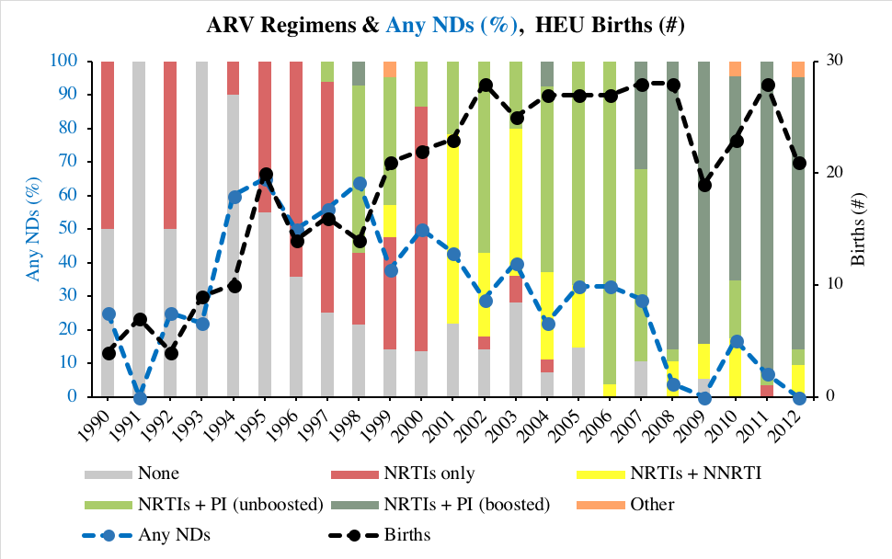

Abbreviations: ARV, antiretroviral; ND, neurodevelopmental disorder; HEU, HIV-exposed uninfected;
NRTI, nucleoside reverse transcriptase inhibitor; NNRTI, non-nucleoside reverse transcriptase
inhibitor; PI, protease inhibitor
SDC 3b. Figure S2. HEU ARV Exposure Durations (N=446)

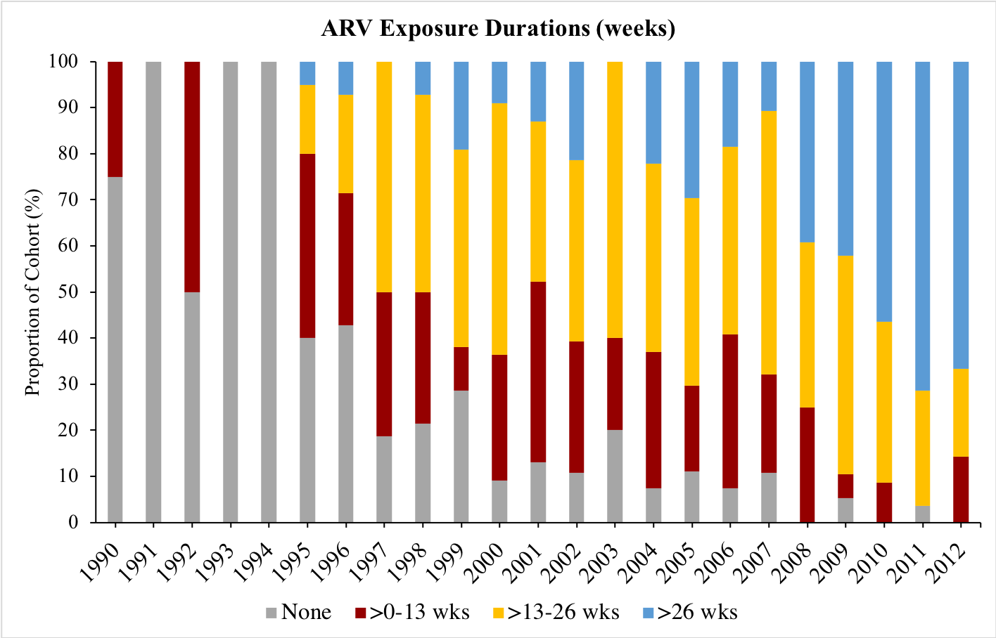

Abbreviations: HEU, HIV-exposed uninfected; ARV, antiretroviral

Supplemental Digital Content 4: Antiretroviral Drugs Used in Pregnancy for Women Living with HIV in BC
SDC 4. Table S5. Antiretroviral Drugs Used During Pregnancy for Mothers Living with HIV in British Columbia (1990-2012)

Nucleoside Reverse Transcriptase Inhibitors (NRTIs): | Non-Nucleoside Reverse Transcriptase Inhibitors (NNRTIs):
Zidovudine (AZT) | Nevirapine (NVP)
Didanosine (ddI) | Efavirenz (EFV)
Zalcitabine (ddC) | Etravirine (ETR)
Stavudine (d4T)
Lamivudine (3TC) | Protease Inhibitors (PIs):
Abacavir (ABC) | Indinavir (IDV)
Tenofovir (TVF) | Ritonavir (RTV) alone or as a booster
Emtricitabine (FTC) | Saquinavir (SQV)
 | Nelfinavir (NFV)
Integrase Inhibitors (IIs): | Lopinavir (LPV)
Raltegravir (RAL) | Darunavir (DRV)

(Data obtained from medical chart information from The Oak Tree Clinic, Vancouver, BC, Canada)

