 | Visit | Tat (pg/ mL) | vRNA (copies/ mL)
Patient #3 | Visit 1 | 471.67 | 42
 | Visit 2 | 0 | 126
 | Visit 3 | 1171.67 | <20
Patient #69 | Visit 1 | 0 | 44
Patient #5 | Visit 1 | 0 | <20
 | Visit 2 | 0 | 40
 | Visit 3 | 135 | <20
Patient #10 | Visit 1 | 1437.82 | 46
 | Visit 2 | 0 | 516
 | Visit 3 | 0 | 30
Patient #16 | Visit 1 | 0 | 42
 | Visit 2 | 1823.46 | <20
Patient #28 | Visit 1 | 199.89 | 47
 | Visit 2 | 1027.88 | 90
Patient #43 | Visit 1 | 0 | <20
Patient #45 | Visit 1 | 0 | 500
All participants had a plasma HIV viral RNA level <40 copies/ml at each of these time points. vRNA levels that reflect CSF escape are bold.
Supplementary Table 1. Summary of relationship between Tat levels and HIV viral RNA (vRNA) in CSF.

Supplementary Table 2. Summary of CSF exosome data showing number of samples positive for Tat protein and/or TAR RNA.
Patient ID | Tat | TAR
02 | + | -
03 | +/- | -
04 | +/- | -
05 | + | -
06 | - | -
07 | + | -
08 | +/- | -
09 | - | +
10 | - | +
11 | +/- | +
12 | +/- | -
13 | +++ | -
14 | +/- | -
15 | - | -
16 | +/- | +
17 | ++ | -
18 | +/- | +
20 | +/- | -
21 | - | -
22 | +/- | +
23 | +/- | +
24 | ++ | -
25 | - | -
26 | - | -
27 | - | -
28 | + | +
29 | +++ | +
36 | +/- | -
69 | +/- | +
70 | +++ | -
71 | +++ | -
72 | + | -
C1 | - | -
C11 | - | -
Symbols shown in Tat column represent western blot densitometry for anti-Tat western blot relative to negative IgG control: - = <1%; +/- = 1%-14.99%; + = 15%-32.99%; ++ = 33%-65.99%; +++ = >66%.

Patient ID | ELISA (pg/mL) | IP-WB (Signal relative to IgG) | Matched?
2 | - | + | No
3 | - | +/- | Yes
6 | - | - | Yes
7 | - | + | No
8 | - |  | Yes
9 | - | - | Yes
10 | - | - | Yes
12 | - | +/- | Yes
13 | 454 | +++ | Yes
14 | 307 | +/- | Yes
15 | - | - | Yes
16 | - | +/- | Yes
17 | 1234 | ++ | Yes
18 | 358 | +/- | Yes
20 | - | +/- | Yes
21 | - | - | Yes
22 | 316 | +/- | Yes
23 | - | +/- | Yes
24 | 196 | ++ | Yes
26 | - | - | Yes
27 | 289 | - | No
28 | 200 | + | Yes
29 | 3800 | +++ | Yes
Supplementary Table 3. Comparison between results obtained from the HIV-1 Tat ELISA and immunoprecipitation-western blot (IP-WB) of CSF-derived exosomes.

Supplementary Table 4. Summary of CEM-GFP LTR reporter assay results.
Sample | Tat | # of Events | % Gated | % Total
No Treatment | - | 22 | 0.22% | 0.22%
Beads Alone | - | 20 | 0.20% | 0.20%
+ HIV | + | 241 | 2.41% | 2.41%
HIV-negative control CSF #1 | - | 24 | 0.24% | 0.24%
HIV-negative control CSF #2 | - | 19 | 0.19% | 0.19%
Patient #27 | +/- | 69 | 0.69% | 0.69%
Patient #24 | +/- | 164 | 1.64% | 1.64%
Patient #17 | + | 75 | 0.75% | 0.75%
Patient #19 | + | 67 | 0.67% | 0.67%
Patient #25 | + | 17 | 0.17% | 0.17%
Patient #3 | + | 23 | 0.23% | 0.23%
Positive events were defined as events above signal detected from untreated CEM-GFP cells. Tat column indicates amount of protein detected on western blot (Fig. 2a).

Supplementary Figure 1. Inter- and Intra-assay coefficients of variation (%CV) for the HIV-1 Tat ELISA. Tat ELISA was performed as described in the Materials and Methods. (A) The coefficient of variation (%CV) was determined individually for 20 CSF samples by calculating the mean and standard deviation (SD) for each sample run in duplicate, then dividing the SD of each sample by the duplicate mean and multiplying by 100. The inter-assay CV was then calculated by taking the average of the individual CVs (N=20). (B) The inter-assay %CV for the Tat ELISA from three independent runs performed in duplicate on different days. First, the plate means for the lowest and highest standards were calculated, then this value was averaged across runs (Mean of means). The standard deviation and %CV for each standard were calculated as described in (A), then the inter-assay %CV was determined by taking the average of the individual %CVs. (C) Calculated Tat protein values decrease uniformly with increasing dilution of an HIV-positive CSF sample. Tat ELISA was performed as described in the Materials and Methods using two-fold serial dilutions of a known Tat-positive CSF sample (#29) in blocking buffer. Results were calculated from the standard curve generated using recombinant Tat protein, without normalization by the dilution factor. Data represent results from a single ELISA plate run in triplicate.

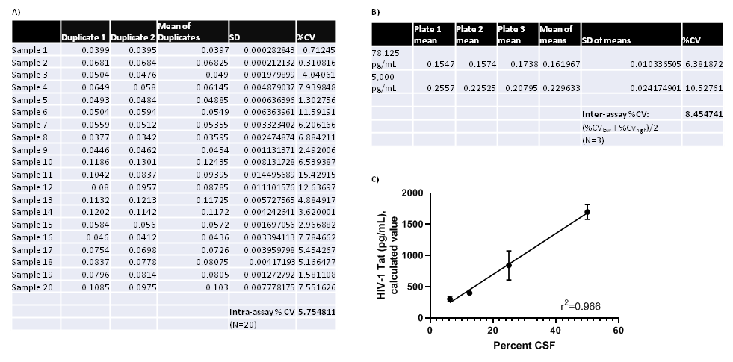

Supplementary Figure 2. Representative Tat western blot performed on exosomes enriched from patient CSF. Exosomes were isolated and prepared for western blot as described in the Materials and Methods and were run in parallel with recombinant Tat protein (lane 1).

