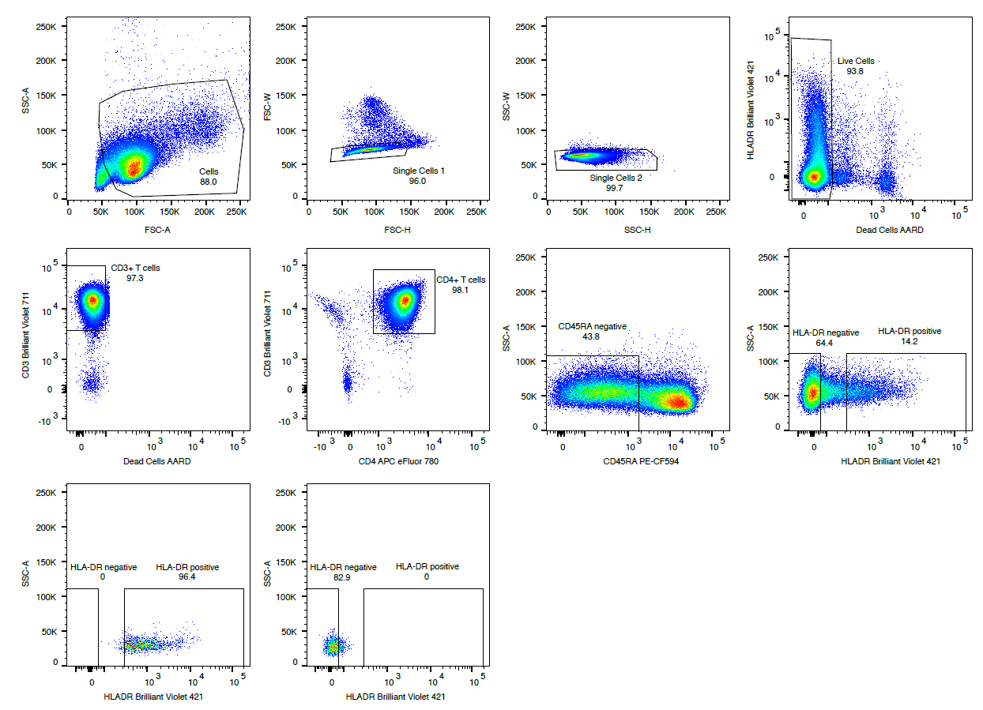Figure S1. Gating strategy for obtaining HLA-DR+ and HLA-DR- memory CD4+ T-cell subsets.

