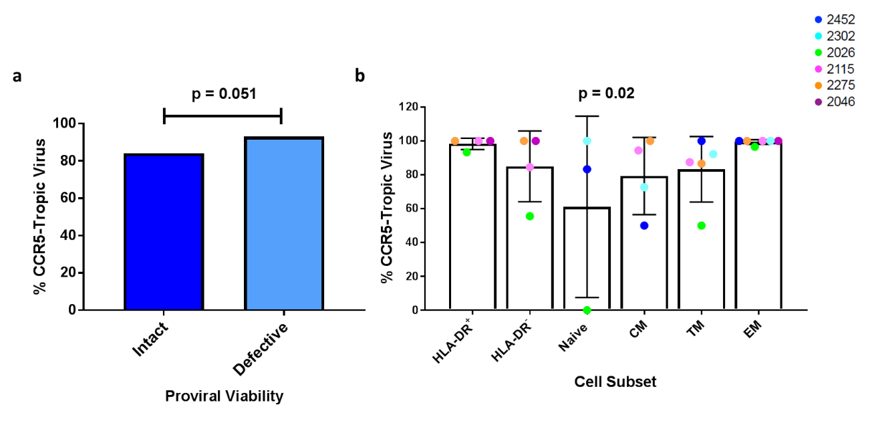
Figure S2. The co-receptor usage of viral DNA isolated from latently infected cells. (a) The percentage of intact and defective sequences using the CCR5 co-receptor. Fisher’s exact test. Data is pooled from all participants. (b) The percentage of viral sequences isolated from different cell subsets that use the CCR5 co-receptor. Likelihood ratio test. Data represented is mean (SD).

