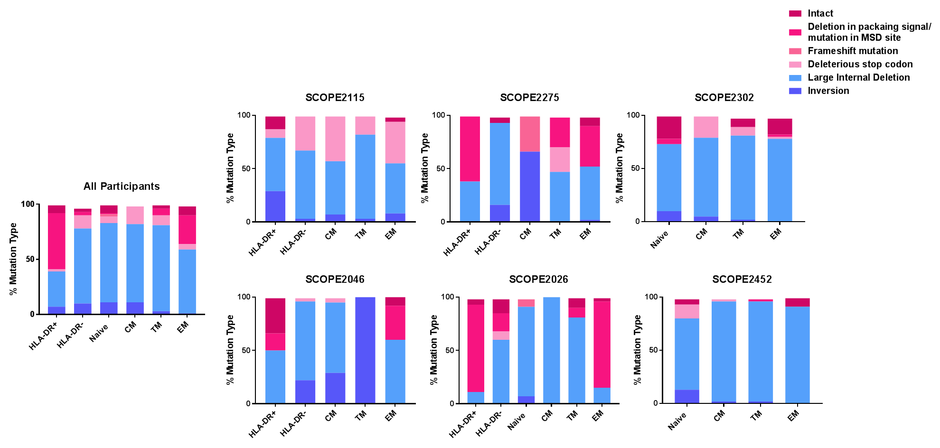
Figure S3. The percentage of different mutation types found within each cell subset and each participant. Mutations resulting in a full-length provirus (intact or defective) are represented in pink, while those resulting in a short provirus are blue.

