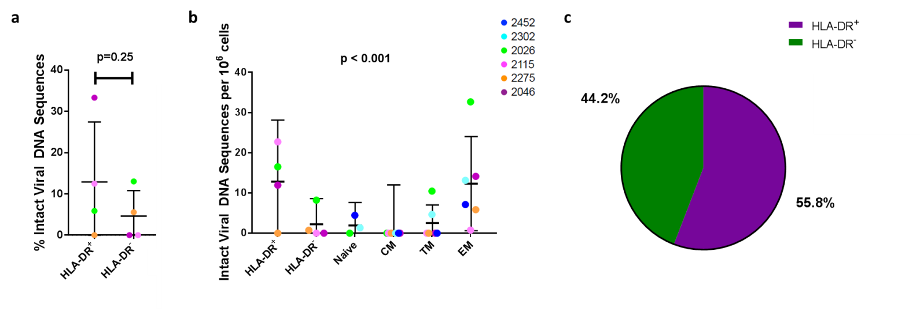
Figure S5. Comparisons between the level of intact viral sequences isolated from HLA-DR+ and HLA-DR- memory CD4+ T-cells and previously studied cell subsets. CM: central memory, TM: transitional memory, EM: effector memory. (a) Percentage of intact sequences isolated from HLA-DR+ and HLA-DR- cells. Wald Test. Data is mean (SD). (b) Number of intact sequences per million cells in each subset. Likelihood ratio test, comparison between cell subsets. Data is mean ± 95% CI. (c) Contribution of HLA-DR+ and HLA-DR- memory CD4+ T-cells to the overall HIV reservoir for all participants combined.

