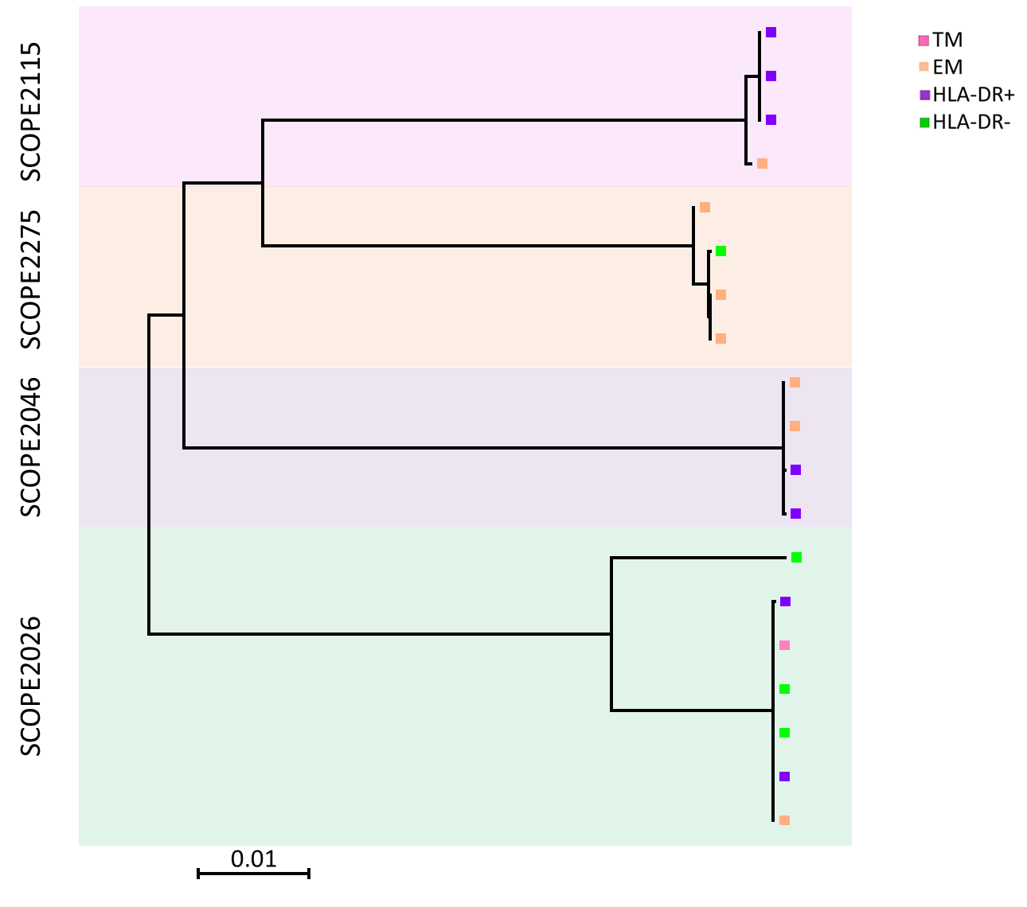

Figure S6. Maximum-likelihood phylogenetic tree drawn from all intact sequences isolated from SCOPE2115, SCOPE2275, SCOPE2046 and SCOPE2026.

