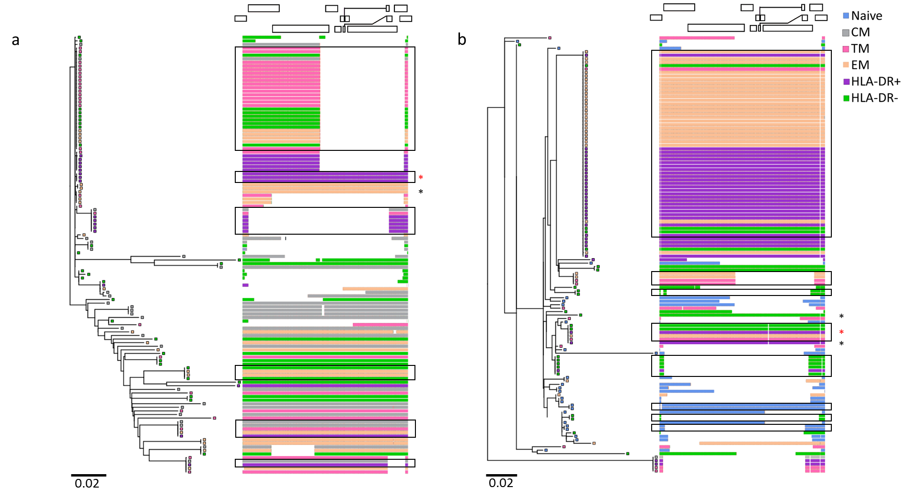Figure S7. Exemplar maximum-likelihood phylogenetic tree drawn from the sequences isolated from SCOPE2115 (a) and SCOPE2026 (b). Intact sequences are indicated by an asterix, with intact identical sequences marked in red and unique intact sequences in black. Boxes indicate examples of expansions of identical sequences (EIS).

