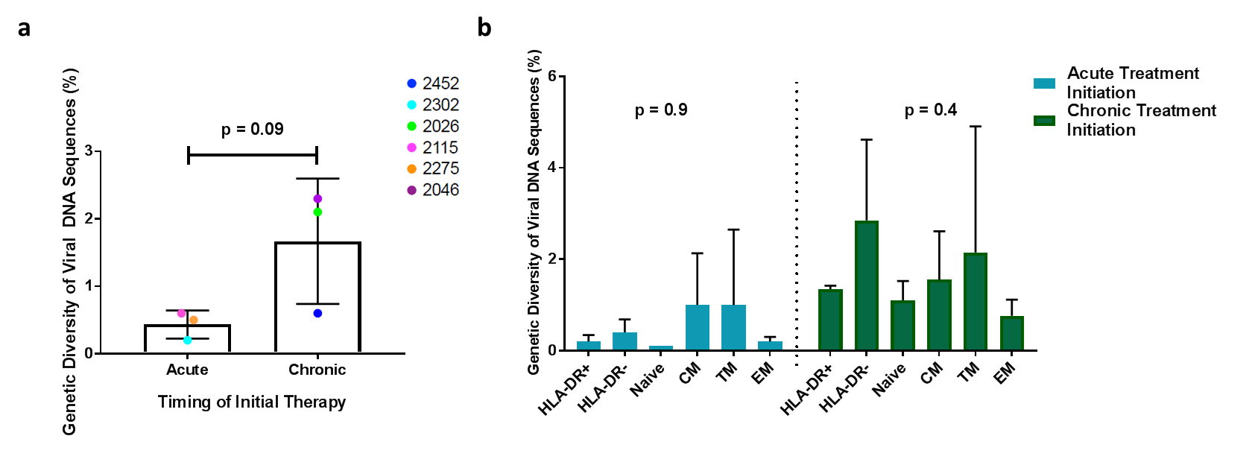Figure S8. Genetic diversity of full-length HIV sequences. (a) Percent genetic diversity of all sequences isolated from acute and chronic participants. T test. Data is mean (SD). All hypermutated sequences or inverted sequences excluded from calculations. (b) Percent genetic diversity of sequences isolated from different cell subsets. ANOVA. Data is mean (SD). All hypermutated sequences or inverted sequences excluded from calculations.

