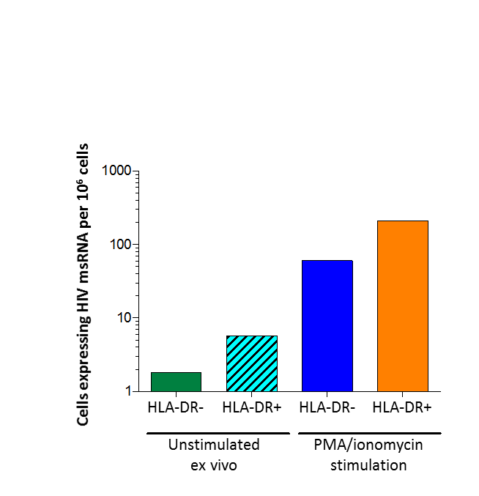Figure S9. The production of multi-spliced (ms) RNA by HLA-DR- and HLA-DR+ memory CD4+ T-cells derived from SCOPE2275. Dashed bar represents limit of detection.

