APPENDICES
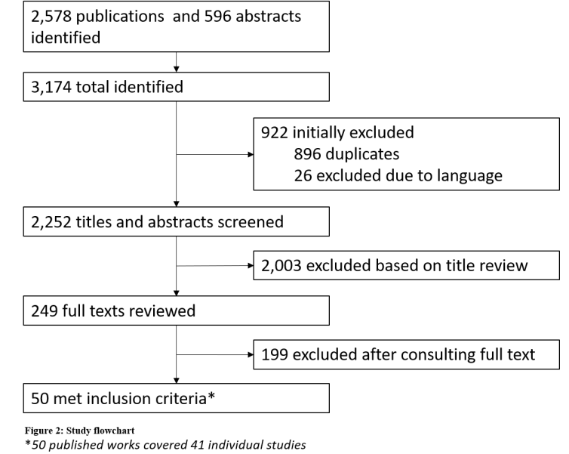
Appendix 1 – Study Flowchart
*50 published works covered 41 individual studies
Appendix 2: Study characteristics
Study code | Authors | Type of study | Country (city/district) | Year of study | Enrolled | Target groups* | Age (years) | PrEP regimen
Swaziland | Nesbitt²⁰ | Open label/Demo | Swaziland (Shiselweni) | 2017 | 108 | All at risk | 16+ | Daily
Providence, RI | Chan²¹ | Implementation | USA (Providence) | 2014–2015 | 61 | All at risk | Not stated | Daily
Jackson, MS | Chan²¹ | Implementation | USA (Jackson) | 2014–2015 | 52 | All at risk | Not stated | Daily
St. Louis, MO | Chan²¹ | Implementation | USA (St. Louis) | 2014–2015 | 26 | All at risk | Not stated | Daily
Los Angeles, CA | Shover²² | Implementation | USA (Los Angeles) | 2014–2017 | 1,764 | All at risk | 18+ | Daily
One-Step PrEP | Tung²³ | Implementation | USA (Seattle | 2015–2016 | 245 | All at risk | 18+ | Daily
Pluspills | Gill²⁴ | Open label/Demo | South Africa (Soweto, Cape Town) | Not stated | 147 | All at risk | 15–19 | Daily
Swaziland demo | Hughey¹ | Open label/Demo | Swaziland | 2017– 2018 | 217 | All at risk | 16+ | Daily
SEARCH (sub-analysis) | Mayer²⁶ | Open label/Demo | Uganda (Ruhoko) | 2017 | 272 | All at risk | 15+ | Daily
Kenya demo FSW | Kyongo²⁷ | Open label/Demo | Kenya | 2015–2017 | 528 | FSW | Not stated | Daily
TAPS demo | Eakle^{28,29} | Open label/Demo | South Africa (Johannesburg, Pretoria) | 2015–2017 | 219 | FSW | 18+ | Daily
India demo | Reza-Paul³⁰ | Open label/Demo | India (Mysore, Mandya) | Not stated | 647 | FSW | 18+ | Daily
BTS OLE | Martin³¹ | Open label/Demo | Thailand (Bangkok) | 2013–2014 | 793 | IDU | 20–60 | Daily
BTS | Choopanya³² Martin³³ | RCT | Thailand (Bangkok) | 2005–2010 | 1,204 | IDU | 20–60 | Daily
Atlanta, GA | Rolle³⁴ | Implementation | USA (Atlanta) | 2015–2016 | 201 | MSM | 16–29 | Daily
Paris clinic | Balavoine³⁵ | Implementation | France (Paris) | 2015–2017 | 1,049 | MSM | 29–43 | Daily or event-driven
San Francisco PrEP clinic | Hojilla³⁶ | Implementation | USA (San Francisco) | 2014–2015 | 268 | MSM | 18+ | Daily
ATN 113 | Hosek³⁷ | Open label/Demo | USA (Various) | 2013–2014 | 78 | MSM | 15–17 | Daily
PRELUDE | Vaccher³⁸ | Open label/Demo | Australia (New South Wales) | 2014 –2016 | 321 | MSM | 18+ | Daily
Kenya demo MSM | Kyongo²⁷ | Open label/Demo | Kenya | 2015–2017 | 438 | MSM | Not stated | Daily
Project PrEPare | Hosek³⁹ | Open label/Demo | USA (various) | 2013–2016 | 68 | MSM | 18–22 | Daily
Project PrEPare 2 | Hosek³⁹ | Open label/Demo | USA (various) | Not stated | 200 | MSM | 18–22 | Daily
PROUD | Gafos,⁴⁰ McCormack⁴¹ | Open label/Demo | England (various) | 2012–2016 | 541 | MSM | 18+ | Daily
Life–Steps | Mayer⁴² | RCT | USA (Boston) | 2012–2014 | 50 | MSM | 18+ | Daily
Intermittent PrEP in Africa | Mutua⁴³ | RCT | Kenya (Nairobi, Kirifi) | 2009–2010 | 48 | MSM, FSW | 18–49 | Daily or intermittent
Princess PrEP | Jantarapakde⁴⁴ | Implementation | Thailand (various) | 2016–2017 | 1,083 | MSM, TGW | Not stated | Not stated
AMPrEP | Hoornenborg⁴⁵ | Open label/Demo | Netherlands (Amsterdam) | 2015–2018 | 376 | MSM, TGW | 18+ | Daily or event-driven
ATN 082 OLE | Grant⁴⁶ | Open label/Demo | USA, Brazil, Peru, Ecuador, South Africa, Thailand | 2011–2012 | 1,225 | MSM, TGW | 18+ | Daily
Be-PrEP-ared | Vuylsteke⁴⁷ | Open label/Demo | Belgium (Antwerp) | 2015 – 2018 | 200 | MSM, TGW | 22–70 | Daily or event-driven
IPERGAY OLE | Molina⁴⁸ | Open label/Demo | France (six sites), Canada (Montreal) | 2014–2015 | 361 | MSM, TGW | 18+ | Event-driven
Brasil demo | Grinsztejn^{49,50} | Open label/Demo | Brazil (Rio de Janeiro, Sao Paulo) | 2014–2016 | 450 | MSM, TGW | 18+ | Daily
US PrEP demo | Liu⁵¹ | Open label/Demo | USA (various) | 2012–2015 | 557 | MSM, TGW | 18+ | Daily
IPERGAY | Molina⁵² | RCT | France (six sites), Canada (Montreal) | 2012–2016 | 199 | MSM, TGW | 18+ | Event-driven
Partners demo project | Baeten⁵³ | Open label/Demo | Kenya, Uganda | 2012–2015 | 985 | SDC | 18+ | Daily
Partners PrEP Study | Baeten^{54,55} | RCT | Kenya, Uganda | 2008–2010 | 3,179 | SDC | 18–65 | Daily
Mozambique | Lahuerta⁵⁶ | Open label/Demo | Mozambique (Gaza) | 2016 | 72 | Women | 18+ | Time-limited
MP3 youth | Inwani⁵⁷ | Open label/Demo | Kenya | Not stated | 28 | Women | 18–24 | Daily
Kenya demo women | Kyongo²⁷ | Open label/Demo | Kenya | 2015–2017 | 619 | Women | Not stated | Daily
FEM–PrEP | Van Damme¹ | RCT | Kenya, South Africa, Tanzania | 2009–2011 | 1,062 | Women | 18–35 | Daily
HPTN 067/ADAPT | Bekker⁵⁸ | RCT | South Africa (Cape Town) | 2011–2012 | 178 | Women | 18+ | Daily, time-driven or event-driven
VOICE | Marrazzo² | RCT | South Africa, Uganda, Zimbabwe | 2009–2012 | 1,915 | Women | 18–45 | Daily
*FSW = Female sex workers, IDU = Injection drug users, MSM = Men who have sex with men, TGW = Transgender women, SDC = Serodiscordant couples

