Supplemental Digital Content – List of items

Figure S1. Client Flow at the “New Start” mobile outreach model with the option of HIV self-testing
Figure S2. Client Flow for the community-based index testing model with the option of HIV self-testing
Text document S1. Estimation of personnel costs allocation factors between HTS and HIVST activities for periods 2 & 3
Table S1. Composition of economic costs for the full costing of HTS and HIVST and assumptions on HIVST costs composition for an incremental cost analysis
Table S2. Description of the pre-defined activities used in the time and motion study
Table S3. Results from the time and motion study and allocation factors of personnel costs between HTS and HIVST activities by period
Table S4.a. Quarterly averages of the full economic cost of HTS and HIVST during the period May 2017 – April 2019 (in 2019 US$)
Table S4.b. Quarterly averages of the full economic cost of HTS and incremental economic costs of HIVST during the period May 2017 – April 2019 (in 2019 US$)
Table S4.c. Quarterly averages of the full economic cost of HTS and incremental financial costs of HIVST during the period May 2017 – April 2019 (in 2019 US$)

Supplemental Digital Content

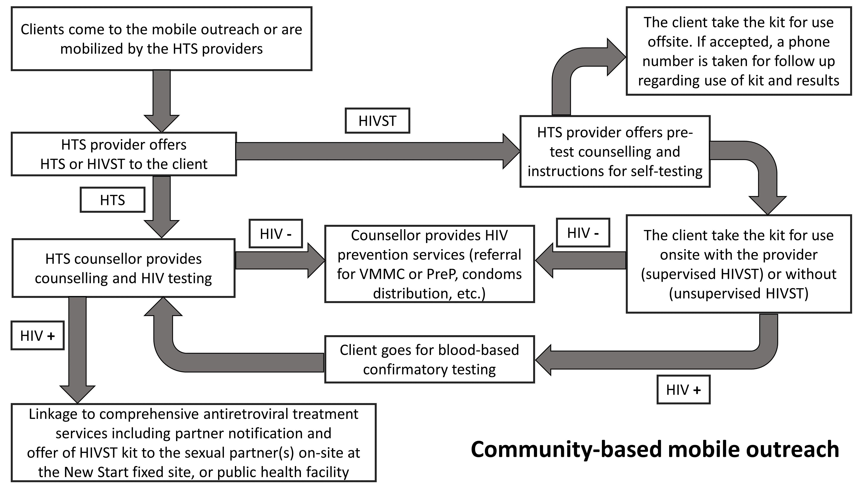
Figure S1. Client Flow at the “New Start” mobile outreach model with the option of HIV self-testing

Figure S2. Client Flow for the community-based index testing model with the option of HIV self-testing
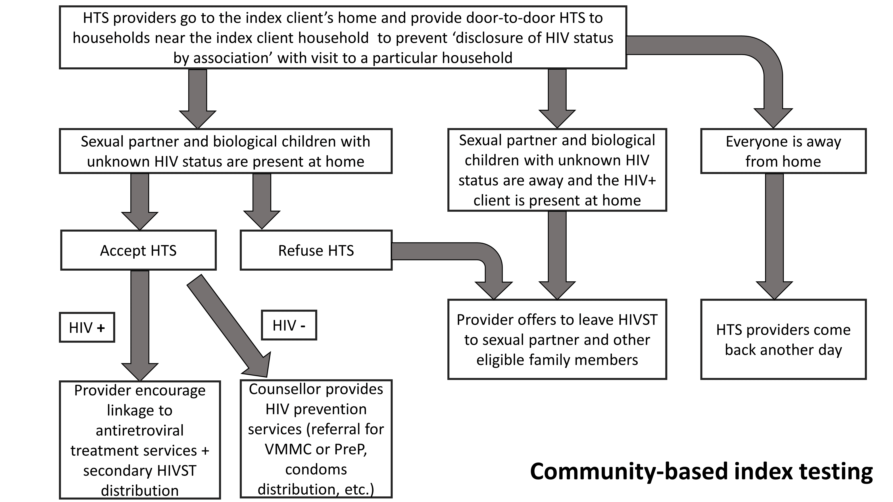

Text document S1. Estimation of personnel costs allocation factors between HTS and HIVST activities for periods 2 & 3

a. Description of the intervention
The first HIVST distribution started in December 2017 (period 2) promoting HIVST for use off-site or on-site using the HTS gazebos. These gazebos were specifically designed to provide HTS, and if a HIVST session was conducted in it, it led to the incapacity of a counsellor to conduct HTS. It is worth noting that a HTS session takes much less time than a HIVST session when the HIV test result is negative.
In period 3, individual booths were introduced in addition to the HTS gazebos. Consequently, people wanting to self-test in private could use these booths while the gazebos were reserved for counsellor who could provide HTS and confirm results of a reactive or inconclusive self-test. As a result, the outreach team could reorganize their activities where some counsellors or interpersonal communication agents could conduct community mobilization or provide support as needed to client self-testing in the booths while the rest of the counsellors were based in the gazebos to provide conventional HTS and confirm HIVST reactive test.
This change meant that TMS data collected in period 2 allocated an important percentage of staff time to HIVST activities while the period 3 allowed to better use the staff time and provide services more efficiently, rebalancing the allocation of staff time between activities.

b. Time and Motion study (TMS) - Methodology
A time and motion study (TMS) was conducted to observe staff providing both HTS/index testing and HIVST services and allocate personnel costs based on the time spent on each activity ^{[1, 2]}. The TMS differentiates between supervised and unsupervised HIVST episodes on-site. An HIVST episode is defined as supervised when the provider is with the client during the entire testing process (pre-test counselling, instruction for self-testing, oral sampling, waiting for results and post-test counselling) and unsupervised if the provider is absent at least while the client waits for the self-test results. This study also estimates provider’s indirect time which corresponds to the personnel time spent not seeing any clients, travel time and administrative work. In the case of the incremental HIVST costing analysis, providers’ indirect time is allocated fully to conventional HTS, while in the full HIVST cost analysis, indirect time is shared between HTS and HIVST, following time allocations from the TMS. M&E, administrative, and programme level staff were charging either CIDLINK or STAR projects and the allocation of costs between projects was based on their timesheets or with individual interviews for senior staff. Field based personnel costs providing both HTS and HIVST services were only charging CIDLINK project. The TMS was conducted as part of the costing exercise to observe staff providing both HTS and HIVST services and allocate personnel costs based on the time spent on each activity. The TMS only used results from observations at the mobile outreach and not the index testing activities which were provided alongside and accounted for 4% to 7% of total community-based HTS and for 2% to 4% of total HIVST index activities. The TMS results also helped to value efficiency gains with the introduction of on-site HIVST.
The TMS used external observers conducting continuous observations of health providers during their normal working day which is considered as the gold standard method ^{[1]}. We conducted continuous observation with paper-based tools to record the start and stop times of observed tasks with a detail of minutes. We used a duration measurement for a series of pre-defined episodes based on our understanding of the intervention. We also aimed to capture the effect of the HIV test results and the supervision level by the provider (for self-testing) on the length of the conventional and self-testing episodes.
The TMS was conducted between September-November 2018 by two data collectors. In total, 16 providers (interpersonal communication agent, lay counsellors, professional counsellors or nurses) gave written consent and were observed either the morning or afternoon, in a rural or urban setting. Some days of observation, provision of HTS/HIVST could be as low as two episodes or up to eighteen per provider in more busy areas.
Data collected included: date, district, name of site, data collector ID, distributor ID, distributor grade, direct patient time (time at the outreach and available to provide HIV testing), driving time to get to the outreach, time to provide HTS to a client, information on HIVST without distribution, HIVST distribution for off-site testing (differentiated between primary and secondary distribution), supervised and unsupervised on-site HIVST, test result for HTS and HIVST. The categories are presented in Table S2.
Since the time of the day and the type of provider, did not affect the length of the testing session, we estimated average time for each episode on the overall sample.

c. Application of results from the TMS to estimation field-based personnel costs allocation factors
Because direct client time was varying significantly between mobile outreach (e.g. outreaches in rural setting could have very low direct client time because of travel time), we did not use the results from the TMS.
Instead, we estimated the average number of episode per provider, per day and per mobile outreach for each episode of HTS (with a positive or negative test result) and HIVST (off-site, on-site/supervised and on-site/unsupervised) based on the M&E data. The method to estimate the % of unsupervised HIVST episodes in period 3 is described in the section c.
We then multiplied the average number of episodes with the corresponding times from the TMS to estimate a proportion of time spent on HTS and on HIVST then used to allocate personnel costs.
For a full costing approach, the denominator was the direct client time estimated as the sum of total HTS and HIVST activities ^{[3]}. For an incremental costing approach, the costs of time spent on activities such as travel, administrative activities, and any other activities with provider’s indirect time should not be included as they are indirect costs. Therefore, the denominator was the average total daily working hours of the employees.

d. Estimation of on-site supervised and unsupervised HIVST episodes in period 3
While efficiency gains were observed during the TMS with the introduction of individual booths in period 3 allowing for more episodes of unsupervised on-site HIVST sessions, the M&E data reported whether the client self-tested on-site or off-site, but the information on whether it was a supervised or unsupervised on-site HIVST episode could not be used.
The M&E results shows an increase of direct client time (expressed by the number of testing/self-testing episodes provided) between period 2 and 3, even after adjusting for the field-based team size over time. We assumed that the team was working at full capacity in period 2, therefore, the estimated total direct client time per provider per day per outreach should be the same between period 2 and 3. The increase of direct client time is due to unsupervised on-site HIVST activities.
Based on the above assumptions and the following algebraic equations with two unknowns, we estimated that 7% of on-site HIVST were unsupervised and that 93% were supervised by a health provider.
Algebraic equation with two unknowns:
x₃ + y₃ = z₃
x₃* Tx +y₃*Ty = Tz₃
x₃: Average number of on-site supervised HIVST per provider per day in period 3 (unknown)
y₃: Average number of on-site unsupervised HIVST per provider per day in period 3 (unknown)
z₃: Average number of on-site HIVST per provider per day in period 3
Tx: Average time spent by a provider on an on-site supervised HIVST episode
Ty: Average time spent by a provider on an on-site unsupervised HIVST episode
Tz₃: Average total time spent on on-site HIVST per provider per day in period 3

The results from these exercises are presented in Table S3.

Table S1. Composition of economic costs for the full costing of HTS and HIVST and assumptions on HIVST costs composition for an incremental cost analysis
Cost category | Composition of conventional HIV testing (HTS) costs | Composition of full HIVST costs | Incremental HIVST costs - Assumptions
Start-up
S1: Training | Fin.: Expenditure report for training venue and per diems, catering, etc. (annualised costs)  Eco.: Annualised and discounted financial costs | Fin.: Expenditure report for training venue and per diems, catering, etc. (annualised costs)  Eco.: Annualised and discounted financial costs | All start-up costs are included in the incremental costs
S2: Sensitisation | Fin.: Advert production, printing of flyers, sensitization meetings with stakeholders (annualised costs)  Eco.: Annualised and discounted financial costs | Fin.: Advert production, printing of flyers, sensitization meetings with stakeholders (annualised costs)  Eco.: Annualised and discounted financial costs | All start-up costs are included in the incremental costs
S3: Start-up other | Fin.: Expenditure reports for all other costs incurred during the start-up period (annualised costs)  Eco.: Annualised and discounted financial costs | Fin.: Expenditure reports for all other costs incurred during the start-up period (annualised costs)  Eco.: Annualised and discounted financial costs | All start-up costs are included in the incremental costs
Capital
A: Building & storage | Fin.: Proportion of the rent of PSI HQ office, storage warehouse and New Start fixed sites where the staff is based for activities not in the field (planning outreaches, storage of equipment, etc.) (annualised costs)  Eco.: Annualised and discounted financial costs | Fin.: Programme costs allocated to rent of PSI central warehouse for storage of HIVST kits only. Storage costs at New Start fixed site are negligible. (annualised costs)  Eco.: Annualised and discounted financial costs | Except for HIVST kits storage, all other building costs are excluded.
B: Equipment | Fin.: Furniture purchase and other equipment at PSI headquarters and New Start sites (tables, gazebos, chairs, booth, etc.) (annualised costs)  Eco.: Annualised and discounted financial costs | Fin.: individual booth only (annualised costs)  Eco.: Include donated goods such as a proportion of equipment used for HTS allocated to HIVST programme based on programmes' activities, then, all costs are annualised and discounted | Except for the individual booth, all other equipment costs are excluded.
C: Vehicles | Fin.: New vehicle bought in period 1 (annualised costs)  Eco.: Includes donated goods such as costs of older vehicles then, all costs are annualised and discounted | Fin.: None since all HIVST activities are attached to existing HTS  Eco.: Includes donated goods such as costs of vehicles allocated to HIVST based on programmes' activities, then all costs are annualised and discounted | Excluded since all HIVST activities are added to existing HTS activities. However, at scale-up, supply chain costs will be considered
Recurrent
E: Personnel & Per diems - HQ | Fin.: Proportion of personnel costs at HQ in Maseru (M&E, finance, admin, etc.) under PSI common costs allocation  Eco.: Financial costs | Fin.: Proportion of personnel costs at HQ in Maseru (M&E, finance, admin, etc.) under PSI common costs allocation  Eco.: Financial costs | Included in the incremental cost analysis
E: Personnel & Per diems | Fin.: Personnel at New Start fixed site (senior HTS counsellor, M&E assistant, team leader, drivers) based on time tracking reports, and field-based professional, assistant and lay HTS counsellors 100% on CIDLINK  Eco.: Financial costs | Fin.: Costs of personnel at New Start fixed site (senior HTS counsellor, M&E assistant, team leader, drivers) based on time tracking reports. Interpersonal communication agents (HIVST distributors) 100% on STAR  Eco.: Includes donated services such as field-based professional, assistant and lay HTS counsellors working for CIDLINK and providing HIVST, and financial costs | Costs allocation based on the results of the time and motion study. Incremental HIVST costs exclude indirect costs of staff spent on travel time, time spent on administrative tasks, etc. One should consider the potential effect of significant HIVST kits shortages on field-based activities (HIVST kit shortages lead to reduced field-based HIVST activities and reduced % allocation of personnel costs to HIVST activities - but this can be justified with a task shifting back to conventional HTS in the situation of HIVST shortages. Additional M&E and management charges (directly charged to STAR are kept to STAR in the incremental costing analysis to reflect this additional charge)
F: Supplies | Fin.: PSI office supplies such as stationery (under common costs allocation)  Eco.: Includes donated goods such as HTS supplies (e.g. rapid test kits Determine, Unigold, etc.) and financial costs | Fin.: PSI office supplies such as stationery (under common costs allocation) + HIVST kits costs  Eco.: Financial costs | Included in the incremental cost analysis
G: Vehicle operation, maintenance & transport | Fin.: Costs such as fuel, insurance, repair and maintenance (oil, etc.) allocated to the programme under PSI common costs allocation  Eco.: Financial costs | Fin.: Costs such as fuel, insurance, repair and maintenance (oil, etc.) allocated to the programme under PSI common costs allocation  Eco.: Financial costs | Excluded since all HIVST activities are added to existing HTS activities. However, at scale-up, supply chain costs will be considered
H: Building operation/maintenance | Fin.: Costs such as office/warehouse reparation and maintenance, utilities, equipment repair/maintenance, and insurance allocated to the programme under PSI common costs allocation  Eco.: Financial costs | Fin.: Costs such as office/warehouse reparation and maintenance, utilities, equipment repair/maintenance, and insurance allocated to the programme under PSI common costs allocation  Eco.: Financial costs | Included in the incremental cost analysis
I: Recurrent training | Fin.: Hiring of venue, hotel, per diem for participants. Training every 2 years so the costs were annualised  Eco.: Annualised and discounted financial costs | N/A | N/A
J: Waste management | Fin.: Contracting with an external company. Costs allocated to the programmes under PSI common costs allocation  Eco.: Financial costs | Fin.: Contracting with an external company. Costs allocated to the programmes under PSI common costs allocation  Eco.: Financial costs | Included in the incremental cost analysis
K: Other recurrent | Fin.: Bank fees, subscriptions, postage, etc. Costs allocated to the programmes under PSI common costs allocation  Eco.: Financial costs | Fin.: Bank fees, subscriptions, postage, etc. Costs allocated to the programmes under PSI common costs allocation  Eco.: Financial costs | Included in the incremental cost analysis

Table S2. Description of the pre-defined activities used in the time and motion study
Code | Activity description
HTS_negative | HIV testing episode which can include individual, couple or group pre-test counselling; individual HIV rapid testing with a negative result and post-test counselling
HTS_positive | HIV testing episode which can include individual, couple or group pre-test counselling; individual HIV rapid testing with a positive result and post-test counselling
On-site HIVST_supervised | HIV self-testing kit primary distribution, which can include pre-test counselling, demonstration on how to self-test, self-testing, waiting for the results and post-test counselling. This account for the time spent by the provider with the client during the entire session
On-site HIVST_unsupervised | HIV self-testing kit primary distribution, which can includes pre-test counselling, demonstration on how to self-test, self-testing, waiting for the results and post-test counselling. The provider is not with the client during the session, in particular when waiting for and reading the test result and this time is not included
Off-site_HIVST | HIV self-testing kit secondary distribution which can include pre-test counselling and demonstration on how to self-test
Other_DPS | Other Direct Patient Services: time allocated to services that are not related to HTS and HIVST (e.g. family planning, PrEP, ART initiation etc.) provided by the health care worker to a client
Non_DPS | Any time spent not facing clients (breaks, lunch, waiting for clients, etc.)
Weekly_average_working_hours | Regular working hours reported by the study participant

Table S3. Results from the time and motion study and allocation factors of personnel costs between HTS and HIVST activities by period
Activities | HTS |  | HIVST
Sessions | HTS-negative | HTS-positive | Off-site HIVST | On-site HIVST - supervised | On-site HIVST - unsupervised
Results - Time and Motion Studyª
Average time per session- Mean(StD^{b}) - min | 17.3(5.5) | 32.3(10.7) | 8.1(4.0) | 24.1(5.2) | 10.4(3.2)
# of observations | 35 | 7 | 9 | 46 | 12
Daily working hours - min | 480
Period 2 - M&E data and personnel costs allocation factors
Average # of session/provider/day | 5.2 | 0.2 | 2.2 | 1.1 | 0.0
Total session time/provider/day - min | 89.1 | 5.4 | 17.9 | 25.5 | 0.0
Total activity time/provider/day - min | 94.6 |  | 43.3
Total direct client time/provider/day - min | 137.9
HTS & HIVST - Full costs analysis  (=Total activity time/Total direct client time) | 68.6% |  | 31.4%
HIVST - Incremental costs analysis  (=Total activity time/Working hours)* | 91.0% |  | 9.0%
Period 3 - M&E data and personnel costs allocation factors
Average # of session/provider/day | 3.6 | 0.1 | 0.6 | 2.6 | 0.4
Total session time/provider/day - min | 61.6 | 4.7 | 5.1 | 62.0 | 4.5
Total activity time/provider/day - min | 66.3 |  | 71.6
Total direct client time/provider/day - min | 137.9
HTS & HIVST - Full costs analysis  (=Total activity time/Total direct client time) | 48.0% |  | 52.0%
HIVST - Incremental costs analysis  (=Total activity time/Working hours)^{c} | 85.1% |  | 14.9%
ªIn total, 16 health providers and 109 episodes were observed ^{b}StD: Standard Deviation, ^{c}Formula applied to HIVST activities, the remaining % is allocated to the existing HTS.

Table S4.a. Quarterly averages of the full economic cost of HTS and ST during the period May 2017 – April 2019 (in 2019 US$)
Cost category | Period 1 |  |  | Period 2 |  |  |  |  | Period 3
 | Full analysis |  |  | Full analysis |  |  |  |  | Full analysis
 | HTS |  |  | HTS |  | HIVST |  |  | HTS |  | HIVST
 | Full costs | % |  | Full costs | % | Full costs | % |  | Full costs | % | Full costs | %
Start-up
S1: Training | - | - |  | - | - | 120 | 0% |  | - | - | 120 | 0%
S2: Sensitisation | - | - |  | - | - | 14 | 0% |  | - | - | 14 | 0%
S3: Start-up other | 15,807 | 2% |  | 15,807 | 2% | 756 | 0% |  | 15,807 | 2% | 756 | 0%
Start-up - sub-total | 15,807 | 2% |  | 15,807 | 2% | 890 | 0% |  | 15,807 | 2% | 890 | 0%
Capital
A: Building & storage | 5,168 | 1% |  | 16,544 | 2% | 274 | 0% |  | 18,526 | 3% | 553 | 0%
B: Equipment | 1,374 | 0% |  | 4,400 | 1% | 2,026 | 1% |  | 1,446 | 0% | 1,921 | 0%
C: Vehicles | 12,470 | 2% |  | 6,187 | 1% | 6,187 | 2% |  | 6,135 | 1% | 6,135 | 1%
Capital - sub-total | 19,012 | 2% |  | 27,131 | 4% | 8,486 | 3% |  | 26,107 | 4% | 8,609 | 2%
Recurrent
E: Personnel & Per diems - HQ | 37,139 | 5% |  | 90,166 | 12% | 4,509 | 2% |  | 55,303 | 8% | 7,761 | 2%
E: Personnel & Per diems | 546,031 | 67% |  | 461,434 | 60% | 225,273 | 83% |  | 396,200 | 61% | 408,716 | 85%
F: Supplies | 115,657 | 14% |  | 86,126 | 11% | 17,396 | 6% |  | 75,490 | 12% | 34,510 | 7%
G: Vehicle operation, maintenance & transport | 59,099 | 7% |  | 44,325 | 6% | 15,056 | 6% |  | 44,325 | 7% | 16,119 | 3%
H: Building operation/maintenance | 6,477 | 1% |  | 12,326 | 2% | 201 | 0% |  | 9,830 | 2% | 456 | 0%
I: Recurrent training | 9,715 | 1% |  | 9,715 | 1% | 0 | 0% |  | 9,715 | 1% | 0 | 0%
J: Waste management | 1,947 | 0% |  | 1,932 | 0% | 133 | 0% |  | 1,915 | 0% | 162 | 0%
K: Other recurrent | 8,756 | 1% |  | 21,977 | 3% | 699 | 0% |  | 17,522 | 3% | 1,700 | 0%
Recurrent - sub-total | 784,822 | 96% |  | 728,001 | 94% | 263,267 | 97% |  | 610,300 | 94% | 469,424 | 98%
Total costs | 819,640 |  |  | 770,939 |  | 272,509 |  |  | 652,213 |  | 478,790
HTS session / HIVST kit distributed per quarter | 25,433 |  |  | 27,045 |  | 6,300 |  |  | 27,780 |  | 12,687
Cost per HTS conducted / HIVST kit distributed | 32.2 |  |  | 28.5 |  | 43.3 |  |  | 23.5 |  | 37.7
Table S4.b. Quarterly averages of the full economic cost of HTS and incremental economic costs of HIVST during the period May 2017 – April 2019 (in 2019 US$)
Cost category | Period 2 |  |  |  |  | Period 3
 | Incremental analysis |  |  |  |  | Incremental analysis
 | HTS |  | HIVST |  |  | HTS |  | HIVST
 | Full costs | % | Incr. costs | % |  | Full costs | % | Incr. costs | %
Start-up
S1: Training | - | - | 120 | 0% |  | - | - | 120 | 0%
S2: Sensitisation | - | - | 14 | 0% |  | - | - | 14 | 0%
S3: Start-up other | 15,807 | 2% | 756 | 1% |  | 15,807 | 2% | 756 | 0%
Start-up - sub-total | 15,807 | 2% | 890 | 1% |  | 15,807 | 2% | 890 | 1%
Capital
A: Building & storage | 16,570 | 2% | 247 | 0% |  | 18,832 | 2% | 247 | 0%
B: Equipment | 5,857 | 1% | 569 | 1% |  | 2,463 | 0% | 905 | 1%
C: Vehicles | 12,374 | 1% | 0 | 0% |  | 12,270 | 1% | 0 | 0%
Capital - sub-total | 34,802 | 4% | 816 | 1% |  | 33,564 | 4% | 1,152 | 1%
Recurrent
E: Personnel & Per diems - HQ | 90,166 | 10% | 4,509 | 5% |  | 55,303 | 6% | 7,761 | 4%
E: Personnel & Per diems | 614,262 | 65% | 72,445 | 75% |  | 674,713 | 71% | 130,203 | 73%
F: Supplies | 86,126 | 9% | 17,396 | 18% |  | 75,490 | 8% | 34,510 | 19%
G: Vehicle operation, maintenance & transport | 59,099 | 6% | 281 | 0% |  | 59,099 | 6% | 1,344 | 1%
H: Building operation/maintenance | 12,326 | 1% | 201 | 0% |  | 9,830 | 1% | 456 | 0%
I: Recurrent training | 9,715 | 1% | 0 | 0% |  | 9,715 | 1% | 0 | 0%
J: Waste management | 1,932 | 0% | 133 | 0% |  | 1,915 | 0% | 162 | 0%
K: Other recurrent | 21,977 | 2% | 699 | 1% |  | 17,522 | 2% | 1,700 | 1%
Recurrent - sub-total | 895,604 | 95% | 95,664 | 98% |  | 903,588 | 95% | 176,136 | 99%
Total costs | 946,212 |  | 97,236 |  |  | 952,958 |  | 178,045
HTS session / HIVST kit distributed per quarter | 27,045 |  | 6,300 |  |  | 27,780 |  | 12,687
Cost per HTS conducted / HIVST kit distributed | 35.0 |  | 15.4 |  |  | 34.3 |  | 14.0
Table S4.c. Quarterly averages of the full economic cost of HTS and incremental financial costs of HIVST during the period May 2017 – April 2019 (in 2019 US$)
Cost category | Period 2 |  |  |  |  | Period 3
 | Incremental analysis |  |  |  |  | Incremental analysis
 | HTS |  | HIVST |  |  | HTS |  | HIVST
 | Full costs | % | Incr. costs | % |  | Full costs | % | Incr. costs | %
Start-up
S1: Training | - | - | 120 | 0% |  | - | - | 120 | 0%
S2: Sensitisation | - | - | 14 | 0% |  | - | - | 14 | 0%
S3: Start-up other | 15,807 | 2% | 756 | 2% |  | 15,807 | 1% | 756 | 1%
Start-up - sub-total | 15,807 | 2% | 890 | 2% |  | 15,807 | 1% | 890 | 1%
Capital
A: Building & storage | 16,570 | 2% | 247 | 1% |  | 18,832 | 2% | 247 | 0%
B: Equipment | 6,417 | 1% | 8 | 0% |  | 2,853 | 0% | 514 | 1%
C: Vehicles | 12,374 | 1% | 0 | 0% |  | 12,270 | 1% | 0 | 0%
Capital - sub-total | 35,362 | 4% | 256 | 1% |  | 33,955 | 3% | 762 | 1%
Recurrent
E: Personnel & Per diems - HQ | 90,166 | 9% | 4,509 | 12% |  | 55,303 | 5% | 7,761 | 11%
E: Personnel & Per diems | 673,021 | 67% | 13,686 | 36% |  | 781,795 | 74% | 23,121 | 33%
F: Supplies | 86,126 | 9% | 17,396 | 46% |  | 75,490 | 7% | 34,510 | 49%
G: Vehicle operation, maintenance & transport | 59,099 | 6% | 281 | 1% |  | 59,099 | 6% | 1,344 | 2%
H: Building operation/maintenance | 12,326 | 1% | 201 | 1% |  | 9,830 | 1% | 456 | 1%
I: Recurrent training | 9,715 | 1% | 0 | 0% |  | 9,715 | 1% | 0 | 0%
J: Waste management | 1,932 | 0% | 133 | 0% |  | 1,915 | 0% | 162 | 0%
K: Other recurrent | 21,977 | 2% | 699 | 2% |  | 17,522 | 2% | 1,700 | 2%
Recurrent - sub-total | 954,363 | 95% | 36,905 | 97% |  | 1,010,669 | 95% | 69,055 | 98%
Total costs | 1,005,531 |  | 37,917 |  |  | 1,060,430 |  | 70,573
HTS session / HIVST kit distributed per quarter | 27,045 |  | 6,300 |  |  | 27,780 |  | 12,687
Cost per HTS conducted / HIVST kit distributed | 37.2 |  | 6.0 |  |  | 38.2 |  | 5.6

Reference list

1. Lopetegui M, Yen PY, Lai A, Jeffries J, Embi P, Payne P. Time motion studies in healthcare: what are we talking about? J Biomed Inform 2014; 49:292-299.
2. Akhavan S, Ward L, Bozic KJ. Time-driven Activity-based Costing More Accurately Reflects Costs in Arthroplasty Surgery. Clin Orthop Relat Res 2016; 474(1):8-15.
3. Terris-Prestholt F, Santos A, Sweeney S, Kumaranayake L. The Rapid Syphilis Test Toolkit Implementation 1: Guidelines for Cost effectiveness analysis of Syphilis Screening Strategies. 2011.

