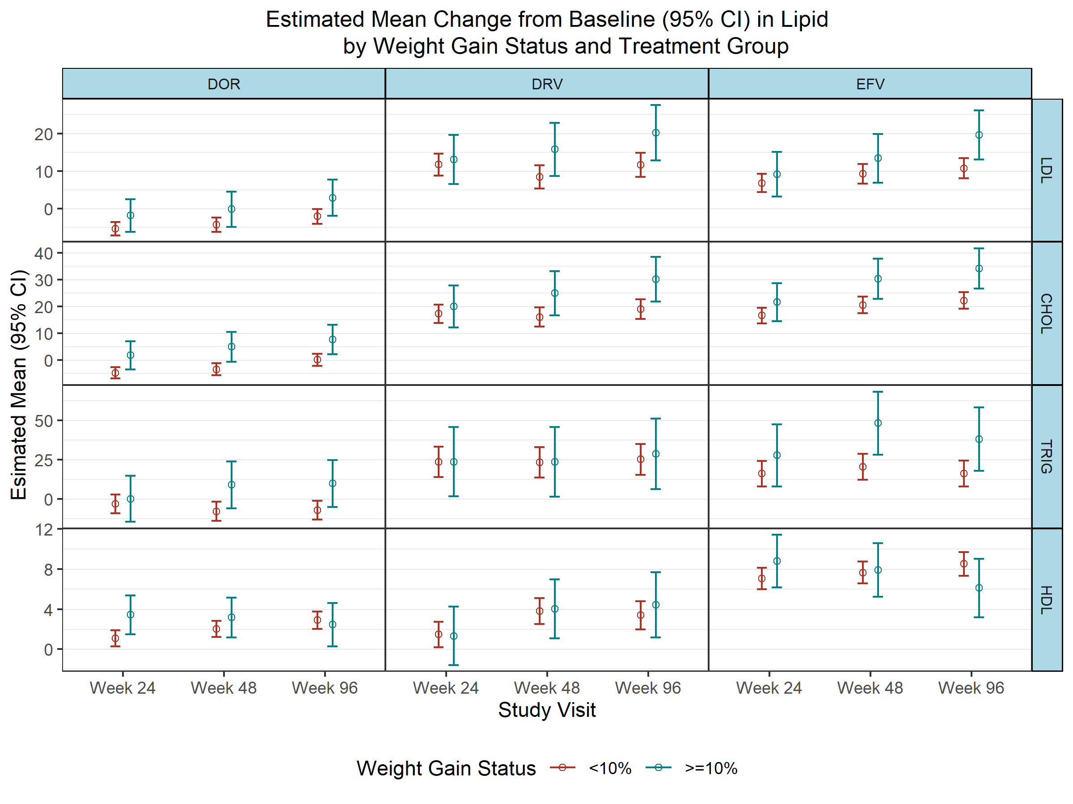
Weight gain percent is 100*(weight at Week 96 - weight at baseline)/(weight at baseline). Subjects with missing weight change are not included in the analysis.
Estimates, differences, and their 95% CI are based on a linear regression model with change from baseline as the independent variable, treatment group, weight change status, visit, their interaction and age, sex, black, baseline values of weight, lipid, CD4 counts and log of viral load as explanatory variables.

