Supplementary material

a.)
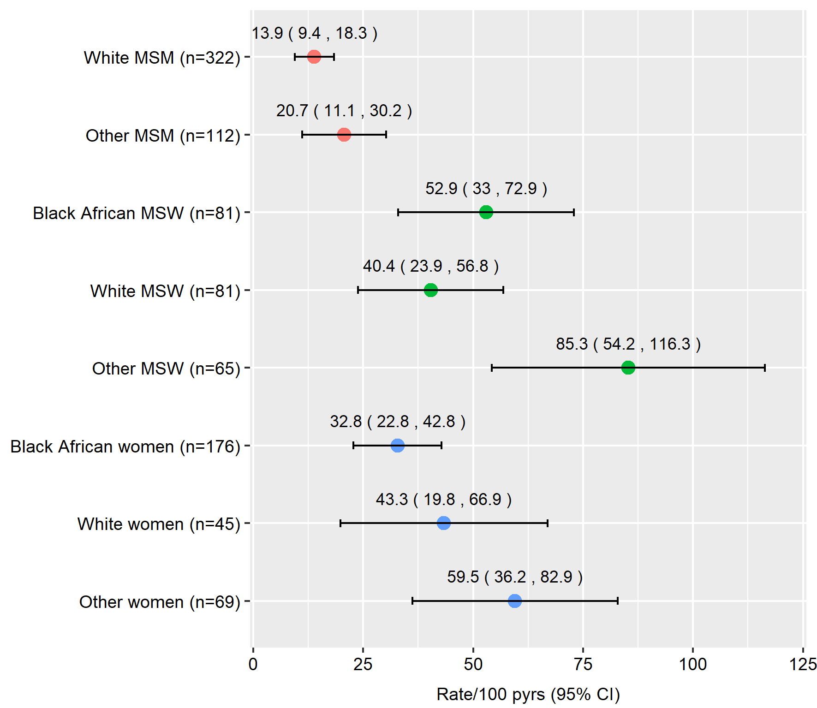

b.)
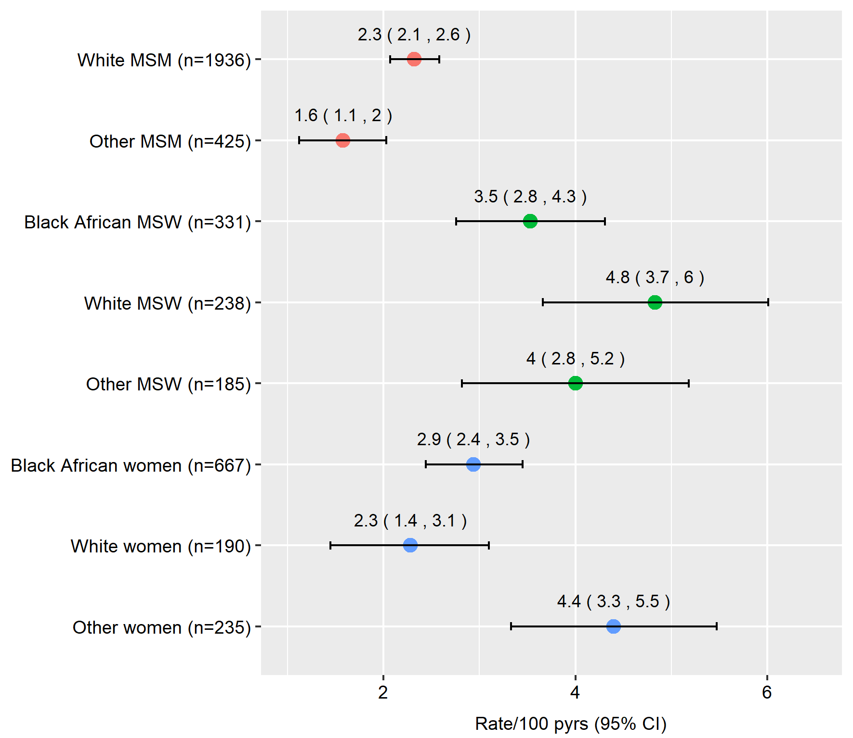

Supplementary Figure 1: Rates across demographic groups further stratified by ethnicity in Analysis A (first year after diagnosis; Figure 1a) and Analysis B (>1 year after HIV diagnosis; Figure 1b). Pyrs=person-years; CI=confidence interval; MSM=men who have sex with men; MSW=men who have sex with women

