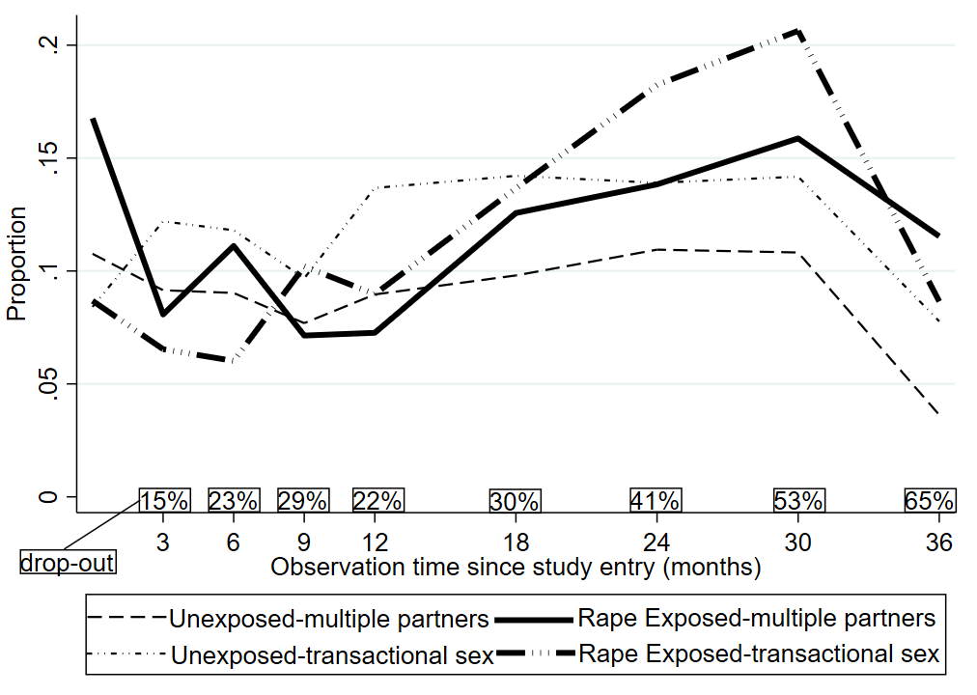
Figure S2: Graph depicting transition of multiple partners and transactional sex over time by exposure group

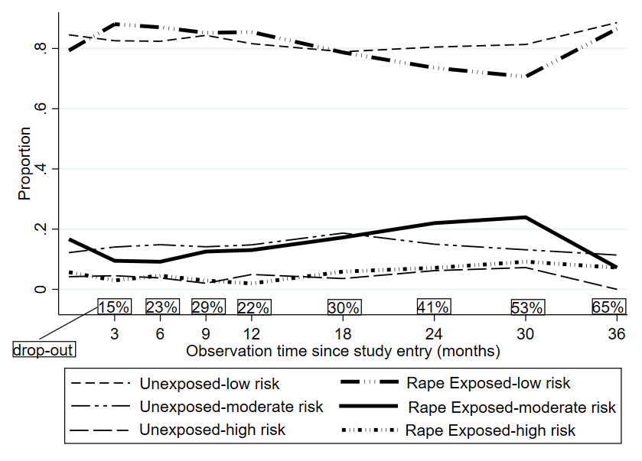
Figure S3: Graph depicting transition of composite risk variable over time by exposure group

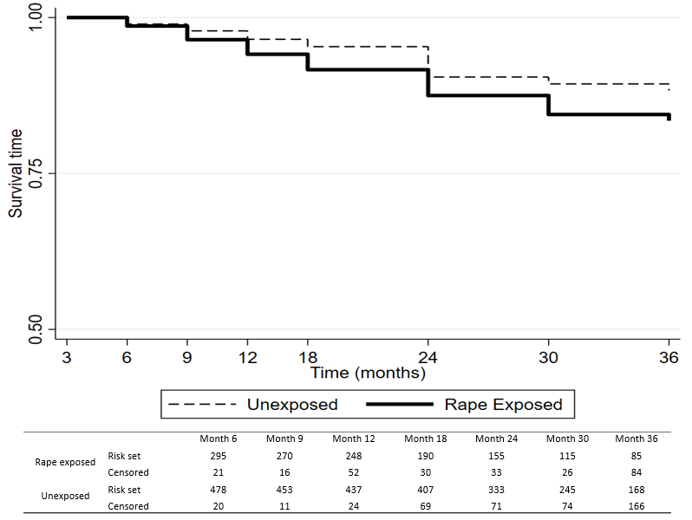
Figure S4: Kaplan-Meier survival plot depicting HIV sero-conversion by month of follow up with starting time shifted to month 3 by exposure group

