Group 2: Interactive digital interventions vs. face-to-face interventions

Figure 6

Forest plot: IDIs vs face-to-face interventions: KNOWLEDGE
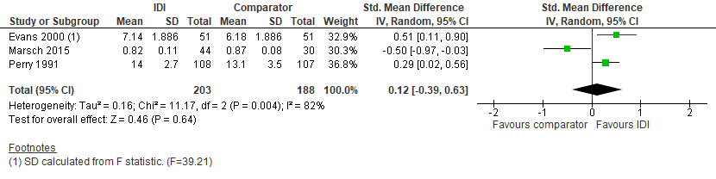

Figure 7

Forest plot: IDIs vs face-to-face interventions: SELF-EFFICACY

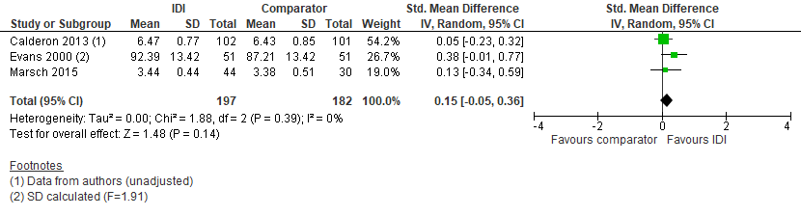

Figure 8

Forest plot: IDIs vs face-to-face interventions: INTENTION

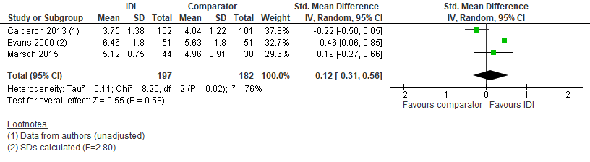

Subgroup analyses – effects of interactive digital interventions by setting

Figure 9. Forest plot: IDIs vs minimal interventions: KNOWLEDGE, by setting
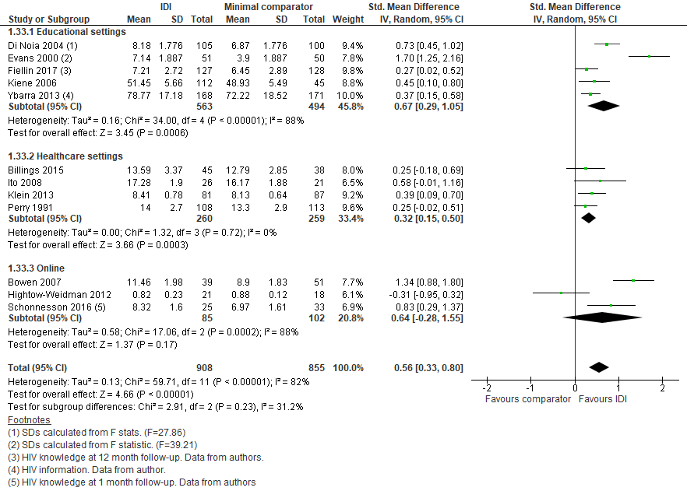
* IDIs were effective for knowledge acquisition in educational and healthcare settings, but not online (although the online sample size was small)

Figure 10. Forest plot: IDIs vs minimal interventions: SELF-EFFICACY, by setting

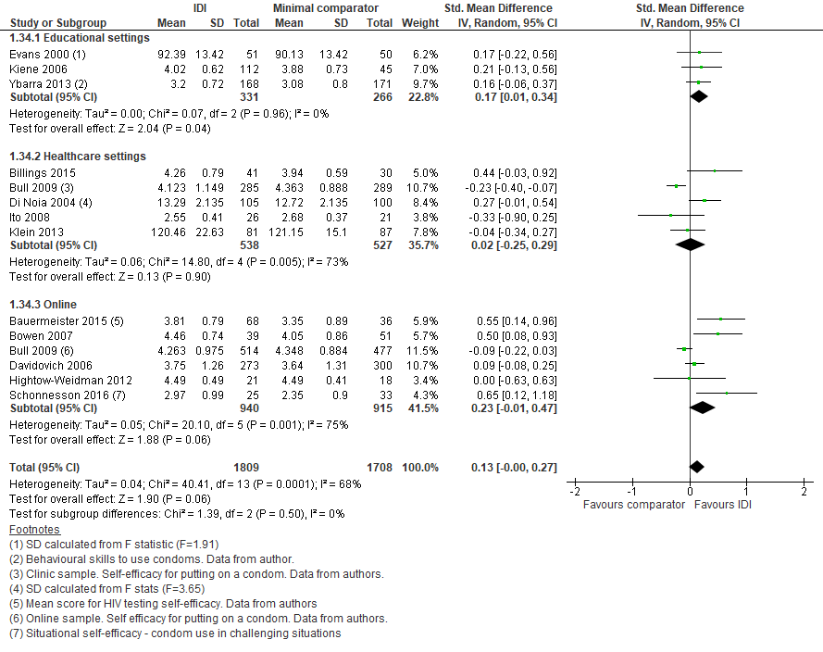

* IDIs were effective for self-efficacy in educational settings only

Figure 11. Forest plot: IDIs vs minimal interventions: INTENTION, by setting

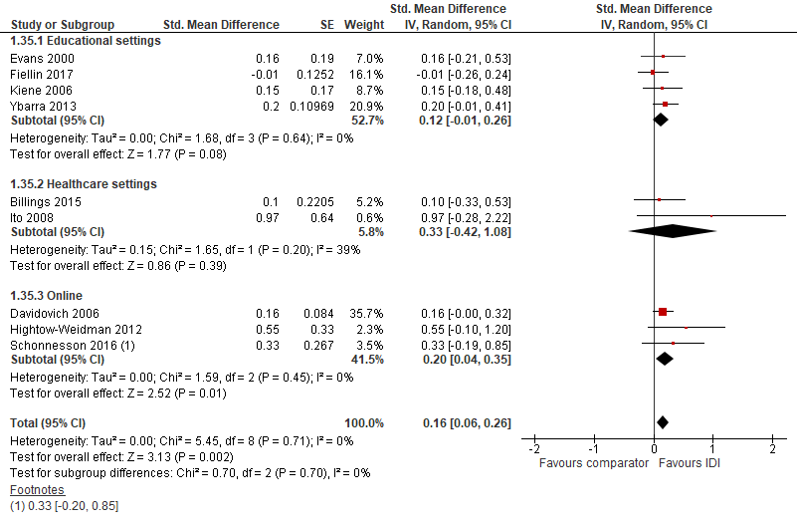

* IDIs were effective for intention in online settings only

Figure 12. Forest plot: IDIs vs minimal interventions: BEHAVIOUR, by setting
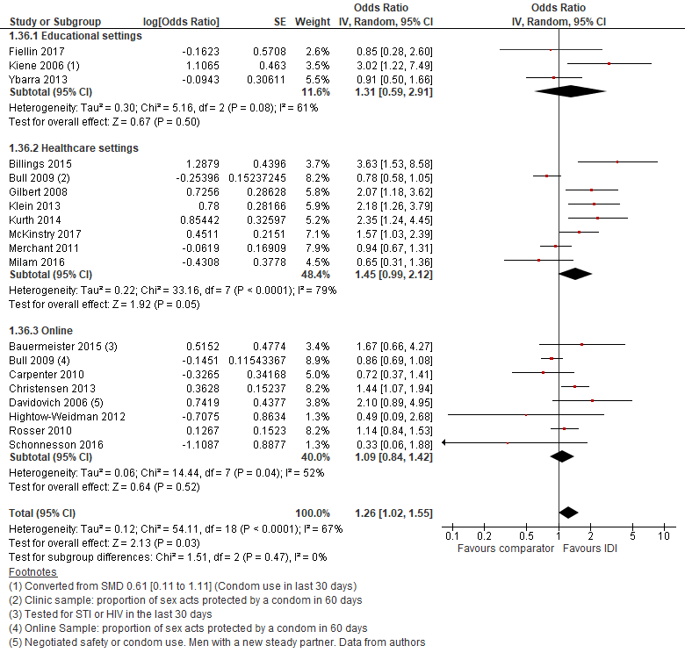
* The meta-analysis of IDIs for behaviour shows very mixed results: IDIs were not effective for behaviour in any single setting, but were effective overall

Subgroup analyses – effects of interactive digital interventions by group targeting

Figure 13. Forest plot: IDIs vs minimal interventions: KNOWLEDGE, by group targeted

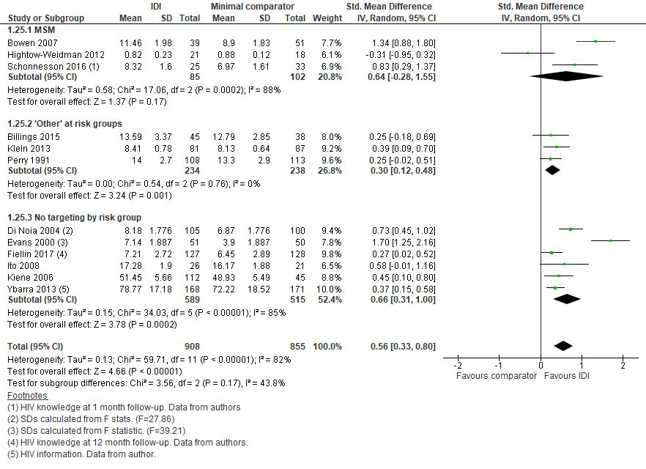

* IDIs were effective for knowledge acquisition for at-risk adults and for general populations, but not for men who have sex with men (although the MSM sample size was small)

Figure 14. Forest plot: IDIs vs minimal interventions: SELF-EFFICACY, by group targeted

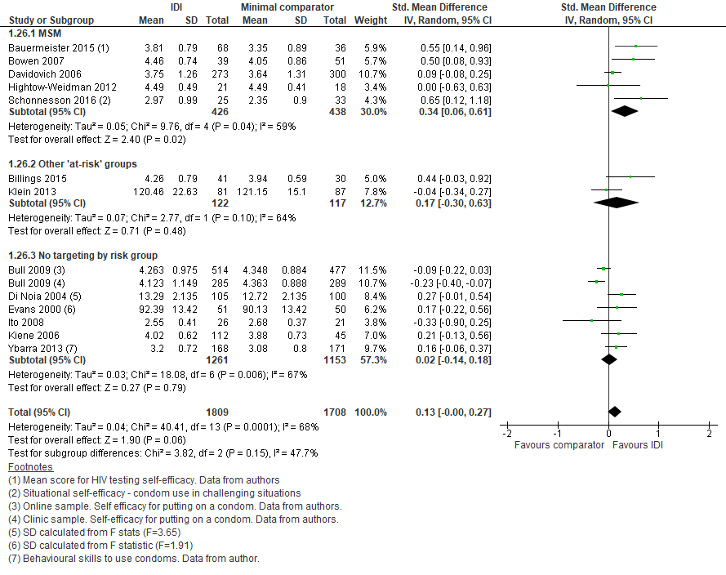

* IDIs were effective for self-efficacy for men who have sex with men, but not other at-risk adults, or general populations

Figure 15. Forest plot: IDIs vs minimal interventions: INTENTION, by group targeted

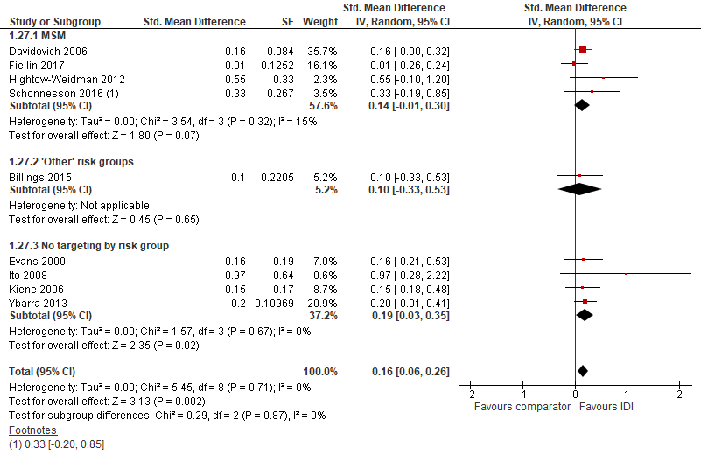

* IDIs were effective for intention for general populations, but not for MSM or other at-risk adults

Figure 16. Forest plot: IDIs vs minimal interventions: BEHAVIOUR, by group targeted
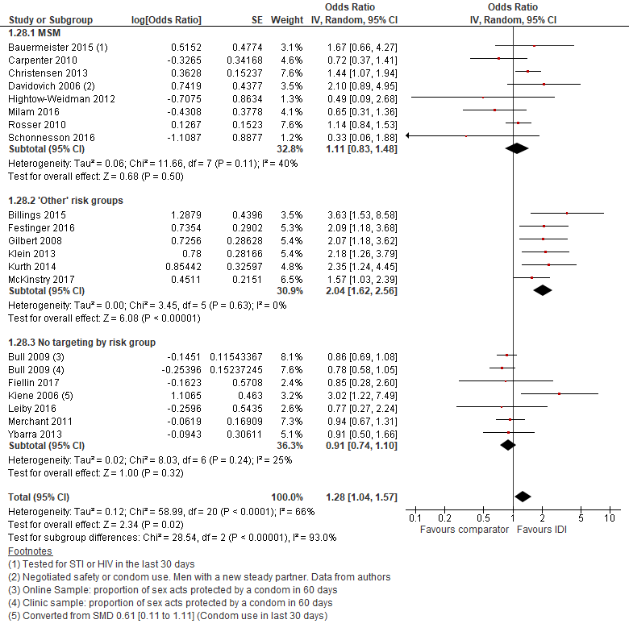
* IDIs were significantly more effective for behaviour change for at-risk adults, with no effects for MSM or general populations

Subgroup analyses – targeting by HIV status

Figure 17. Forest plot: IDIs vs minimal interventions: KNOWLEDGE, by HIV Status

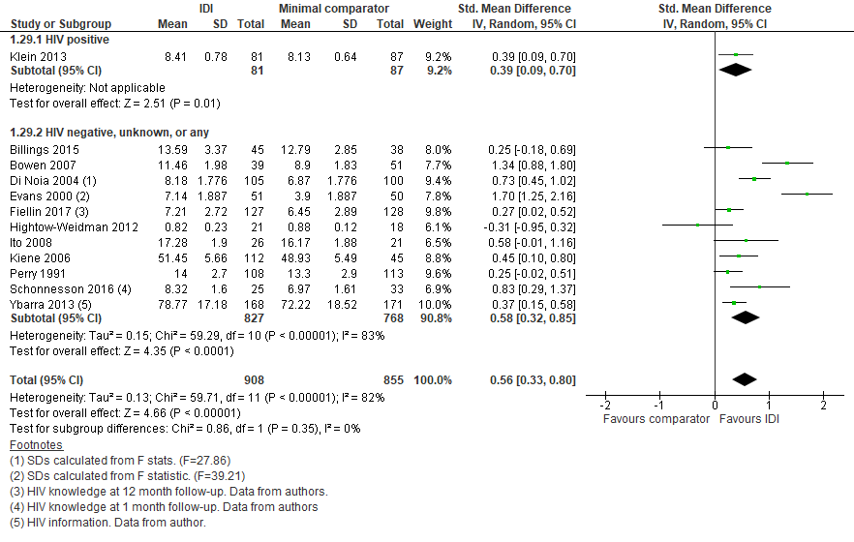

* IDIs were effective for knowledge for people living with HIV, and people who were negative, unknown, or any HIV status

Figure 18. Forest plot: IDIs vs minimal interventions: SELF-EFFICACY, by HIV Status

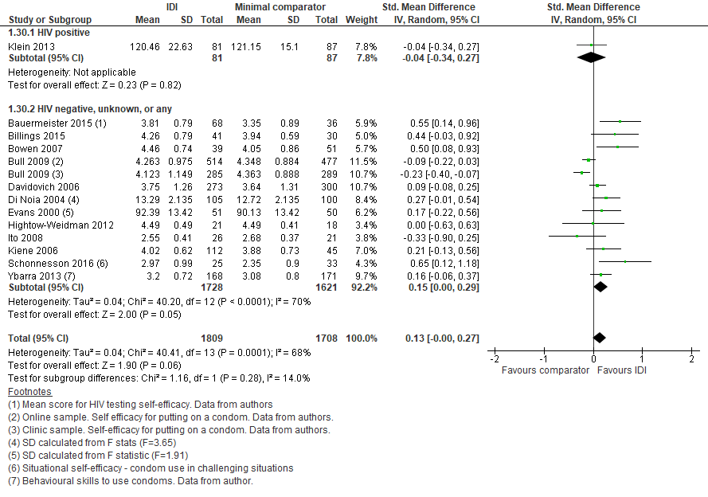

* IDIs did not show an impact on self-efficacy for people of any HIV status

Figure 19. Forest plot: IDIs vs minimal interventions: INTENTION, by HIV Status

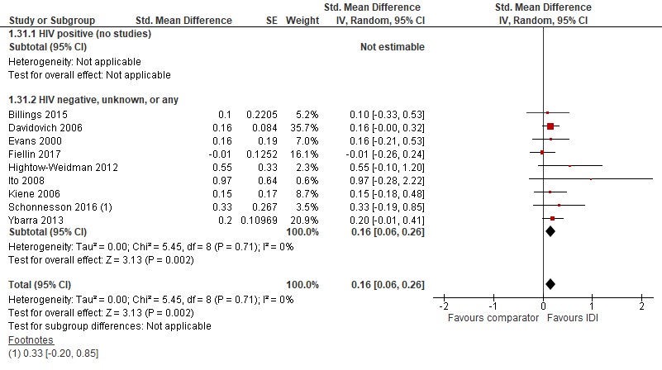

* IDIs were effective for intention for people who were HIV negative, unknown, or any status

Figure 20. Forest plot: IDIs vs minimal interventions: BEHAVIOUR, by HIV Status
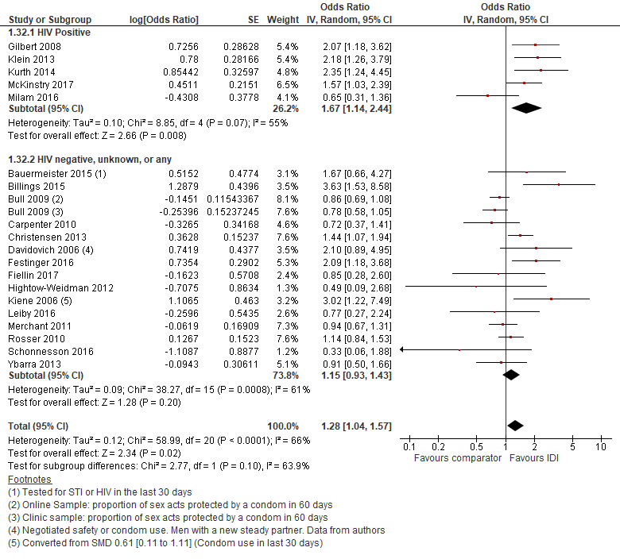
* IDIs were effective for behaviour change for people living with HIV, but not for people who were HIV negative, unknown, or any status

